Small Starts for Toddlers (1-3 years old)
Parent Goal Setting Work Sheet

Circle one small start to try at home.

EAT BETTER
Know when your toddler is full
EAT BETTER
- She does not need to eat everything on the plate
- Watch for cues! Shaking her head no. Saying "no more" "all done".
-Throwing food.
-At mealtime, I will notice when my toddler is done eating.

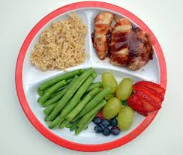
Build a healthy plate
-Make half your plate fruits and vegetables” + 1/4 grains + 1/4 protein + dairy
-Veggie ideas: Peas, corn, carrots, broccoli, cauliflower, green beans, can be frozen
-Fruit ideas: apples, pears, strawberries, blueberries
-We will build healthy plates for one meal each day this week.

Know how much to serve
-For your toddler, 1 serving = 1/4 cup = size of toddler fist
-In 1 day: 5+ servings of fruits and veggies; 4 whole grain servings;
-3 protein servings; 2 glasses of milk
-I will have at least one serving of fruits/vegetables at a meal every day.

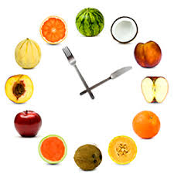
- Set meal times and snack times
- Plan 3 meals and 2 or 3 snacks each day.
See the American Academy of Pediatrics
- Include 4 food groups at meals and 2 food groups at snack
-Healthy snacks: bite size fruits and veggies
-I will serve 3 healthy meals days this week.
AND/OR
- I will serve 2 healthy snacks days this week.

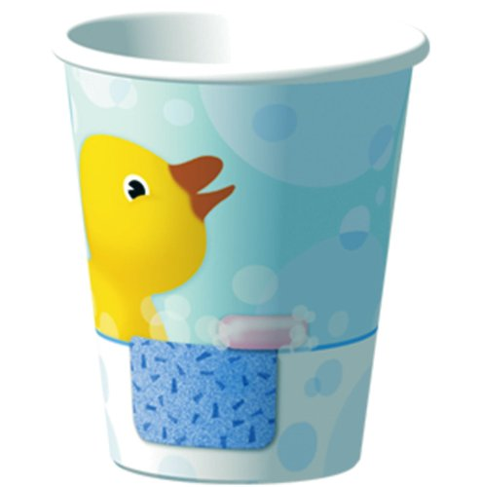
Choose a healthy drink
-If your toddler is thirsty, offer water!
-Aim for 2- 3 cups of low-fat milk per day for toddlers ages 2 and older.
-Think of Juice as dessert. Give none to < ½ cup per day
-No soda
- I will replace juice with water.

Play everyday!
BE

ACTIVE
-Aim for 60 minutes a day, divided up.
-Ask your toddler to bring you books, shoes, balls, etc. Clean up together. Let her help push the stroller.
- TV gets in the way of playtime, so turn it off.
-I will play an active game with my toddler each day.

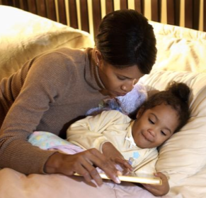
SLEEP
BETTER
Have a bedtime routine
- Your toddler needs 12-14 hours of sleep.
-Most of growth occurs during sleep.
-A routine helps your toddler know it is time for sleep.
- Try a warm bath and bedtime story.
-I will use a bedtime routine nights this week.

Try doing that small start every day for 3 weeks, to form a new habit.
Circle each day you try it. Don’t worry if you miss a day. Just start again.

My Goal is _______________________________________________________________
Circle each day you try that new habit. | Mon | Tues | Wed | Thurs | Fri | Sat | Sun | I did it!
 | Mon | Tues | Wed | Thurs | Fri | Sat | Sun | I did it!
 | Mon | Tues | Wed | Thurs | Fri | Sat | Sun | I did it!

Visit healthierTN.com/families for more small starts ideas.

Visit kidcentraltn.com to see a list of state services for children and families.

