Tennessee Regional Perinatal Centers

FY 2021 Fact Sheet
- Together, prematurity and low birthweight are the second leading cause of
infant death in Tennessee.
- Tennessee's smallest and most fragile babies have a better chance of survival if they are born at an appropriate facility.
- Perinatal regionalization is a key national strategy to reduce infant mortality.

What is the purpose of the regional perinatal system?
To provide and support an appropriate, accessible high-risk perinatal and neonatal health care system that meets the needs of high-risk infants and child-bearing aged women in Tennessee.
How does the system work?
Funding is provided by the State to five designated regional tertiary centers to assure that the infrastructure for high-risk perinatal services is in place statewide. This system includes 24-hour telephone consultation with physicians and nurses, professional education within the region, transportation of high-risk pregnant women and infants, and post-neonatal follow-up.
Why is the system important?

Regional Perinatal Centers

West Tennessee – Memphis
- Regional Medical Center at Regional One Health
Middle Tennessee – Nashville
- Vanderbilt University Medical Center
Monroe Carell, Jr. Children’s
Hospital
Southeast Tennessee – Chattanooga
- Erlanger Health System
Children’s Hospital at Erlanger
East Tennessee – Knoxville
- The University of Tennessee Medical Center at Knoxville
Northeast Tennessee – Johnson City
- Johnson City Medical Center
The Regional Perinatal Centers provide a statewide system of high-risk obstetric and infant care.
Research indicates that ensuring high-risk pregnant women and newborns receive risk-appropriate care can reduce maternal and infant morbidity and mortality.
Who is eligible?
All pregnant women and infants who are high risk are accepted for services at the five regional tertiary hospitals without regard to income.

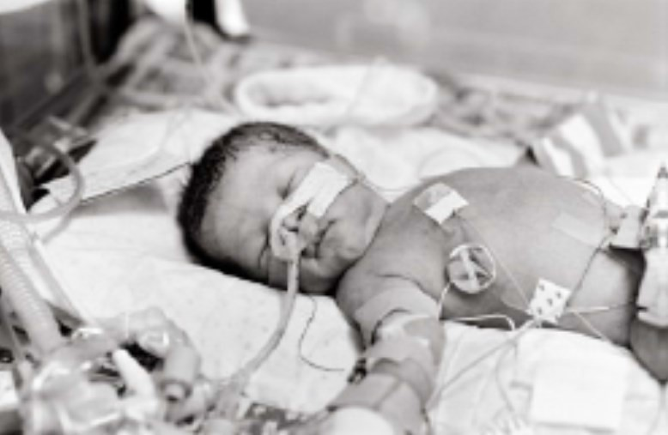
January 2022

Perinatal Center Activities

Direct Clinical Care and Consultation
Care is provided to high-risk pregnant women and Tennessee’s most fragile and sick infants at five centers throughout the state. Specialized care is available for individuals with complex medical conditions or with high-risk pregnancies. Services also support critically ill infants, including those born extremely premature or with serious conditions requiring medical or surgical care. Highly trained staff are available for consultation with Tennessee providers 24 hours a day, 7 days a week. Outpatient consultation services are also available. In FY 2021, 101,842 consultations were performed by perinatal center staff.
Snapshot: Perinatal Activities FY 2021
Hospital-based Services
- 16,206 deliveries to Tennessee residents at
regional obstetrical centers
- 4,092 NICU admissions to Tennessee infants
  - 44.1% low birth weight
  - 11.9% very low birth weight
  - 5.0% extremely low birth weight
Consultation Services
- 101,842 obstetrical consultations (outpatient)
Outpatient Services
- 3,941 NICU follow-up clinic visits
- 806 transports of Tennessee infants to
regional neonatal centers
Community Services
- 7,783.5 educational hours taught to staff throughout the state

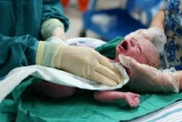

January 2022
In Calendar Year 2020 in Tennessee:
- Total resident births were 78,685
- 495 infants died in the first year of life (infant mortality rate - 6.3/1,000)
- 10.9% (8,583) were born preterm
- 1.6% (1,223) were born very low birth weight

Education for Community Hospitals and Providers
Expert staff from the perinatal centers travel throughout the state to provide training to staff at community hospitals. The training helps prepare staff in community hospitals and provider offices for recognizing and treating complex medical conditions. Additional training equips local staff with the knowledge and skills to stabilize critically ill infants until they can be transported to a specialized center. In FY 2021, 7,132.5 hours of educational training were provided throughout the state.

Technical Assistance to State Agencies
Staff from the regional perinatal centers are active and regular participants in a number of initiatives aimed at improving birth outcomes in Tennessee, including the Tennessee Initiative for Perinatal Quality Care (TIPQC) and the Department of Health’s Perinatal and Genetics Advisory Committees, Maternal Mortality Review Committee, and the Maternal Health Task Force.
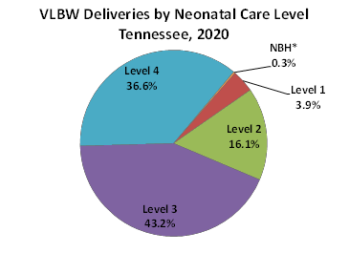
Experts from the regional perinatal centers and local hospitals provide guidance throughout the year as needed. Members also participate in ad hoc work groups convened by the Department of Health and other agencies. During calendar year 2020, expert workgroups updated the Guidelines for Regionalization and Transportation.

In calendar year 2020, 80% of very low birth weight (VLBW) infants were delivered at level 3 or level 4 facilities.

