Primary Prevention Initiative Bright Spot Nomination

Date: 07/23/15 County: Weakley
Project Title: Walk Across Tennessee Topic: Obesity
Problem Overview: Studies cited by the World Health Organization and US Department of Health and Human Services state that physical activity levels are declining globally. The World Health Organization and US Department of Health and Human Services recommend that for good health, adults should get the equivalent of two and a half hours of moderate to vigorous physical activity each week (Harvard School of Public Health, 2015). Weakley County has a relatively high physical inactivity rate compared to that of the state and US. In Weakley County, 34% of adults age 20 and over report no leisure-time physical activity, compared to 30% state rate (County Health Rankings, 2015).

Researchers believe that physical activity prevents obesity by increasing people’s total energy expenditure, decreasing fat around the waist, decreasing total body fat, building muscle mass, increasing the amount of energy that the body burns throughout the day, and reducing depression and anxiety (Harvard School of Public Health, 2015).

PPI Objective:
- PPI Project/Activity Description: The Weakley County Obesity PPI Team aimed to increase the availability of exercise opportunities in Weakley County by offering education and fitness programs to the Weakley County community. The PPI team partnered with UT Extension to host the 8-week “Walk Across Tennessee” (WAT) program in the county. The primary goal of WAT is to encourage exercise among participants. Participants formed groups of 5-7 individuals plus a team captain. Participants walked individually or as a group and turned in their miles weekly to their team captain who then weekly reported miles to the Weakley County Health Department. Walking and running were acceptable activities, and a conversion chart for other activities such as aerobic exercise, bicycling, and swimming was given to participants.

- Who Was Involved: Six PPI Obesity Team members included Jackie Franks, Health Educator; Denise Bell, RN; Rita Jeter, PHOS; Dede McClure, NA; Ava Laycook, RD; and Bobbie Sue Arnold, PHOA. Other individuals involved included the Weakley County Tobacco PPI Team, UT Extension Agent Beverly Shelby, the Weakley County Health Council, and a number of local businesses and organizations that supported the program.

- Description of Activity:

  - Planning for Walk Across Tennessee (WAT) began in November 2014, for the program beginning March 7 and ending May 2. During the planning period, PPI team members spent extensive time familiarizing themselves with the program, with the assistance of Beverly Shelby from UT Extension. Community promotion for WAT began in January. During this time, each team member was assigned an area of the county, and she was responsible for making face to face contact with businesses and organizations in that area to explain WAT. Information about the program was left in public places in the community such as the library and courthouse. Also during the planning phase, the PPI team secured the support of County Mayor Jake Bynum, who offered to sign a proclamation; form his own team; and share the information on his Facebook page. WAT was promoted to the Health Council and Interagency Council, and was even adopted as a “Council Project”. A state map to track teams’ progress was planned for display at the health department.
  - A kickoff for WAT was held on March 28th (which was rescheduled from an earlier date due to inclement weather). The event was held at the local farmer’s market pavilion and featured Mayor Bynum as emcee, information about WAT, HealthierTN, tobacco cessation, free Zumba, and lots of door prizes. Participation at this event was low due to cold weather.
  - Once WAT began on March 7, teams reported their miles to the health department on Wednesdays. Some teams were able to make it across the state in a week or two, while other teams never quite made it across. The majority of teams were walking and reporting their miles in a timely basis. Planning for the closing ceremony was ongoing during the 8-weeks that WAT was actually occurring.
  - The closing ceremony was a reception to honor all participants. The event was held May 5th, at the health department, and over 50 participants or team leaders were in attendance. Every WAT participant was awarded a “Certificate of Completion” for participation in WAT. Prizes were awarded to the winning teams as well as other categories such as “Most Gung-Ho team captain” and “Best Team Picture.”
- Tracking Progress: WAT participants turned in their weekly miles to the health department. These miles were tabulated in an excel spreadsheet. The map on display in the health department lobby was updated weekly to reflect each team’s standings. Participants were also asked to complete a post-survey so we could further track their progress.
Project/Activity Outcome: Weakley County’s Walk Across Tennessee program was immensely successful with a total of 48 teams made up of 367 participants who walked a total of 62,180.77 miles. This distance is equivalent to walking around the Earth’s equator 2.5 times! The winning team, Itri2run had 4605 miles during this 8-week period. Despite this overwhelming number, the PPI Team made sure to stress that everyone that increased their physical activity was a winner.
Survey Results: Surveys from UT Extension were tabulated by Sandi Smith, DPN at the Weakley County Health Department. Highlights of the surveys included:
- 42.5% of respondents reported losing weight
- 44.4% of respondents reported maintaining a healthy weight
- 66.6% of respondents reported maintaining a regular exercise routine because of participation in WAT
- 75.9% of respondents reported an increase in energy from daily exercise
- 51.8% of respondents reduced their stress levels as a result of exercising daily
- 70.7% of respondents reported that they increased the amount of exercise they did during WAT
- 94.8% of respondents reported an intention to continue their exercise routine after the conclusion of WAT
Highlight: The key to the success of this project was the face to face interaction between PPI team members and local businesses, agencies, and organizations. WAT had never been implemented in Weakley County before, so there was a great deal of education that needed to be done regarding the program in order to obtain a high level of community support.
Words of Wisdom: Study the UT Extension WAT manual thoroughly and reach out to other counties that have implemented WAT through PPI in order to know what to expect. Spend some time researching the types of forms and surveys to use that best suit your project. Reach out to a “wellness champion” at the larger businesses/organizations to organize multiple teams.
Project Contact:
Jackie Franks, MPH, Public Health Educator
Obion & Weakley County Health Departments
9852 Tennessee 22
Dresden, TN
731-885-8722
731-364-2210
Jaclyn.Franks@tn.gov

Appendix A- WAT Photos

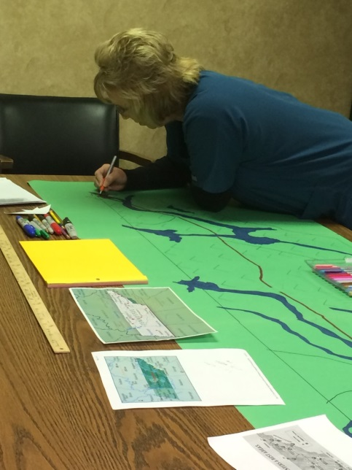
Bobbie Sue Arnold hand-drawing the Tennessee map.
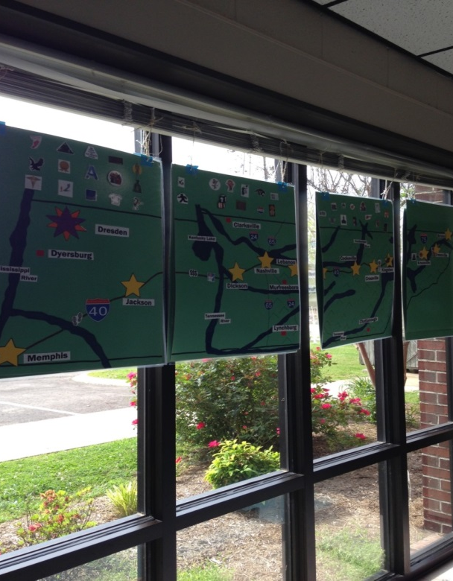
The map on display in the windows of the lobby. The map was double-sided so it could be seen from inside or outside.
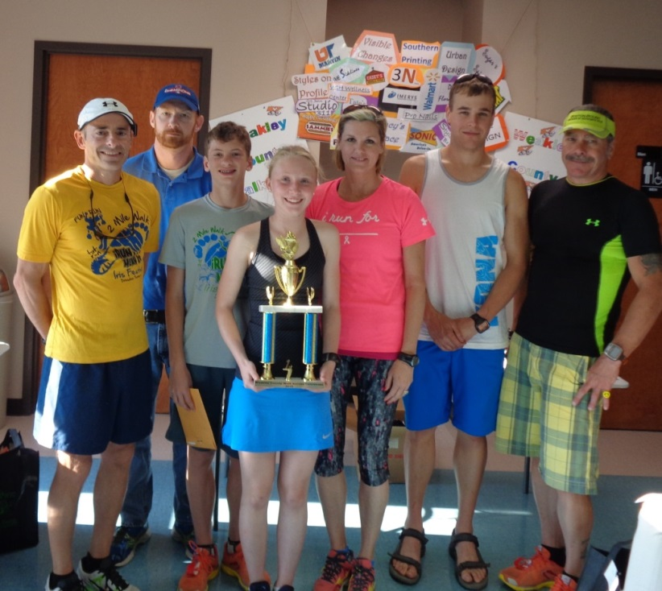
The winning team- ITri2Run
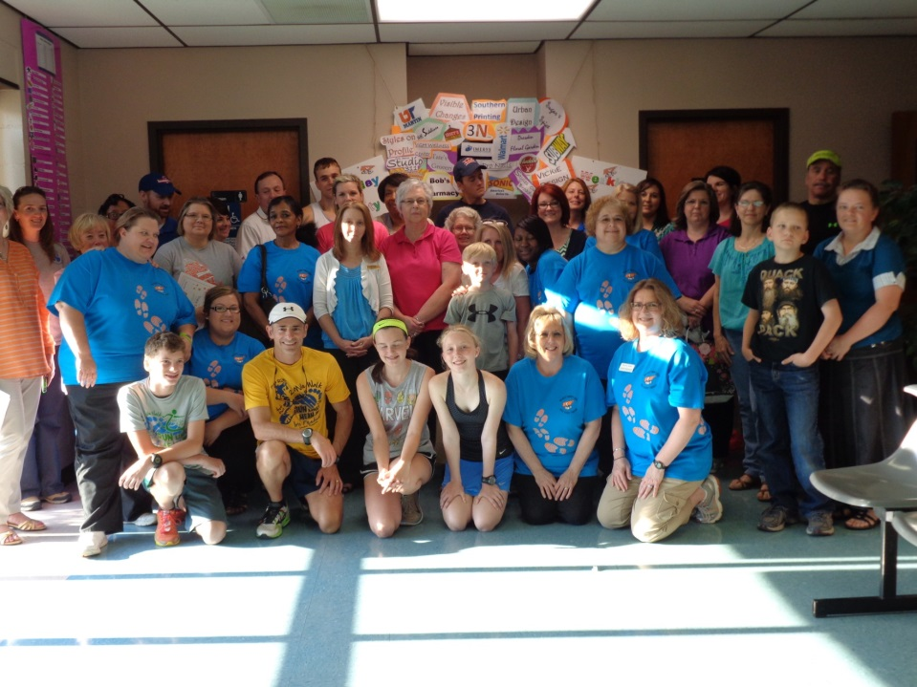
Participants and team captains with HD staff at the closing ceremony.

Appendix B- Mayor’s Proclamation
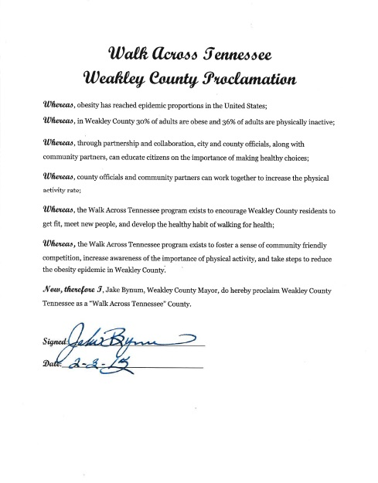
Appendix C- Article from Dresden Enterprise
