TDH TBI Service Coordinators by Region and County:
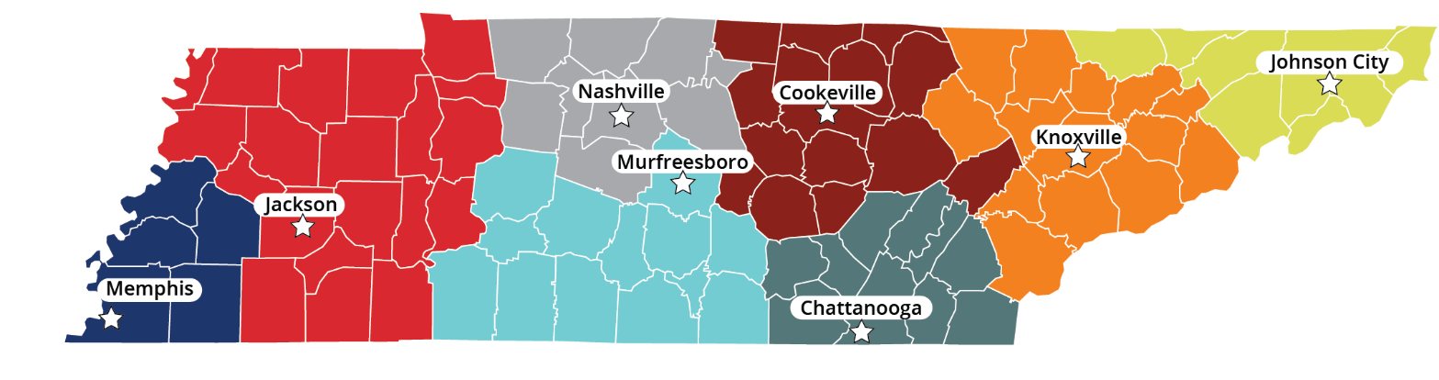
Alt Text for image on website: This image shows a color-coded map of Tennessee divided into 8 regions for Traumatic Brain Injury (TBI) Service Coordination. Within each region, a major city is highlighted.
Asia Burks
Regional One Health
901.545.8487
asburks@regionalonehealth.org
Serving Tennessee Counties: Fayette, Haywood, Lauderdale, Shelby (Memphis), Tipton
----
Jimmie Lee Morris
West Tennessee Rehabilitation Center
731.541.4941
Jimmie.Morris@WTH.org
Serving Tennessee Counties: Benton, Carroll, Chester, Crockett, Decatur, Dyer, Gibson, Hardin, Hardeman, Henderson, Henry, Houston, Humphreys, Lake, Madison (Jackson), McNairy, Obion, Perry, Stewart, Weakley
----
Carolina Valdez
Brain Injury Association of America
615.551.8960
cvaldezrios@biausa.org
Serving Tennessee Counties: Cheatham, Davidson (Nashville), Dickson, Montgomery, Robertson, Sumner, Trousdale, Williamson, Wilson
----
Heather Henderson
Brain Injury Association of America
931.271.8560
hhenderson@biausa.org
Serving Tennessee Counties: Bedford, Coffee, Franklin, Giles, Hickman, Lawrence, Lewis, Lincoln, Marshall, Maury, Moore, Rutherford, Wayne
----
Samantha Bales
Brain Injury Association of America
931.271.8660
sbales@biausa.org
Serving Tennessee Counties: Cannon, Clay, Cumberland, DeKalb, Fentress, Jackson, Macon, Overton, Pickett, Putman (Cookeville), Roane, Smith, Van Buren, Warren, White
----
Ginger Storrar
Chattanooga Area
Brain Injury Association (CABIA)
423.602.7246
CABIA@cabiatn.org
Serving Tennessee Counties: Bledsoe, Bradley, Grundy, Hamilton (Chattanooga), Marion, McMinn, Meigs, Polk, Rhea, Sequatchie
----
Patty Cruze
Patricia Neal Rehabilitation at Fort Sanders
865.331.1499
PCruze@CovHlth.com
Serving Tennessee Counties: Anderson, Blount, Campbell, Cocke, Grainger, Hamblen, Jefferson, Knox (Knoxville), Loudon, Monroe, Morgan, Sevier, Scott, Union
----
Jake Sipos
Crumley House
423.257.3644 EXT 6
jake@crumleyhouse.com
Serving Tennessee Counties: Carter, Claiborne, Greene, Hancock, Hawkins, Johnson, Sullivan, Unicoi, Washington (Johnson City)

