

Shipping Information for Private Clinics and Midwives

The State of Tennessee Newborn Screening Program began providing FedEx overnight shipping labels to primary care providers and midwives who collect and submit newborn screening specimens to the state laboratory. Implementation of this service will play a large role in helping the state meet the national goal of reporting out-of-range results by the fifth day of life and all results by the seventh day of life. The FedEx shipping labels are being provided at no cost to you, the providers, and are available as of November 1, 2018.

The provided prepaid, pre-printed FedEx shipping labels can be used to send the newborn screening specimens you collect overnight Monday through Saturday via FedEx. Instructions for use of the labels and shipping are enclosed. Remember that the specimen must dry for 3 hours prior to packaging for shipping, so please allow time for drying when scheduling your pick-up. Dried specimens should be placed directly into the FedEx/manila envelope for shipping. Do not place in biohazard, plastic, or poly-bag.

Please be aware that these labels can only be used to send newborn screening dried-blood-spot specimens to the state public health laboratory, tracking is provided, and the labels do not expire. Please email DCLab.Supply@tn.gov to re-order labels.
If you have questions about this process, please email LabNBS.Health@tn.gov.

Shipping Steps for Primary Care Providers & Midwives via FedEx

The Tennessee State Public Health Laboratory wants Newborn Screening blood samples sent via FedEx for a reliable and trackable service. Below are steps to use to send the State Lab dried blood spot samples:
- Use the FedEx Billable Stamp that was provided to you and affix to envelope exterior. FedEx will not bill you for this service.
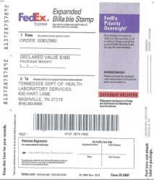

- Place dried blood spot samples in a FedEx Envelope or similar container/mailer. DO NOT place in a biohazard, plastic, or poly bag before placing in envelope.

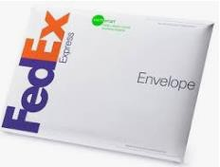

- Here are two ways to ship via FedEx to the State Lab:
    - Call 800-463-3339 at least 2 hours before your office closes for a pickup at your location.
    - Drop package off at a FedEx Office location, Authorized Ship Center. For the best preservation of your sample DO NOT USE AN OUTDOOR DROP BOX.
    - To find the nearest FedEx location, go to www.fedex.com and search for FIND A LOCATION:
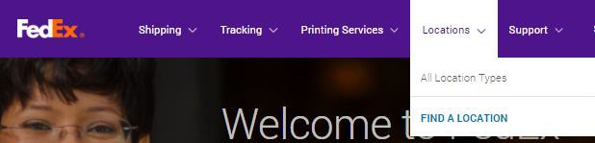
    - If your location has an automatic daily FedEx pickup, just place package with your outgoing shipments.

- Track your package to the State Lab via the tracking number of the Billable Stamp. See left side for a peel off tracking number sticker and keep for your records. Track your package at www.fedex.com.
