


TDH Partner Portal
Simplifying Grants. Strengthening Communities.
Quick Start Guide
Tennessee Department of Health | Partner Portal User Guide

About This Guide
This guide will walk you through every step to get started on the TDH Partner Portal. By the end, you will know how to create an account, find grant opportunities, and submit an application.

What You Need Before You Start
Have these things ready before you begin:
- A valid email address you check often
- Your organization's legal name and address
- Your organization's Unique Entity Identifier (UEI) — get one free at sam.gov if you do not have one
- Your Edison Supplier number, if your organization is already registered with the State of Tennessee

Tip
You do not need a UEI or Edison number to start your account. You can add these later. But you will need both before you can receive a grant award.

Step 1: Create Your Account
First, you need to sign up for the portal. This only takes a few minutes.

Go to the Portal
- Open a web browser.
- Website: Go to:
- https://tndeptofhealth.caspio.app/tdh-partner-portal/home
- You will see the TDH Partner Portal login page.

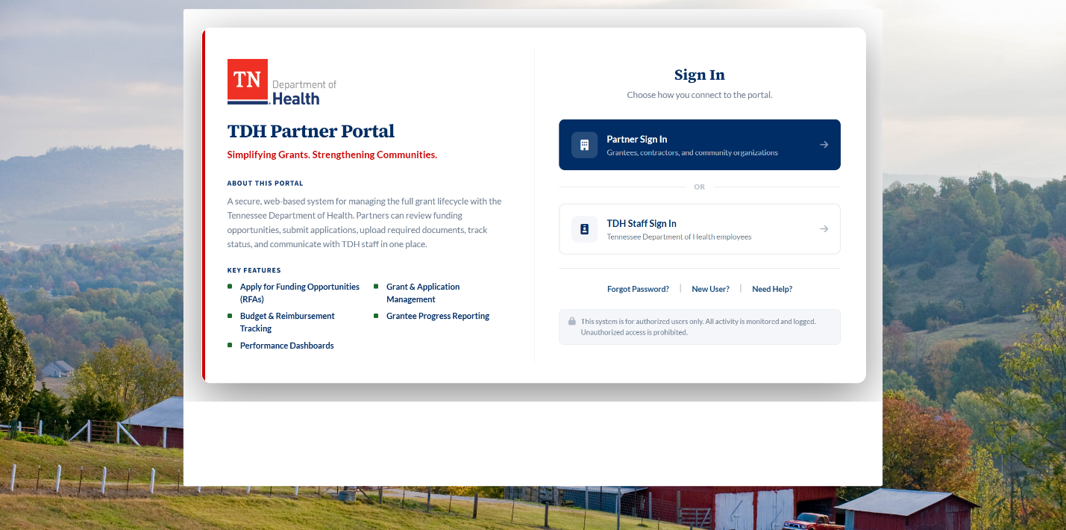

Fill Out the Sign-Up Form
- Click New User? on the login page.
- Enter your first name, last name, and email address.
- Create a password. Use at least 8 characters.
- Click Register.
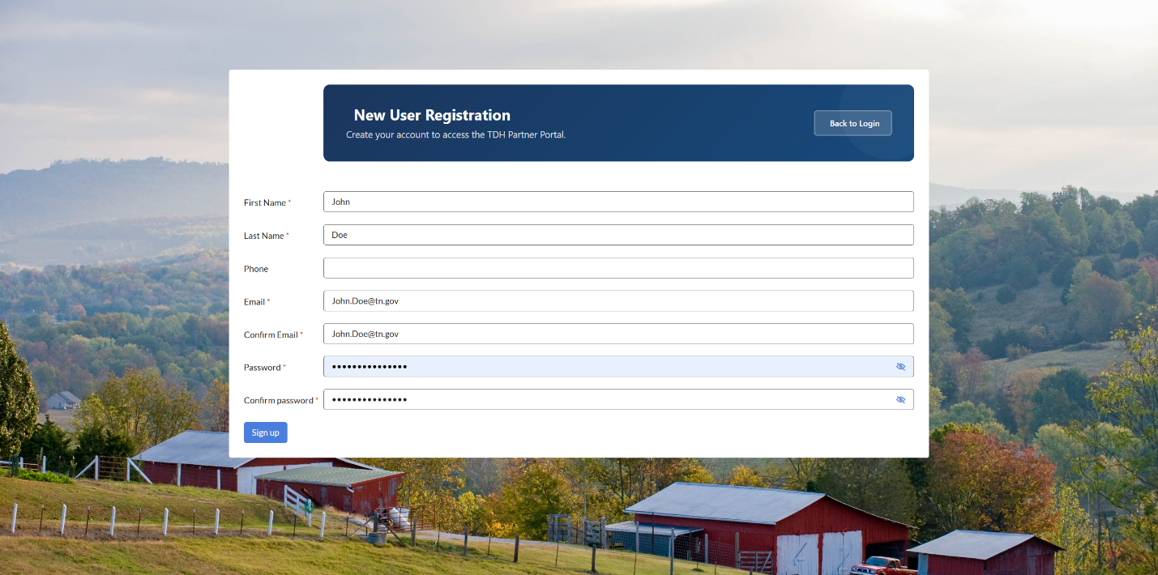

Confirm Your Email
- Check your email inbox. You will receive a message from the portal.
- Open the email and click the confirmation link.
- Your account is now active.
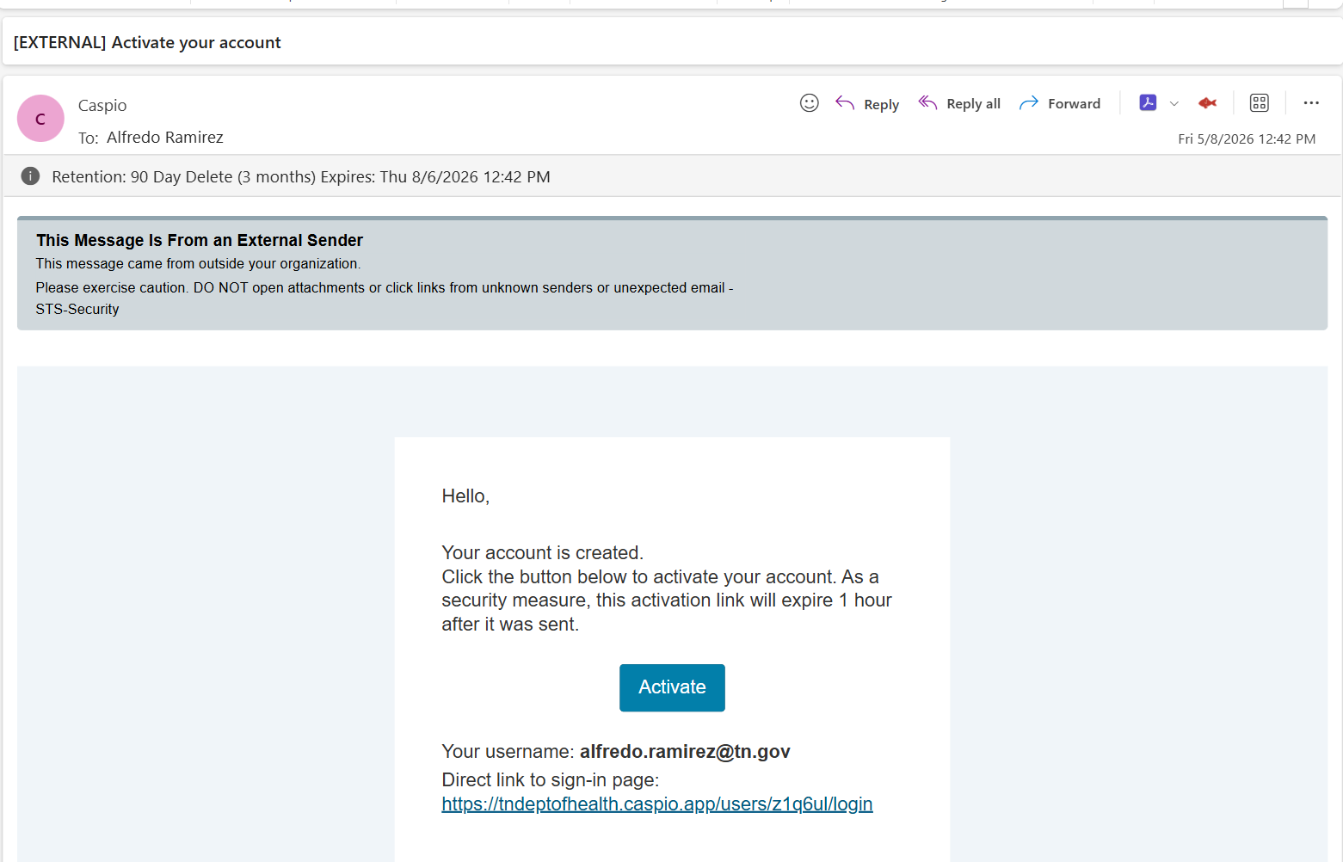

Did not get the email?
Check your spam or junk folder. If you still do not see it, wait a few minutes and try again. Contact Competitive.Health@tn.gov if problems continue.

Step 2: Set Up Your Organization
After you confirm your email, you will be asked to link your organization. This connects your account to your team and grant applications.

Search for an Existing Organization
- On the Organization Setup screen, type your organization's name in the search box.
- If your organization appears in the list, click Select next to it.
- A request will be sent to your organization's administrator for approval.
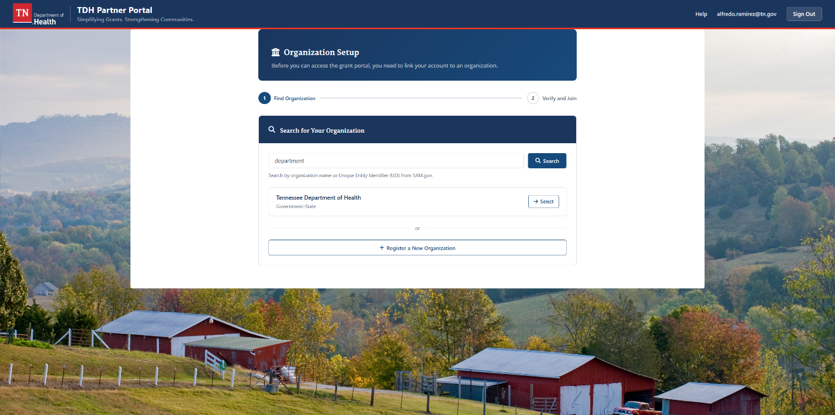

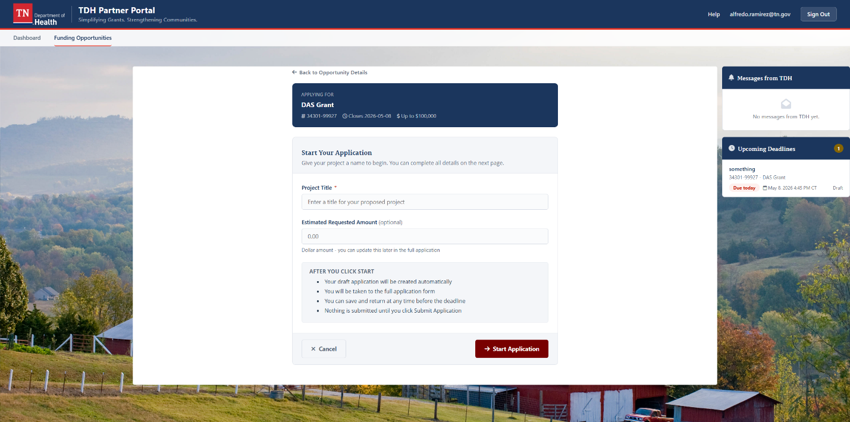Create a New Organization
If your organization does not appear in the search, you can add it.
- Click Create New Organization.
- Fill in your organization's legal name, address, city, state, and zip code.
- Add your website address if you have one.
- Click Save.
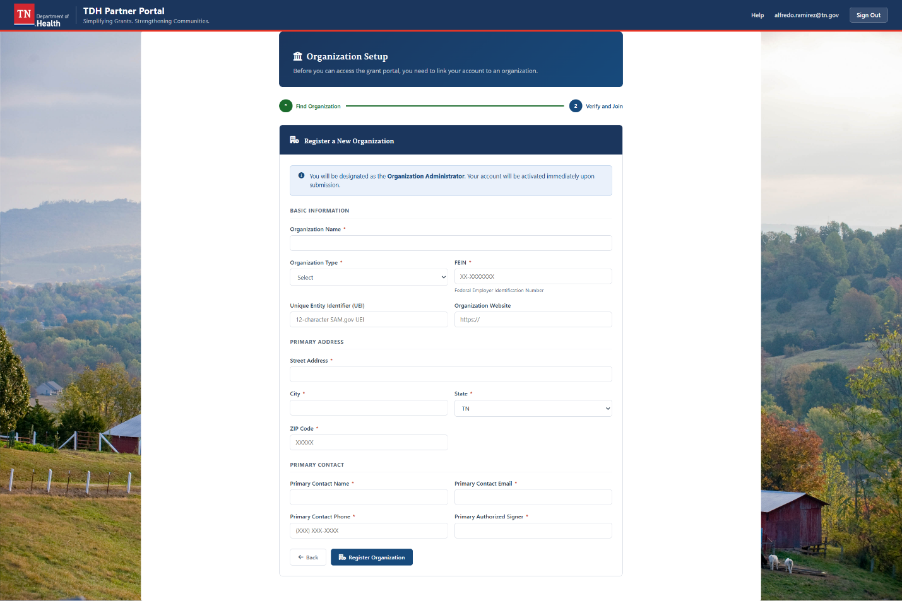

What happens next?
After your account is approved, you will receive an email. Then you can sign in and start exploring funding opportunities.

Step 3: Explore Your Dashboard
Once you are signed in, you will land on your Dashboard. This is your home base in the portal.
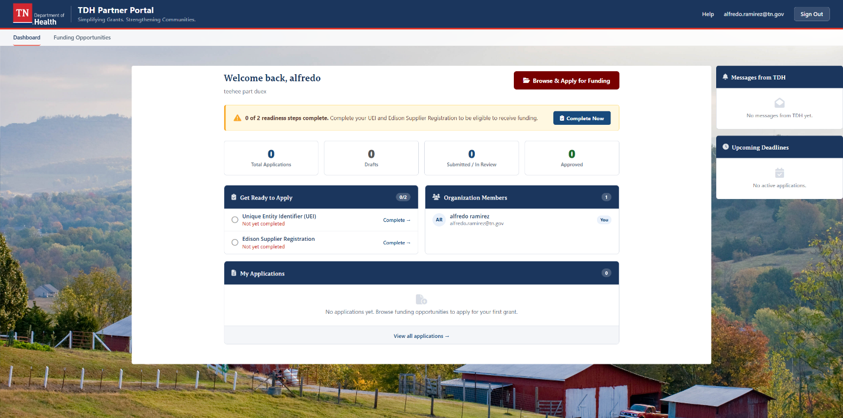

What You Can See on the Dashboard
- Total Applications — how many grant applications you have started
- Drafts — applications you have saved but not yet submitted
- Submitted / In Review — applications being reviewed by TDH
- Approved — applications that have been awarded

Get Ready to Apply Checklist
The Get Ready to Apply section shows tasks you need to finish before you can receive funding. Complete each one when you are ready:
- Unique Entity Identifier (UEI) — register at sam.gov
- Edison Supplier Registration — register with the State of Tennessee

Messages from TDH
TDH staff can send you messages about your applications. Check this panel often so you do not miss important updates.

Step 4: Find a Funding Opportunity
The portal lists all open grant opportunities from TDH. Browse the list to find one that fits your work.

- Click Funding Opportunities in the top menu.
- Scroll down to see the Open Funding Opportunities list.
- Each card shows the grant name, program office, funding range, and deadline.
- Click View & Apply on a grant to learn more.
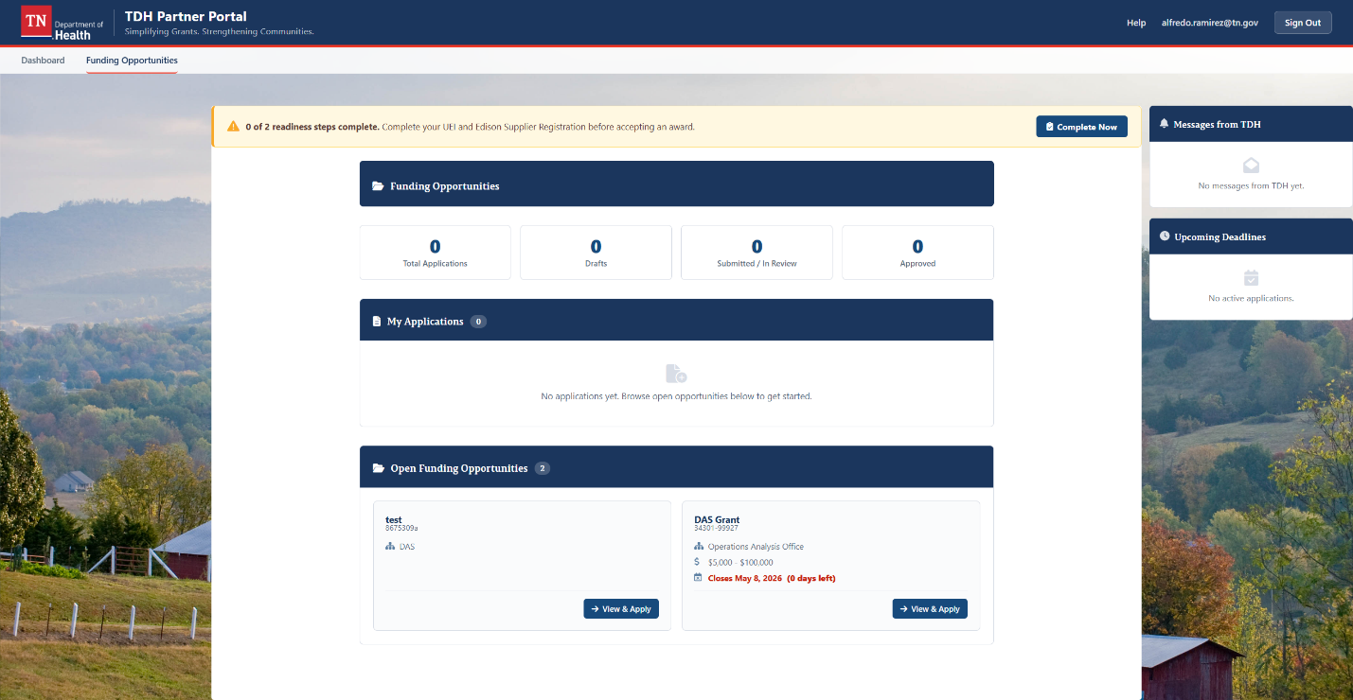
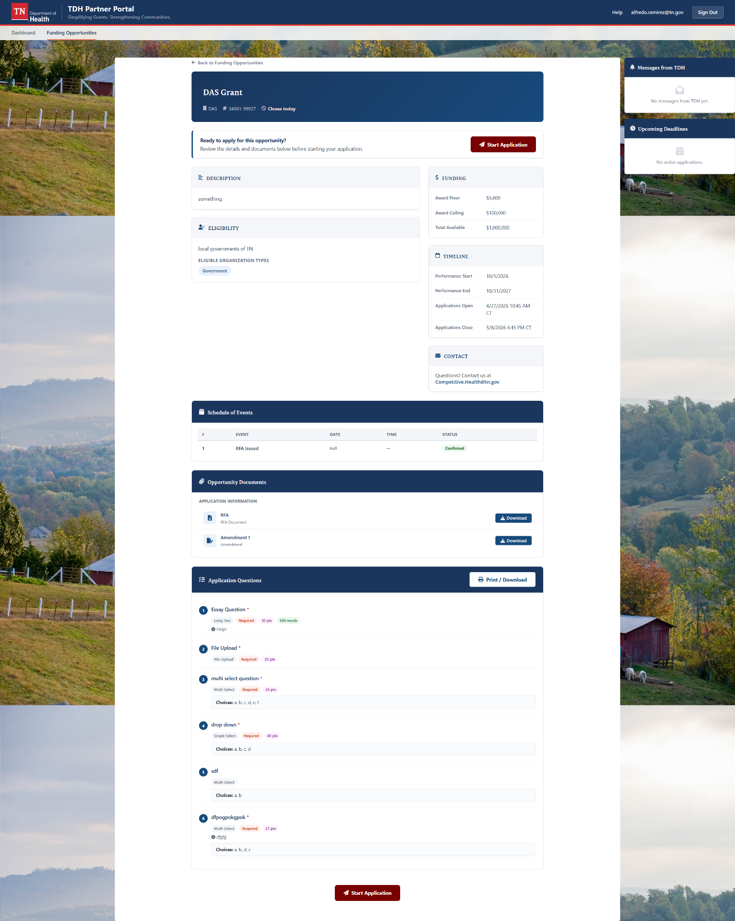

Check the Deadline
Each opportunity shows a closing date. The portal will show how many days are left. Do not wait until the last minute — you cannot submit after the deadline.

Not sure if you are eligible?
Read the full opportunity description on the detail page. Look for the Eligibility section. If you have questions, use the Messages panel to contact Competitive.Health@tn.gov.

Step 5: Start Your Application
When you are ready to apply, follow these steps to start a new application.

- On the opportunity detail page, click Apply.
- A “Start Your Application” screen will appear. Type a name for your project in the Project Title box. This is required.
- You can also enter an Estimated Requested Amount. This is optional and can be updated later.
- Click Start Application. Your draft will be created and the full application will open.
- You will see three tabs at the top: Applicant Info, Project Info, and Questions.
- Start on the Applicant Info section. Your name and organization details will fill in automatically.

Fill In Your Applicant Info
Review the pre-filled information. Update anything that has changed. Required fields are marked with an asterisk (*).
- Check that your first name, last name, and email are correct.
- Confirm your organization's name and address.
- Answer the eligibility questions at the bottom of the page.
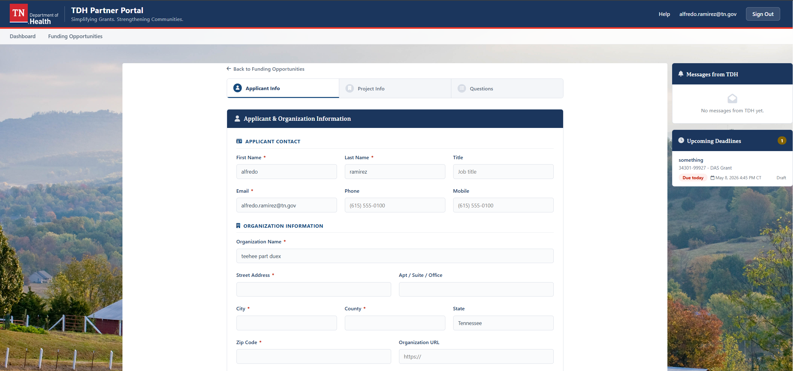

Save as a Draft
You do not have to finish in one sitting. Click Save Draft at any time to save your progress. You can come back later and pick up where you left off.
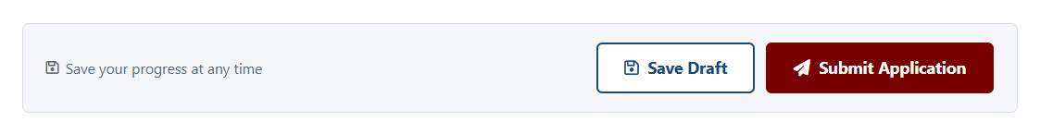

Important
Your draft is saved but not submitted. The TDH program cannot see your application until you submit it. Be sure to submit before the deadline.

Step 6: Complete and Submit Your Application
Work through each section in the application. When everything is done, you will submit it to TDH for review.

Project Info Section
Describe your project clearly. Answer each question fully. Use plain language — you do not need to use technical terms.

Questions Section
This section has specific questions from TDH. Some questions require a written answer. Others ask you to upload a file or choose from a list.
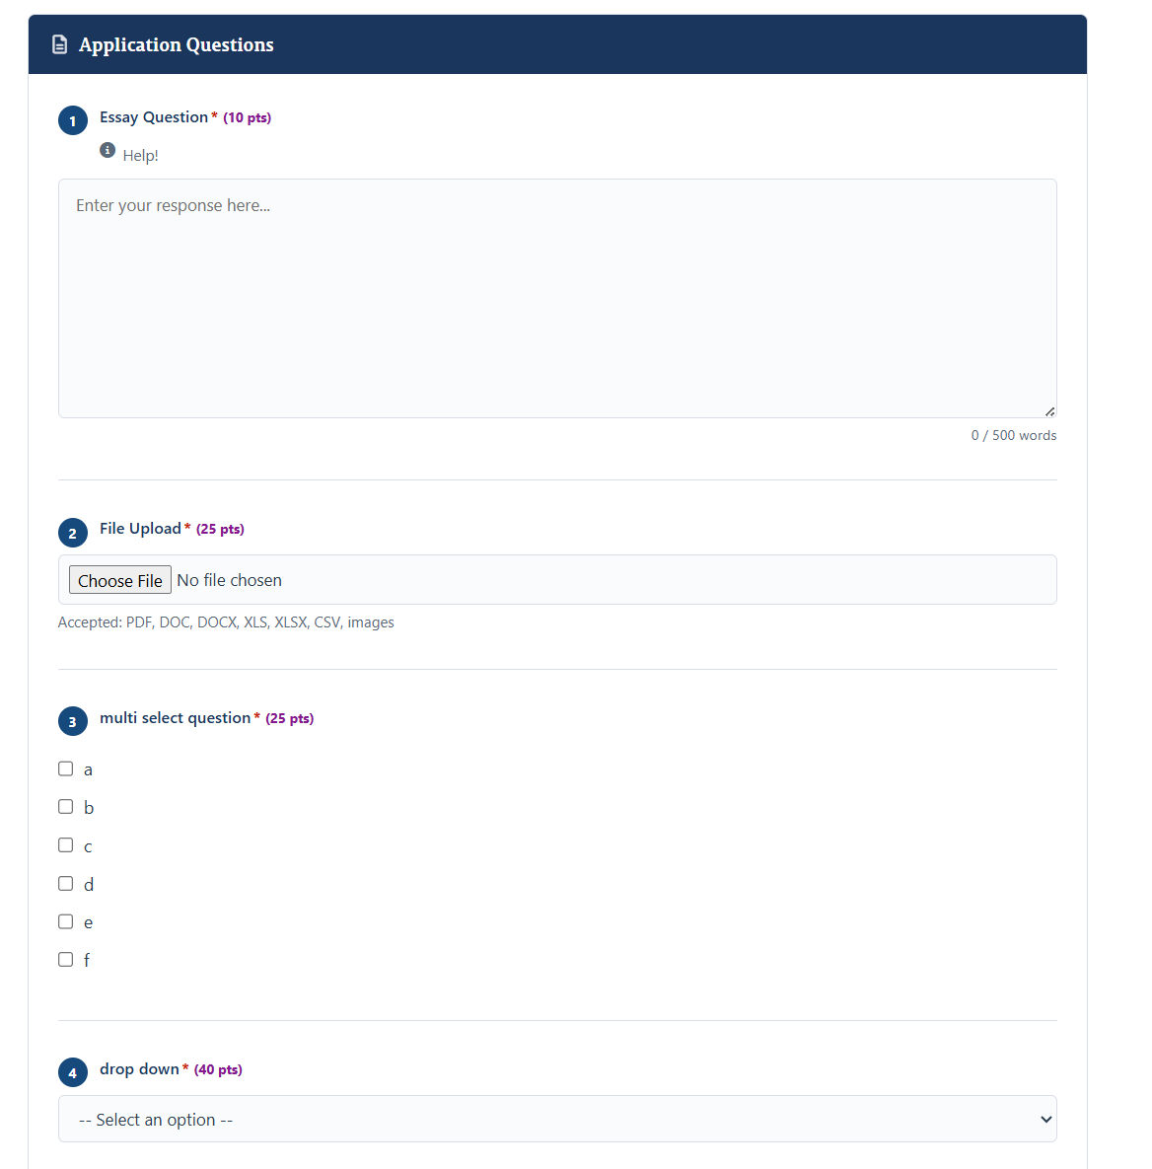
- Essay questions — type your answer in the box. A word counter shows how many words you have used.
- File upload questions — click Choose File, then select the document from your computer. Accepted file types are listed below the button.
- Multiple choice questions — check all answers that apply.
- Dropdown questions — click the menu and pick one answer.

Review Before You Submit
Before you submit, do a final check:
- Did you answer all required questions?
- Did you upload all required files?
- Is your contact information correct?
If anything is missing, the portal will show a warning and tell you what to fix.

Submit Your Application
- When you are ready, click Submit Application.
- A confirmation message will appear. Read it carefully.
- Click Confirm to finalize your submission.
- You will receive a confirmation email. Save it for your records.

After you submit
Your application status will change to Submitted / In Review. TDH staff will review it and may send you a message if they need more information.

Need Help?
We are here to help you. If something is not working or you have a question, use one of these options.

Message TDH Through the Portal
The easiest way to get help is to use the Messages panel on your dashboard. TDH staff will respond as quickly as possible.

More Information
For more resources and updates, visit:
tn.gov/health

Tennessee Department of Health | tn.gov/health

