ESSENCE is a real-time system that collects emergency department (ED) data on suicide related visits, including suicide ideation, attempts, and self-harm.

ESSENCE ALERTS: SUICIDE

SURVEILLANCE IN TENNESSEE
Electronic Surveillance System for the Early Notification of Community-Based Epidemics

WHAT ARE ESSENCE ALERTS?
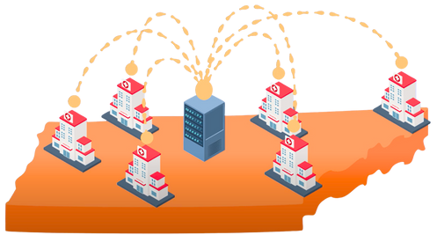
- Weekly email alerts of near-real-time increases in suicide-related ED visits.
- Includes county of residence, age groups, risk factors, and suicidal behavior.

WHY THEY MATTER
- Helps identify trends and inform local responses.
- Focuses resources where they are needed the most.
- Empowers local community partners to take timely action.

STAY INFORMED. TAKE ACTION.
SAVE LIVES WITH ESSENCE.
SIGN UP FOR ESSENCE ALERTS
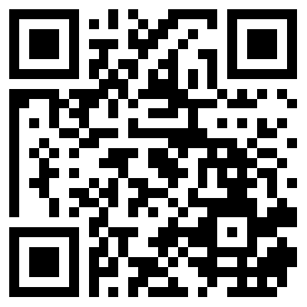 | LEARN ABOUT ESSENCE ALERTS

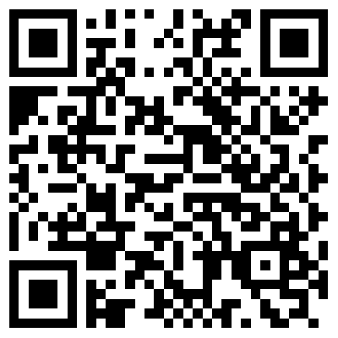
TURN ALERTS INTO ACTION
- Share the alert with community members and partners to ensure a unified response.
- Use the TDH ESSENCE Rapid Response Plan and Guidelines to guide timely, evidence-based action.
- Track your community's response to strengthen future planning and coordination.





This publication was supported by grant number 5NU50CE002589-05-00 funded by the Centers for Disease Control and Prevention (CDC). Its contents are solely the responsibility of the authors and do not necessarily represent the official view of the CDC or the Department of Health and Human Services.
Department of Health Authorization No.
N10WT9. This Electronic publication was promulgated at zero cost. September 2025.

