Attachment 9
Registration for Sales and Use Tax in Tennessee
Job Aid for Vendors
- Enter the link into your browser or click on the link below.
http://www.tn.gov/revenue

- Click on the "Revenue Help" link on the keyboard or at the bottom of the page.
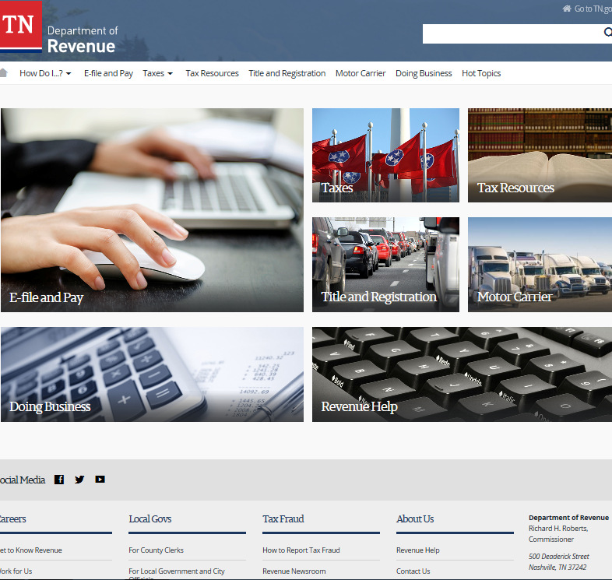

- The vendor should then click on the "Submit a request" link.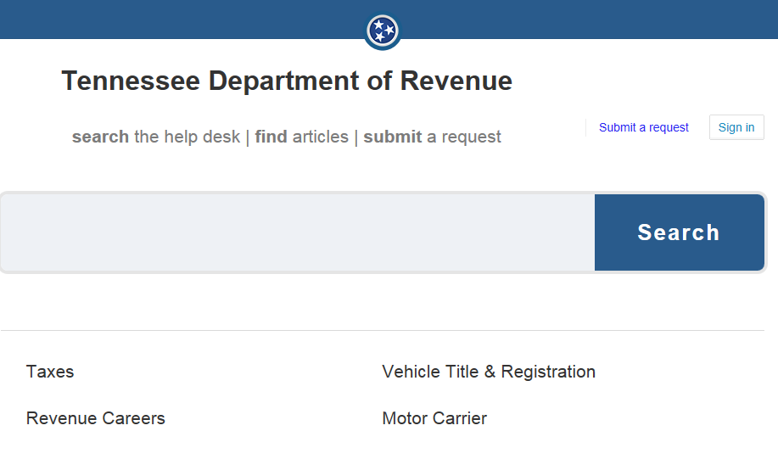
- In the drop down menu select “Tennessee Tax Law” .
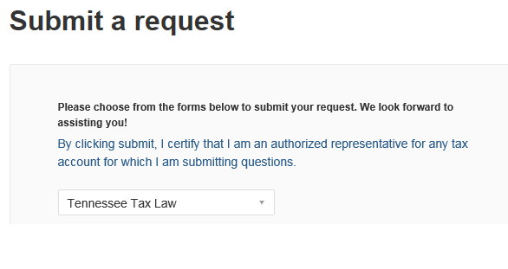

- Complete each field that has an asterisk (*) with your information.
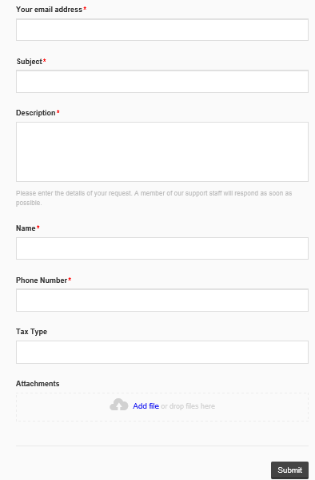
- In the subject field enter Vendor Sales and Use Tax.

- Answer the questions below. Copy and paste the questions with your response in the description field.
  - As an out-of-state vendor, what are you selling or providing to a Tennessee entity?
  - Do you have any employees in Tennessee?
  - Do you have a business location in Tennessee?
  - Do you have sales reps that enter Tennessee?
  - How is your product delivered to a Tennessee customer? (common carrier or company vehicles, electronically, or by tangible method)
  - If installation is required, who installs the product?

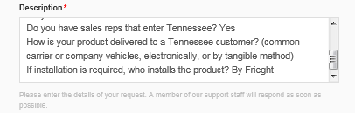
- Type in your name and phone number.

- Click the Submit button.

Once these questions are answered, the Tennessee Department of Revenue will contact you via e-mail within 24 hours and determine if your business needs to register for a Sales and Use Tax account or if you are exempt from such registration.

