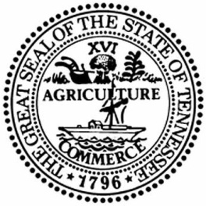
STATE OF TENNESSEE DEPARTMENT OF MILITARY
EVENT 34101-14018 AMENDMENT #ONE
FOR BIRD SURVEY AT SMYRNA AND CATOOSA
DATE: September 22, 2026

EVENT #34101-14018 IS AMENDED AS FOLLOWS:

- State responses to questions and comments in the table below amend and clarify this ITB.
Any restatement of ITB text in the Question/Comment column shall NOT be construed as a change in the actual wording of the ITB document.

Question | ITB SECTION | QUESTION / COMMENT | STATE RESPONSE
1 |  | The 2020 surrey report for bird packages couldn’t be found. | The Survey is now attached to the bid packet.
2

- Event Amendment Effective Date. The revisions set forth herein shall be effective upon release. All other terms and conditions of this ITB not expressly amended herein shall remain in full force and effect.

