Change Control Process

[Agency Name]
[Project Name]

[Publish Date]

Table of Contents

Using this Template 1

Revisions 2

Introduction 3

Change Management Process 4

Acceptance 5

Using this Template
This template contains “suggested language” and assumes that the author of this document will make appropriate additions, deletions, and changes for their specific project needs.

To create a document from this template:
- Replace [bracketed text] on the cover page, in the header, and throughout the document with your project and agency information by filling in the [bracketed text] area in the document text. Filling in the information once will propagate that field throughout the document.
- Complete the entire template making all necessary adjustments.
- Each section contains abbreviated instructions (Green Font) and an example using (Black Font).
- Delete this “Using This Template” page.
- Update the Table of Contents by clicking on the “References” tab, selecting “Update Table”, then “Update Entire Table” and click “Ok”.
- Save.

To provide any suggested improvements or corrections, please email TBSM.info@tn.gov.

Revisions

Revision | Description of Change | Author | Effective Date
v1 | Initial document upload to TBSM intranet site | BSD Team | 09/28/12
v1.1 | Typo corrections | BSD Team | 01/17/13
v1.2 | Updated Change Control Flow for readability | BSD Team | 3/25/2013

Introduction
Change Management is an important part of any project. Changes must be vetted and managed to ensure that they are within the scope of the project and are communicated to all stakeholders if they are approved. The process for submitting, reviewing, and approving changes must also be communicated to all stakeholders in order to properly set expectations. If changes are allowed to be submitted or are implemented in an unorganized way, any project is sure to fail. All projects must include a Change Management Process as part of the overall Project Plan.

Change Control
The purpose of the Change Management Process is to ensure that each change introduced to the project environment is appropriately defined, evaluated and approved prior to implementation.
Change Management will be introduced to the project through the implementation of five key processes:
- The submission and receipt of change requests
- The review and logging of change requests
- The determination of the feasibility of change requests
- The approval of change requests
- The implementation and closure of change requests.

The following swim lane diagram describes the roles, processes and procedures to be undertaken to initiate, implement and review the effects of changes within the project.

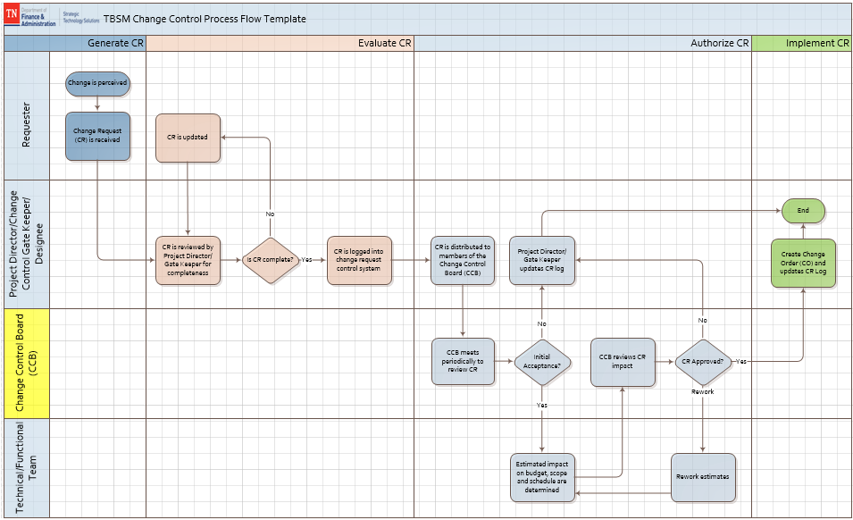

Change Management Process

Identify and Submit Change Request
This process provides the ability for any member of the project team to submit a request for a change to the project.
The Change Requester:
- Identifies a requirement for change to any aspect of the project (e.g. scope, deliverables, timescales and organization)
- Completes a Change Request form (CR) and distributes the form to the Senior Project Director. The CR summarizes the change:
  - Description
  - Reasons/Goals for changes
  - Recommendations
  - Impacts (Cost, Scope, Schedule, and/or Quality)
  - Solution
  - Disposition (Approve, Reject, Defer)

Review Change Request
The Senior Project Director/Change Control Gate Keeper reviews the CR and determines whether or not additional information is required for the Change Control Board (CCB) to assess the full impact of the change to the project time, scope and cost. The decision will be based on factors, such as:
- Number of change options presented
- Feasibility and benefits of the change
- Complexity and/or difficulty of the change options requested
- Scale of the change solutions proposed.

The Senior Project Director/Change Control Gate Keeper will record the CR details in the Change Log to track the status of the change request.

Approve Change Request
The Senior Project Director/Change Control Gate Keeper will forward the Change Request Form and any supporting documentation to the CCB for review and final approval. The CCB will determine the feasibility of this change by examining factors, such as:
- Risk to the project in implementing/not implementing the change
- Impact on the project in implementing the change (time, resources, finance, quality).

After a formal review, the CCB may:
- Approve the change as requested
- Reject the change
- Request more information related to the change.

Acceptance
(This section should be modified for best application to specific projects. Include all project team members that should have some level of authority regarding document review and approval.)

Approved by:

Date:
<Name of Approver>
[Project Name] Executive Sponsor

Date:
<Name of Approver>
[Project Name] Business Sponsor

Date:
<Name of Approver>
[Project Name] Project Director/Manager

Date:
<Name of Approver>
[Project Name] Stakeholder

