Introduction to the
Tennessee Business Solutions Methodology

11/3/2014

Table of Contents

Revisions 1
Introduction 2
Methodology Development Approach 2
Methodology Overview 3
How To Use The Templates 7
Other Resources For Additional Information 8

Revisions

Revision | Description of Change | Author | Effective Date
v1 | Initial document upload to TBSM intranet site | BSD Team | 09/28/2012
v2 | Revisions, corrections | BSD Team | 10/08/2012
v3 | Revised with updated Model Project Approach | BSD Team | 01/11/2013
v4 | Revisions | BSD Team | 11/03/2014

Introduction

Development, delivery and control of IT projects are significant efforts which require that a proven project management methodology is utilized to deliver quality products within scope, on schedule and within budget. The purpose of the Tennessee Business Solutions Methodology (TBSM) is to provide the framework that will be used by the State of Tennessee for initiating, planning, executing, monitoring, controlling, and closing successful IT projects.

This methodology has been developed to meet the needs of Tennessee state agencies and organizations and is based upon the principles of The Project Management Body of Knowledge (PMBOK®) and the Business Analysis Body of Knowledge (BABOK®). The TBSM covers both Project Management and Business Analysis techniques, Systems Development Life Cycle (SDLC), Testing/Quality Assurance, and Organizational Change Management Methodologies.

Intended Audience

The intended audience of the TBSM includes personnel involved in the implementation of Information Technology projects across our state agencies. This methodology is aimed at providing agency project teams with insight into the processes involved in the management of successful projects.

To be successful in the application of the methodology, the users of the documentation and templates must be generally familiar with the important fundamentals of Project Management and Business Analysis. The TBSM is not intended to instruct and train project resources in how to function in their job as a Project Manager or Business Analyst. Proper application of the methodology principles assumes some level of competency in these two disciplines to be understood. Rather, the goal of the methodology is to introduce industry-proven methodologies and tools to assist in the delivery of high quality project management and business analysis processes for the State of Tennessee. It also serves to better prepare all agency personnel to participate fully and effectively on large, complex IT projects.

Methodology Development Approach

The Tennessee Business Solutions Methodology was developed using the Project Management Body of Knowledge (PMBOK) and the Business Analysis Body of Knowledge (BABOK) as a baseline framework. The approach used to refine the existing PMBOK and BABOK involved teamwork and an iterative development process. The team used industry standard project management templates and drafted modifications and customizations to fit the State of Tennessee environment. As a team, each template was reviewed, updated and finalized. Additionally, the Project Management User’s Group (PMUG) Standards Committee reviewed the overall methodology approach and the individual templates and provided feedback. It is understood that the methodology will be continuously enhanced and improved over time. The methodology will be published on the TBSM intranet site at: http://intranet.tn.gov/finance/tbsm/ and the TBSM internet site at: http://www.tn.gov/finance/tbsm/tbsm.shtml.

Introduction and training will be provided to state agencies via web training presentation or through limited classroom sessions, per request.

It is important that agencies as well as vendors be required to use this methodology to help ensure the success of project work.

Methodology Overview

The full development of the TBSM is based upon the tenant that a full business process analysis should be conducted prior to a solution being determined. Project management phases to be conducted thereafter (included in the TBSM) are Initiation, Planning, Execution, Monitoring and Control, and Closing. The Project Model Approach diagram on the following page provides a visual of the Project Management and Business Analysis activities. Also provided is a mapping from those activities to the documents which would be expected to be developed during those phases. This should allow for a full view of the entire Tennessee Business Solutions Methodology for efficient future reference.

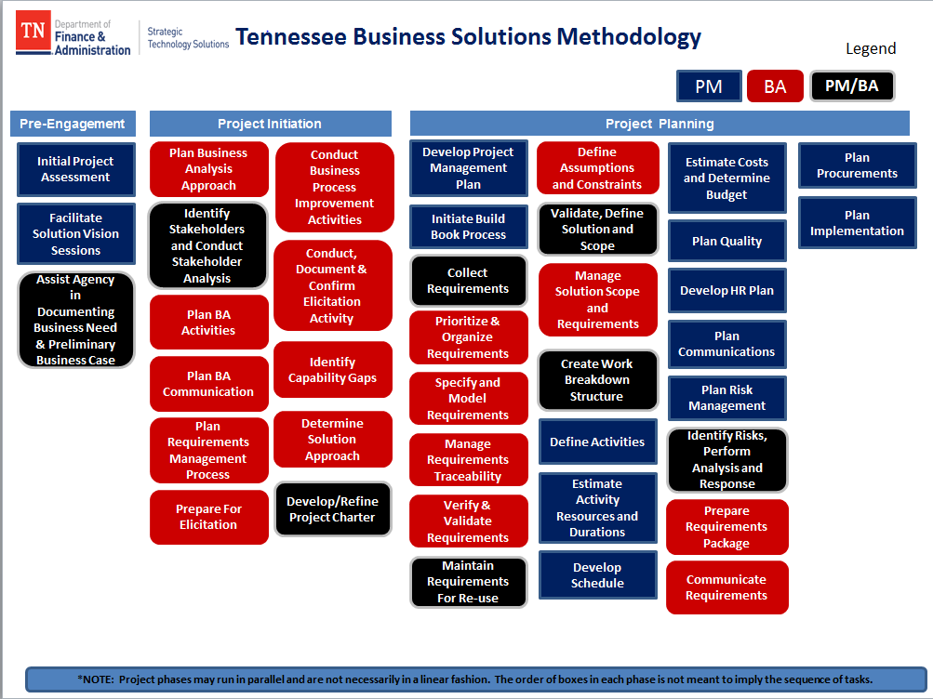

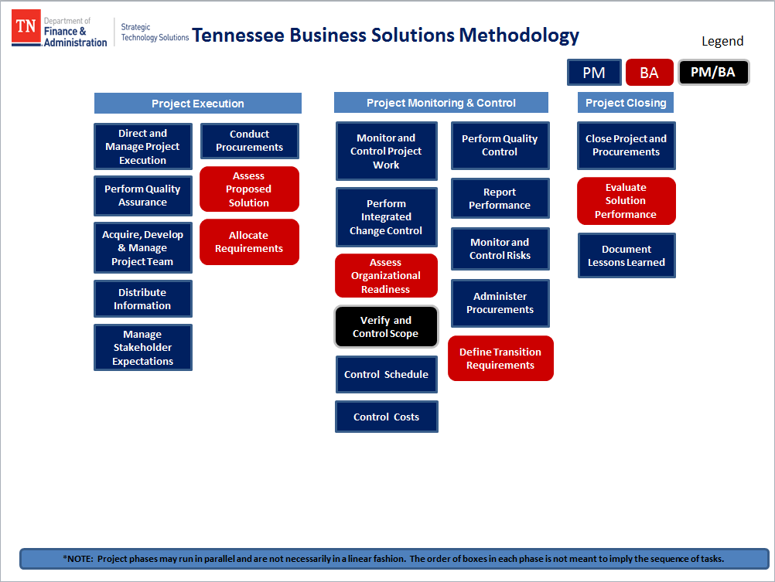

Phase | Activity | Associated Deliverable
Pre Engagement | Initial Project Assessment | Initial Project Assessment
 | Facilitate Solution Vision Sessions | Project Charter  Information for IS/CBA (Project Proposal, Business Case, etc.)
 | Assist Agency in Documenting Business Case
Initiation | Plan Business Analysis Approach | Business Analysis Approach
 | Identify Stakeholders | Stakeholder Register
 | Conduct Stakeholder Analysis
 | Plan BA Activities | Business Analysis Plan
 | Plan BA Communication | Communication Management Plan
 | Plan Requirements Management Process | Requirements Management Plan  Required Capabilities
 | Prepare for elicitation | Process to get ready to conduct elicitation sessions
 | Conduct, document, and confirm elicitation activity | Outputs can be stated requirements (not finalized) and list of stakeholder concerns
 | Assess Capability Gaps | Required Capabilities
 | Determine Solution Approach | Solution Scope
 | Develop/Refine Project Charter | Content to be presented in the most appropriate way for State procurement procedures  Project Charter  Statement of Work
Planning | Develop Project Management Plan | Project Management Plan
 | Initiate Build Book Process | Requirements Traceability Matrix  Requirements Development Plan
 | Collect Requirements
 | Prioritize & Organize Requirements
 | Specify and Model Requirements
 | Manage Requirements Traceability
 | Verify & Validate Requirements
 | Maintain Requirements for re-use
 | Refine Assumptions & Constraints | Project Management Plan
 | Validate, Define Solution & Scope | Scope Statement  Solution Scope
 | Manage Solution Scope & Requirements | Scope Management Plan
 | Create Work Breakdown Structure | Work Breakdown Structure
 | Define Activities | Activity List
 | Estimate Activity Resources & Durations
 | Develop Schedule | Project Schedule
 | Estimate Costs and Determine Budget | Project Cost Management Plan
 | Plan Quality | Project Quality Management Plan
 | Develop HR Plan | Project Roles  Human Resource Plan
 | Plan Communications | Communication Management Plan
 | Plan Risk Management | Risk Management Plan
 | Identify Risks, Perform Analysis and Response | Risk Register
 | Prepare Requirements Package | Process to get sign-off and approval of ALL requirements  Requirements Package (includes Requirements Attributes Table, Requirements Development Plan, & Requirements Management Plan)
 | Communicate Requirements | Structured walkthrough process
 | Plan Procurements | Procurement Management Plan
 | Plan Implementation | Implementation planning process
Execution | Direct and Manage Project Execution | Change Control Process  Project Management Plan
 | Perform Quality Assurance | Project Quality Management Plan
 | Acquire, develop and manage project team
 | Distribute information | Communication Management Plan  Project Schedule
 | Manage Stakeholder Expectations | Communication Management Plan Status Report
 | Conduct Procurements | Procurement Management Plan
 | Assess Proposed Solution | Pre-construction: assessing RFP/RFI proposals (process)
 | Allocate Requirements | Release planning process
Monitoring & Control | Monitor & Control Project Work | Project Management Plan
 | Perform Integrated Change Control | Change Control Process
 | Assess Organizational Readiness
 | Verify and Control Scope | Change Control Process  Scope Statement
 | Control Schedule | Project Schedule
 | Control Costs | Process of tracking & managing costs
 | Perform Quality Control | Project Quality Management Plan
 | Report Performance | Status Report  Project Measurement
 | Monitor & Control Risks | Risk Management Plan  Risk Register
 | Administer Procurements | Process of monitoring procurement process against Procurement Management plan
 | Define Transition Requirements | Implementation planning process
Closing | Close Project & Procurements | Process of finalizing all project documentation & deliverables
 | Evaluate Solution Performance | Post-implementation questionnaires and/or focus groups to gauge Customer Satisfaction with the solution
 | Document Lessons Learned | Lessons Learned

How To Use The Templates

The TBSM is an informative and flexible methodology designed for use on any IT project for the State of Tennessee. The templates contain suggested or sample language which the author can use as a guideline and then can remove to make appropriate customizations throughout the document for each project. Customizations can be made by utilizing Auto-Text functionality in brackets, replacing the agency logo, removing green instruction text and following the samples throughout the documents. Exact instructions are found at the beginning of each document for thorough instruction.

This methodology is scalable to meet the needs of various project complexities and sizes. While the TBSM methodology is scalable for large or small projects, there is a foundation of processes and documents which should be completed, regardless of the size of the project, to ensure that the project is built upon a solid base. It is important to gather and analyze critical project and management information, such as: Why is the project needed, what is the financial and budgetary picture, what are schedule implications, potential risks, how will changes be managed, what are the requirements and test management plans, as well as what methods will be used for managing the overall project. This information is most effectively managed by development and usage of the following documents:

Document Name | Chapters Included
Project Charter | - Business Need / Reason for Project  - Financial Parameters / Budget  - Scope Statement (high level)
Project Management Plan | - Schedule  - Budget  - Communication Plan  - Risk Management  - Change Management
Scope Management Plan | - Approach  - Roles and Responsibilities  - Work Breakdown Structure
Requirements Management Plan | - Approach  - Requirements Traceability Matrix
Communication  Management Plan | - Stakeholder Communication Requirements  - Develop Communications  - Guidelines for Meetings

Other Resources For Additional Information

Templates and additional information can be found on the Tennessee Business Solutions Methodology website at the following URL:
http://intranet.tn.gov/finance/tbsm/

Business Solutions Delivery: http://intranet.tn.gov/finance/faDivisions/BSD/bsd_Intranet.html

STS: http://www.intranet.state.tn.us/finance/oir/

To find more information about project management methodology, detailed information can be found in The Project Management Body of Knowledge (PMBOK) or the PMI website at the following URL: http://www.pmi.org/

To find more information about business analysis methodology, detailed information can be found in The Business Analysis Body of Knowledge (BABOK) or at the IIBA website: http://www.iiba.org/

Project Management Users Group (PMUG): http://sharepoint.intranet.state.tn.us/itma/PMUG/default.aspx

