
Fill & Sign –
Adobe Acrobat

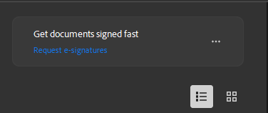
- Once Adobe Acrobat is installed, look for the tile labeled “Get documents signed fast.”
- Select Request e-signatures. This takes the user to the E-Sign section to upload or add the document.
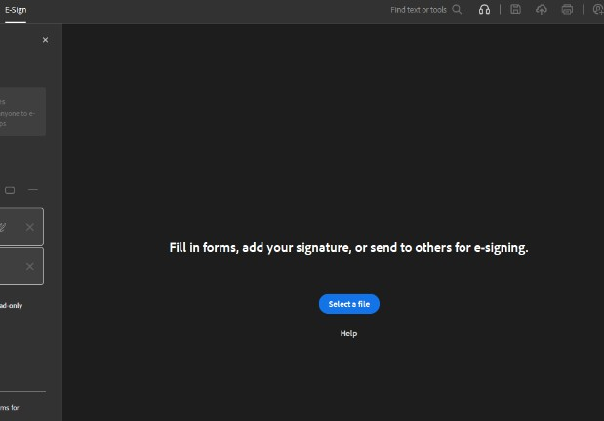
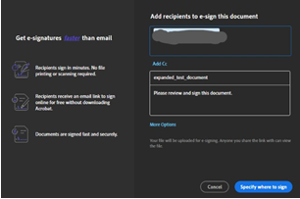
• Upload the user file. After the file is added, a screen will automatically open
prompting you to place the signature fields.

- Add the recipient(s) who will be signing, then click the blue button to place the signing area.
Fill & Sign – Adobe Acrobat

Page 2/4
  - If you select More Options, the document will open in Adobe Acrobat Sign, where you can complete the setup.
- Otherwise, you can continue working directly in Adobe Acrobat.
- When continuing in Adobe Acrobat, a screen will appear displaying the document. Here, you can add required fields, including signature fields, text fields, dates, or checkboxes.

- Select the desired location in the document to add a form field. You should see it appear just like the sample field below.


- Click the three dots to open additional configuration options for that field.
Fill & Sign – Adobe Acrobat

Page 3/4
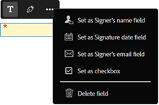

- Selecting the middle option converts the current form field into a signature field.

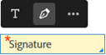

- Once the fields have been added, the user can click the Send button to complete the request.

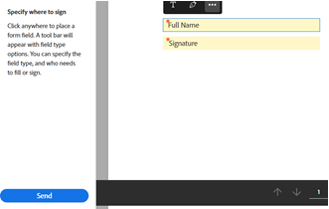

Fill & Sign – Adobe Acrobat

Page 4/4
• After sending, a confirmation message will appear indicating the file was
successfully sent for signature, and the user can modify Alert Settings if desired.

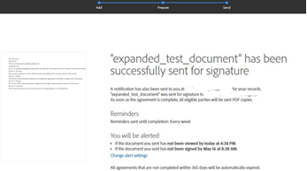

• The user can then log into their Adobe Acrobat Sign account and track the sent
documents status under the Manage tab.

