FY28 Cost Increase Request
Sample Program Request for Demo Purposes*
*IMPORTANT NOTE: This is a sample cost increase request for a fictional state-run program for demonstration only. Look for the EXAMPLE tag to see strong sample responses; NON-EXAMPLE indicates sample responses that are not ideal. Please turn on comments for helpful explainers in the margin.

Instructions
This form should be completed for each cost increase request that is not mandated by law. Forms should correspond to budget system adjustments on a 1:1 basis. Before completing this form, please review guidance materials that were emailed to fiscal officers. Additional resources from OEI are available here. Budget officers should:
- Compile all necessary information in this form, and name it with this convention: Priority#_AdjustmentName (e.g., 3_Analyst Positions).
- Enter information into Sherpa.
- Include the budget system adjustment number in this form.
- Email a final copy of this form to their budget office analyst, who will review each request and return submissions that do not provide sufficient detail.

General Information
Agency | Finance and Administration
Adjustment Number  Starting an entry in Sherpa will generate this number. | 12345
Adjustment Name  Short name of request | Victims Housing First Initiative
Agency Prioritization  1 is the highest priority | 05
Is this a programmatic request? | ☐No: this request is for rate increases, internal department operations (HR, administration, legal, etc.), facilities, equipment, IT improvement, or an advisory board or committee.  ☒Yes: this request is for, or directly supports (e.g., expands, staffs), a discrete program, intervention, or service; any systematic activity that engages participants to achieve desired outcomes. If Yes, is it listed in the program inventory? (Check the dashboard here: Program Inventory)  ☐No  ☒Yes à Enter Inventory Program Name: Victims Housing First Initiative
Brief Description  Limit two sentences | EXAMPLE This request would provide the third and final planned $500,000 recurring funding increment for the Victims Housing First Initiative, an existing program that helps crime victims avoid homelessness through case management, rapid access to permanent housing, and crisis intervention. The request would complete the program's previously approved three-year phased implementation in Shelby County.
Brief Expected Result  What do you expect to accomplish with this funding?  Limit two sentences | EXAMPLE We expect to complete the third and final phase of the program's previously approved three-year implementation plan, bringing Victims Housing First to its planned staffing and service configuration. No additional funding associated with the original three-year rollout is anticipated after FY28.

Requested Funding
FY28 | Recurring | Non-Recurring  (Sunsetting in FY29)
General Fund State | $500,000 | $0
Dedicated Funds | $0 | $0
Federal Funds* | $0 | $0
Other Funds* | $0 | $0
TOTAL Dollars Requested enter manually | $500,000 | $0

*If using federal or other funds, provide the source of those funds:
EXAMPLE No federal or other funds are requested; the request is supported by General Fund State dollars.

Is there funding in your base budget for this item? If so, how much? (Expenditures & Revenue Source)
EXAMPLE Yes. Victims Housing First currently receives $1,500,000 in recurring General Fund State dollars in the base budget.

Positions
FY28 | Full Time Positions | Seasonal/Part Time Positions
Positions Requested  Related to this request only | 1 | 0
Current Positions  Related to this request only | 2 | 0
Number of Current Vacancies for the Same Job Titles being Requested  Listed in Section 5 | 0 | 0
Total Current Vacancies  Department-wide as of  Aug. 1, 2026 | 20 | 0

Funding Details
1. New vs. Ongoing Effort: This request is: (select all that apply; add details where requested)
☐ A change to an existing program/initiative/resource (e.g., adding staff or resources, serving more or a different group of people, making changes to the service model, etc.).
☐ A completely new program/initiative/resource.
☒ A planned multi-year effort.
Briefly describe what fiscal requests we can expect in the future and how this will impact program rollout: EXAMPLE Victims Housing First was approved as a three-year phased implementation beginning in FY26. The FY28 request is the third and final planned $500,000 recurring increment. No additional funding associated with the original rollout is anticipated after FY28.
☒ This is a continuation of a prior commitment.
Provide insight into the status of the program and its implementation:
EXAMPLE FY28 is Year 3 of the previously approved implementation plan. FY26 established core operations and two positions. FY27 added the second planned funding increment, and this request completes the final phase.

2. Long Description & Connection to Strategic Plan: What is the program/initiative/resource that this request would fund?
Describe any included key services/interventions. How does this request tie to the agency’s vision and mission and the goals within the agency’s strategic plan (e.g., Four-year Strategic Plan)?
Note to budget officers: this answer can take the place of the detailed entry in the Long Description box in Sherpa. Copy and paste the description from here into Long Description box before uploading this document.
EXAMPLE
Victims Housing First provides resources and assistance for crime victims who are experiencing, or are likely to experience, homelessness. The program supports individuals and families through rapid access to permanent housing (Rapid Rehousing), without a pre-condition of treatment, along with ongoing support services such as crisis intervention, needs assessment, and case management. Clients may be placed in apartments throughout a community or in a centralized housing location with on-site support for those requiring more intensive services; clients can receive housing regardless of substance use history. Housing First practices are evidence-based and have been used as a cost-effective approach to reduce homelessness by pairing supportive housing with services.

The FY28 request is the third and final funding increment under a previously approved three-year implementation plan. It would complete the program's planned staffing and service configuration in Shelby County without changing the program's geography, eligibility, or core service model. It is directly connected to F&A's strategic goal related to reducing violent crime in Tennessee by helping victims secure stable housing and reducing the risk of homelessness and further victimization. It also supports the Governor's broader priorities of Supporting Tennessee Families and Resilient Communities.

3a. Needs Assessment: What opportunity/problem is this budget adjustment trying to address? How will this adjustment address the issue?
Describe the need or opportunity, who would benefit, and why it is important to address now. Explain how the requested funding will address the identified need. If applicable, share any available research about the need or the proposed approach.
EXAMPLE
This budget request would complete the final phase of the previously approved three-year implementation of Victims Housing First in Shelby County. The requested funding would provide the final planned resources for rapid rehousing, crisis intervention, needs assessment, case management, and program monitoring and reporting.

The target population is crime victims and their families in Shelby County who are experiencing or at risk of housing instability. Research has found that domestic violence is among the leading causes of housing instability for women and children (Baker et al., 2010), supporting the use of housing-focused assistance for this population.

The program partners with the Community Alliance for the Homeless and the Memphis/Shelby County Continuum of Care (CoC). The CoC works to reduce homelessness in the area but does not have a specific focus on crime victims experiencing homelessness. Victims Housing First currently serves approximately 300 victims per year; the FY28 request would complete the staffing and service resources included in the program's original three-year implementation plan rather than add a new geographic area, eligibility group, or service model. Data regarding rising program demand are available in the chart in our response to 3b.

NON-EXAMPLE 1 (NOT ENOUGH DETAIL)
• This is the final year of a three-year plan and the program needs more funding.
• The funding will help the program complete implementation.

3b. Trends/Historical Data: Please provide historical or trend data that help demonstrate and support this request.
- Use available data from prior years to show what has changed over time and what is driving the need for additional funding. Relevant data may include caseloads, population served or eligible, demand, waitlists, staffing or workload, service costs, utilization, or other relevant measures.
- Include charts, graphs, tables where helpful. If historical data are limited or unavailable, briefly explain why and provide the best available information supporting the request.
EXAMPLE - PLANNED MULTI-YEAR EFFORT / YEAR 3 REQUEST

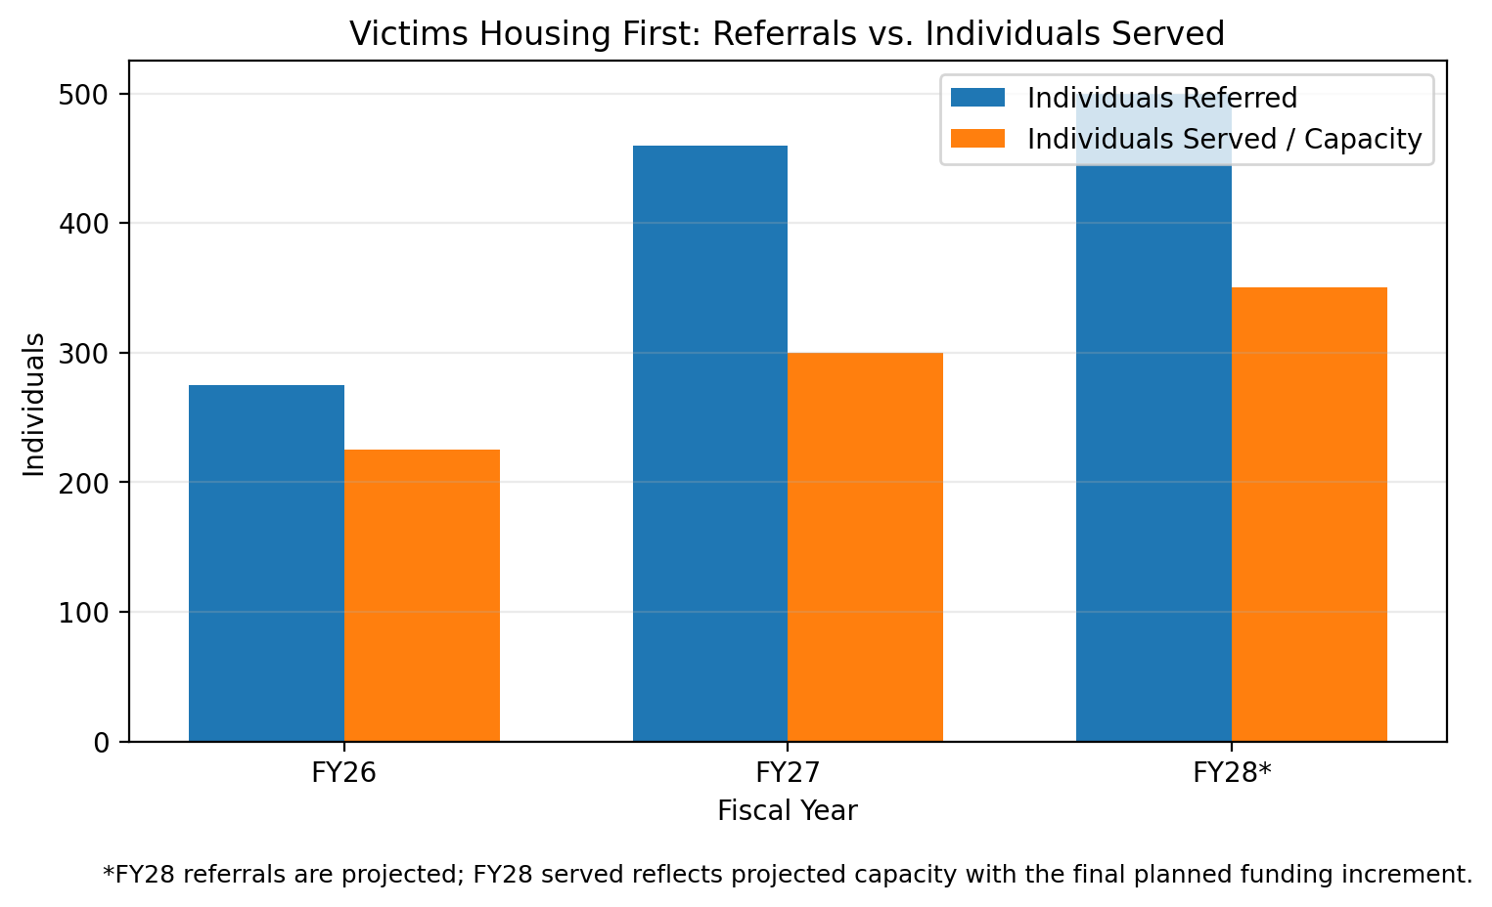

Program data collected during implementation show that referrals have consistently exceeded available service capacity, with the gap widening over time. This sustained demand supports completing the final planned funding phase so the program can operate at the service level intended in the original three-year implementation plan.

4. Anticipated Impact: How does the department plan to track success—even if it’s a new effort?
- How will this adjustment “move the needle”? What changes or benefits do you expect to see as a result of this adjustment? If applicable, list any new outputs, outcomes, or KPIs that you plan to measure in the future, but do not currently measure now. Be sure this response directly connects to the demonstrated problem.
- FOR NEW PROGRAMS: what is the proposed logic model (If we do X, Y, Z, then we expect to see A, B, C)? Is there any existing research regarding program effectiveness of this model in other states? If so, please describe and provide a link here.
EXAMPLE
With the final planned FY28 funding increment, Victims Housing First would complete its approved three-year implementation plan and operate at the staffing and service level contemplated in the original rollout. The department would continue tracking whether the fully implemented program is delivering the intended housing-stability and safety outcomes for participants.

The program will continue to track the following measures:
- Percentage of participants with stable housing after 1 year
- Percentage of victims with increased feelings of safety and security after being in the program
- Number of victims served and housing placements completed

NON-EXAMPLE 1 (NOT ENOUGH DETAIL)
Additional funding will allow us to finish the program rollout and monitor program metrics.

5. Budget & FTE Detail: What would the requested funds purchase, and what is the corresponding cost? (e.g., personnel, salary increases, equipment, contracted services, etc.).
Describe the assumptions used to determine funding and position requests. If the impact is not specifically quantifiable, is a cost avoidance, or if additional information is needed to explain the fiscal impact, please elaborate. For each proposed FTE, include the role name, the proposed annual salary, and a brief description of the role’s purpose and why the role is needed.
e.g.: Personnel:
- 2 FTE (Data Analyst) at $87,000 each – this position supports data collection, analysis, and reporting
- 1 FTE (Program Director) at $104,000 – this position oversees hiring, program planning and operations, and oversees new data analysts
Equipment: $400,000
Contracted Services: $1,000,000 for marketing campaign
EXAMPLE
Personnel:
• 1 FTE (Program Analyst) at $75,000 - completes the planned staffing model and supports participant coordination, community partnerships, and program monitoring and reporting.

Program Implementation:
• $250,000 for housing subsidies and rental assistance included in the final planned implementation phase.
• $100,000 for contracted crisis-intervention services included in the final planned implementation phase.
• $75,000 for contracted case-management services to complete the planned service configuration.

These items total $500,000 in recurring funding.

External Effects
6. Statute Change: Would this solution require an associated rule or statutory change? If so, provide a specific reference to TCA or rule that would need to be modified and how it would need to be changed.
☒No ☐Yes (explain) Click or tap here to enter or paste text.

7. Agency Impact: Does this solution have an impact programmatically or fiscally on any other agency? If so, which one(s)? Indicate if this program or initiative is jointly funded by any other agencies and if so, which ones and to what extent.
☒No ☐Yes (explain) Click or tap here to enter or paste text.

