FY23 Cost Reductions

Instructions
This form should be completed for requests that are program/service reductions only. Operational reductions should not be included here and are not required for submission during this budget cycle. Prior to completing this form, please review additional guidance materials here.

For each program/service proposed for reduction or elimination:
- Complete a separate form in full (Parts I and II required).
- Include only vacancies/position reductions directly tied to the program or service.

Budget officers should:
- Complete this form
- Name the form with this convention: R_Priority#_AdjustmentName (e.g., R_3_ Analyst Positions)
- Upload into the Budget Entry Analysis and Reporting System (BEARS)
- Email a final copy to their budget office analyst, who will review each request and return entries that do not provide sufficient detail

Part I

Section 1: General
Agency | Choose an agency.
Adjustment Number | BDEADJ- Click here to enter five-digit code.
Adjustment Name  Short name of request | e.g., Rural Opportunity Fund
Agency Prioritization  1 is the most preferred reduction | Choose a number.
Is this reduction a result of an efficiency?  i.e., spending under the budgeted amount | ☐No  ☐Yes
Is this program or service revenue generating? | ☐No, this program/service does not generate revenue  ☐Yes, this program/service generates revenue

Total Proposed Reduction
This chart should be reflective of all funds that would be impacted by the proposed reduction in state dollars. If a federal match or interdepartmental allocation would be reduced because of the state reduction, include those figures in the respective columns.

Allotment Code | State Funds | Federal Funds | Other Funds | Total Positions
0 | $0 | $0 | $0 | 0
0 | $0 | $0 | $0 | 0
0 | $0 | $0 | $0 | 0
0 | $0 | $0 | $0 | 0
0 | $0 | $0 | $0 | 0
0 | $0 | $0 | $0 | 0
TOTAL enter manually | $0 | $0 | $0 | 0

Position Reductions
For position reductions directly related to the program/service only, use the table to provide position title, salary reduction, and whether the position(s) is currently vacant or filled.
Position Title | Salary Reduction | Filled Positions | Vacant Positions
Title | $0 | 0 | 0
Title | $0 | 0 | 0
Title | $0 | 0 | 0
Title | $0 | 0 | 0
Title | $0 | 0 | 0
Title | $0 | 0 | 0

Section 2: Program/Department Effect
The purpose of this section is to understand how the reduction might impact the department and any related services or resources.

1. | What is the program/initiative/resource that this request would reduce? How does this request impact the agency’s vision and mission and the goals within the agency’s strategic plan (e.g., Four-year Strategic Plan)?  Include a list of any included key services/interventions. How would the proposed reduction impact the program’s capacity/eligibility criteria? How many people could be impacted, and how is that number estimated? With any data available, include program outcomes from the last two years.
Click or tap here to enter or paste text.

2. | Is this reduction being accomplished through a structural or organizational change to the department? If so, describe the structural and/or organizational changes being made.  Is there an opportunity for consolidating existing programs in order to offer the same services elsewhere? If so, provide additional information.
☐No
☐Yes: structural/organizational change (explain)
☐Yes: opportunity for consolidation (explain)
Click or tap here to enter explanation for any Yes selected above.

3. | Why was this proposal identified ahead of other proposals the department considered? How did you arrive at the amount of this proposal, and what assumptions are included?
Click or tap here to enter or paste text.

4. | Has this proposal been submitted in the past? If so, did a reduction occur at that time? Provide any necessary context regarding why the proposal was not accepted at the time of its submission.
☐No ☐Yes (explain)
Click or tap here to enter explanation for Yes.

5. | What is the timeline associated with the implementation of the proposed reduction? Include the date you anticipate the full reduction being realized, and any relevant milestones that would be necessary to achieve the full reduction.
Click or tap here to enter or paste text.

Section 3: External Effect
The purpose of this section is to understand risks and impacts to statute, other agencies, and/or stakeholder groups.

6. | Are there any challenges or down the line risks that could be associated with the reduction or elimination of this program/service?
☐No ☐Yes (explain)
Click or tap here to enter explanation for Yes.

7. | Would this solution require an associated rule or statutory change? If so, provide a specific reference to TCA or rule that would need to be modified and how it would need to be changed.
☐No ☐Yes (explain)
Click or tap here to enter explanation for Yes.

8. | Does this solution have an impact programmatically or fiscally on any other agency? If so, which one(s)? Describe the impact.
☐No ☐Yes (explain)
Click or tap here to enter explanation for Yes.

9. | Does this change impact constituents, groups, or stakeholders (locally or statewide)? If so, who might be in favor of this budget solution? Who might oppose?
☐No ☐Yes (explain)
Click or tap here to enter explanation for Yes.

Part II

Section 4: Evidence & Impact
The purpose of this section is to understand the evidence and research that the program is based on to provide context for the basis of the program design and how similar successes may be realized in Tennessee.

Every program will fall within one of the five steps in the Tennessee Evidence Framework below. Answering the questions in the table will help determine the step for this budget item. Remember to review guidance materials here prior to completing this part.
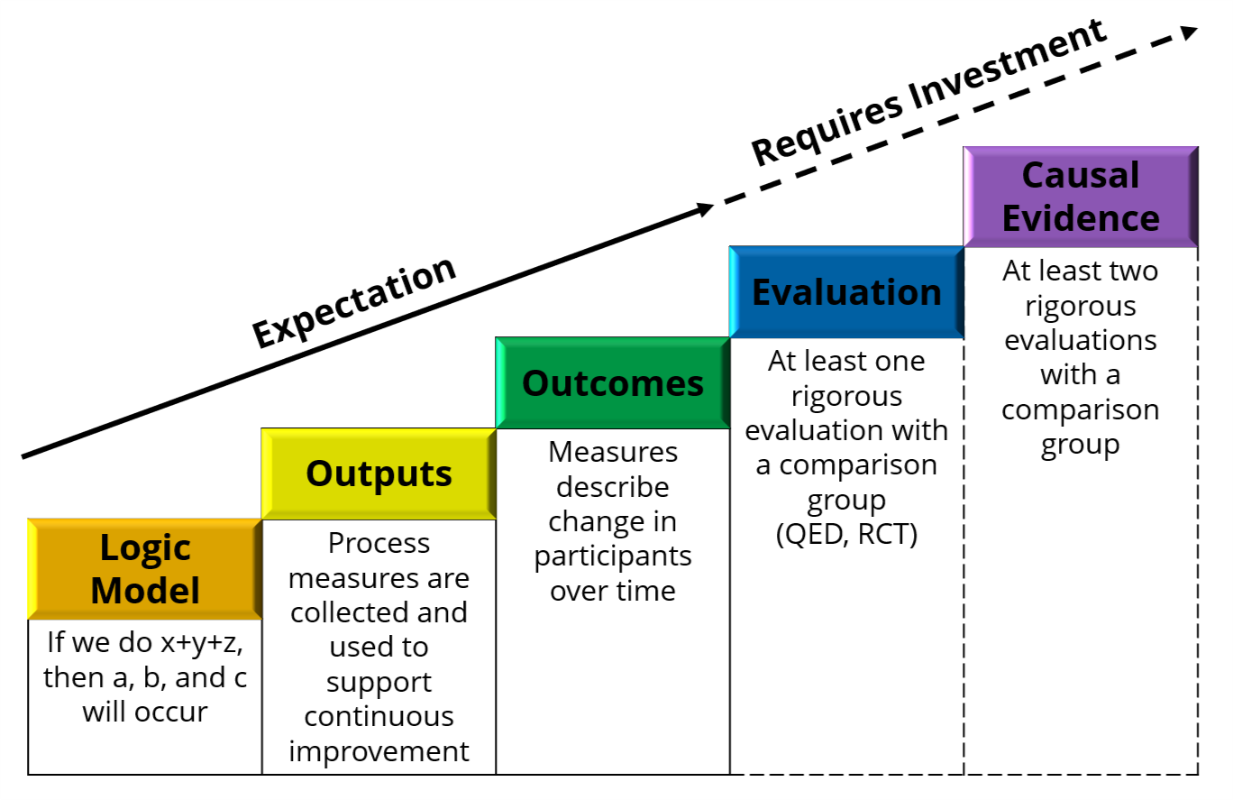

10. | Does the proposed reduction have a corresponding evaluation that is currently in progress? If so, provide relevant details.
☐No ☐Yes (explain)
Click or tap here to enter explanation for Yes.

11. | To complete the table for the program, move in the columns from left to right. Check the box in the top row, then enter the requested information currently available in the box below. STOP when a requirement does not yet exist or apply to the program. See the first table below for sample responses; enter program information in the table on the next page.

This table contains examples from different programs. Note: not all programs will have all evidence steps complete.
☒ Logic Model | ☒ Outputs | ☒ Outcomes | ☒ Evaluation | ☒ Causal Evidence
Provide the program’s theory of action in the form of a brief if/then statement. At minimum, the statement should identify key activities as inputs, and short-term results as outcomes. | Identify 3-5 key outputs for this program below and include most recent data. | What outcome(s) do you intend to measure to ensure the program is having the desired impact? What data will you collect to track these outcomes? List up to three outcomes for this program below and include most recent related data. | Does this program, or one very similar to it, currently have an evidence base cited in a national clearinghouse or clearinghouse database like Results First’s? If so, list the clearinghouse, entry name, link, and rating.  If your program model or your population differs from the cited evidence, add a brief note explaining the difference(s).
E.g., If we allocate funds to provide math remediation to high school students , then we expect to see students entering postsecondary better prepared, resulting in greater success in postsecondary gateway math courses. | E.g., Output 1: 18,826 students enrolled at an eligible institution in the most recent cohort with complete data (cohort 5), and over 88,000 students have enrolled since the start of the program in 2015.  Output 2: The average number of credit hours earned by students in the first semester in the most recent cohort with complete data (cohort 4) is 9.8. The average number of first semester hours attempted is 13.2.  Output 3: Almost 6,000 students have transferred to a Tennessee public university to continue their education this year. | E.g., Outcome 1: The success rate in 2019 (students graduated or still enrolled) is 59.8% for cohort 1, 59.9% for cohort 2, and 57.5% for cohort 3.  Outcome 2: Tennessee’s FAFSA filing rate has increased from 58.2% in 2013 (prior to the start of the program) to 78.6% in 2019. | E.g., Results First Clearinghouse Database/ CrimeSolutions.gov  Cognitive Behavioral Therapy (CBT) for Offenders  https://www.countyhealthrankings.org/take-action-to-improve-health/what-works-for-health/strategies/cognitive-behavioral-therapy-cbt-for-offenders  Highest Rated  Note: While the model of this program in TN is like that in the research, the program in Tennessee targets a smaller population, specifically students in at-risk and distressed counties only.

The last row of the table will expand with your entered text. If entered text goes beyond this page, the two header rows will duplicate for easy reference; return to this page to check a header box or begin a new column.
☐ Logic Model | ☐ Outputs | ☐ Outcomes | ☐ Evaluation | ☐ Causal Evidence
Provide the program’s theory of action in the form of a brief if/then statement. At minimum, the statement should identify key activities as inputs, and short-term results as outcomes. | Identify 3-5 key outputs for this program below and include most recent data. | What outcome(s) do you intend to measure to ensure the program is having the desired impact? What data will you collect to track these outcomes? List up to three outcomes for this program below and include most recent related data. | Does this program, or one very similar to it, currently have an evidence base cited in a national clearinghouse or clearinghouse database like Results First’s? If so, list the clearinghouse, entry name, link, and rating.  If your program model or your population differs from the cited evidence, add a brief note explaining the difference(s).
Click or tap here to enter or paste text. | - Output 1  - Output 2  - Output 3  - Output 4  - Output 5 | - Outcome 1  - Outcome 2  - Outcome 3 | Click or tap here to enter or paste text.

