Where to locate payment detail for a specific payment?
The TN_AP04 series of queries can be run to obtain payment detail for a specific payment reference number. The three queries are listed below:
1. TN_AP04_VNDR_CHK_REMIT_NVID - Run this query to recall detail for a warrant (check) by entering the 10 digit Payment ID (check number) at the prompt and clicking view results:
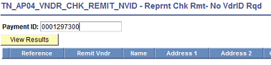
Example below of data recalled:
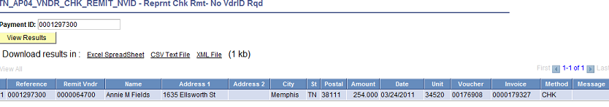
2. TN_AP04_VNDR_REMIT_ADVICE_NVID - Run this query to recall detail for an EFT or ACH payment by entering the 10 digit payment ID (deposit number) and vendor number at the prompts and clicking view results:
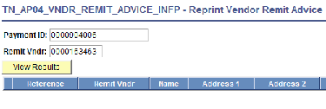
Example below of data recalled:
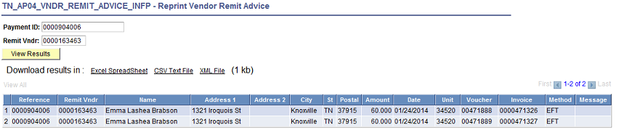
3. Query TN_AP04_VNDR_REMIT_ADVICE_INFP – This query is also for ACH and EFT payments. It does not require the vendor number. Please note that it will bring back all payments with the reference number supplied and you will have to filter out those not wanted.

