How to obtain autodraft Utility detail:
TN_CM12_ACCOUNTING_UTILITY
- Navigation: Main Menu > FSCM Reporting Tools > FSCM Query Viewer
- Enter ‘TN_CM12_ACCOUNTING_UTILITY’ into the begins with field located after “Search By Query Name”.
- Click on the Search button.
- To run the query to HTML, click on the works ‘HTML’.
- In the new window, enter the accounting date range desired into the Acctg Date From and the Acctg Date To fields. (Example: 12/1/2013 and 12/31/2013)
- Enter the General Ledger Business Unit into the GL Unit field. (Example: 30601)
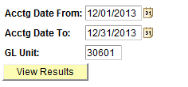
- Click on the View Results button.
- A screen shot of results are shown below.
- To download the results to excel, click on the ‘Excel SpreadSheet’ link. Results should pop up in Excel.
