AP Journal Corrections
You can do a journal in AP (Accounts Payable) when wanting to make corrections to an AP voucher that has been paid. Auditors prefer that you correct your errors in AP instead of General Ledger because of the following reasons:
- Both the original voucher and correcting journal entry are done in the Accounts Payable Module.
- It provides a better audit trail to the original voucher.
Before you begin, you should have the Voucher Number and the Vendor Number of the AP voucher you are correcting.
The navigation is the same as when you are entering a regular payment in AP.
Accounts Payable > Vouchers > Entry > Regular Entry

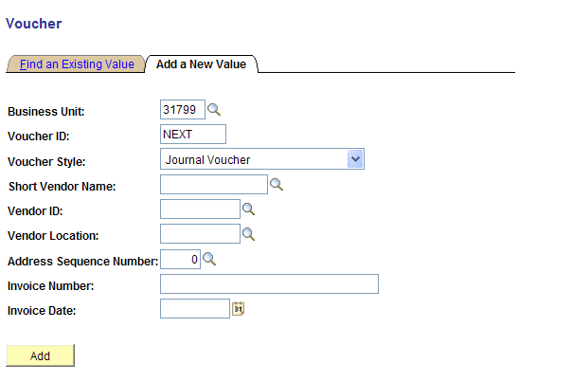
In the Voucher Style drop down, choose Journal Voucher.
The Invoice Date can either be the original or the date you are doing the AP Journal correction.
On the Invoice Tab, you will see a box called Related Voucher. You can either use the lookup glass to enter the AP Voucher you are correcting, or you can just key it in.
Key Points when entering AP Journal Vouchers
- Enter CF distribution from the related (original) voucher.
- Enter the amount from Line 1 as a negative value (credit).
- Add a new row.
- Enter the correcting distribution.
- Enter the amount for Line 2 as a positive value (debit).
Notes to Remember
AP Journal Vouchers are created to correct distribution coding errors on vouchers. Users must relate them to the original voucher. However, the entire distribution must be entered online because the coding does not copy from the original voucher. There should be at least two distribution lines on an AP Journal Voucher. The first line should be the incorrect coding from the original voucher (with a -$0.00 amount). Once entered, click the + icon to add a new distribution row. This will automatically create the second row with the same coding as the first but with a positive dollar amount. Update the field(s) where the distribution correction is needed.
AP Journal Vouchers cannot be used to make changes to a fund, the first five digits of the department code, or account codes. These changes need to be made on a GL journal.
AP Journal Vouchers require approval, budget check, and voucher post, but never pay. (Vendors do not see Journal Vouchers; they are in-house coding corrections).
AP Journal Vouchers can only correct current-year coding errors. GL journals are used to correct prior-year coding errors.
FileNet documentation attached to support the AP Journal Voucher should contain a copy of the original AP voucher with a notation indicating the changes that need to be made.

