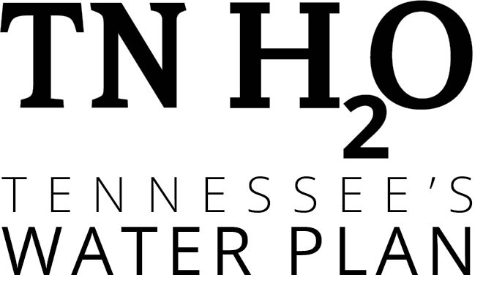

Imagine a Day Without Water: Op-Ed Framework

Imagine a Day Without Water: Commit to a sustainable water future for all Tennesseans.

Tennessee is blessed with abundant natural water resources. We are surrounded by the world famous underground water source of the Memphis Sand Aquifer and the mighty Mississippi River on the west, and the Tennessee and Cumberland Rivers running right through the heart of our state.

The state’s river systems – including special places like the Duck River – are home to some of the richest freshwater biodiversity on Earth including fish, crayfish, mussels and snails. (Who knew mussels were a Tennessee delicacy?)

Unlike our neighboring states, which are forced to wrestle with the hard reality of water shortages caused by competing demands on limited resources, we have renewing sources of water throughout our geographic footprint. Our water recreation economy is a multi-million dollar industry, providing jobs for rural Tennesseans and small business growth opportunities. Water has been the fuel in our economic engine, and the tide that has brought prosperity across our state.

Water is critical to our success as a thriving state economy. Which is why today, we come together to Imagine a Day Without Water.

Could you go a day without water? No water to drink or to make coffee. Pools would be empty, fishing boats would be resting on dry riverbeds and the famous Tennessee Aquarium would be shuttered. Firefighters couldn’t put out fires, doctors couldn’t scrub their hands, and farmers couldn’t water their crops. Factories across the state would close and schools would not open.

When you have reliable water service, you don’t have to think twice about the infrastructure that brings water to your home or business, and then safely returns water to the environment – but we all should.

A day without water would be a public health and safety crisis across Tennessee.

This year, the world, our country and our state are faced with a public health crisis from the coronavirus. This pandemic demonstrated the critical role that water and wastewater systems play in our communities, protecting public health, safeguarding the environment, and making a healthy economy possible. Without water, we would be unable to take necessary precautions to limit the spread of coronavirus.

While these water systems are critical to the health and safety of us all, the truth is, our water and wastewater systems are getting older. Some were installed a century ago. And everyone should be concerned with the vulnerability of those systems due to threats from weather patterns bringing record rainfalls, flooding and drought, as well as river pollution and accelerated development across the state.

The threats are real, but Tennesseans can be proud of the leadership we have seen from our government, universities, nonprofits and businesses. (choose one regional specific message below, or insert a paragraph about a specific water challenge / collaboration in your community.)

Here in Tennessee, the Department of Environment and Conservation (TDEC) took the lead in gathering a diverse range of partners to develop a statewide plan for water use – TNH2O. Stakeholders, including more than 120 participants from federal, state and local governments, as well as industry, academia, environmental advocacy groups and public utilities contributed to the report and planning process. The plan includes an assessment of current water resources and recommendations to ensure our state continues to enjoy water resources enough to support future population and economic growth. TDEC continues to implement key findings and recommendations across the state, ensuring Tennesseans have the water they need to grow for generations to come.

Here in West Tennessee, we’ve seen firsthand the value of leadership on the Memphis Sands Aquifer Project, as the state agricultural team has partnered with the University of Memphis and our regional farmers to study how we can keep this magnificent water source strong. Through a combination of high-tech precision agriculture tools and old-fashioned relationship building, this team is working to ensure that farmers across the tri-state area can access the water resources they need to keep growing healthy crops and feeding hungry Tennesseans for generations to come. This kind of large-scale investment in water resources is what it will take to make a difference.

Here in Middle Tennessee, we’ve seen firsthand the value of leadership as many government and non-profit partners collaborate to help protect the Duck River, tackle water supply challenges and expand resource planning for this essential watershed. By working together, partners have improved tools for water management and planning, improved water quality, provided recreation opportunities, and protected habitat for plants and animals. Collaborative efforts like this can be replicated across the state to keep Tennessee’s network of streams and rivers running strong.

Here in East Tennessee, we’ve seen firsthand the value of strong leadership as we’ve made rebuilding aging water system infrastructure a top priority. In West Knox County, the community has invested over $70 million in wastewater infrastructure, ensuring quality water service for existing and new neighbors in one of the fastest growing areas of the state. In Chattanooga, water and wastewater investment continues to grow as manufacturers from around the world bring factories and jobs and employees to the Scenic City. Increases in manufacturing and housing drives the need for more water treatment and wastewater facilities to manage the increased volume and demands. This kind of large-scale investment in maintaining and rebuilding water infrastructure is what it will take to protect our water resources for generations to come.

Water has always been there for Tennesseans. Today, on Imagine a Day Without Water, we recommit ourselves to value the quality of life water creates for each of us, to care for this resource, and to preserve it for future generations. Join us in protecting our state’s treasured water resources, so we never have to Imagine a Day Without Water in Tennessee.

