Automotive Fluid Collection
Center Grant Manual
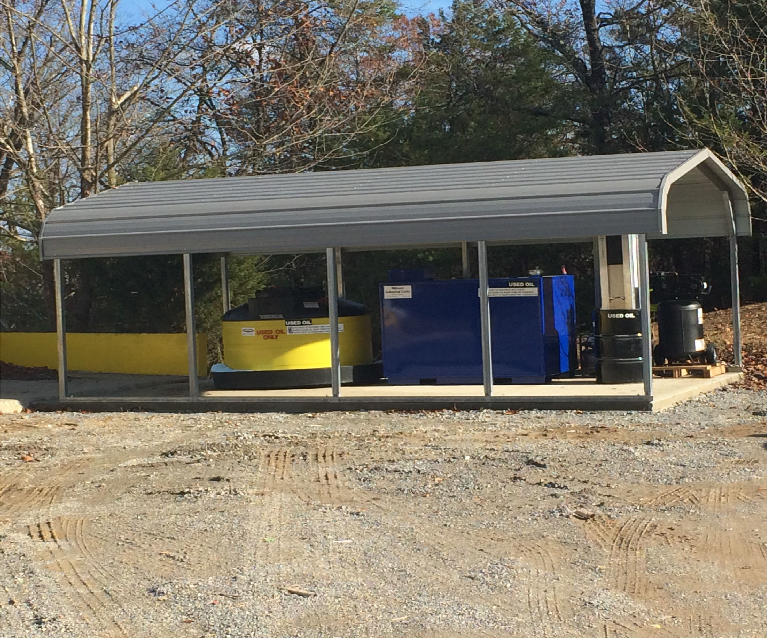



Opportunity for Funding
Tennessee Department of Environment & Conservation | Grant Manual | FY26





Automotive Fluid Collection Center Grant
FY26
Application Manual

Prepared by:



Division of Solid Waste Management
Materials Management Program
Davy Crockett Tower, 7th Floor
500 James Robertson Parkway
Nashville, TN 37243

Overview
The Used Oil Collection Act of 1993, Tenn. Code Ann. §§ 68-211-1001 to -1019 (“Act”), was enacted by the General Assembly to reduce the amount of used oil disposed of improperly by providing incentives to increase the number of collection facilities for used oil. Tenn. Code Ann. § 68-211-1003. The Act established a used oil collection fund to be utilized in part to establish used oil collection centers and automotive fluid collection centers, as well as a fee of $.02 per quart of automotive oil, levied on every distributor at sale, to be deposited into the used oil collection fund. Tenn. Code Ann. § 68-211-1004 to -1006.
The Act complements the Solid Waste Management Act of 1991, which requires all counties to provide at least one center to collect used automotive oil and fluids. Tenn. Code Ann. § 68211-866(b). The Act provides for collection center grants to be awarded to municipalities, counties, counties having a metropolitan form of government for the purpose of establishing used oil collection centers, local governments purchasing equipment which burns used oil as fuel and providing technical assistance. Tenn. Code Ann. § 68-211-1005(2). The Act and regulations promulgated thereto, Tenn. Comp. R. & Regs. Chapter 0400-12-01-.11, establish operation standards for used oil collection centers at publicly owned facilities or other suitable public or private locations. It also assists with establishing used oil collection centers for do-it-yourselfers for safe automotive fluid disposal.

Purpose of the Grant
The purpose of the Automotive Fluid Collection Center Grant is to reduce the amount of improperly disposed used oil and other automotive fluids by providing incentives to increase the number of collection facilities for used oil and automotive fluids generated by do-ityourselfers (DIY’ers).


P a g e | 2
Used Automotive Fluids Recycling Grant FY26

Per Tennessee Code Annotated 68-211-1005, the Department may use the “used oil collection fund” as follows:
- The Department may award grants to municipalities, counties, and counties having a metropolitan form of government to establish and operate automotive fluid collection centers at publicly owned facilities or other suitable public or private locations; and provide technical assistance to persons who organize such programs.
T.C.A. § 68-211-1005 (2).
- The Department may award grants to local governments to purchase equipment that burns used oil as fuel. Priority shall be given to local governments to establish automotive fluid collection centers. T.C.A. § 68-211-1005 (3).
- The Department may award grants to develop and implement educational programs to encourage proper handling, disposal and recycling of used oil and other automotive fluids. T.C.A. § 68-211-1005 (5).
- The department may award grants to develop and implement programs to provide direct incentives to DIYers to properly handle and dispose of used oil and other automotive fluids. T.C.A. § 68-211-1005 (6).

Eligibility
Tennessee municipalities, counties, and counties having a metropolitan form of government for establishment and operation of automotive fluid collection centers; or local governments purchasing equipment which burns used oil as fuel may apply.
Three Priorities have been established for this offering:
- First Priority - to establish new automotive fluid collection center infrastructure in an underserved location or new site.
- Second Priority - to upgrade or replace existing equipment at automotive fluid collection centers not currently meeting the standards specified in the “Automotive Fluid Collection Centers Requirements and Specifications.”
- Third Priority - to establish an automotive fluid collection center at an existing recycling center, solid waste collection facility, or other publicly owned facility.

Non-Eligibility
The Department will not award any grant funds to any applicant that is not in compliance with the State’s rules and regulations. This includes, but is not limited to, missing or incomplete APR, financial assurance, violations, and annual solid waste fees. Grant funding for Automotive Fluid Collection Centers is limited to management and operation by
Tennessee municipalities, counties, and counties having a metropolitan form of government.

Funding
The Department has allocated $600,000.00 for grants for the collection of used oil and other automotive fluids. Grants shall not exceed $80,000.00 per site and will be awarded based on merit according to a technical and administrative evaluation of the submitted Grant Application Proposal.
Eligible Applicants may apply for one or all the items listed in the Automotive Fluid Collection Center Funding Guide Table [Attachment 1] with adequate documentation. The Department has identified the maximum funding amount for each item listed in this Table.
The Division will issue this Grant for the maximum amount allowable for the equipment requested but will only reimburse according to actual costs up to the granted amount.
Only those items listed and approved in the “Automotive Fluid Collection Center Grant Funding Guide Table” [Attachment 1] are eligible for funding under this grant.

Funding Conditions
Applicants selected for grant funds, must follow all terms and conditions within the grant contract. Awardees will be expected to submit or maintain for inspection during normal hours operational data relative to daily operations to include, but not limited to, weights, feed stocks utilized, temperatures, residual disposal or diversion, marketing, and project maintenance logs. Furthermore, municipal and metropolitan government entities shall report total weight of used oil recovered to the County in which the center is located for the Annual Progress Report due annually by March 31.
Upon award, Grantees must participate in a scheduled virtual or in-person “Project Management Conference” (PMC) within 30 days of contract execution. The PMC will be hosted by the Department and will cover contract requirements, deadlines, and provide an opportunity for Grantees to complete the “Statement of Understanding” and the “Grant Contract Budget Acceptance” activities with assistance.
Grantees must be ready to proceed with the project as soon as possible after the grant contract has been fully executed and PMC requirement has been completed. However, prior to procuring goods or services, Grantees shall complete the Title VI Training Certification Form and any other training verification requirements. This should be completed and uploaded to the Grants Management System (GMS) portal within 30 days following contract execution.
“Quarterly Progress Reports” must be submitted in the Grants Management System (GMS) by or on the dates of March 31, September 30, and December 31. For grants initially executing within 30 days or less of any of the prior dates, grantees will be required to submit reports starting on the next scheduled date. Please include all necessary dates of projects related to the approved grant activities and budget. At these times, Grantees shall review the dates in scope A.8. – A.11. of the executed contract and/or any executed amendments for compliance. Additionally, Grantees will review the dates of the last Title VI Training Certificate Form located in the “activities” tab to assure it is updated appropriately. If it needs to be completed, Grantees shall provide an estimated date of completion in the “Quarterly Reporting” activity summary. Any inactivity for long periods, need to be explained in the summary. Inactivity on awarded projects greater than six months may result in contract termination at the Department’s sole discretion.
”End of Fiscal Year” (EOFY) Form for accrued liability reporting must be submitted by June 30. This is for all reimbursements anticipated will be expended on or before June 30 but will be submitted after July 1. This should not include expenditures for previously submitted or paid reimbursement.
Grantees must comply with all national, state, and local laws and regulations during construction and operation. This includes contracting with an engineering or construction consultant for architectural documents, SPCC plans, if applicable. Certain laws and rules may require a general contractor to provide oversight of project work. Applicants must research this need and are responsible for meeting appropriate requirements. SPCC plans, if required, can be completed internally by a licensed, qualified engineer of the municipality or county government. If not available, external licensed, qualified engineer fees can be requested as Development of Spill Prevention, control, and Countermeasure Plan in the maximum amount of $8,000.00.
The Department’s intent with this grant offer is to promote environmentally preferable purchasing in support of the current Solid Waste and Materials Management Plan to encourage the purchase of equipment made with recycled content, when available.

Deadline to Submit
A complete Grant Application must be submitted in the online Grants Management System (GMS) on or before June 30, 2025, by 4:30 p.m. CST. Applications received after this date and time will be returned to the Applicant without review.
A complete application consists of a digital signature of a person with signatory authority for the Applicant, and clear and detailed completion of all application prompts in GMS, including but not limited to the Narrative Questions, Budget Worksheet, Title VI Pre-Audit Survey, Sam Debarment Report, and submission of the Automatic Clearing House Form FA-0825. All the information required has been implemented in GMS from required TDEC forms, such as Form CN-0915 (Grant Application) and Form CN-1448 (Title VI Pre-Audit Survey) but is made convenient in a digital format.
Entities who have individuals assisting or completing the application for them and are not responsible or have authority to complete other activities on this grant once the contract is executed, including, but not limited to, signing the contract, completing activities such as Quarterly Reports, Amendments, Procurements, or Reimbursements, then a “Letter of Signatory Authority” must be submitted on letterhead by the highest authority of the entity in which the contract will be signed. This letter must state which individual is being authorized and what activities, if not all, is permitted. Once this letter is in place, the letter can only be changed or removed by the individual who submitted the letter. In case of a position changeover, then a new letter will need to reissue with the above information.
TENTATIVE GRANT TIMELINE:
The anticipated timeline for this grant offering is as follows:
May 15, 2025: | Request for Applications Announced
June 30, 2025: | Deadline for Application Submittal
July 30, 2025 (Approx): | Announce Awards and Prepare Grant Contracts
October 1, 2025: | Executed Contract Start Date
December 29, 2025: | Grantee Submits Subcontract Request and Bid Packages
May 30, 2026: | All Equipment, Materials, Services Shall Be Installed
August 30, 2026: | Final Request for Grant Reimbursement Deadline
October 1, 2028: | Contract End Date for Grants without Vested Interest
October 1, 2030: | Contract End Date for Grants with Vested Interest

Selection Criteria
Applications shall first be reviewed for completeness and eligibility. Applications shall be rated based on two categories, and four possible modifiers, averaged among ratings completed by a minimum of three raters. Sixty percent (60%) of the Grant Application’s weight shall be considered based on the proposed project’s value, including, but not limited to:
- Does the project offer a significant return on investment (ROI) , as measured in tons of used oil collected?
- Does the project increase the level of service in the county or city? Does the project add or expand an existing program?
- Is the project for the benefit of the citizens of a given region, or is it an attempt to set up a “for-profit venture”?
Forty percent (40%) of the Application’s weight shall be considered based on the proposed project’s feasibility, including, but not limited to:
- Does the Applicant have ready funds for purchase of equipment prior to reimbursement?
- Has the project been thoroughly and carefully considered? (Detailed project plans, maps, quotes, and studies will increase the Application’s value.)
- In the past five years, has the Applicant had significant delays in completing other grant projects, or failed to follow established administrative procedures? Alternately, has the Applicant proven to rapidly and efficiently complete projects?
Modifiers shall be applied to an Application lastly, and are considered as follows:
Major Disaster Declared Area | +10
Distressed County | +10
At-Risk County | +5
Top 5 County | -5
No Utilization of Tennessee-based Landfill | -5
Received Same Grant Type in Past 3 Years | -10

AUTOMOTIVE FLUID COLLECTION CENTER LINE-ITEM BUDGET AMOUNTS:
Maximum Grant amounts for each type of eligible equipment (including freight and installation) are shown in the “Automotive Fluid Collection Center Grant Funding Guide Table Funding Guide Table” [Attachment 1]. Only the items shown in this Attachment 1 are eligible for Grant reimbursement at the maximum shown per site under for this grant. Reimbursement will be based on either the actual item price or the Grant Budget maximum, whichever is less.
The State must review and approve in writing all bids for selected equipment prior to any commitment for purchase.
Grantees must purchase all equipment requested in the Application Proposal, approved, and awarded in the Grant. This is to ensure existing or new centers funded under this Program meet the Program standards in the Automotive Fluid Collection Centers Requirements and Specifications, found at:
https://www.tn.gov/content/dam/tn/environment/solid-waste/documents/hazardouswaste/sw_auto-fluid-collection-requirements.pdf.
Failure to bid and purchase all approved equipment may result in all costs being denied for reimbursement.

TDEC SUSTAINABILITY STATEMENT
The Tennessee Department of Environment and Conservation (TDEC) acknowledges that the products and services we procure have fundamental human health, environmental, and economic impacts, and that purchasing decisions should exemplify our commitment to sustainability and to protecting the environment and the quality of life of Tennesseans. TDEC endeavors to reduce the environmental impacts of its operations and to promote fiscal responsibility and community and environmental stewardship by integrating sustainability considerations in sourcing processes while continuing to observe general state purchasing laws and procurement policies.

TDEC TITLE VI STATEMENT
All Grantees will be required to affirm the following statement as part of the Grant Contract:
The Grantee hereby agrees, warrants, and assures that no person shall be excluded from participation in, be denied benefits of, or be otherwise subjected to discrimination in the performance of this Grant Contract or in the employment practices of the Grantee on the grounds of disability, age, race, color, religion, sex, national origin, or any other classification protected by Federal, Tennessee State constitutional, or statutory law. The Grantee shall, upon request, show proof of such nondiscrimination and shall post in conspicuous places, available to all employees and applicants, notices of nondiscrimination.

Contacts
The person(s) named below shall be the points of contact through the term of the Grant Contract. The below contacts are the only Division contacts designated to speak on official grant and contract-related matters. All Grantees shall direct their communications (regular mail, express mail, or electronic mail) concerning this Grant Application and Award process to:
Tennessee Department of Environment and Conservation
Division of Solid Waste Management
Materials Management Program
Davy Crockett Tower, 7th Floor
500 James Robertson Parkway
Nashville, TN 37243
General and Administrative Questions:  Robin Chance  DSWM, MMP Grants Program Manager  Phone: 615-571-6364  Robin.Chance@tn.gov | Technical Questions:  Amy Katcher  DSWM, MMP Program Administrator  Phone: 423-377-3373  Amy.Katcher@tn.gov  Michelle Forbess  BOPAE Coordinator
Michelle. Forbess@tn.gov.

Grantee’s Contacts:
All Contract actions must be requested, certified, or otherwise authorized by the Executive Director or Mayor of the Grantee. A letter of Signatory Authorization must be provided by the Grantee if these actions will be completed by another individual.

In the Contract body, Section D.8. must display the Executive Director and the additional Technical Representative authorized to speak on the Grantee’s behalf for common project communications.
P a g e | 10
Used Automotive Fluids Recycling Grant FY26

Technical Narrative Questions:
Priority Questions:
- Are you establishing new automotive fluid collection center infrastructure in an underserved location or establishing a new site? If so, include where the new collection center is being established.
- Are you upgrading or replacing existing equipment at an automotive fluid collection center? If so, include what equipment is being updated and indicate why.
- Are you establishing an automotive fluid collection center at an existing recycling center, solid waste collection facility, or other publicly facility? If so, include where the automotive fluid collection center is going to be located and why.
Funding:
- Attachment 1, “Funding Guide Table” indicates the equipment, material, or services needed to establish a collection center. Indicate what equipment, materials, or services needed at proposed or existing sites by marking “yes” or “no” from the drop downs. Please choose all items that apply. NOTE: All equipment awarded MUST be purchased according to the executed contract.
- For each piece of equipment requested for funding, provide price quote(s) and specification sheet(s). Documents can be uploaded using the box below.
Capital Purchase Questions:
- If collecting automotive fluid or used oil, please estimate the amount of fluid you anticipate collecting in the next year.
  - If you already collect automotive fluid, include how much used oil (gallons) and filters (pounds) were recycled in the last year. If you submit an annual progress report, this information should be in the TDEC Forms Reports.
- Do any of your current sites have more than 1,320 gallons of automotive fluid or chemicals on site? What emergency spill plans are currently in place at your facilities?
  - If any site contains more than 1,320 gallons and you are applying for grant funding, you must establish a Spill Prevention, Control, and Countermeasure Plan (SPCC). These plans are important for spills because they are guidelines on what steps need to be followed in case of a large spill.
- Is a collection tank being requested without the purchase of a canopy or concrete pad? If so, please explain why a canopy and/or concrete pad are not included.
- Is a used oil-burning space heater being requested? Where is the heater to be located? Will DIYer’s used oil need to be transported to this location to burn the used oil?

P a g e | 11
Used Automotive Fluids Recycling Grant FY26

- Is a new convenience center being established? Please note money from the used automotive fluid grant cannot be used for a match on any other grant.
Is a used oil transport trailer being purchased? Per Chapter 0400-12-01-.11(5)(a), if you transport more than 55 gallons of used oil at a time, or more than 1,000 gallons in a calendar year, you must register with TDEC for an EPA ID.
  - Do you require assistance to register as a used oil transporter?
- To be eligible for grant funding for oil filter crushers, you must recycle the oil and metal from oil filters. If you are seeking funding for a filter crusher, include how you will recycle the oil and metal from the oil filters.
- For the land on which the collection center is being established or exists currently, please upload a copy of proof of ownership or a copy of a lease demonstrating that the applicant is leasing the property for the duration of the grant (5 years).
- Upload four representative photos of the site where equipment is going to be installed, indicating which direction the photos were taken.
- Upload aerial imagery indicating the location where the equipment will be installed.
- Grantees are eligible to order used oil absorbents from the used oil program once a year for the duration of the grant contract (5 years). To receive absorbents, the used oil absorbents form must be filled out and submitted. The following items are available to order: absorbent socks, absorbent pads, granular absorbent, and spill kits. Each request is limited to $750 per used automotive collection site. Do you anticipate utilizing this service during the grant duration?

Frequently Asked Questions
- What is the process for grant project expense funding?
Payment of project expenses is on a reimbursement basis and only for approved procurement equipment or services and on the fully executed contract. The Grantee must make payments for approved equipment purchased, submit and receive an approved inspection, and then submit the required invoice documentation and proof of payment to TDEC for reimbursement. Equipment and/or services not approved in procurement activities, not inspected, and not on or within the dates on the executed grant contract, will not be eligible for reimbursement.
- When can the grant project begin?
Projects shall begin only after the grant contract has been fully executed, an executed copy received by the Grantee, AND the Grantee has completed the mandatory PMC meeting and Statement of Understanding in GMS. Also, all quotes and bids for equipment or services must be submitted and approved by the State prior to ordering and purchasing equipment. Failure to do so will result in no reimbursement for equipment purchased/received prior to the begin date of the approved contract.
- Do I have to follow a bidding process?
While some local governments may use their own established purchasing policies, the alternate bidding process used must reflect State requirements prior to the grantee making obligations for purchases. All grant purchases must reflect the entities approved purchase policy or the State’s purchasing policy. If using the entities policy, it must be as strict or stricter than the State. The executed grant contract requires all grantees to follow a competitive bidding process, when applicable. If equipment or service does not meet the threshold for bidding, competitive quotes from multiple vendors is required.
- Does the State have to approve quotes, bid, and the bidding process?
Yes, the grantee is only authorized to purchase equipment or materials after submitting quotes or bids and receiving approval in writing. Any purchases made prior to approval of the grantee’s bids/quotes may result in denial of reimbursement.
- May I enter a subcontract for third party services to complete grant actions?
Yes, in fact funds approved under the budget line-item Professional Fee, Grant & Award most often result in a subcontract being necessary to complete the grant actions. The grantee should submit an unsigned drafted subcontract for State review, and upon receiving written State approval, may then enter the subcontract agreement to fulfill grant actions.

- Do I have to purchase all of the equipment under the grant contract?
Yes, the equipment has been reviewed and approved based upon the submitted project proposal application. Unless otherwise approved by the State in writing, which may require a Grant Contract Amendment, the grantee shall be expected to fulfill the purchase obligations as they are laid out in the contract’s Budget Attachment 1, Page 1, and Page 2. If the Grantee wished to not purchase an item on the executed grant contract, a letter must be sent to Grants Administration to review and approve.
- Do I have to purchase a spill pan for a used oil or antifreeze collection tank?
Yes, spill containment is required for a used automotive collection tanks purchased with grant funds. Most tanks have a built-in spill pan and double walls.
- Do I need a Spill Control and Countermeasure Plan (SPCC)?
Grantees who store more than 1,320 gallons (aggregate total per center) of oil or chemicals must have and implement a Spill Control and Countermeasure Plan. Contact the Used Oil Coordinator for more information concerning a SPCC. Additionally, grantees Used Oil Collection Sites that are close to areas of running water (streams, rivers, or other aquatic waterways) need an SPCC.
- Do I have to recycle used oil filters?
Yes, under this grant program, all grantees approved to receive grant funds to purchase a filter crusher shall recycle the used oil and metal from the filters.
- Will the State fund more than one used oil-burning space heater at the same location?
The maximum amount of funding available for a used oil heater is $21,000 per center. If the grantee has been granted a heater in previous grant cycles, can justify the need for a second heater, and show that adequate amounts of DIY used oil are generated and available in sufficient quantities to fuel the additional heater, then the State may approve funding for a second heater depending on funding availability.
- Does the cost of the used oil space heater include a collection tank?
The space heater should include an attached used oil tank that stores used oil to fuel the space heater and is considered part of the heater. A separate, publicly accessible collection tank and spill pan will be needed to collect used oil from DIY-ers.

- Is there a list of vendors for the equipment that meet program specifications?
Yes, there is a list of known vendors that sell used oil equipment in the Used Automotive Fluid Collection Center Grant Requirements and Specifications, found at https://www.tn.gov/content/dam/tn/environment/solid-waste/documents/hazardouswaste/sw_auto-fluid-collection-requirements.pdf. TDEC does not endorse any of these vendors and provides the list as a convenience to applicants. This list does not include all vendors that sell equipment, therefore, any vendors whose equipment meets the specifications noted in the “Designing Used Automotive Collection Centers” may be used. Vendors may contact the Department for inclusion on future offerings.
- How long will I have to complete the grant project?
The Contract Section A. Scopes of Services contains specific completion dates and requirements. Grantees must be precise in the timelines submitted in the application to assure that sufficient time is allowed for purchases and work activities.
- What is required to receive reimbursement for equipment expenses?
After the bids/quotes have been approved, and the equipment is installed and operational, an inspection will be made to verify completion by Division staff. After the inspection, approval will be provided to the grantee to proceed with the submission of a Request for Grant Reimbursement Activity in the Grants Management System (GMS) online portal. The grantee should provide supporting documentation (vendor invoices, copies of cancelled checks issued for payment, etc.) to ensure quick payment. Payments will be made electronically through the Automated Clearing House (ACH). Grantees will be required to provide banking account information in order to receive grant reimbursements. The ACH form will be included in all grant offers.
- What are the Grantee’s responsibilities for the project after the grant is paid in full?
Grantees are responsible for the continued operation and maintenance of the equipment for a period of five years after grant award. Failure to comply with this provision will result in prorated repayment of grant funds to the State or the equipment being removed. Grantees shall maintain records of the quantities of used oil, used oil filters recycled, and other automotive fluids collected during this five year period. The grantee shall report these amounts to the State in the Annual Progress Report due March 31each year.
- Can applicants that have received funding in a prior year apply again this year?
Yes, an applicant may apply for each grant solicitation if all activities from prior grant funding have been completed and the grantee has been paid in full.
- Can we submit supplemental documents?
Yes, supplemental documents applicable to the grant may be submitted, but only to the extent that these documents support the narrative information provided and are submitted at the time of application. Only necessary supplemental documents should be included.

- What is the general contractor request for?
The general contractor is for counties that are establishing multiple sites in their county to make it easier on managing the site installation. It is also for smaller counties that do not have a solid waste or public works director. This is not for the counties that are installing one or two sites that can be managed by the public works or solid waste director.
- Who is responsible for the antifreeze after it is stored?
Antifreeze recycling and removal is to be handled by the agency or organization the collected and stored the antifreeze. The Department is currently providing grant funding for a containment system for proper storage of antifreeze to lessen the chance for spillage and decrease the potential for impact to the environment.
- Where can I find grant documents?
The Grants Management System (GMS) online portal found at: http://www.tennessee.gov/environment/topic/about-grants
- When a grant is awarded, what are my Title VI responsibilities?
When applying for this grant, the applicant must complete a Title VI Pre-Audit Survey and provide various prompted non-discrimination documentation, including but not limited to complaint procedures and LEP (Limited English Proficiency) Policy. Upon contract execution, a grantee has 30 calendar days to complete the Title VI Training requirements. If the awarded organization does not have a Title VI program, the Department has various resources that may assist you in the administration of this grant. More information may be found at the link below: https://www.tn.gov/environment/program-areas/opsp-policy-andsustainable-practices/opsp-title-vi-and-environmental-justice/policy-title-vi-faqs.html Attachment 1:
Automotive Fluid Collection Center Grant Funding Guide Table
* Only available to Applicants who recycle oil and metal from filters
** Per Applicant not individual sites
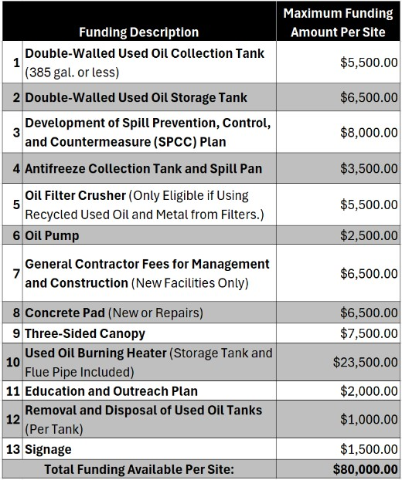

Attachment 2:
Used Oil Grant Rating Rubric

Project Specifics (Value) – 60 Points Maximum
60 - 45 Points |  | 44 - 30 Points |  | 29 - 0 Points |  |  |  | Score
- Project clearly identifies equipment and collection assurance.  - Project includes all necessary supporting documents including lease and/or ownership documents and price quotes. |  | - Project vaguely identifies equipment and collection assurance.  - Project includes most necessary supporting documents including lease and/or ownership documents and price quotes. |  | - Project equipment and collection assurance plans are poorly described or missing.  - Project missing some or all necessary supporting documents including lease and/or ownership documents and price quote.
Technical Plan and Photos/Maps (Feasibility) – 40 Points Maximum
40 - 30 Points |  | 29 - 19 Points |  | 18 - 0 Points |  |  |  | Score
- Assessment provided clearly shows proposed location and service area.  - All recommended components are included in proposed project. (i.e., All tanks are equipped with spill pan, concrete pad with canopy, and/or SPCC plans (if applicable). |  | - Assessment materials vaguely show proposed location and service area.  - Most recommended components are included in proposed project. (i.e., All tanks are equipped with spill pan, concrete pad with canopy, and/or SPCC plans (if applicable). |  | - Assessment materials are poorly shown on and do not represent the location or service area.  - Some or all recommended components are not included in proposed project. (i.e., All tanks are equipped with spill pan, concrete pad with canopy, and/or SPCC plans (if applicable).
[ ] Fully Funded at  $ | [ ] Partially Funded at  $ |  | [ ] Proposal Not Funded  $ |  | Total Modifiers: |  | Total Score:
Rater Explanation/Comments:
Grant Rater: 1 2 3 4 |  |  | Date: |  |  | Reviewed By:

