March 8, 2019

U.S. & Electronic Mail
Dr. Shane Johnston, Director of Schools
Jefferson County Schools
1221 Gay Street
Dandridge, Tennessee 37725
sjohnston@jcboe.net

Dear Dr. Johnston,

Pursuant to Tenn. Code Ann. § 49-6-3004(a) (6), in the event of a natural disaster or serious outbreaks of illness affecting or endangering students or staff during a school year, the commissioner of education may waive for that school year the requirement under subdivision (a) (1) of one hundred eighty (180) days of classroom instruction, if a request is submitted to the commissioner by the director of schools.

Because of the unique and rare circumstances of our recent weather due to flooding and the impact on school districts throughout the state, the department received several requests to waive instructional days due to the Level 3 – State of Emergency that was issued on February 23, 2019. The criteria for school districts to be considered for this waiver is that all available inclement weather stockpiled days must be used before a waiver will be granted. The request for waivers of instructional days due to this flooding will be reconsidered if a school district is required to make up instructional days during the remainder of this school year due to circumstances that would qualify for the use of a stockpile day.

You have submitted a request to waive instructional days for Jefferson County Schools. Pursuant to my above referenced authority, at this time, I hereby deny this waiver request to Jefferson County Schools for instructional days during this period of severe flooding. Please use your remaining inclement weather stockpiled days to replace these missed instructional days. Thank you for continuing to notify the Department of revisions to your school calendar.

Sincerely,
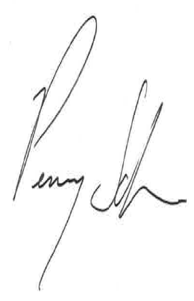
Penny Schwinn, Ph.D.
Commissioner

