March 8, 2019

U.S. & Electronic Mail
Matt Hixson, Director of Schools
Hawkins County Schools
200 N Depot Street
Rogersville, Tennessee 37857-2699
matt.hixson@HCK12.NET

Dear Mr. Hixson,

Pursuant to Tenn. Code Ann. § 49-6-3004(a) (6), in the event of a natural disaster or serious outbreaks of illness affecting or endangering students or staff during a school year, the commissioner of education may waive for that school year the requirement under subdivision (a) (1) of one hundred eighty (180) days of classroom instruction, if a request is submitted to the commissioner by the director of schools.

Because of the unique and rare circumstances of our recent weather due to flooding and the impact on school districts throughout the state, the department received several requests to waive instructional days due to the Level 3 – State of Emergency that was issued on February 23, 2019. The criteria for school districts to be considered for this waiver is that all available inclement weather stockpiled days must be used before a waiver will be granted.

You have submitted a request to waive three instructional days for Hawkins County Schools and four days for Clinch School. Pursuant to my above referenced authority, and seeing that you have no inclement weather stockpile days remaining, I hereby grant this waiver request to Hawkins County Schools for three instructional days and Clinch School for four instructional days during this period of severe flooding. Thank you for continuing to notify the Department of revisions to your school calendar.

Sincerely,
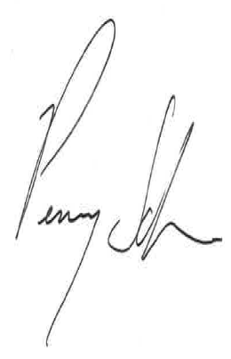
Penny Schwinn, Ph.D.
Commissioner

