Criminal Justice & Correction Services
Law, Public Safety, Corrections, & Security
Level Four
Level Three
Level Two
Level One
Dual Credit/ Dual Enrollment/ Industry Certifications options include:
- Statewide Dual Credit

ABOUT THE PROGRAM OF STUDY
Criminal Justice and Correction Services prepares students for a range of careers in law enforcement, crime scene analysis, corrections, public safety, and criminal justice. Course content emphasizes procedures and laws governing the application of justice in the United States, from constitutional rights to crisis scenario management to the elements of criminal investigations. Upon completion of this POS, students will be equipped with strong knowledge and skill preparation for postsecondary or career opportunities in many law- and justice-related fields.

This is not an exhaustive list of all of the opportunities available in Tennessee.

Law Enforcement Related Occupations with Positive Growth in Tennessee (2014-2024)
Occupations | Total Percent Change | Total Annual Av. Openings
Parking Enforcement Workers | 17% | 10
Police Officers | 11% | 500
Detectives and Criminal Investigators | 4% | 40

CAREER OPPORTUNITIES

Nationally there is a 5 percent increase expected in employment for police officers, 5 percent for bailiffs, 5 percent for correctional officers and jailers, and 12 percent for security guards and gaming surveillance officers. These figures are lower in Tennessee. Students wishing to pursue careers as law enforcement officers may seek employment as corrections officers/jailers until they reach their 21st birthday then apply for employment and training as law enforcement officers. A second option for entry into the law enforcement sector is through the many postsecondary programs offered. across Tennessee.

Students in this program of study will be eligible to join Skills USA. In addition to school events, students will be able to compete at the regional, state, and national level. Skills USA improves the quality of America’s skilled workforce through a structured program of citizenship, leadership, employability, technical, and professional skills training. Skills USA enhances the lives and careers of students, instructors, and industry representatives as they strive to be champions at work. See your manufacturing teacher to learn more about Skills USA or visit http://www.skillsusa.org.
Crime Scene Investigation contestants will be directed to the crime scene and briefed as to the situation. The contestants will, as a three-person team, process the crime scene. They will legally search for, properly collect, and remove evidence of the crime. One member of the team will be required to lift a latent fingerprint from a pre-selected item of evidence. After the scene has been processed, the contestants will write their report, draw the crime scene sketch, and mark their evidence.
The Criminal Justice contest will utilize both written examination and practical exercises to evaluate the contestants’ abilities and knowledge of the field. The contestants are scored on their knowledge and application of the U.S. Constitutional Law, written and verbal communication skills, and their ability to handle an entry-level law enforcement position.

2024 Projected Employment for Security Guards
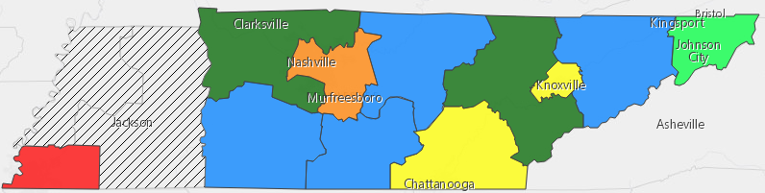

Postsecondary Offerings Aligned to this Program of Study
School | Degree Program
Columbia, Dyersburg, Nashville, Roane, Volunteer, Walters, North Ease, South West Tennessee Community Colleges | A.A.S. Criminal Justice
Austin Peay, TSU, ETSU, U of Memphis MTSU, & UT Chattanooga | B.S. Criminal Justice

Have you registered for the Tennessee Promise? Seniors enrolled in this program have the chance to attend a two year program at a Tennessee College of Applied Technology (TCAT), community college, or some two year university programs for free! To learn more, please see your school counselor or visit http://www.tennesseepromise.gov .
For more college and career planning resources, visit http://collegefortn.org.

For more information, contact:
School High School
County Name Schools
CTE Director: Name
Email
Instructor: Name
Email

