Health informatics

HEALTH SCIENCE
Program of Study
Health Informatics is a program of study intended to prepare students with an understanding of the changing world of health care information. With the inclusion of electronic medical records, electronic billing, and electronic prescriptions, students in all healthcare professions must increasingly demonstrate competency in health information and health informatics. Upon completion of this course, proficient students will be able to differentiate among the types of health information/informatics, code and manage medical records, retrieve crucial data from health information systems and indexes, and understand the implications for careers in a range of health care fields.
Level Four
Dual Credit/ Dual Enrollment/ Industry Certifications options include:
•Dual Credit Medical Terminology

Level Three
Level Two
Level One

Career Opportunities

Source: Jobs4TN.gov and CollegeforTN.org

^{Employment Outlook}
Nationwide employment of health information technicians is projected to grow 15 percent from 2014 to 2024, much faster than the average for all occupations. Tennessee employment projections are favorable as well. Students can pursue employment as a medical secretary upon graduation from high school and while pursuing postsecondary programs in health information technology. The demand for health information services is expected to increase as the population ages and the nation moves toward a national health information system.
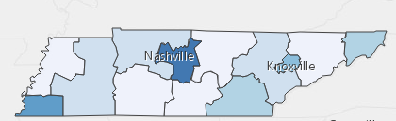
Estimated employment for Health Information Technicians (2014-2022)
Health Information Related Occupations with Positive Growth in Tennessee (2014-2022)
Occupations | Total Percent Change | Total Annual Av. Openings
Medical Transcriptionist | 9.0% | 40
Health Information Technician | 20.4% | 245

Postsecondary Offerings Aligned to this Program of Study
School | Degree Program
TCAT Crump, Memphis, Chattanooga, Murfreesboro, Paris, Whiteville | Certificate in Health Information Technology
Chattanooga, Dyersburg, Roane, Walters, Volunteer State Community Colleges | A.A.S. Health Information Management/Technology
For more college and career planning resources, visit http://collegefortn.org.

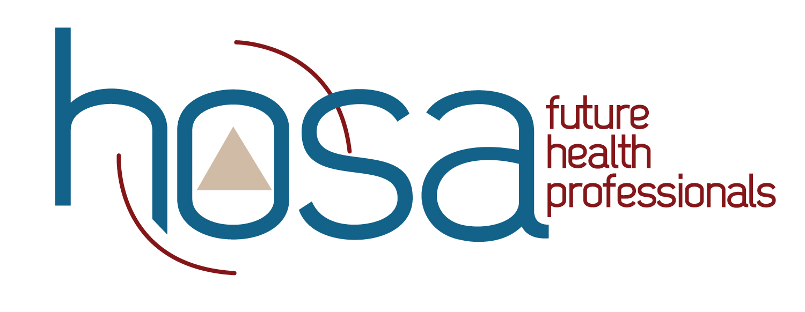
Students in this program of study will be eligible to join HOSA: Future Health Professionals. In addition to school events, students will be able to compete at the regional, state, and national level.
HOSA's two-fold mission is to promote career opportunities in the health care industry and to enhance the delivery of quality health care to all people. HOSA's goal is to encourage all health occupations instructors and students to join and be actively involved in the HSE-HOSA Partnership. HOSA provides a unique program of leadership development, motivation, and recognition exclusively for secondary, postsecondary, adult, and collegiate students enrolled in HSE programs. HOSA is 100% health care! For more information, please visit http://www.hosa.org .

POSTSECONDARY OPTIONS
Have you registered for the Tennessee Promise? Seniors enrolled in this program have the chance to attend a two-year program at a Tennessee College of Applied Technology (TCAT), community college, or some 2-year university programs for free! To learn more, please see your school counselor or visit http://www.tennesseepromise.gov.

For more college and career planning resources, visit http://collegefortn.org.

For more information, contact:
School Name
District/County Name
CTE Director: Name
Email
Instructor: Name
Email

