Level One
Level Two
Level Three
INTERIOR DESIGN
__________

Architecture & Construction
__________

Level Four

ABOUT THE PROGRAM OF STUDY
Dual credit/ dual enrollment options include:
- Course A
- Course B

The Interior Design program of study is designed for students interested in becoming residential or commercial interior designers. Course content covers concepts and skills such as elements and principles of design, sketching techniques for perspective floor plans, computer-aided drafting, board presentation techniques using textiles samples and three-dimensional sketches, building technology, building codes, product applications, product testing research and development, and project management for the interior design industry. In the program of study, students will have the opportunity to participate in a work-based learning internship and will be equipped for further study of interior design at the postsecondary level upon completion of the program of study.

Career Opportunities

Occupation | Total Percent Change | Annual Avg. Openings
Architectural and Engineering Managers | 9.2% | 90
Wholesale and Retail Buyers, Except Farm Products | 3.20% | 85
Merchandise Displayers and Window Trimmers | 9.10% | 85
Architects, Except Landscape and Naval | 12.7% | 50
Interior Designers | -0.4% | 25
Commercial and Industrial Designers | 2.7% | 15
Materials Engineers | 7.4% | 15

Interior Design Related Occupations with the Most Annual Average Openings in Tennessee (2014-2022)
CAREER OPPORTUNITIES
In Tennessee, 25 total annual average openings are projected for interior designers between 2014 and 2022. These projected openings are due to replacements. In 2014, 960 interior designers were estimated to be employed in Tennessee. By 2022, that number is projected to decline to 950 representing a 0.4 percent decline for the occupation group. More openings are projected in urban and surrounding areas with Nashville leading with 10 annual average openings.¹ Nationally, the employment of interior designers is projected to grow faster with 4 percent growth between 2014 and 2024.²

¹ TN Department of Labor and Workforce Development. (2015). Employment Security Division, Labor Market Information Section, on the internet at https://www.jobs4tn.gov/ (visited Feb. 5, 2016)
² Bureau of Labor Statistics, U.S. Department of Labor, Occupational Outlook Handbook, 2016-17 Edition, Interior Designers, on the Internet at http://www.bls.gov/ooh/arts-and-design/interior-designers.htm (visited Feb. 10, 2016)

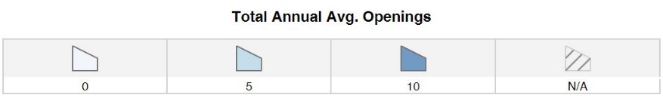
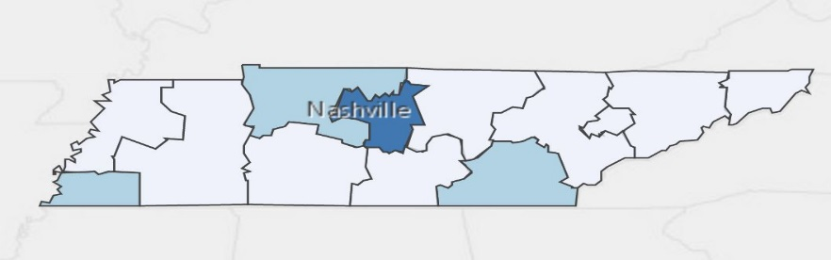
Students in this program of study will be eligible to join Family, Career, and Community Leaders of America (FCCLA). In addition to school events, students will be able to compete at the regional, state, and national level. Through FCCLA, students not only learn about interior design, but also professionalism, leadership, and workplace skills. Walk away from your high school career with experience in competing, networking, applying course content,
Annual Average Openings for Interior Designers in Tennessee (2014-2022)

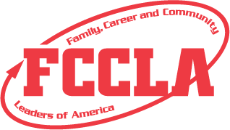
and more! See your teacher to learn more about FCCLA or visit http://tennesseefccla.org/.
For more information, contact:
Central High School
County Name Schools
CTE Director: Susan Smith Susan.Smith@school.edu
Instructor: Bob Johnson Bob.Johnson@school.edu

Source: TN Department of Labor and Workforce Development. (2015). Employment Security Division, Labor Market Information Section, on the internet at https://www.jobs4tn.gov/ (visited Feb. 5, 2016)
School | Degree Program
Pellissippi State Community College | Interior Design Technology
For more college and career planning resources, visit http://collegefortn.org.

POSTSECONDARY OPTIONS

community college, or some 2-year university programs for free! To learn more, please see your school counselor or visit http://www.tennesseepromise.gov.

Have you registered for the Tennessee Promise? Seniors enrolled in this program have the chance to attend a two-year program at a Tennessee College of Applied Technology (TCAT), community college, or some 2-year university programs for free! To learn more, please see your school counselor or visit http://www.tennesseepromise.gov.

