aGRICULTURAL ENGINEERING AND aPPLIED tECHNOLOGIES
Agriculture, Food, and Natural Resources
__________

Level Four
Level Three
Level Two
Level One

Dual credit/dual enrollment options include:
- Course A
- Course B
¹ Satisfies one lab science credit required for graduation.
ABOUT THE PROGRAM OF STUDY
Agricultural Engineering and Applied Technologies prepares students for careers or further study in engineering, environmental science, agricultural design and research, and agricultural mechanics. Courses in this program of study address navigation, maintenance, repair, and overhaul of electrical motors, hydraulic systems, and fuel-powered engines. In addition, special emphasis is given to the many modern applications of geographic information systems (GIS) and global positioning systems (GPS) to achieve various agricultural goals, preparing students for immediate application of these skills in a career setting or postsecondary institution.

This is not an exhaustive list of all of the opportunities available in Tennessee.

Agricultural Engineering and Applied Technology Related Occupations with the Largest Annual Percentage of Openings in Tennessee (2014-2024)
Occupation | 2014 Estimated Employment | 2024 Projected Employment | Employment Change | Annual Avg. Percent Change
11-9041 Architectural and Engineering Managers | 2,640 | 3,070 | 110 | 16%
49-3041 Farm Equipment Mechanics and Service Technicians | 810 | 910 | 100 | 12%
45-2091 Agricultural Equipment Operators | 1,190 | 1,200 | 40 | 0%
17-2021 Agricultural Engineers | 2,900 | 3,000 | 100 | 4%
Source: TN Depart of Labor & Workforce Dev, Div Emp Sec, R&S
Downloaded: May 17, 2017
The job outlook is growing with jobs within the architectural and engineering manager occupations. 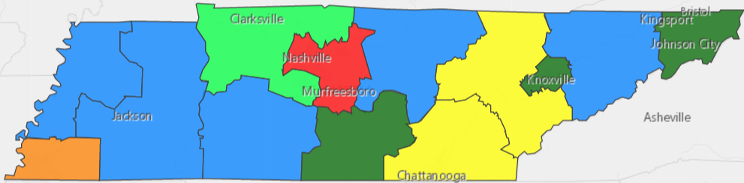
Source: TN Dept. of Labor & Workforce Development. Accessed Aug. 15, 2017

POSTSECONDARY OPTIONS
Have you registered for the Tennessee Promise? Seniors enrolled in this program have the chance to attend a two-year program at a Tennessee College of Applied Technology (TCAT), community college, or some two-year university programs for free! To learn more, please see your school counselor or visit http://www.tennesseepromise.gov.

For more college and career planning resources, visit http://collegefortn.org

Postsecondary Offerings
Program of Study | School | Degree Program
Biosystems Engineering, | University of Tennessee, Knoxville | Bachelor’s, Master’s , Doctoral
Agricultural Engineering Technology | University of Tennessee, Martin | Bachelor’s
Agricultural Engineering Technology | Tennessee Tech University | Bachelor’s

For more information, contact:
Name of High School
Name of School System
CTE Director: [enter name]
Email
Teacher: [enter name]
Email
Students in this program of study will be eligible to join FFA. In addition to school events, students will be able to compete at the district, regional, state, and national levels. Through FFA, students not only learn about agriculture, but also professionalism, leadership, and soft skills. Walk away from your high school career with experience in competing, networking, applying course content, and more! See your agriculture teacher to learn more about FFA or visit http://www.tnffa.org.

