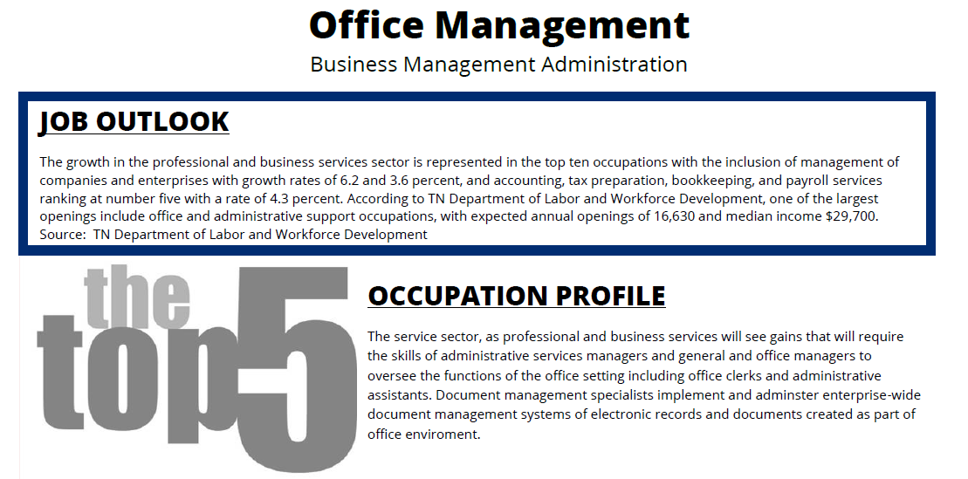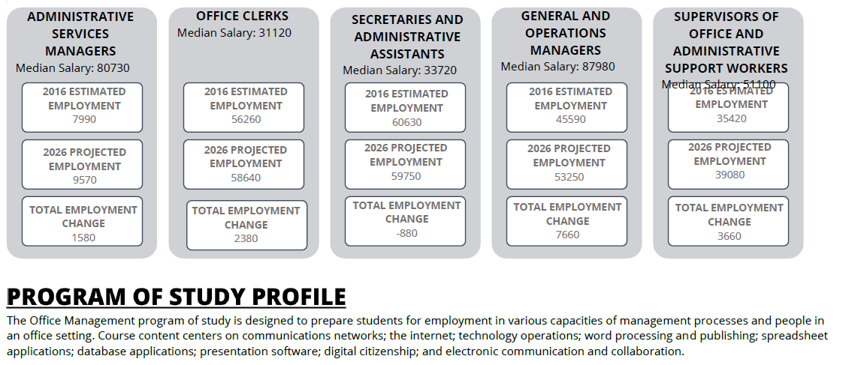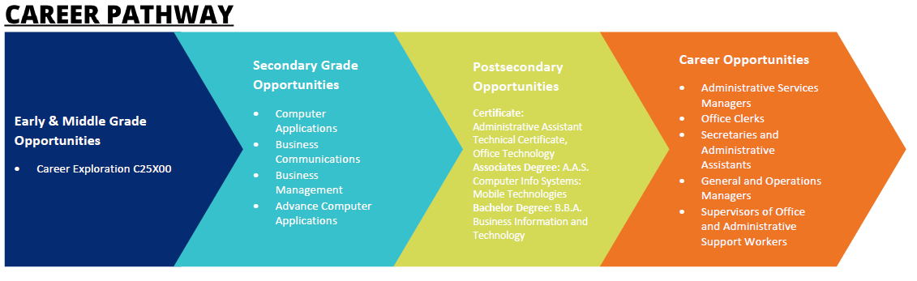

**How to use this document as a marketing material:**

* Update header/footer with information.
* Share with parents, students, administrators

**IDEAS to include:**

* Add district/school CTE logo
* Add a second page to highlight course enrollment, CTSO achievements, and/or WBL opportunities.

**Be sure to delete this box before printing/sharing!**