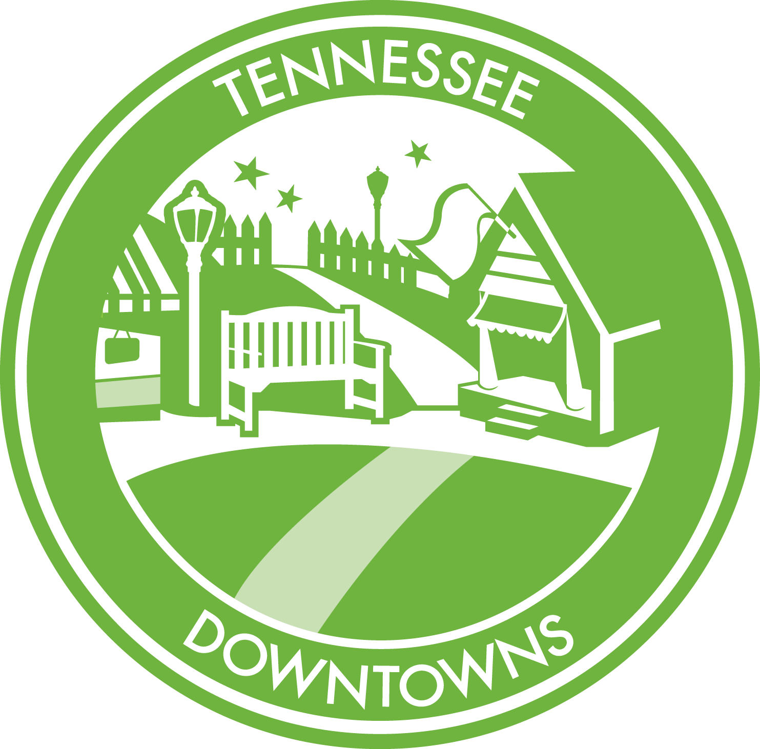

APPLICATION
July 2020 - June 2022 Program

Tennessee Downtowns is an affiliate program of:
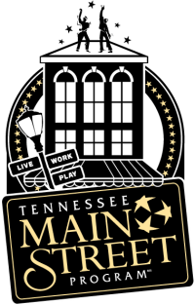
The Tennessee Main Street Program
A Coordinating Partner of the National Main Street Center

Tennessee Department of Economic and Community Development
312 Rosa L. Parks Avenue, 27th Floor
Nashville, Tennessee 37243
https://www.tn.gov/ecd/rural-development/tennessee-main-street/tennessee-downtowns.html

The Tennessee Downtowns Program

Think about the heart of your community, the traditional business district where it all got started many years ago. It is easy to recognize that this place is special and unique. The buildings, the stories, the people...all of these elements combine to form a unique place rich with character that can be found nowhere else in the world. We often refer to this place as “main street” or “downtown”. It is the representative physical heart of your community.
When the Tennessee Downtowns program talks about “main street”, we are referring to Main Street America™ (notice the trademark), the nationally recognized downtown revitalization movement started several decades ago by the National Trust for Historic Preservation. This movement is now led by the National Main Street Center and is comprised of over 2,000 communities and neighborhoods across America. Here in Tennessee, 35 communities have earned official designation as a Tennessee Main Street community, five of those are former Tennessee Downtown communities. What that means is they have met the criteria set forth by both the National Main Street Center and the Tennessee Main Street program for managing effective downtown revitalization programs. They are busy all year working to create better downtowns for their communities to enhance quality of life, increase hometown pride, stimulate the local economy, create distinctive experiences, and reconnect with their unique heritage and sense of place.

Tennessee Main Street Designated Communities
Athens ▪ Bolivar ▪ Bristol ▪ Brownsville ▪ Cleveland ▪ Collierville ▪ Columbia ▪ Cookeville ▪ Dayton ▪ Dyersburg ▪ Fayetteville ▪ Franklin ▪ Gallatin ▪ Greeneville ▪ Jackson ▪ Jonesborough Johnson City ▪ Kingsport ▪ Lawrenceburg ▪ Lebanon ▪ McKenzie ▪ McMinnville ▪ Maryville ▪ Murfreesboro ▪ Morristown ▪ Paris ▪ Pulaski ▪ Rogersville ▪ Tiptonville ▪ Savannah ▪ Sevierville ▪ Sweetwater ▪ Union City ▪ Ripley ▪ Winchester

Earning designation as a Tennessee Main Street community requires a lot of preparation, hard work, and financial commitment and typically happens after laying extensive groundwork. All great downtown revitalization efforts have to start somewhere and that’s where the Tennessee Downtowns program comes in. Tennessee Downtowns is a sister program of Tennessee Main Street and is designed to help communities fully understand what it takes to embark on a comprehensive revitalization effort for their downtown based upon the proven National Main Street Center’s Four-Point Approach™. This 24-month program coaches selected downtowns and their steering committees through the steps of launching a successful and sustainable downtown revitalization effort. Tennessee Downtowns can be a great path to becoming a designated Tennessee Main Street community, but it is not required after completing the program and participating does not automatically earn Tennessee Main Street designation.

Eligibility

Space in the Tennessee Downtowns program is limited and highly competitive. To participate in Tennessee Downtowns, communities must have not previously participated in the program and:

- Be a city located in a county that is an active participant in the ThreeStar program.

- Designate a program area (revitalization district) focused on a traditional commercial district. The district should feature a pedestrian scale and orientation that is compact in size and has a regular pattern of sidewalks that can be comfortably walked. It should also have a critical mass of buildings, at least 2/3 of which are commercial in nature, and businesses which form the foundation for revitalization efforts.

- Establish a dedicated five-member volunteer “Downtown Revitalization Steering Committee” of community leaders who will participate for the length of the program. This will involve allocating time for on-site meetings and training sessions.

- Have a designated non-profit or local government organization that will house the steering committee and serve as a conduit for the associated grant. This organization must have the financial resources to spend $15,000 on a project which will be reimbursed through the Tennessee Downtowns program upon completion. It must also become a member of the National Main Street Center ($350 annually).

- Illustrate interest and support from local government, chambers of commerce, merchant organizations, business and property owners within the district, and others who recognize the importance of downtown to their community and are willing to learn along with the steering committee and be involved where needed.

- Adopt a resolution by the city government to participate in the program.

- Clearly demonstrate community need for downtown revitalization assistance.

How to Apply

Nine communities will be selected in 2020 to participate in the 24-month Tennessee Downtowns program. The selection of communities will take place through a competitive application process (application attached). Completed applications must be received by 4:30 PM CST on February 14, 2020. To apply, please follow these steps:

Step 1: Review the eligibility requirements and be prepared to demonstrate those in the application.

Step 2: Assemble your steering committee, the group responsible for preparing the application. Ask any questions regarding the program and application process before beginning.

Step 3: Send via email a Letter of Intent to Apply (sample attached) to the contact below by January 14, 2020.

Step 4: Complete the attached application. Answer all questions and include all requested attachments. Tell your story well! We want to learn about your community and your desires for improvement. The Tennessee Downtowns application is extensive, but the time involved in completing it will be well spent. Regardless of whether you are selected to participate in the program at this time, you will have assembled valuable reference materials for your community that can be used to further your goals.

Step 5: Mail a flash drive or deliver electronically via email or Dropbox one complete PDF file of your final application to the contacts below. Make sure that you have received verification by email or phone that your application was received prior to the deadline highlighted above. Sending the Letter of Intent early will help us know about your plan to submit an application.

Step 6: Application reviews will take place during March. Selected communities will be announced April 7, 2020. Announcements of selected communities will be made via email and/or telephone to the primary contacts listed on the application. A TNECD press release will follow. Once that occurs, selected communities may begin their own publicity campaigns. The program will be underway July 2020 through June 2022.

Application Contact
Nancy Williams, Tennessee Main Street Director
Tennessee Department of Economic and Community Development
312 Rosa L. Parks Avenue, 27th Floor
Nashville, Tennessee 37243
Telephone: 615.806-3185
Email: Nancy.Williams@tn.gov

What to Expect if Selected

Communities selected to participate in Tennessee Downtowns will be involved in a 24-month process of learning about downtown revitalization based upon the National Main Street Center’s Four Point Approach™, a successful strategy proven to work in communities of varying sizes and with different levels of resources. You can learn more about the Main Street Approach™ by visiting www.mainstreet.org

The first 12 months of the Tennessee Downtowns program will focus on education, building resources, and organization. The second 12 months will focus on a community project that will be funded by a $15,000 reimbursable grant from TNECD. The following activities and resources will be included in the July 2020 - June 2020 program:

Getting Started Site Visit Each community will receive an on-site half-day visit by National Main Street Center and Tennessee Main Street staff. They will meet with the steering committee and tour the downtown. The steering committee will receive a written Preliminary Assessment following the visit.

Four PointsTM Workshop All nine steering committees will assemble for a full-day workshop presented by National Main Street Center staff. This workshop will serve as an introduction to the Four Point Approach™. This approach focuses on four key aspects of successful revitalization programs: Design, Economic Restructuring, Organization, and Promotion. The workshop is held in the Nashville area, so travel will be required.

Webinars At least four webinars will be provided for the steering committees during the first 12 months. These webinars last about one hour and will include more in-depth information on the Four Points™.

SWOT Analysis Each community will receive an on-site half-day visit by National Main Street Center staff to conduct a SWOT Analysis (Strengths, Weaknesses, Opportunities, Threats). The “Top Five” priorities for downtown will be determined. A written SWOT Analysis Report will be provided.

Work Plan Development Each community will receive a half-day on-site visit to conduct Work Plan development. Work Plans are based on the Four PointsTM and this process will generate objectives and activities the community will begin implementing during the program. It will also assist with grant planning.

Innovation Grant Each community will receive a $15,000 reimbursable grant to use for a project that incorporates the Four Point Approach™.

Materials & Signage Steering committees will receive digital copies of the following materials: the Revitalizing Main Street book from the National Main Street Center, the Main Street Board Members Handbook, four committee handbooks (design, economic restructuring, organization, and promotion), PowerPoint summaries from sessions and webinars, and a Tennessee Downtowns metal community sign.

Moving Forward Report Upon “graduating”, each community will receive a “Moving Forward” report provided by National Main Street Center field staff. The report will provide written recommendations for carrying the downtown revitalization initiative forward.
Application for Tennessee Downtowns
July 2018 - June 2020 Program

Municipality Name

☐ This municipality is located in a county that is a certified Tennessee ThreeStar program (http://www.tn.gov/ECD/threestar/).

County Name

Contact Information

Non-profit or local government organization that will house the Downtown Revitalization Steering Committee, serve as a conduit for grant payments and reimbursement, and become a member of the National Main Street Center:

Name of Organization:

Non-profit Designation: Federal ID No.

Key Organization Contact:

Address, City, Zip:

Phone: Email:

Signature:

Downtown Revitalization Steering Committee Chair (Primary Contact)

Name:

Organization:

Title/Position:

Address, City, Zip:

Phone: Email:

Signature:

Downtown Revitalization Steering Committee Member No. 2

Name:

Organization:

Title/Position:

Address, City, Zip:

Phone: Email:

Signature:

Downtown Revitalization Steering Committee Member No. 3

Name:

Organization:

Title/Position:

Address, City, Zip:

Phone: Email:

Signature:

Downtown Revitalization Steering Committee Member No. 4

Name:

Organization:

Title/Position:

Address, City, Zip:

Phone: Email:

Signature:

Downtown Revitalization Steering Committee Member No. 5

Name:

Organization:

Title/Position:

Address, City, Zip:

Phone: Email:

Signature:

* * * * * * * * * * * * * * * * * * * * * * * * * * * * * * * * * * * * * * * * * * * * * * * * * * * *

Is this a new Steering Committee assembled to lead downtown revitalization efforts or has this committee previously existed?

☐ This is a new committee
☐ This is an existing committee that has been in place since

* * * * * * * * * * * * * * * * * * * * * * * * * * * * * * * * * * * * * * * * * * * * * * * * * * * *

City Mayor

Name: Year Elected:

Address, City, Zip:

Phone: Email:

Signature:

County Mayor

Name: Year Elected:

Address, City, Zip:

Phone: Email:

Signature:

Section 1: Community Support

To be successful for the long-term, a downtown revitalization program represents and involves a coalition of organizations, businesses, and individuals from throughout the community; not just those who own property or businesses in the commercial district or who have a direct economic tie to it, but all members of the community who are interested in its overall health. Involvement by both the public and private sectors is critical as well; neither sector can revitalize the commercial district without the skills and vantage points of the other.

A. Describe the level of understanding and support for the Tennessee Downtowns program among the following entities. List each local entity by category below, and use additional space or pages to complete this question. Also describe how partnerships/cooperative efforts will occur. If any group is not aware of or not involved with your effort at this time, please indicate that.

Municipal Government (council, planning commission, inspections, etc.):

County Government:

Community and Economic Development Organizations:

Downtown Business Owners:

Downtown Property Owners:

Historic Preservation Groups:

Tourism Agencies:

Arts/Cultural Organizations:

Residents:

Industrial Board/Major Industries:

Other Institutions in the Community (financial, hospitals, colleges, etc.):

Other Groups Not Categorized Above (major churches, civic groups, etc.):

B. Insert a copy of the resolution from the local municipality supporting this application to participate in the Tennessee Downtowns program following this section.
(A sample resolution is included in the appendix.)

C. Insert up to 5 written letters of partnership or other evidence of local philosophical support for the program from individuals or groups listed in 1A following this section. Letters of partnership should include statements as to their willingness to participate in the program (such partnerships support may include building improvements, joint promotional activities, serving on future committees, financial contributions, etc.).
(A sample partner letter is included in the appendix.)

Section 2: Program Goals

A. Discuss specific issues that currently exist within the downtown area that are a top priority for the community’s leadership (high vacancy rates, dilapidated buildings, aging infrastructure, etc.). Clearly and convincingly articulate the need for downtown revitalization.

B. How may participating in the Tennessee Downtowns program assist with addressing these issues?

C. Describe any previous downtown revitalization efforts that have occurred in your community. Share success stories or explain why the efforts failed.

D. What is your long-term vision for downtown?

Section 3: Preservation Ethic

Historic preservation is central to downtown revitalization. The historic buildings and public spaces of a traditional commercial district enrich civic life and add value to the community. Developing a historic preservation ethic is an ongoing process of education and discovery for a community focused on downtown revitalization. A strong historic preservation ethic is successful in saving, rehabilitating, and finding new uses for traditional commercial buildings and in intensifying the uses of the district’s buildings, through both specific building improvement projects and through policy and regulatory changes which make it easier to develop property within the commercial district.

A. Does your community have a National Register District?

☐Yes ☐ No
If yes, does it include the proposed Tennessee Downtowns program area? ☐Yes ☐No

B. Does your community have a locally designated historic district?

☐Yes ☐ No
If yes, does it include the proposed Tennessee Downtowns program area? ☐Yes ☐No
Is a historic zoning commission in place? ☐Yes ☐No
Are design guidelines in place and enforced? ☐Yes ☐No

C. Is the community recognized as a Certified Local Government (CLG) by the State of Tennessee?

☐Yes ☐ No
If yes, is it a municipal ☐ or county ☐ CLG?
Certification date:

D. Has a historic building/architectural survey of the downtown project area been completed?

☐Yes ☐ No
If yes, who completed the project and when?

E. List historically significant buildings located within the proposed Tennessee Downtowns program area (indicating any listed on the National Register of Historic Places). Include street address and an explanation of the historic significance. Include a description of the building’s general condition and attach photographs of the buildings following this section.

F. Not including the proposed Tennessee Downtowns program area, please briefly discuss other historic assets that exist within the city and county and how they are being utilized (privately owned, tourist site, public building, etc.)?

Section 4: Downtown Profile

Downtown revitalization works best when the local focus begins with a good understanding of the district’s current realities. Applicants must define boundaries for the proposed Tennessee Downtowns program area in which the steering committee will focus its efforts and activities.

A. Briefly explain the development of your downtown. Include basic historical background such as how and when the town began and the original foundations for the local economy. Discuss significant changes in the community over the years and the factors that have brought about prosperity and/or decline and those trends currently affecting the downtown.

B. Insert a map of the proposed Tennessee Downtowns program area following this section. Describe the physical boundaries for the program area and why those boundaries were selected.

C. Describe the downtown district’s primary traffic generators (government offices, library, farmer’s market, cultural attractions, major highway, significant tourist attractions, etc.).

D. List the special events or festivals currently held within the downtown district. Note as best you can the following for each special event or festival: name; year it began; who organizes it; annual budget; what it celebrates; and the annual attendance.

E. Describe significant civic improvements, building rehabilitations (public or private), and/or new construction projects that have occurred downtown during the past five years (include dollar amounts if available).

F Insert a series of color photographs representing the buildings, amenities, streetscapes, and other important features of the proposed Tennessee Downtowns program area following this section (that have not already been included in Section 3E). You may have up to four pictures per page. Please be sure each photo is labeled in a way that explains its location, features, etc.

Section 5: Downtown Statistics/Economic Data

Tracking statistics provides a tangible measurement of a downtown revitalization program’s progress and is crucial to garnering financial and programmatic support for the revitalization effort in the long-term. Statistics should be collected on a regular, ongoing basis using the baseline criteria listed below. This information should be collected from within the designated Tennessee Downtowns project area.

A. Number of businesses within the proposed Tennessee Downtowns program area in each of the following categories:

_______ Casual dining (diners, limited service)
_______ Fast food
_______ Fine dining (full-service)
_______ Coffee Houses
_______ Bakeries, ice cream, candy, etc.
_______ Antiques
_______ Consignment
_______ Men's clothing and accessories
_______ Women's clothing and accessories
_______ Children's clothing and accessories
_______ Shoes
_______ Sporting goods
_______ Books/stationery
_______ Jewelry/china/crystal
_______ Hobby supplies, toys and games
_______ Gifts, novelties and souvenirs
_______ Musical instruments
_______ Sewing, needlework and piece goods
_______ Florists
_______ Dance/exercise studios
_______ Banks
_______ Accountants
_______ Attorneys
_______ Dental
_______ Optical
_______ Pharmacies
_______ Physicians
_______ Real Estate
_______ Hardware
_______ Home Furnishings
_______ Groceries

Add additional categories not mentioned above:
_______ _______________________ _______ _______________________
_______ _______________________ _______ _______________________
_______ _______________________ _______ _______________________
_______ _______________________ _______ _______________________

B. Total number of businesses in the downtown: (as indicated in Section 5A)

C. Number of commercial buildings within the downtown:

D. Commercial building ground floor vacancy rate:

E. Commercial building upper floor vacancy rate:

F. The average rental rate per square foot for commercial space: $ (per month)

G. Percentage of buildings downtown that are

owner-occupied % renter-occupied %

H. Rank the general condition of the buildings in the downtown project area as:

% excellent % good % fair % poor

I. Number of housing units within the downtown project area:

______ Lofts (upper floors of commercial buildings)
______ Storefront residence (lower level of commercial buildings with front entrance)
______ Lower level residence (rear of commercial building with no front entrance)
______ Apartments (stand-alone complexes)
______ Condominiums (stand-alone complexes)
______ Townhomes
______ Single-family detached homes

J. Total appraised value of buildings within the downtown project area:

$

Section 6: Community Profile

A. City population
B. Total number of households
C. City median household income
D. County population
E. County median household income
F. Unemployment rate

G. Does your municipality have or use any of the following:

1. Comprehensive Plan ☐Yes ☐ No Date adopted

2. Zoning Ordinance ☐Yes ☐ No Date adopted

- What is/are the current zoning classification(s) for the downtown program area?
- Does the zoning above allow for residential uses? ☐Yes ☐ No

3. Building Codes ☐Yes ☐ No Date adopted

- What is the current building code?

4. Sign Ordinance ☐Yes ☐ No

5. Landscape Ordinance ☐Yes ☐ No

6. Community Development/Planning staff? ☐Yes ☐ No

I. Has a market study of the trade area been completed? ☐Yes ☐ No

If yes, who completed the project and when?

J. List your community's major assets, including any special or unique characteristics (man-made or natural).

K. List your community’s 5 largest employers and number of employees.

L. List relevant technical resources available to your community (for example, a Tennessee Small Business Development Center, a local career center, a regional preservation network, etc.)

APPENDIX

- Tennessee Downtowns Q & A

- Sample Letter of Intent to Apply

- Sample Resolution for a City Council

- Sample Letter of Support

- National Main Street Center’s Four Point Approach & Eight Guiding Principles

Tennessee Downtowns Q & A

1. How will communities be selected to participate in the Tennessee Downtowns program?
A team of professionals will review each application based on the information provided by that community. The team will be composed of individuals with a professional background in neighborhood revitalization, economic and community development, planning, historic preservation, tourism and/or other applicable professions.

2. Who should complete the application?
It is always best to have the Downtown Revitalization Steering Committee work together as a team to complete the application. A strong application will address all the questions with clear and concise answers.

3. What if our downtown is not historic?
This program follows the National Main Street Center’s Four-Point Approach™ for downtown revitalization which was originally designed to work best in a traditional commercial district setting featuring commercial buildings at least 50 years old. It is the “walkable” nature of such a district, its opportunity to incorporate a variety of uses, and it’s “anchor position” in the hearts and minds of citizens that make it important to the community. Downtown does not have to be officially designated a local historic district to participate in Tennessee Downtowns.

4. Can our community apply even if we have already started a downtown revitalization effort?
Yes! An established effort focusing on downtown is an important first step. If your community has started a downtown revitalization effort and is in the early stages of implementation, this program will be an excellent opportunity to learn more. However, if you have had a substantial downtown revitalization effort in place for some time, the information provided by Tennessee Downtowns may be too basic. In that case, consideration should be given to pursuing Tennessee Main Street designation. Past participants in Tennessee Downtowns and designated Tennessee Main Street communities are not eligible to apply to participate in this Tennessee Downtowns program.

5. Do we need to have paid staff for participation in Tennessee Downtowns?
No. This program is designed to work with a dedicated five-member volunteer steering committee that should comprise a broad mix of individuals from the community. Tennessee Downtowns will focus on local organizational development strategies that may eventually include board of directors, standing committees, volunteers and staff. It is not a requirement or recommended that paid staff be on board to participate in Tennessee Downtowns.

6. How much does it cost to participate in Tennessee Downtowns?
If selected to participate in Tennessee Downtowns, each community will receive a reimbursable grant of $15,000 to complete a downtown project. The cost of the project will be reimbursed after completion and invoices have been paid. The Downtown Revitalization Steering Committee members will be required to participate in all mandatory meetings, workshops, and webinars during the 24-month program. This may involve some travel expenses to and from the one day workshop near Nashville. Tennessee Downtowns participates must also join the National Main Street Center ($350 annually)

7. What is the difference between the Tennessee Main Street program and the Tennessee Downtowns program?
The Tennessee Main Street program designates communities that meet or exceed the National Main Street Center’s standards of performance for recognition on an annual basis. This includes having a non-profit organization in place that is dedicated to the revitalization and management of downtown with a board of directors and managing staff, an annual work plan focused on implementing the Four Point Approach™, and collecting statistics on downtown progress (such as new jobs and public/private investment). Tennessee Downtowns is a learning program for communities that are just getting started with a revitalization effort. It requires a five-member steering committee to lead the effort over a 24-month period.

8. Will we automatically be designated a Tennessee Main Street community after completing the Tennessee Downtowns program?
No. Communities that participate in the Tennessee Downtowns program may wish to continue a self-initiated downtown revitalization effort at the end of the program or apply for designation as a Tennessee Main Street community through a separate application process. Communities will not automatically be accepted into the Main Street Program and it is not required to pursue that designation.

Sample Letter of Intent to Apply

Tennessee Downtowns Program

The city/town of ____________________________________ intends to complete and submit an application to participate in the Tennessee Downtowns program during the July 2018 to June 2020 program year. We understand the eligibility requirements and are prepared to meet all financial and time expectations if selected to participate in this program.

Our downtown is in need of a revitalization strategy and we look forward to the learning opportunity Tennessee Downtowns can provide through resources from the Tennessee Main Street Program and National Main Street Center.

___________________________________ __________________________ Signature of Mayor Date

___________________________________ __________________________ Signature of Steering Committee Chair Date

SAMPLE RESOLUTION
(For a City Council)

A resolution authorizing ___________________________ to submit an application to participate in the Tennessee Downtowns program, a downtown revitalization education and grant program offered by the Tennessee Main Street Program and the Tennessee Department of Economic and Community Development.

Whereas the Tennessee Downtowns program has been created to help communities fully understand what it takes to embark on a comprehensive revitalization effort for downtown through a 24-month education and grant process; and

Whereas the Tennessee Department of Economic and Community Development will be selecting Tennessee cities to participate in the Tennessee Downtowns program based on a competitive application process;

NOW THEREFORE BE IT RESOLVED BY THE CITY COUNCIL OF_____________________, that the city:

Endorses the submission of this application and agrees to participate in the Tennessee Downtowns program if selected; and

Endorses the goal of economic revitalization of the downtown within the context of the preservation and rehabilitation of its historic buildings; and

Endorses the Downtown Revitalization Steering Committee members participation in all required meetings/training sessions for the Tennessee Downtowns program; and

Endorses (if applicable) ____________________________________________________
as the non-profit organization to house the Downtown Revitalization Steering Committee and serve as the financial conduit for associated grants.

[add additional provisions here]

PASSED, APPROVED, AND ADOPTED THIS _______ day of _____________,_____.

_______________________________
MAYOR

________________________________
CITY CLERK

Sample Partner Letter

[“Partner” letterhead with address and contact information]

Date

Tennessee Downtowns Program
312 Rosa L. Parks Avenue, 27th Floor
Nashville, Tennessee 37243

RE: Application to the Tennessee Downtowns Program

On behalf of [the “partner”], it is my pleasure to write a letter supporting a local application to participate in the Tennessee Downtowns program.

I/We understand the value of downtown in our local economic and community development strategies. Downtown is a key asset for encouraging tourism, recruiting and retaining businesses, preserving local heritage and bringing the community together through festivals and events. Tennessee Downtowns will provide the expertise needed to embark on a comprehensive downtown revitalization effort and our community will benefit from resources, training, and technical assistance provided by the Tennessee Main Street Program and National Main Street Center.

A healthy and vibrant downtown [name of city] is important to our local economy and the quality of life of our citizens. [The “supporter”] intends to support this mission by [please explain how the support will be manifested {financial, in-kind, partnership, etc.}].

I/We will partner in the effort by [explain role here].

Thank you for considering [name of city] for participation in the Tennessee Downtowns program.

Sincerely,

[Writer’s name with signature above ]

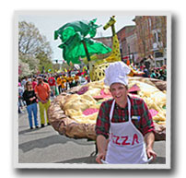
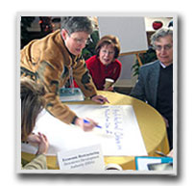
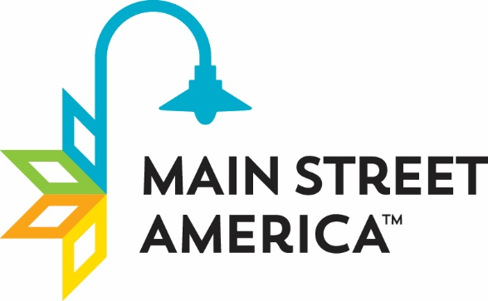

Organization
Organization establishes consensus and cooperation by building partnerships among the various groups that have a stake in the commercial district. By getting everyone working toward the same goal, your downtown revitalization program can provide effective, ongoing management and advocacy for your downtown or neighborhood business district. Through volunteer recruitment and collaboration with partners representing a broad cross section of the community, your program can incorporate a wide range of perspectives into its efforts. A governing board of directors and standing committees make up the fundamental organizational structure of volunteer-driven revitalization programs. Volunteers are coordinated and supported by a paid program director. This structure not only divides the workload and clearly delineates responsibilities, but also builds consensus and cooperation among the various stakeholders.

Promotion
Promotion takes many forms, but the goal is to create a positive image that will rekindle community pride and improve consumer and investor confidence in your commercial district. Advertising, retail promotions, special events, and marketing campaigns help sell the image and promise of downtown to the community and surrounding region. Promotions communicate your commercial district's unique characteristics, business establishments, and activities to shoppers, investors, potential business and property owners, and visitors.

Design
Design means getting downtown into top physical shape and creating a safe, inviting environment for shoppers, workers, and visitors. It takes advantage of the visual opportunities inherent in a commercial district by directing attention to all of its physical elements: public and private buildings, storefronts, signs, public spaces, parking areas, street furniture, public art, landscaping, merchandising, window displays, and promotional materials. An appealing atmosphere, created through attention to all of these visual elements, conveys a positive message about the commercial district and what it has to offer. Design activities also include instilling good maintenance practices in the commercial district, enhancing the district's physical appearance through the rehabilitation of historic buildings, encouraging appropriate new construction, developing sensitive design management systems, educating business and property owners about design quality, and long-term planning.

The Main Street Four-Point Approach

As a unique economic development tool, the Main Street Four-Point Approach™ is the foundation for local initiatives to revitalize their districts by leveraging local assets—from cultural or architectural heritage to local enterprises and community pride. The four points of the Main Street approach work together to build a sustainable and complete community revitalization effort.

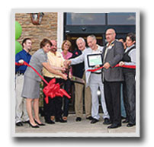

The Eight Principles

The National Main Street Center's experience in helping communities bring their commercial corridors back to life has shown time and time again that the Main Street Four-Point Approach succeeds. That success is guided by the following eight principles, which set the Main Street methodology apart from other redevelopment strategies. For a downtown program to be successful, it must whole-heartedly embrace the following time-tested Eight Principles.
• Comprehensive: No single focus — lavish public improvements, name-brand business recruitment, or endless promotional events — can revitalize downtown. For successful, sustainable, long-term revitalization, a comprehensive approach, including activity in each of Main Street's Four Points, is essential.
• Incremental: Baby steps come before walking. Successful revitalization programs begin with basic, simple activities that demonstrate that "new things are happening " in the commercial district. As public confidence in the downtown district grows and participants' understanding of the revitalization process becomes more sophisticated, Main Street is able to tackle increasingly complex problems and more ambitious projects. This incremental change leads to much longer-lasting and dramatic positive change in the Main Street area.
• Self-help: No one else will save your downtown. Local leaders must have the will and desire to mobilize local resources and talent. That means convincing residents and business owners of the rewards they'll reap by investing time and money in Main Street — the heart of their community. Only local leadership can produce long-term success by fostering and demonstrating community involvement and commitment to the revitalization effort.
• Partnerships: Both the public and private sectors have a vital interest in the district and must work together to achieve common goals of downtown's revitalization. Each sector has a role to play and each must understand the other's strengths and limitations in order to forge an effective partnership.
• Identifying and capitalizing on existing assets: Business districts must capitalize on the assets that make them unique. Every district has unique qualities like distinctive buildings and human scale that give people a sense of belonging. These local assets must serve as the foundation for all aspects of the revitalization program.
• Quality: Emphasize quality in every aspect of the revitalization program. This applies to all elements of the process — from storefront designs to promotional campaigns to educational programs. Shoestring budgets and "cut and paste" efforts reinforce a negative image of the commercial district. Instead, concentrate on quality projects over quantity.
• Change: Skeptics turn into believers and attitudes on Main Street will turn around. At first, almost no one believes downtown can really turn around. Changes in attitude and practice are slow but definite — public support for change will build as the revitalization program grows and consistently meets its goals. Change also means engaging in better business practices, altering ways of thinking, and improving the physical appearance of the commercial district. A carefully planned downtown revitalization program will help shift public perceptions and practices to support and sustain the revitalization process.
• Implementation: To succeed, the downtown program must show visible results that can only come from completing projects. Frequent, visible changes are a reminder that the revitalization effort is under way and succeeding. Small projects at the beginning of the program pave the way for larger ones as the revitalization effort matures, and that constant revitalization activity creates confidence in the downtown program and ever-greater levels of participation.

Economic Vitality
Economic restructuring strengthens your community's existing economic assets while diversifying its economic base. This is accomplished by retaining and expanding successful businesses to provide a balanced commercial mix, sharpening the competitiveness and merchandising skills of business owners, and attracting new businesses that the market can support. Converting unused or underused commercial space into economically productive property also helps boost the profitability of the district. The goal is to build a commercial district that responds to the needs of today's consumers.
Coincidentally, the four points of the Main Street approach correspond with the four forces of real estate value, which are social, political, physical, and economic.

