WHAT IS TN SHIP?
The State Health Insurance Assistance Program (SHIP) provides local, in-depth, and objective insurance counseling and assistance programs to Medicare-eligible individuals, their families, and caregivers.
HOW CAN TN SHIP HELP ME?
- Get one-on-one assistance reviewing Medicare health or prescription drug plan options.
- Learn if you or your loved ones are eligible for Medicare health or prescription drug plan options.
- Understand eligibility criteria and what Medicare does or does not cover.
- Know your rights under Medicare.
- Volunteer to help others.
WHO IS ELIGIBLE?
Anyone who has questions about their healthcare benefits can reach out to TN SHIP, but the focus is on Medicare-eligible individuals who are 65 or older or who are on Medicare due to disability.
HOW DO WE GET MORE INFORMATION ABOUT OPTIONS?
Call the statewide SHIP hotline 877-801-0044 or email dda.ship@tn.gov to request assistance.
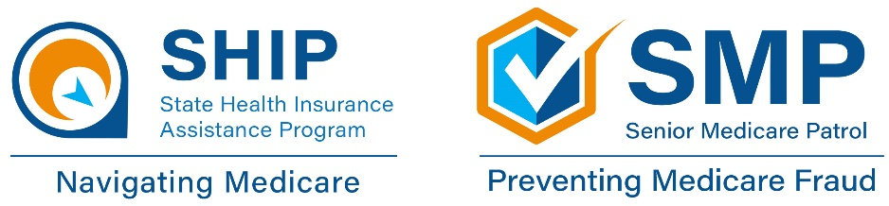
In-person visits can be scheduled at a local regional office.

