- Open the email containing the meeting invitation.
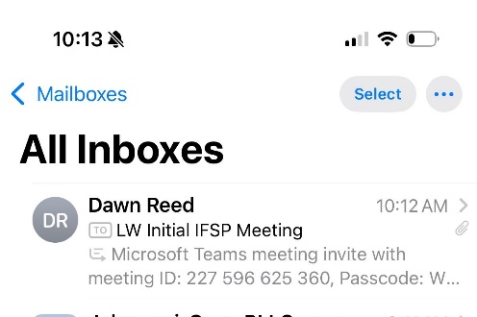

- Click “Join the meeting now” at the top of the email when it is time for the meeting to begin. You may want to do this a minute or two before the meeting time so you can get set up. An account is not needed to join a meeting.
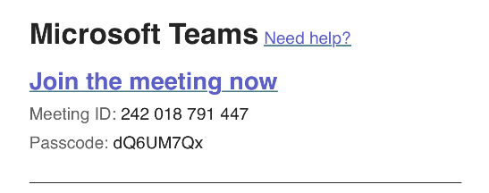
- Check that your video/camera and mic are on (there is not a slash / through the icon). Make sure the sound is on “Speaker”.



- Enter your name in the box and click “join now”.


- The host of the meeting will let you into the meeting shortly.

- Click “Leave” when the meeting has concluded.
Note: To see the meeting details or set reminder alerts, scroll to the bottom of the email and click to open the attachment. 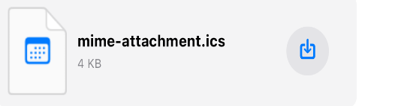
The Microsoft Teams app can be downloaded to your desktop, iOS, or Android device from the App Store or Google Play. Teams may also be accessed on the web without download at:
https://teams.microsoft.com


