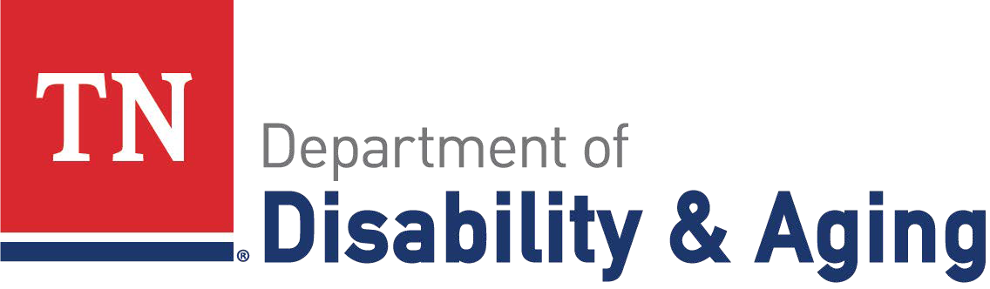

**USING YOUR KATIE BECKETT PART B BENEFITS: HRA**

The **Katie Beckett HealthCare Reimbursement Account** (HRA) allows people to spend program dollars on IRS qualified healthcare expenses. The HRA for the Katie Beckett Program is Total Administrative Services Corporation (TASC).

|  |  |
| --- | --- |
| **How can I use it?**  The HRA can be used two ways:   * With the provided TASC card to pay for covered out-of-pocket medical expenses   + Important: The card can currently only be used at medical offices such as hospitals, doctors’ offices, or therapy offices.   + When using the card, run it as credit, not debit. * Reimbursement of claims with an itemized receipt. Reimbursement requests are typically processed in 3 business days. They are paid by check or direct deposit.   Information about eligible expenses can be found  on TASC's website. Common expenses include but are not limited to:   * Copays and deductibles * Speech Therapy, Occupational Therapy, Physical Therapy and Non- Traditional Therapies * Orthotics * Vision and Dental * Respite (reimbursement only) * Prescriptions (reimbursement only)   **A full list can be found on the TASC website**, and questions can be directed to the TASC contact information listed on this flyer. | **Things to know…**   * Only the enrolled child is covered. The HRA is a one-time per year allocation and cannot be modified during the ISP year. * You must submit receipts to validate every purchase. * Some purchases need a Letter of Medical Necessity (LOMN) from a doctor to be an eligible expense. * Credit/debit card processing fees are not a covered expense. * You can access your account at any time via the   TASC Online Portal.   * There is no daily spending limit for the   TASC card.  **Helpful Websites**   * [https://www.tn.gov/disability-and-aging/ disability-aging-programs/katie-beckett/ services.html](https://www.tn.gov/disability-and-aging/disability-aging-programs/katie-beckett/services.html)  * [www.tnkbbtasc.com](http://www.tnkbbtasc.com)   **TASC Contact Information**  Phone: (844) 529-8137 |

**Want more information?**

Check out the Katie Beckett website and contact your KB Case Manager for more details about using your HRA.