

|  |
| --- |
|  |
| Employment History Guidance Document |
| Information for Providers using Employment History |

|  |
| --- |
| Dennis Watson, Carrie Brna  9-27-2023 |

# Table of Changes

|  |  |  |
| --- | --- | --- |
| **Date** | **Author** | **Description** |
| 6/27/2023 |  | Initial Draft |
| 7/13/2023 | Carrie Brna | Edited content |
| 9/20/23 | Carrie Brna | Edited content |
| 9/21/23 | Carrie Brna | Edited content |
| 9/25/23 | Dennis Watson | Edited content |
| 9/26/23 | Dennis Watson | Edited content |
| 9/26/23 | Carrie Brna | Edited content |
| 10/12/23 | Carrie Brna | Added who this document is for |
| 10/12/2023 | Oileen Roberts | Check formatting, added headers and footers with page numbers.  Added definitions in the glossary where there were blanks.  Moved reports to glossary |
| 10/13/2023 | Oileen Roberts | Replaced introduction section on page 4. |
| 2/15/2024 | Carrie Brna | Updated guidance of order of reporting responsibilities |
| 12/12/2024 | Carrie Brna | Updated branding, removed order of reporting responsibilities |
| 1/14/2025 | Carrie Brna | Removed employment milestone as a required data element |
|  |  |  |
|  |  |  |
|  |  |  |

Contents

Table of Changes 1

**Therap Employment History Guidance Document** 3

Log In to Therap 3

Provider Home Page 3

Setup Employment History 4

Corporate Entity (PROVIDER OPTIONAL FIELD) 4

Employer (PROVIDER REQUIRED SECTION) 5

Contact Person (PROVIDER OPTIONAL FIELD) 8

Job Template (PROVIDER REQUIRED FIELD) 12

Import Employer from Excel 16

Search Imported Excel 18

Contact/Interaction (PROVIDER OPTIONAL FIELD) 19

Employment History for Individuals 23

Job/Employer Search 25

Funding Source (PROVIDER REQUIRED FIELD) 27

Career Development Plan (PROVIDER OPTIONAL FIELD) 29

Search, Update, and Delete Career Development Plan 31

Training/Coaching (PROVIDER OPTIONAL FIELD) 35

Job Detail (PROVIDER REQUIRED FIELD) 40

Search, Update, and Delete Job Detail 45

Application and Interview (PROVIDER OPTIONAL FIELD) 50

Benefits Counseling (PROVIDER REQUIRED FIELD, only if individual has received or is receiving benefits counseling services) 53

Variance (PROVIDER REQUIRED FIELD for individuals who are unemployed) 55

Additional Information (PROVIDER OPTIONAL FIELD) 57

**Appendix** 59

Reports 59

Acronyms and Abbreviations Definitions 60

# **Therap Employment History Guidance Document**

**All individuals receiving 1915(c) waiver services, regardless of work status, must have their employment information entered - this includes individuals who are not receiving employment services because of retirement, choosing not to work, or working without a job coach.**

## Log In to Therap

* Three pieces of information plus the URL will be needed to log into Therap.
* URL: [Therap :: Login (therapservices.net)](https://secure.therapservices.net/auth/login)

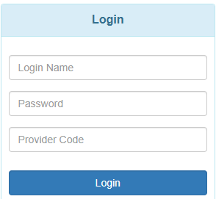

* Your credentials: This will be provided to you by the person who sets up your account, usually the DDA Help Desk, for DDA employees, or by your systems Super Admin for ISC agencies.
  + Login Name
  + Initial Password
  + Provider Code
* Your provider code will be based on who you are employed by. Each Provider will have its own provider code.
* Enter all three pieces of information then click the Login button to get to the Therap Dashboard.
* If you are logging in for the first time, you will be presented with the screens to change your temporary password to a permanent password.

## Provider Home Page

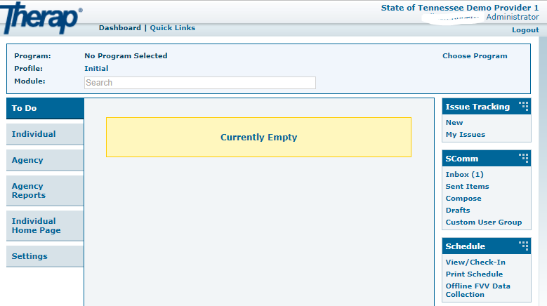

Depending on your access you will see more or less tabs on your Dashboard. Not all modules have been turned on for providers.

## Setup Employment History

There are a few steps that a provider will need to do in order to use the Employment History Module in Therap

* Click on the Agency tab
* Look for Employment History section of the page.

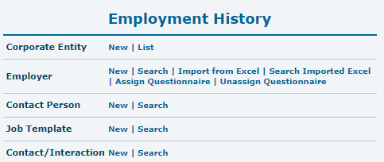

### Corporate Entity (PROVIDER OPTIONAL FIELD)

Corporate Entity is an **Optional Field** that is highly encouraged for Agency use when an individual is employed with a larger corporation such as Target, McDonald’s, Microsoft, etc.

1. Click on the **New** link next to the Corporate Entity option on the Agency tab.

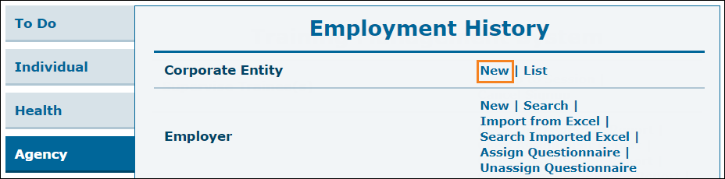

1. This will open the 'Corporate Entity' form. Enter the required information and click on the **Save** button.

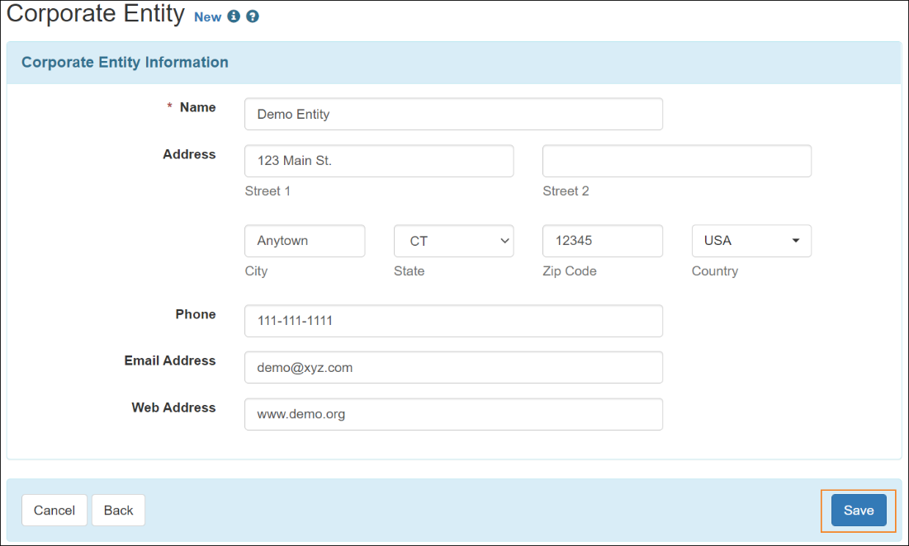

1. A confirmation message will appear to confirm that the form has been successfully saved. You may click on **Add Corporate Entity** link on this page to create more corporate entities.

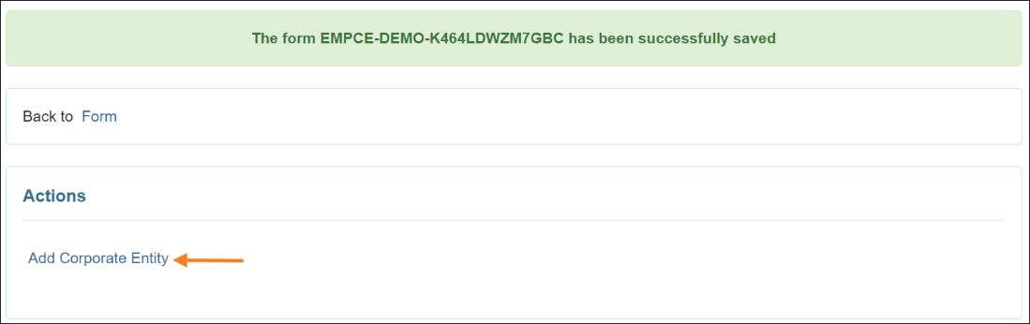

### Employer (PROVIDER REQUIRED SECTION)

Providers are **required** to utilize the Employer subsection in order to develop an Employer Profile. This profile will be the location for which all Job Templates associated with specific employers will reside.

The process for establishing an Employer Profile is noted in the following steps:

1. Click on the New link next to the Employer option on the Agency tab.

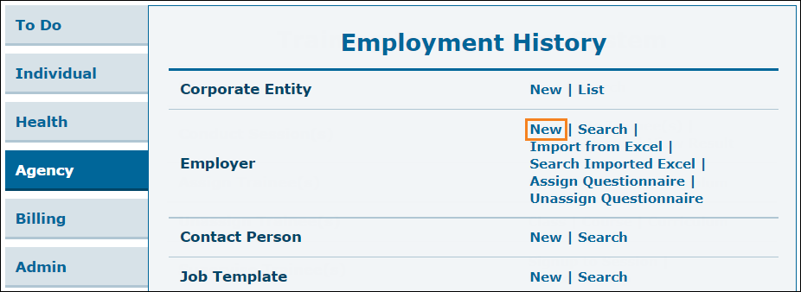

1. On the ‘Employer’ page, enter information in the ‘Employer Information’ section. Click on the Save button in order to create the form.
2. If you created a Corporate Entity, you can link Employers to Corporate Entities on this page.

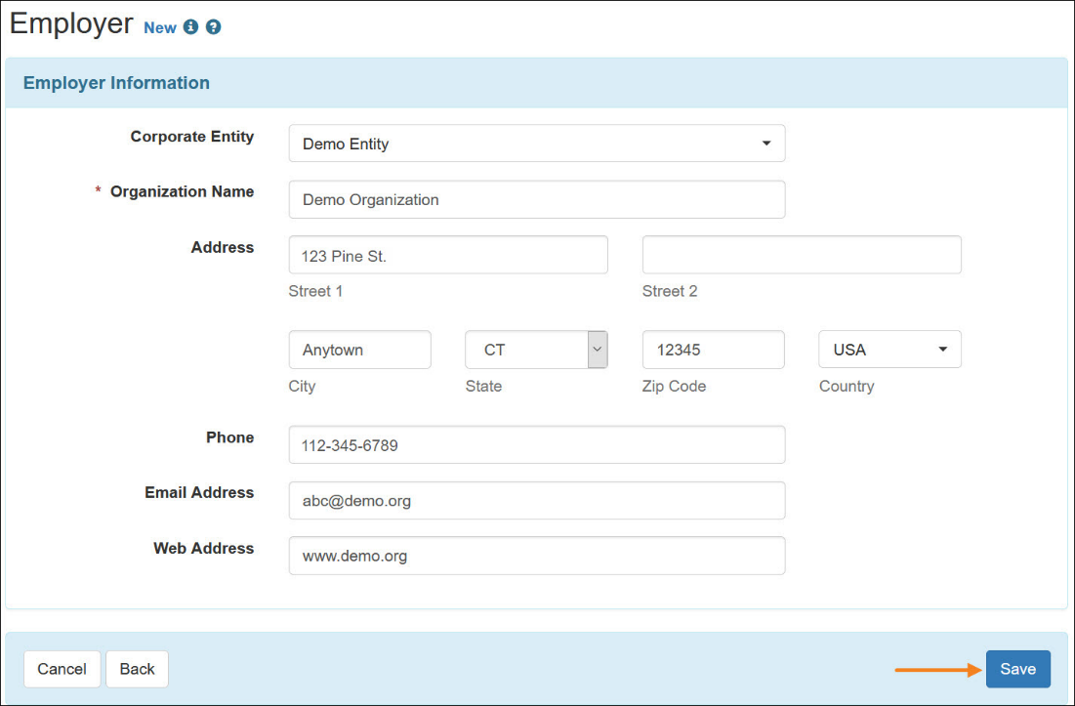

1. A confirmation message will appear to confirm that the form has been successfully saved. You will be able to create more Employers by clicking on the Add Employer link from this page.

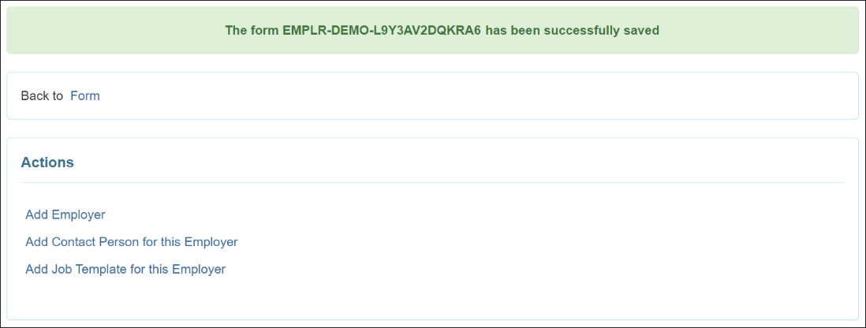

1. Once the Employer has been saved with a Corporate Entity, an ‘Employer’ section will appear on the Corporate Entity form.

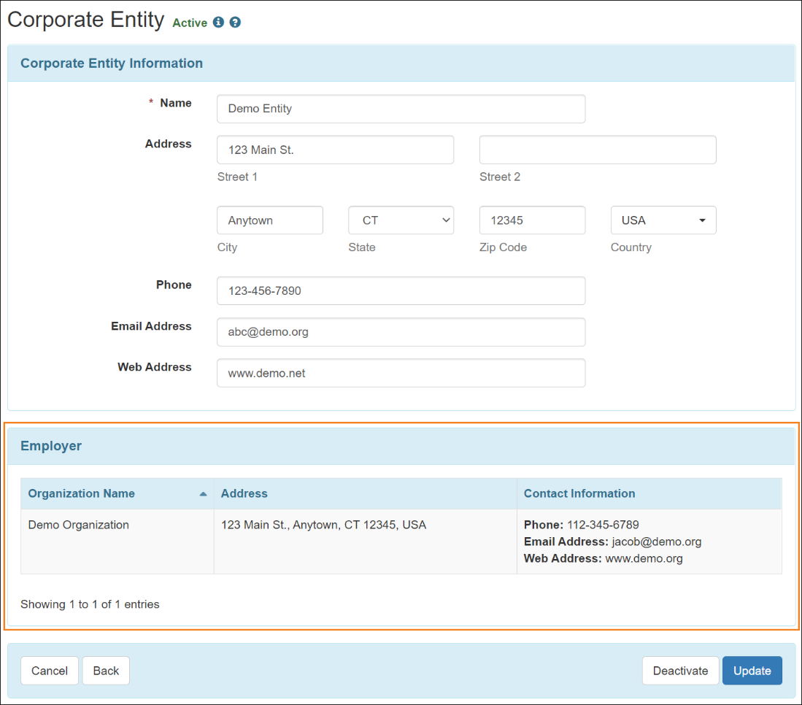

### Contact Person (PROVIDER OPTIONAL FIELD)

1. Click on **New** link next to the Contact Person option under the Agency tab.

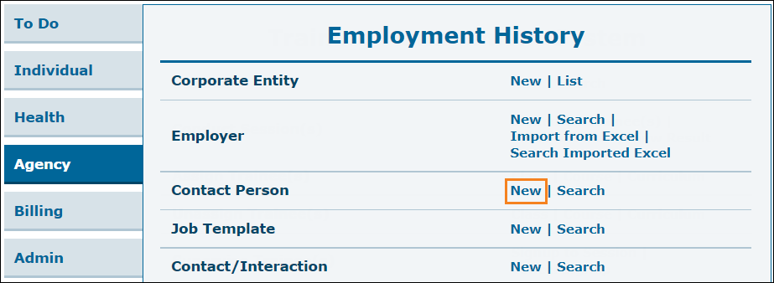

1. You will be directed to the 'Employer Search' page. Select the Employer for whom you want to create the Contact Person.

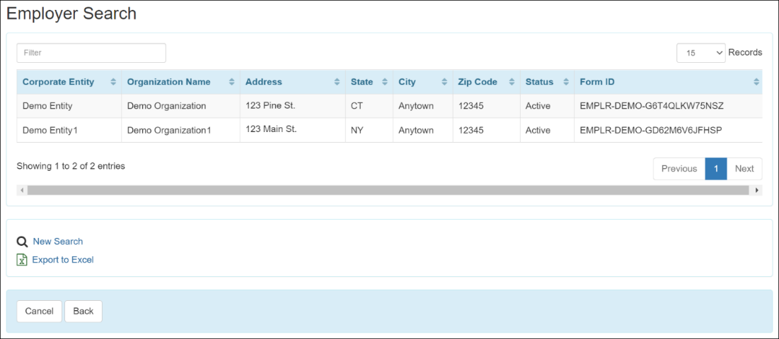

1. On the 'Contact Person' form, fill out the necessary information. The Address will be populated from the Employer form, users will be able to update the address here if needed. Click on the **Save** button to create a Contact Person.

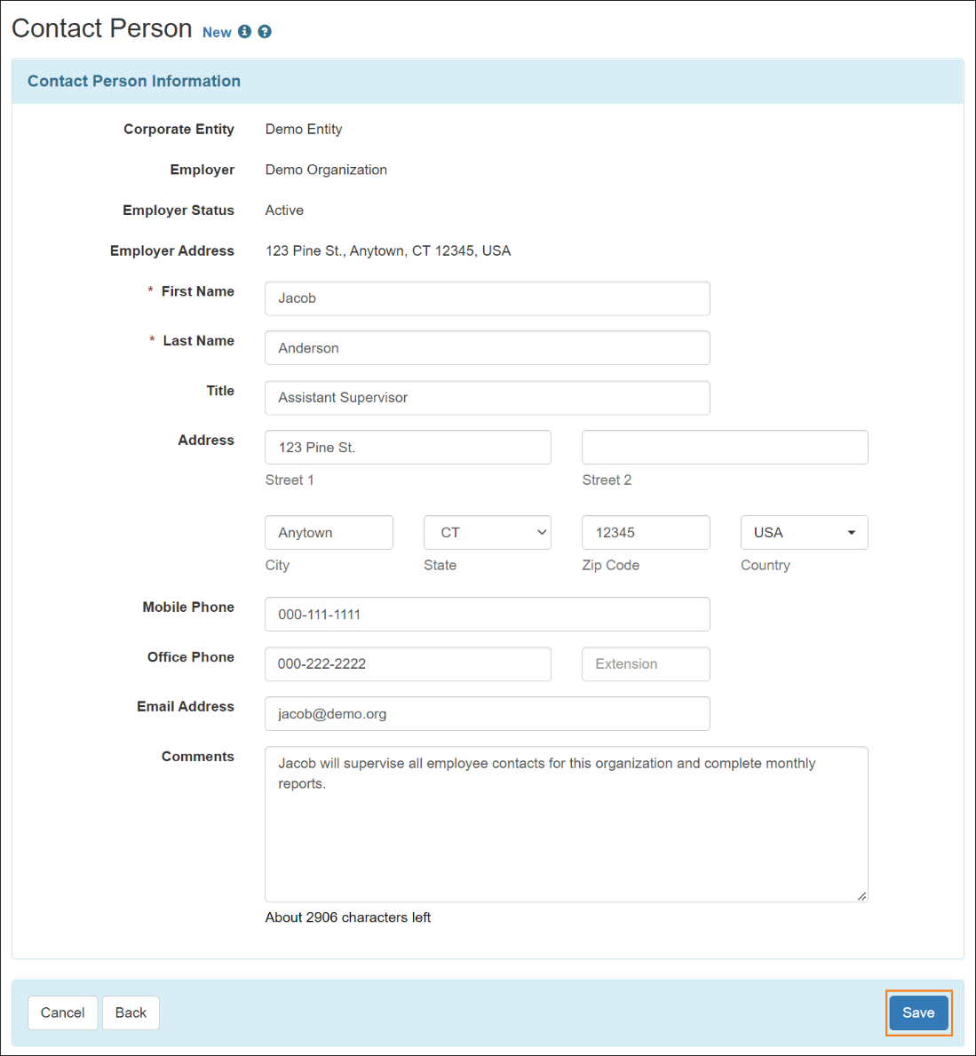

1. A confirmation message will appear if the Contact Person is successfully saved. Users may click on the Back to **Form** link to navigate back to the form or click on the available links listed under the Action section.

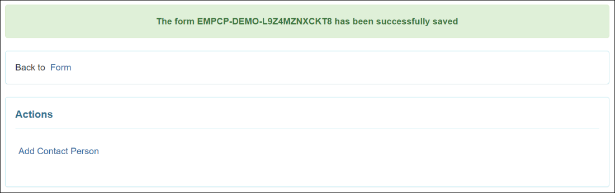

1. Once a Contact Person has been saved, it will be available on the Employer form.

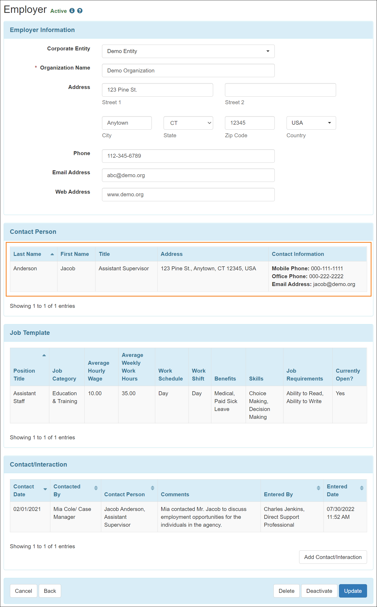

## Job Template (PROVIDER REQUIRED FIELD)

A Job Template affords the provider the ability to develop a generic baseline template for a role under an employer. This template will assist providers with not having to create multiples of the same job in the system when a provider may have more than one person who performs the role for an employer. Job Templates will be assigned to the individual under the Job Details section of the individual’s Employment History. Variances in Wages and Average Hours scheduled between multiple individuals will be modified in the Job Details Section under the individual’s Employment History. Jobs must be created under the Job Template section before they can be assigned to an individual.

1. Click on the **New** link next to the Job Template option under the Agency tab.

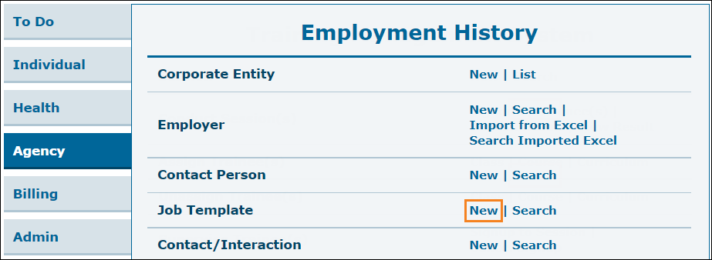

1. You will be directed to the 'Employer Search' page. Select the Employer from the list for whom you want to create the Job Template.



1. On the 'Job Template' form, fill out the Job Template information. Multiple items can be selected from the Benefits, Skills Needed for the Job, and Job Requirements dropdown fields. Click on the **Add File** or the **Scan File** button in the 'Attachment' section to add external documents. Once completed, click on the **Save** button to create a new Job Template.

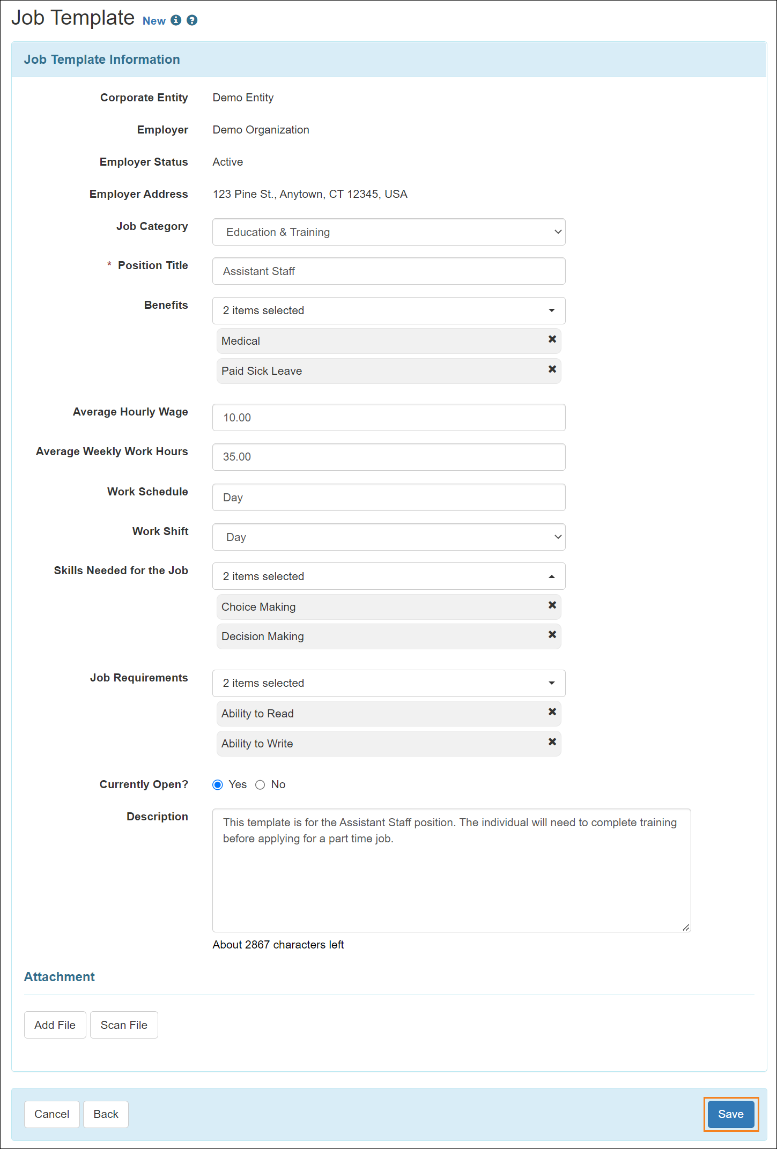

1. Users will receive an error message if the values entered in the following fields do not meet the requirements:
   * Average Hourly Wage must be greater than or equal to 0.00
   * Average Weekly Work Hours must be less than or equal to 168.00

These fields will show the value up to two decimal places. If users enter values which is not in this format, then decimal point and zero(es) will be automatically added to match this format.  
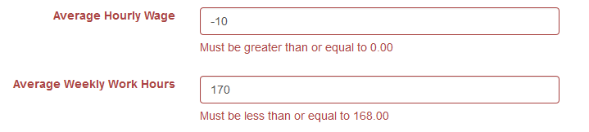

1. While adding an attachment, clicking on the **Add File** button, the 'Add File' window will open. Click on the **Browse** button to select a file from your device, then click on the **Upload** button to upload the form.
2. Once a Job Template has been saved, it will be available on the Employer form.

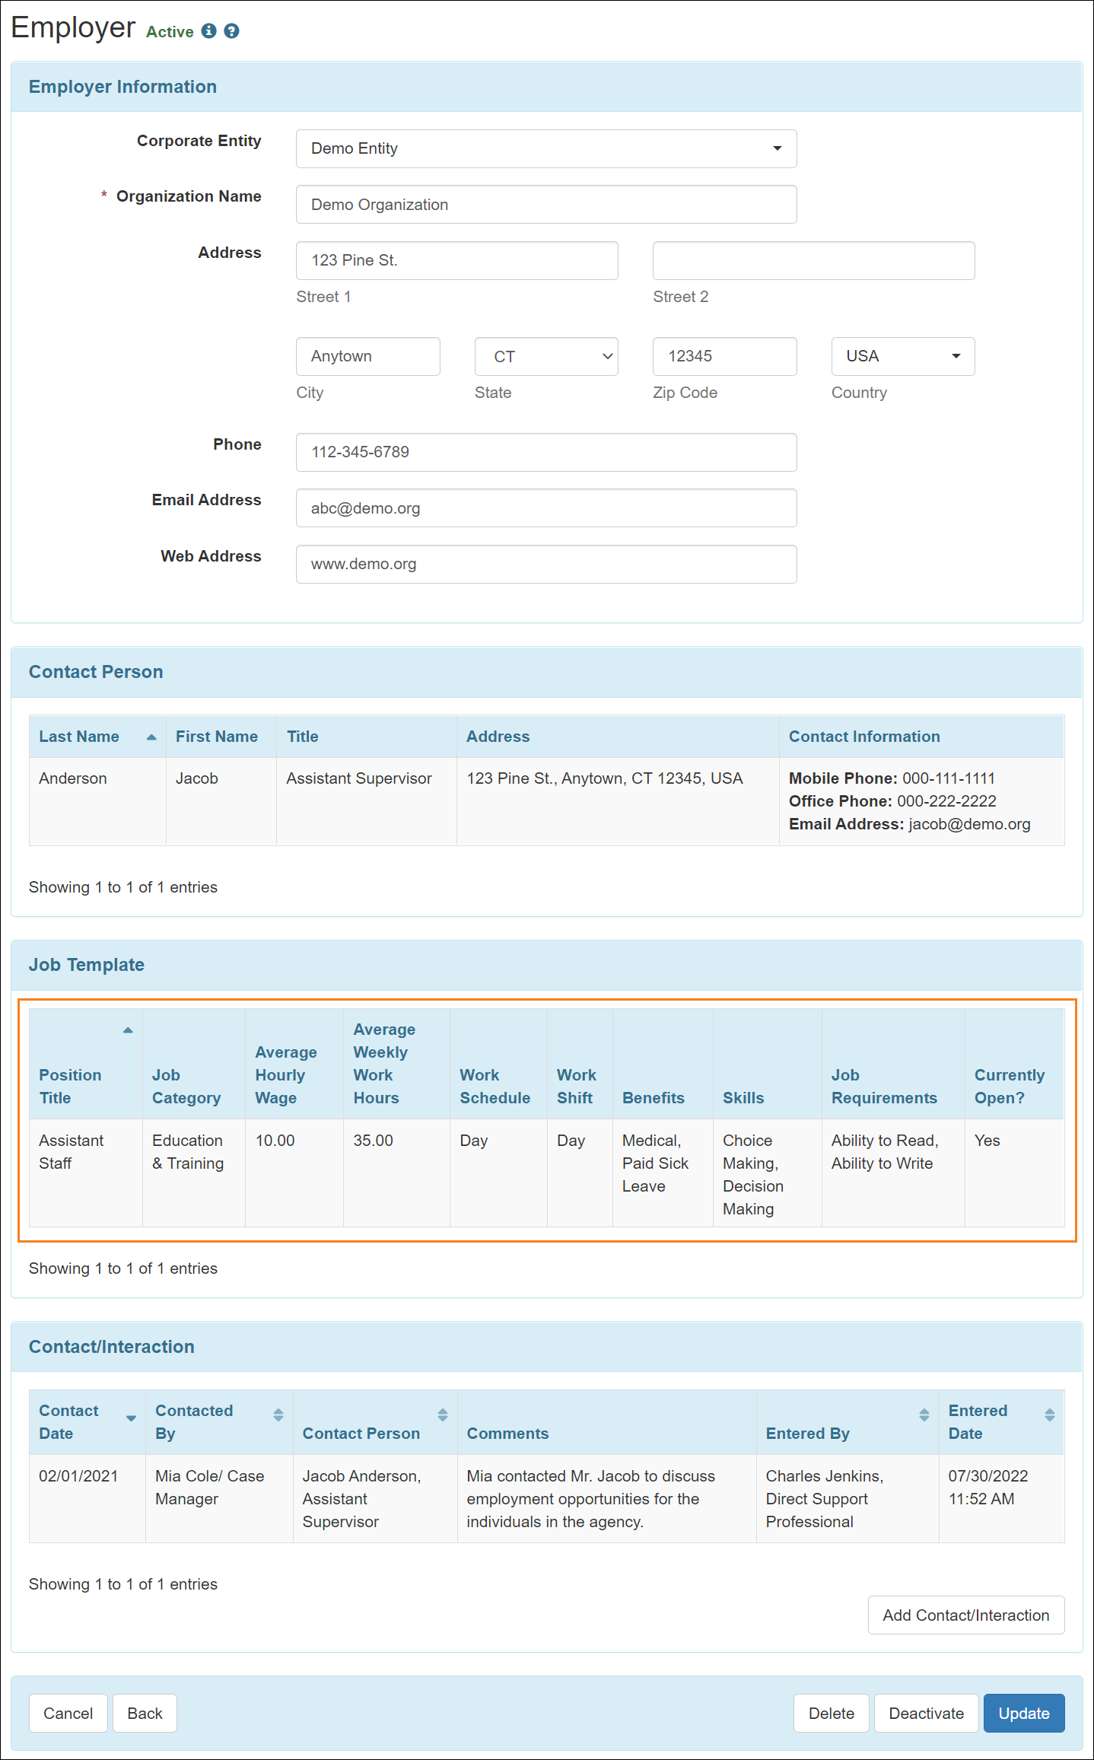

### Import Employer from Excel

In order to upload the information necessary to create Job Templates for several employers at once, providers have the option of using a customized Excel template to add this information. The instructions to download and fill out the Excel template are below.

1. Download the “DDA Employment History Module Import Template” from DDA’s Employment First → Employment and Day Services Resources → Therap: Employment History Module Resources webpage here: [https://www.tn.gov/DDA/for-consumers/employment--first/employment-day-services/employment-day-services-resources.html](https://www.tn.gov/didd/for-consumers/employment--first/employment-day-services/employment-day-services-resources.html).
2. This will let you download a template Excel file that contains columns for the information required to create a new Employer. You may fill out this Excel file and use it to import Employers into the application. This template has been modified to allow for multiple selections under the Benefits and Skills Needed for the Job fields using macros. Select your first option and then go back to the same drop down and select another option as needed, repeating as required. Instructions for activating macros has been provided on the “Macros Activation” tab of the workbook.

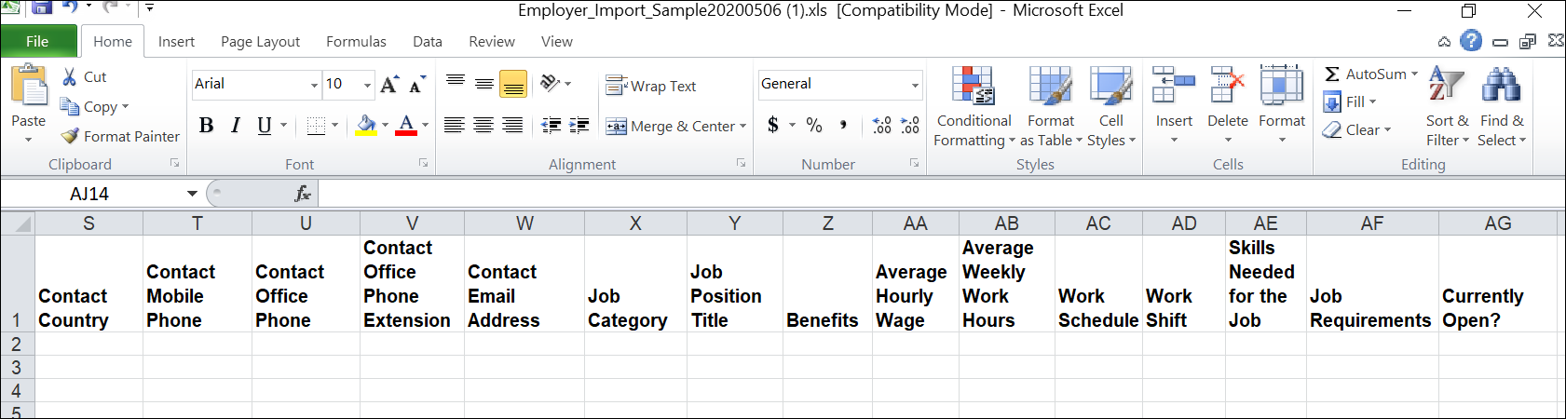

1. Once this template has been filled out. The user will need to “Save As” the file as an Excel Workbook (.xlsx). Once saved the file is prepared for Import. Note: Please verify the information prior to uploading. Once uploaded, the information cannot be removed from the system.
2. Click on the **Import from Excel** link beside the Employer option on the Agency tab.

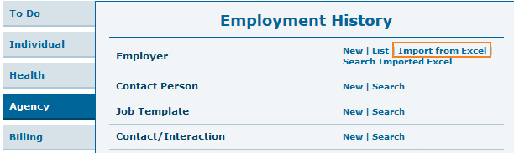

1. Click on the **Choose File** button once you have prepared the Excel file from which you will be importing the employers. Find and select the Excel file from your device.

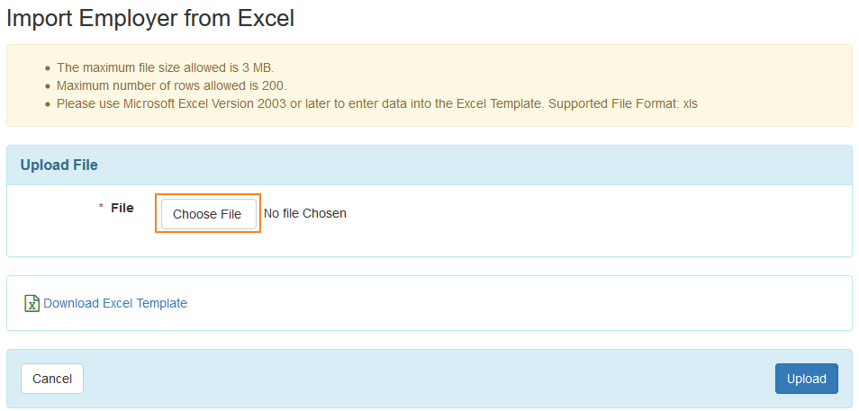

1. Once you have chosen the Excel file, click on the **Upload** button.

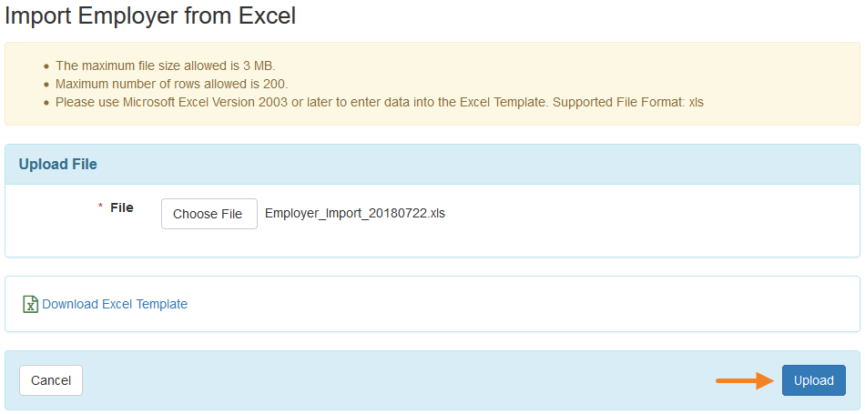

1. If the Excel file contains errors, the errors will be listed with row number and column name under the 'Error(s)' section on the 'Import Employer from Excel' page.

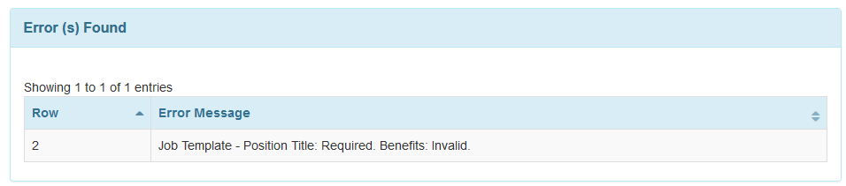

1. A confirmation message will be displayed if the file is uploaded successfully, along with a Tracking ID which can be used to search for the Excel file later. The message will also display the number of Employers that have been successfully created, and the number of rows that contain errors. For more information on these errors, click on the **Detail Report** link. Click on the **New Upload** link to upload another Excel file.

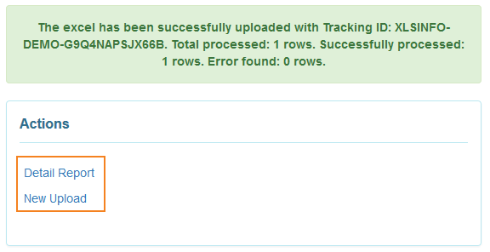

1. Clicking on the **Detail Report** option will let you download an updated version of the Excel file you had uploaded. Within the file's last column titled Result Message, details regarding the source of the errors will be displayed. If an Employer was successfully imported, a 'Successfully saved' message will be displayed with the Form ID of the Employer, Contact Person, and Job Template.

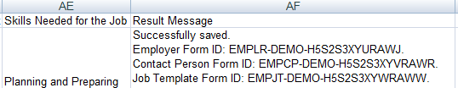

### Search Imported Excel

1. Click on the **Search Imported Excel** link beside the Employer option on the Agency tab.

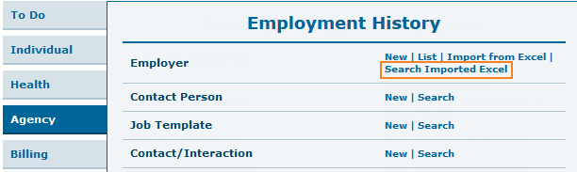

1. In the 'Excel Upload Info Search' page, enter search parameters and click on the **Search** button.

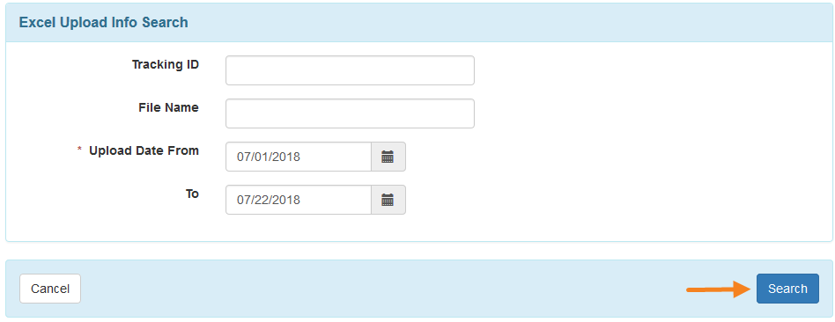

1. In the 'Excel Upload Info Search' results page, import information regarding the Excel file(s) you were searching for will be displayed, including total row, error count, and success count. Click on the Tracking ID of an Excel file to download the file.

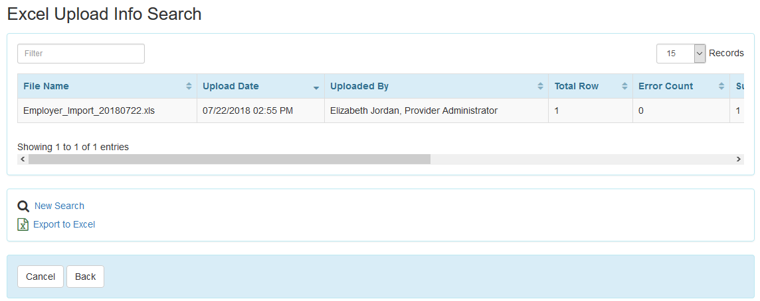

### Contact/Interaction (PROVIDER OPTIONAL FIELD)

1. Click on the **New** link in the Contact/Interaction row on the Agency tab.

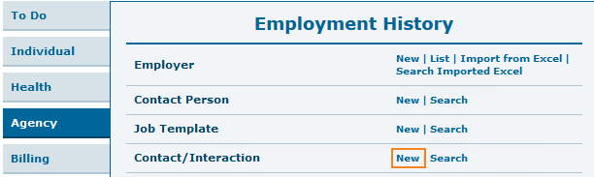

1. The Employer List page will show the list of existing Employers with at least one active Contact Person. Click on the Organization Name for whom you want to add Contact/Interaction information.

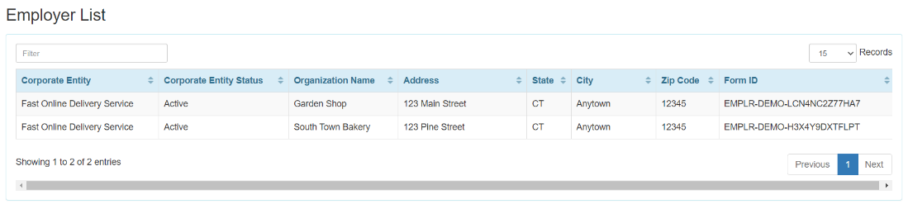

1. Fill out the 'Contact/Interaction' form and click on the **Save** button.

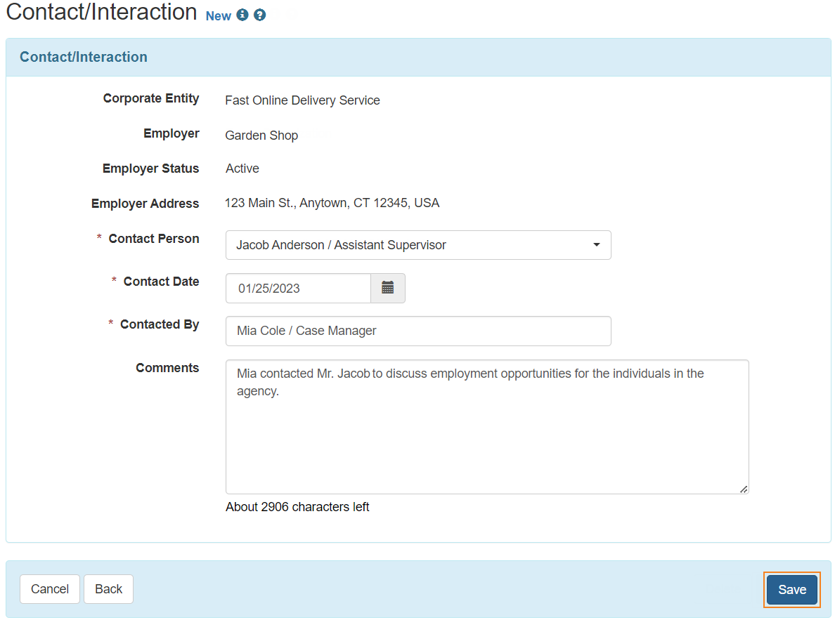

1. A confirmation message will be displayed if the Contact/Interaction has been successfully saved.

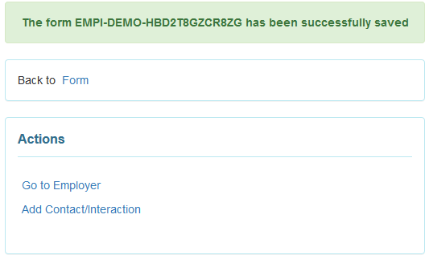

1. Once a Contact/Interaction has been saved, it will be added under the 'Contact/Interaction' section of the Employer form. Users will be able to add Contact/Interactions directly from the Employer form by clicking on the **Add Contact/Interaction** button.

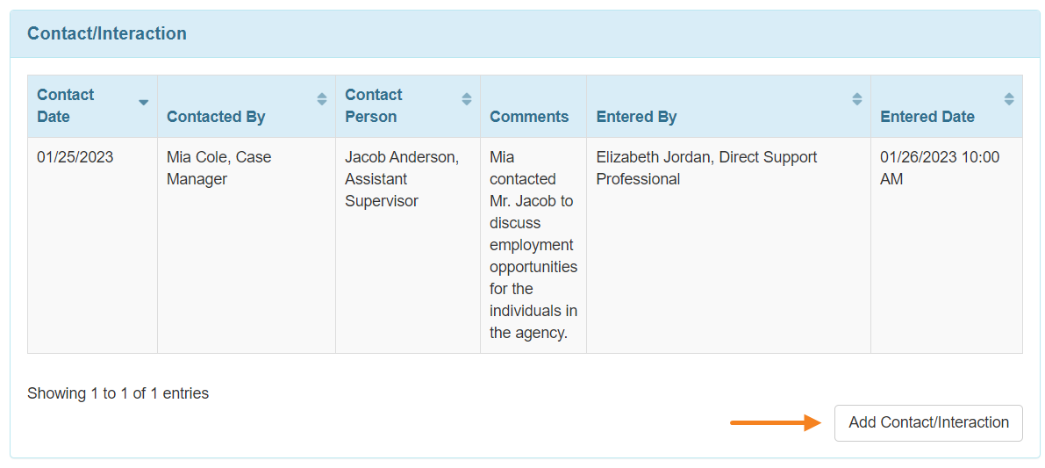

1. Once a Contact/Interaction has been saved, it will also be added under the 'Contact/Interaction' section of the Contact Person form.

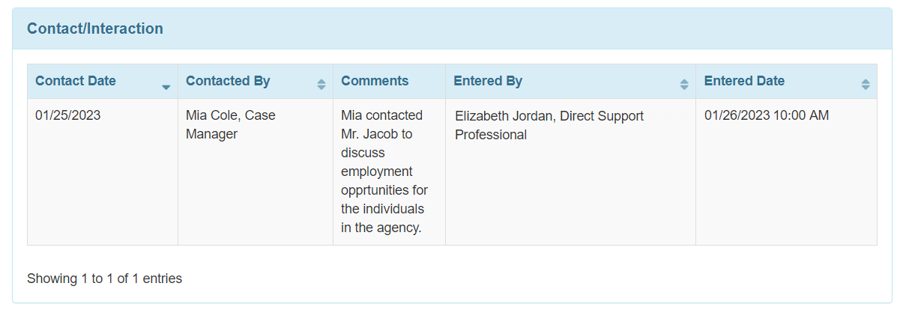

**When each section is complete, you are now ready to attach an individual to available jobs.**

## Employment History for Individuals

**The sections listed below are required by DDA for every individual who is employed:**

* Funding source
* Job Detail
* Benefits Counseling (only required for individuals who have received or are receiving Benefits Counseling)

**The section listed below are required by DDA for every individual who is unemployed:**

* Variance

1. Click on the **Show** link beside the Employment History option of the Individual tab.

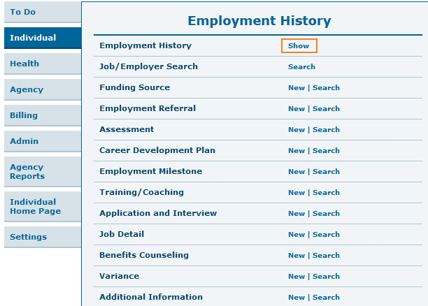

1. Select the individual from the 'Individual List' page.

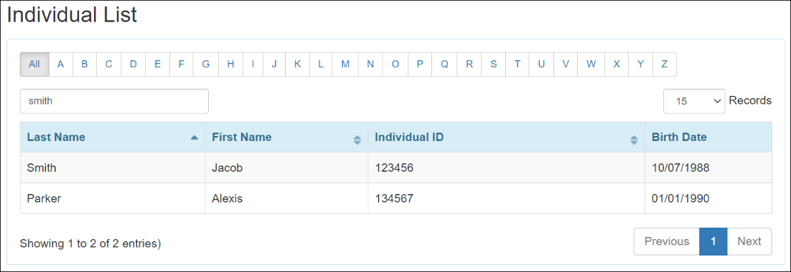

1. You will be taken to the 'Employment History Report Criteria' page, where you will be able to select the sections which you want to see on the report. The sections selected from the 'Employment History Preference' page on the Admin tab will be available to be selected on this page. All the sections will be selected by default, and you will be able to select or deselect all items by clicking on the **Select All** / **Deselect All** link. Click on the **Generate** button to generate the report.
2. 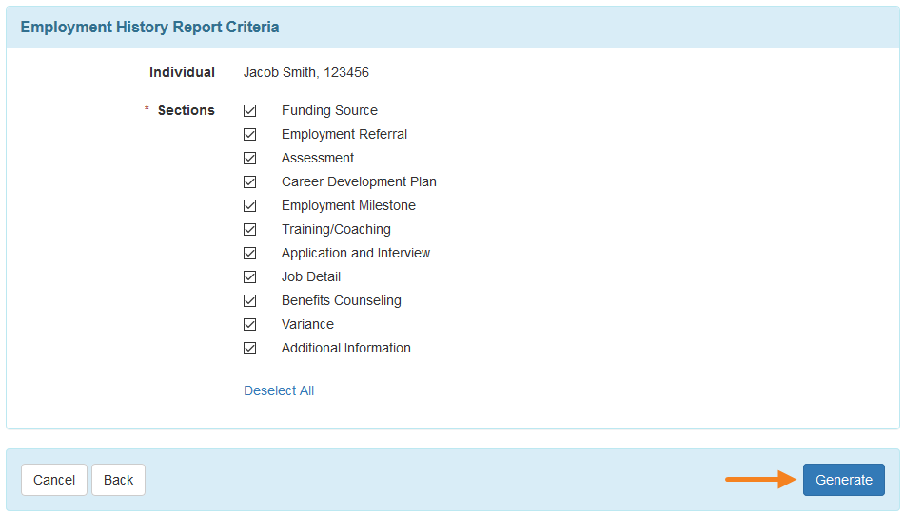
3. You will be taken to the Employment History page. Clicking on the individual's name in the Individual field will open the Individual Data form in a pop-up window. Clicking on the rows under each section will open the respective forms. Clicking on the Attachment links will allow the users to view or download that attachment. You can enter data by clicking on the 'Add' buttons in each section.

Users can directly go to other sections of the page by clicking on the **Jump To** button instead of scrolling down the page. You can generate a PDF version of the form by clicking on the **Display PDF** link at the bottom of the form.

## Job/Employer Search

1. Click on the **Search** link beside the Job/Employer Search option on the Individual tab.

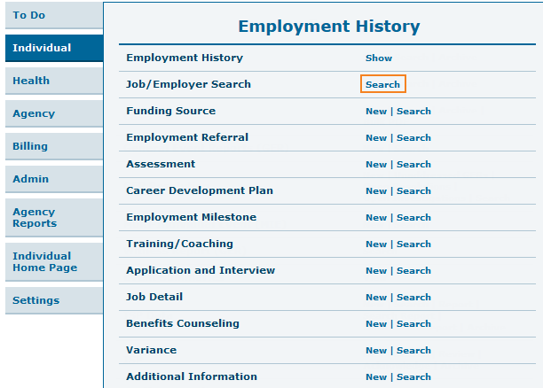

1. On the 'Job/Employer Search' page, fill out the search parameters and click on the **Search** button.

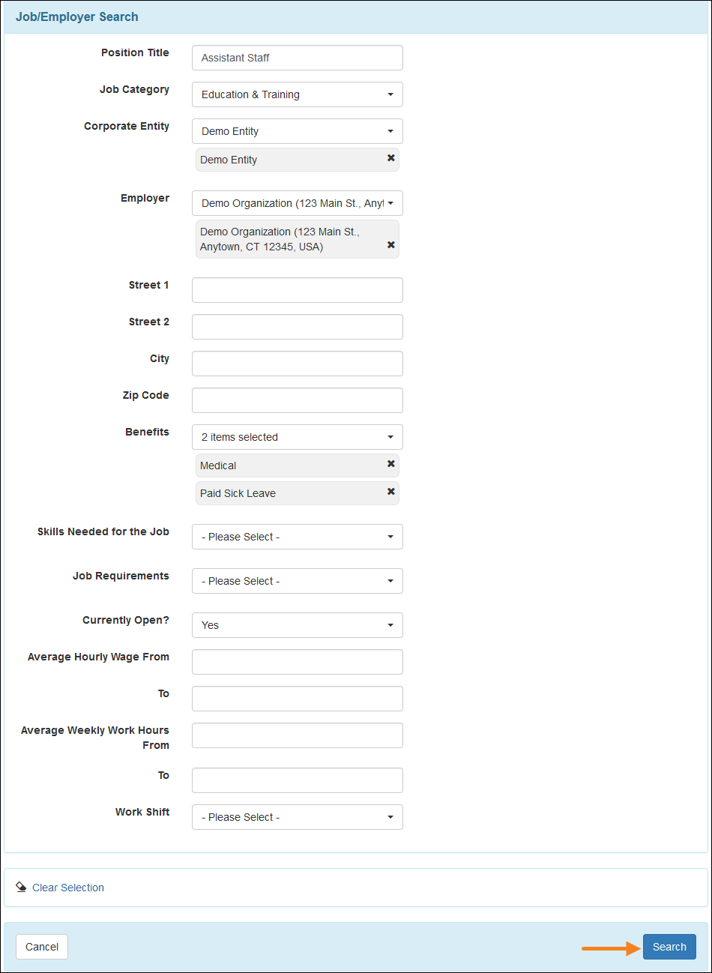

1. It will take you to the search result page. You may click on the search result to open the Job/Employer. You will be able to export the search result to an Excel file by clicking on the **Export to Excel** link. Click on the **New Search** link to perform another search.

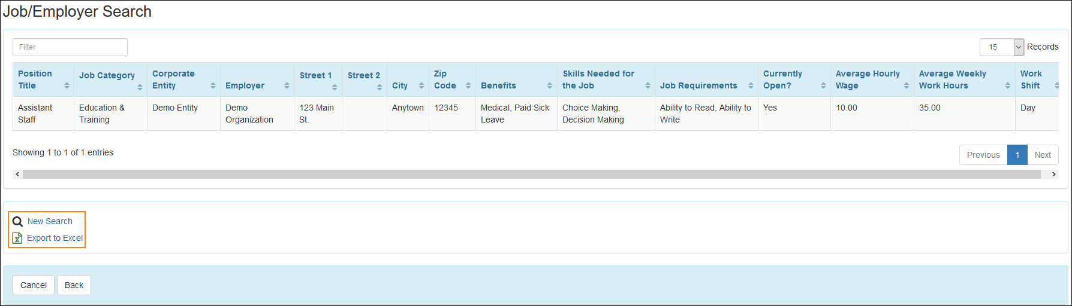

Clicking on an item from the search results will direct you to the Individual List page. You will be able to create Job Detail forms by selecting an individual.

## Funding Source (PROVIDER REQUIRED FIELD)

1. Click on the **New** link beside the Funding Source option of the Individual tab.

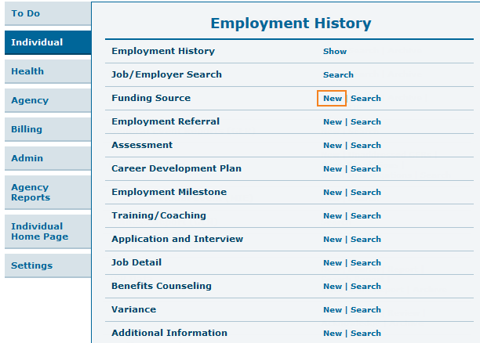

1. Select an individual from the Individual List page.

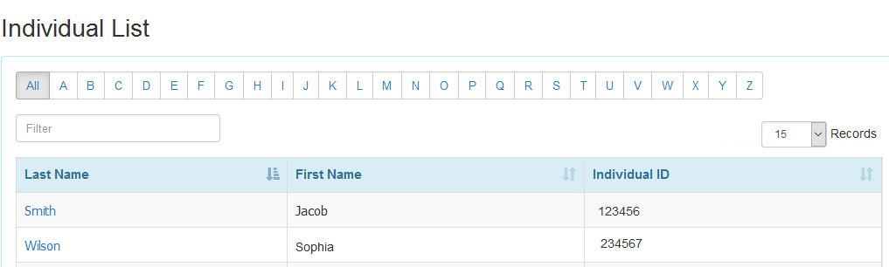

1. Now you will be taken to the Funding Source page where you will need to fill out required information. Click on the **Add File** or **Scan File** buttons in the 'Attachment' section to add external files to the form. Click on the **Save** button to save the Funding Source.

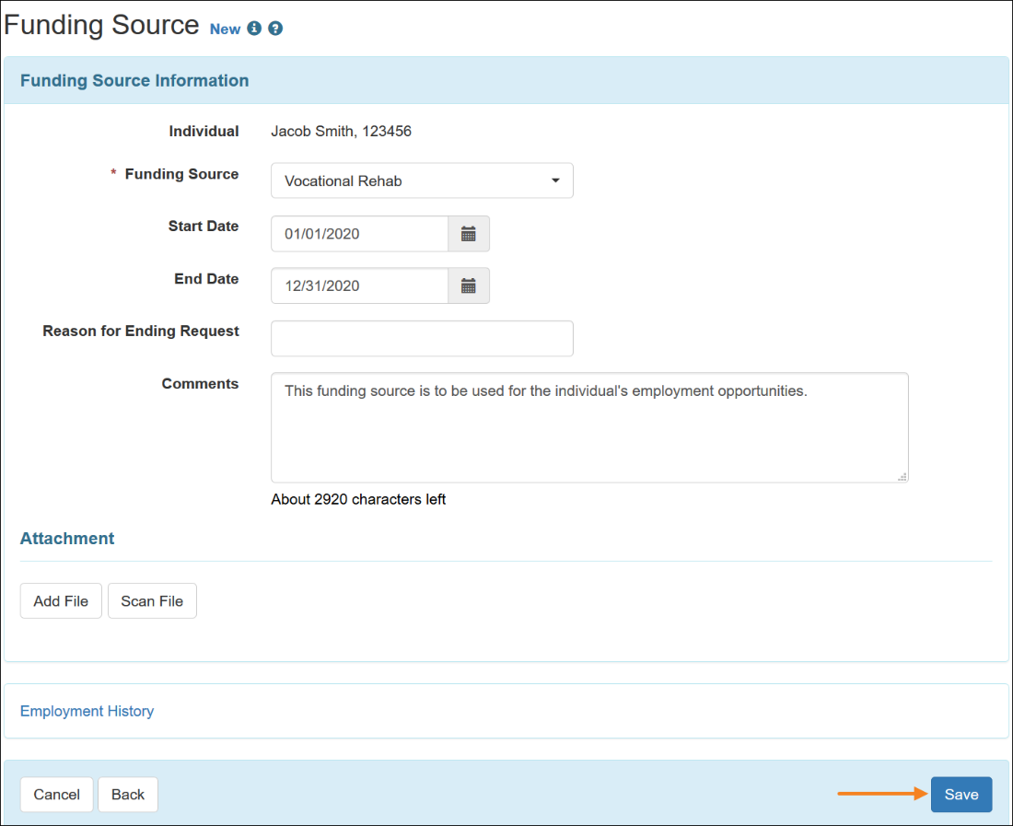

1. The following confirmation message will appear after saving the Funding Source.

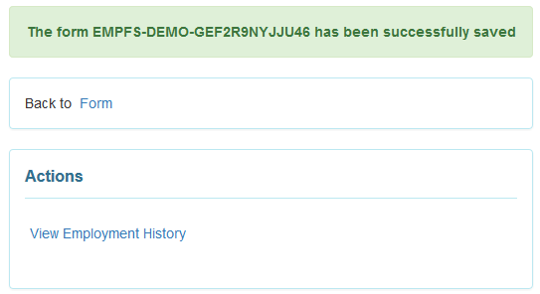

## Career Development Plan (PROVIDER OPTIONAL FIELD)

Users assigned with the ***Employment Submit*** role will be able to save Career Development Plan forms.

1. Click on the **New** link beside the Career Development Plan option of the Individual tab.

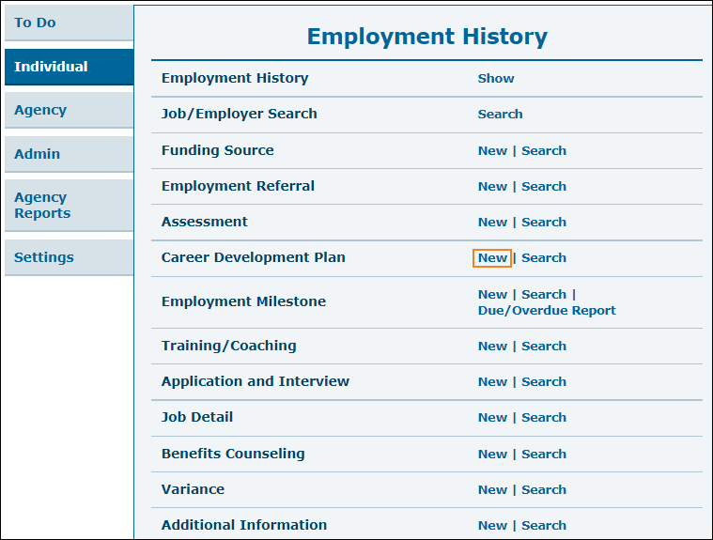

1. Select an individual from the Individual List page.

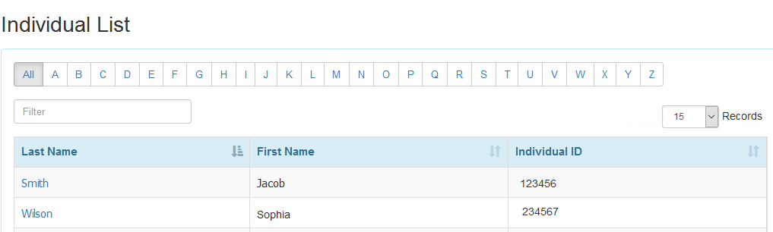

1. You will then be taken to the Career Development Plan page where you will need to fill out career development plan information. Click on the **Add File** or **Scan File** buttons in the 'Attachment' section to add external files to the form. Click on the **Save** button to save the Career Development Plan.

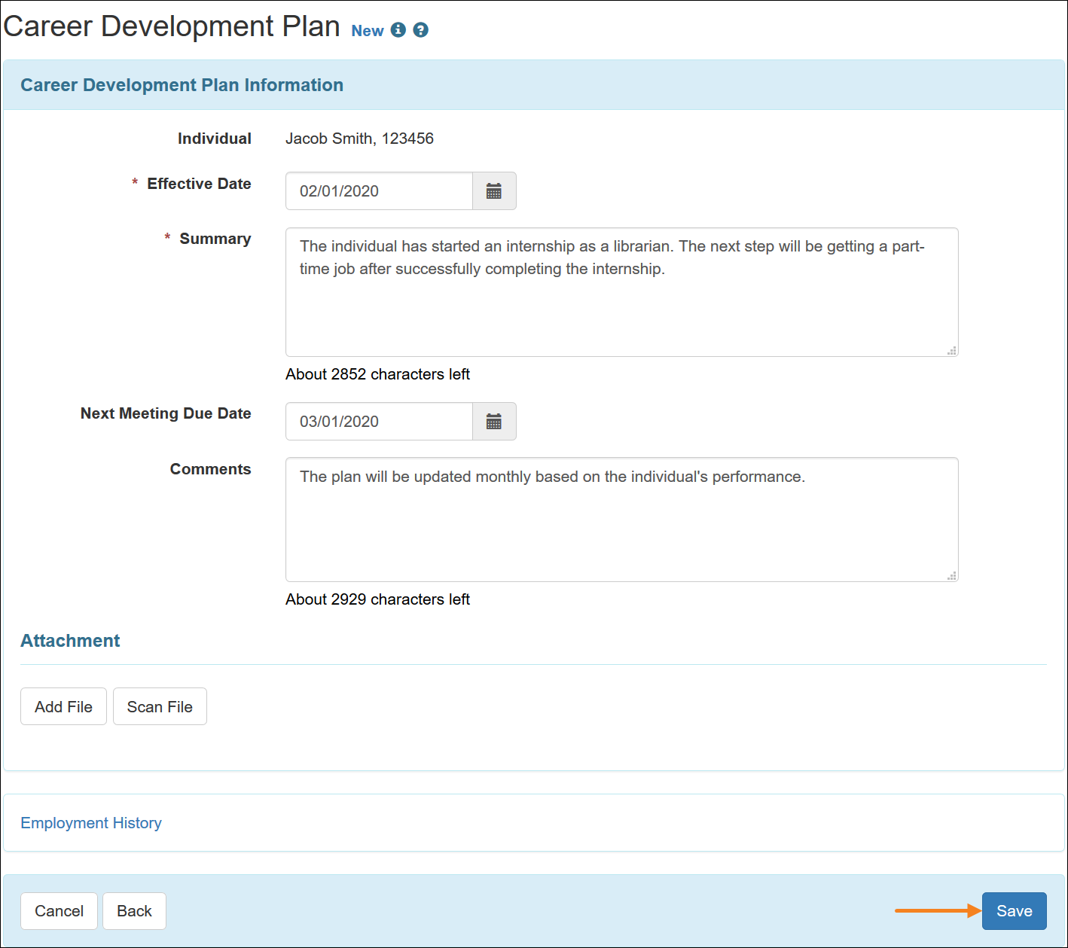

1. The following success message will appear if the Career Development Plan has been successfully saved.

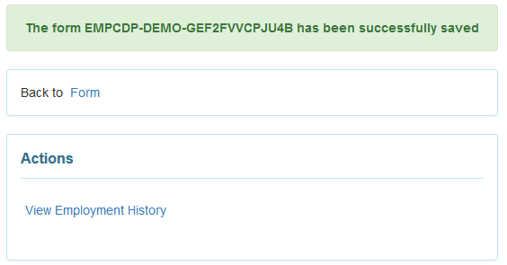

### Search, Update, and Delete Career Development Plan

Users assigned with the **Employment Submit** or **Employment View** will be able to search for and view approved Career Development Plan forms. Users will require the **Employment Update** role to be able to update Career Development Plan forms and will require the **Employment Delete** role to be able to delete approved forms, and view approved and deleted forms.

1. Click on the **Search** link beside the Career Development Plan option of the Individual tab.

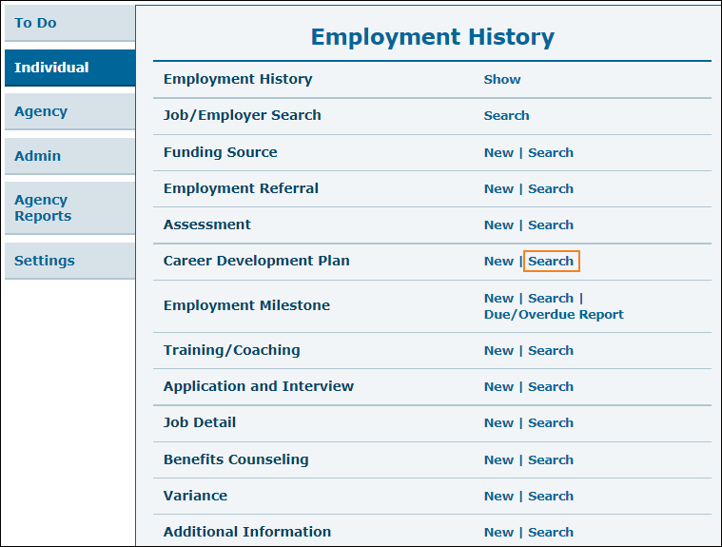

1. You will be taken to the 'Career Development Plan Search' page. Fill in your search parameters then click on the  **Search** button.

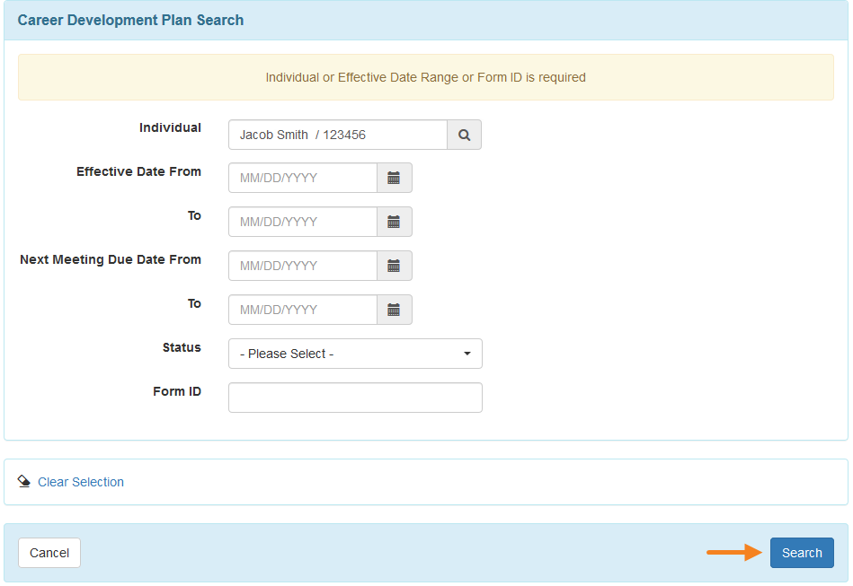

1. Click on the individual name in order to view the career development plan information for that individual. Clicking on the **New Search** link will take you back to the previous page to search for a different career development plan. You may click on the **Export to Excel** link to export the search results to Excel.

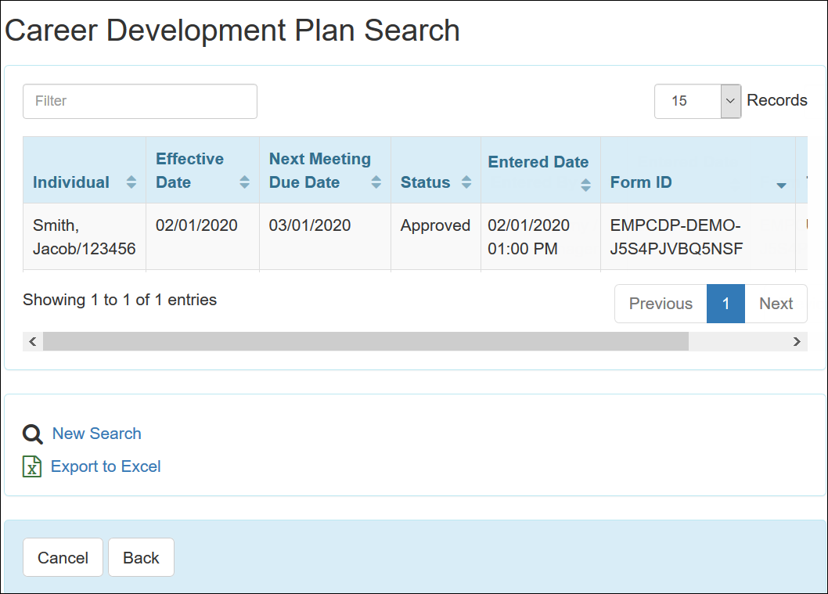

1. Once you select the individual, you will be directed to the Career Development Plan page. On this page, you can edit the career development plan information for the individual. When you are done, click on the **Update** button available at the bottom of the page. To delete a Career Development Plan form, click on the **Delete** button.

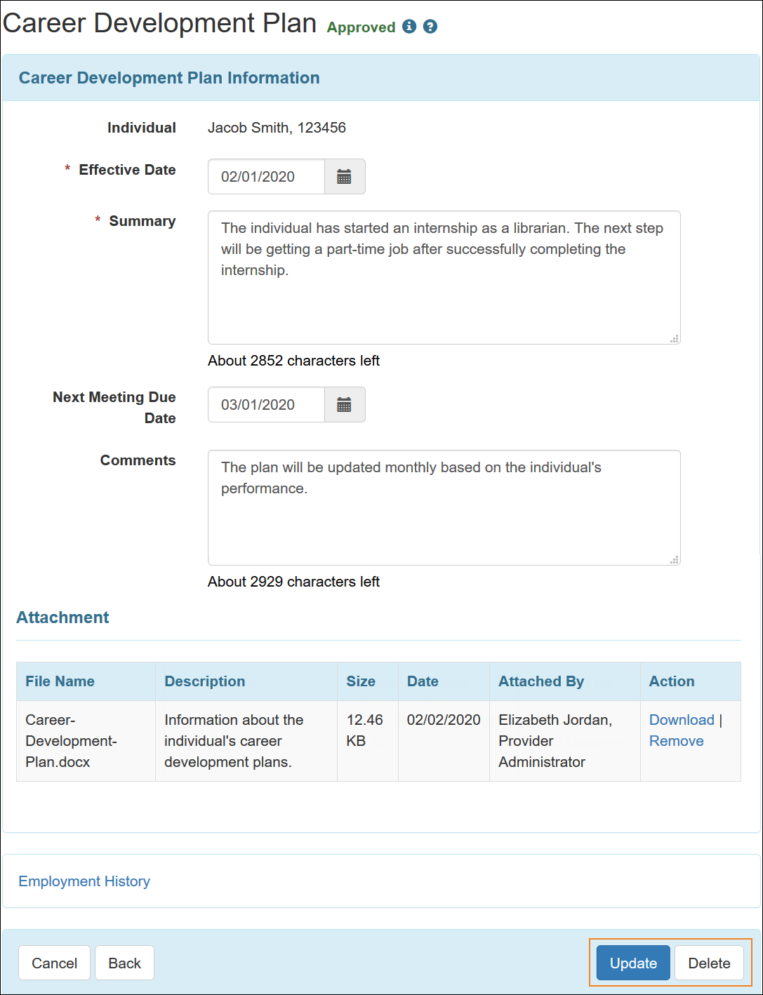

## Training/Coaching (PROVIDER OPTIONAL FIELD)

Users assigned with the ***Employment Submit*** role will be able to save Training/Coaching forms.

1. Click on the **New** link beside the Training/Coaching option of the Individual tab.

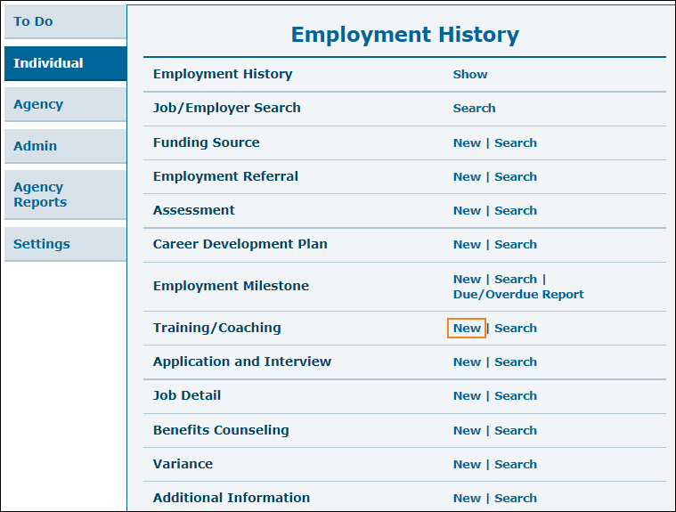

1. Click on the individual name in Individual List page.



1. You will be taken to the Training/Coaching page where you will need to fill out Training/Coaching information. Multiple items can be selected from the Skill Developed dropdown field. Click on the **Link ISP Report** button to link an ISP Report to this Training/Coaching form.

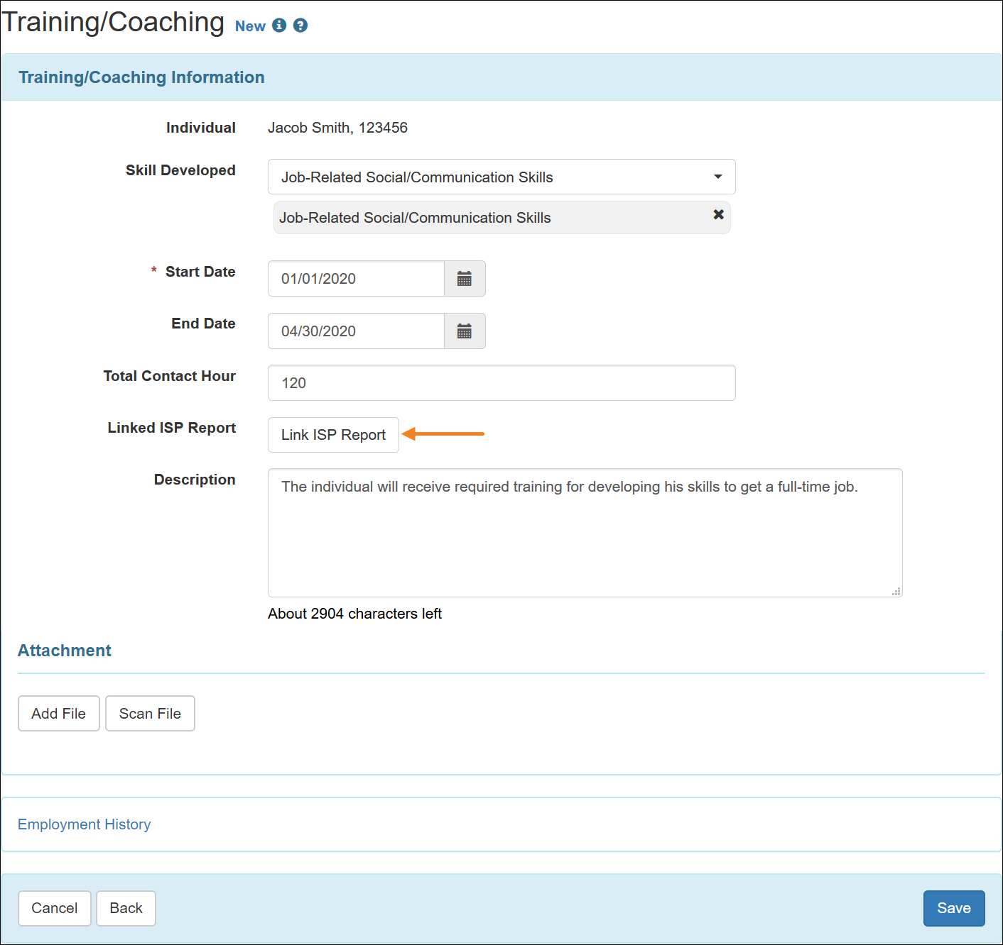

1. The Total Contact Hour field will show the value up to two decimal places. If users enter values which is not in this format, then decimal point and zero(es) will be automatically added to match this format. Users will receive an error message if the value entered in the Total Contact Hour field is not greater than or equal to 0.00.

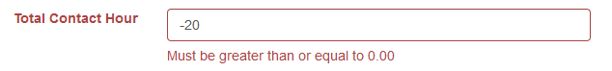

1. Clicking on the **Link ISP Report** button will open the 'ISP Report Search' popup window, from where users will be able to search for Saved ISP Reports of this individual. Users will need to be assigned with either the ***ISP Report*** role or the ***ISP Report View*** role to be able to search for ISP Reports. Click on the **Search** button after selecting the parameters.

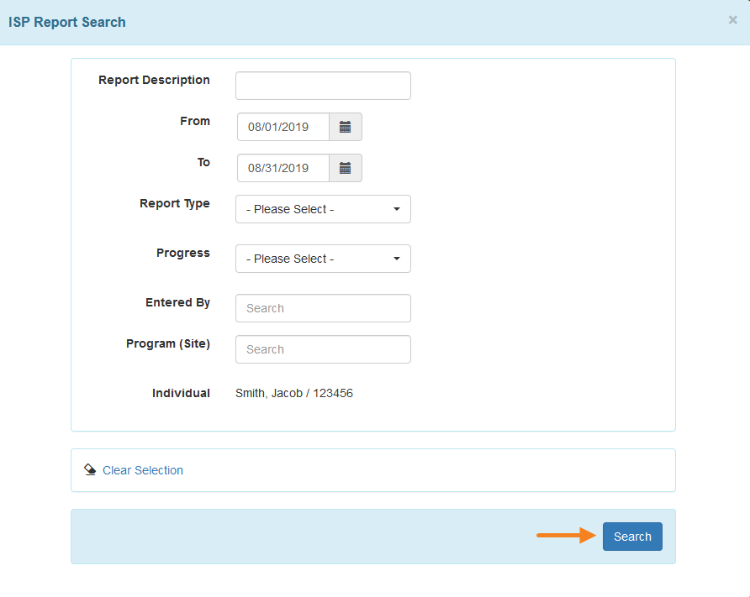

1. Users will be able to select the ISP Report from the search results page by clicking on the **Add** button.

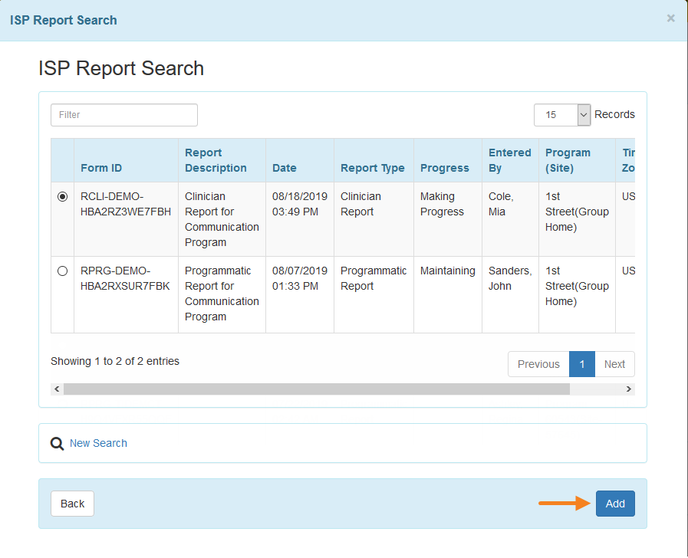

1. The ISP Report will be added to the Training/Coaching form. Users with either the ***ISP Report*** role or the ***ISP Report View*** role will be able to open the report in a popup window by clicking on the report link. Users will also be able to remove the linked report from the Training/Coaching form by clicking on the **Remove ISP Report Link** button. Click on the **Add File** or **Scan File** buttons in the ‘Attachment’ section to add external files to the form. Click on the **Save** button to create Training/Coaching. Click on the **Save** button to save the Training/Coaching form.

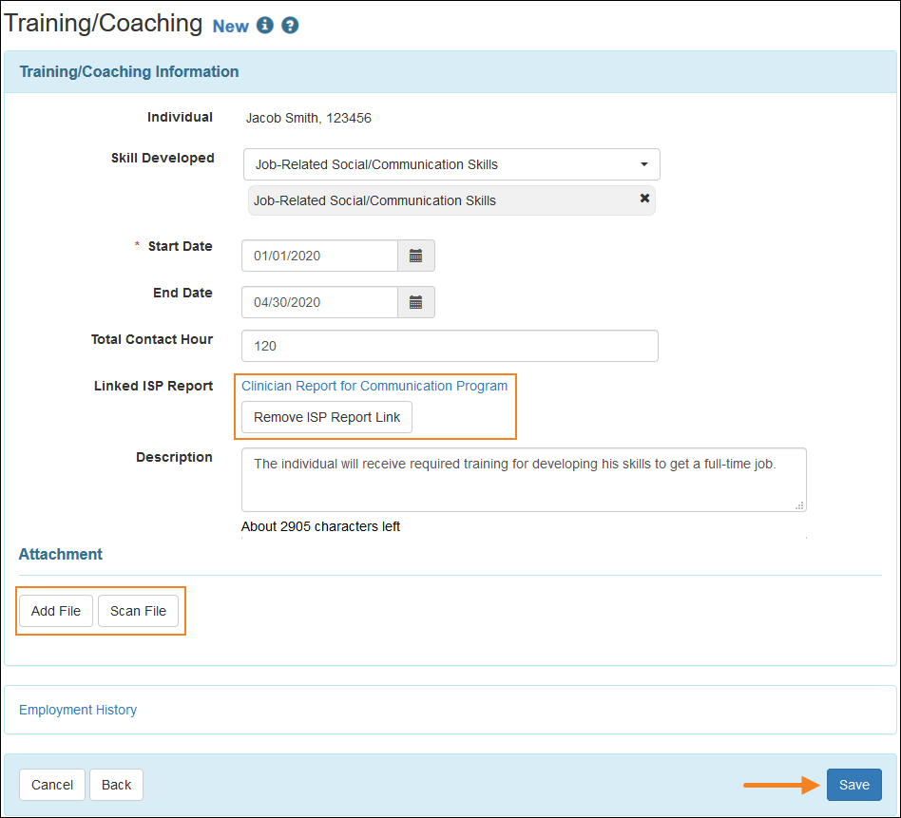

1. A confirmation message will appear once the form is successfully saved.

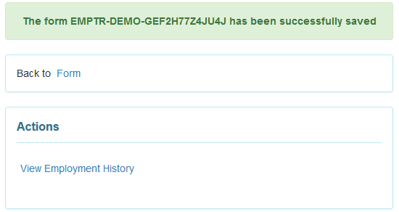

## Job Detail (PROVIDER REQUIRED FIELD)

Users assigned with the ***Employment Submit*** caseload-based role can save Job Detail forms.

1. Click on the **New** link beside the Job Detail option on the Individual tab.

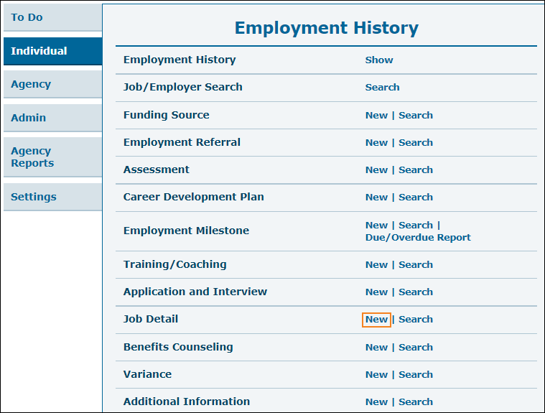

1. Select the individual from the Individual List page.



1. Select the Employer from the Employer List page.

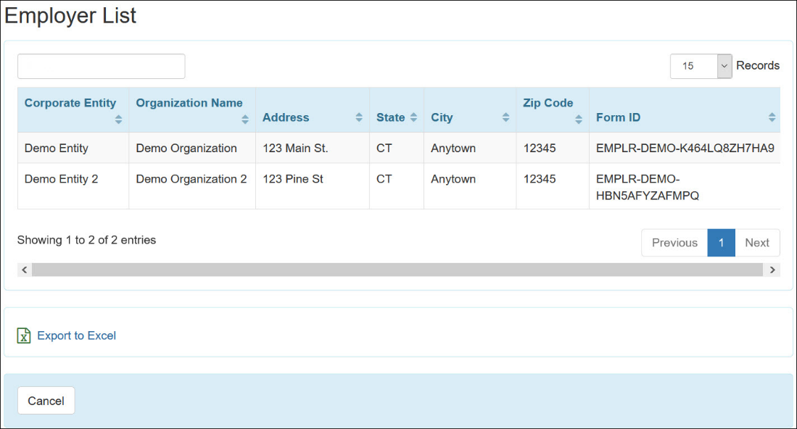

1. Select the Job Template from the Job Template List page.

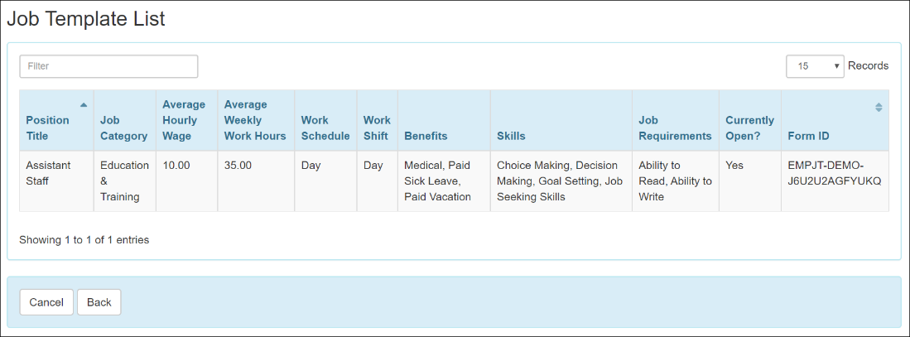

1. On the Job Detail page, fill out the required information. Multiple items can be selected from the Benefits dropdown field. Click on the **Add File** or **Scan File** buttons in the 'Attachment' section to add external files to the form. Click on the **Save** button to create the Job Detail for the individual.

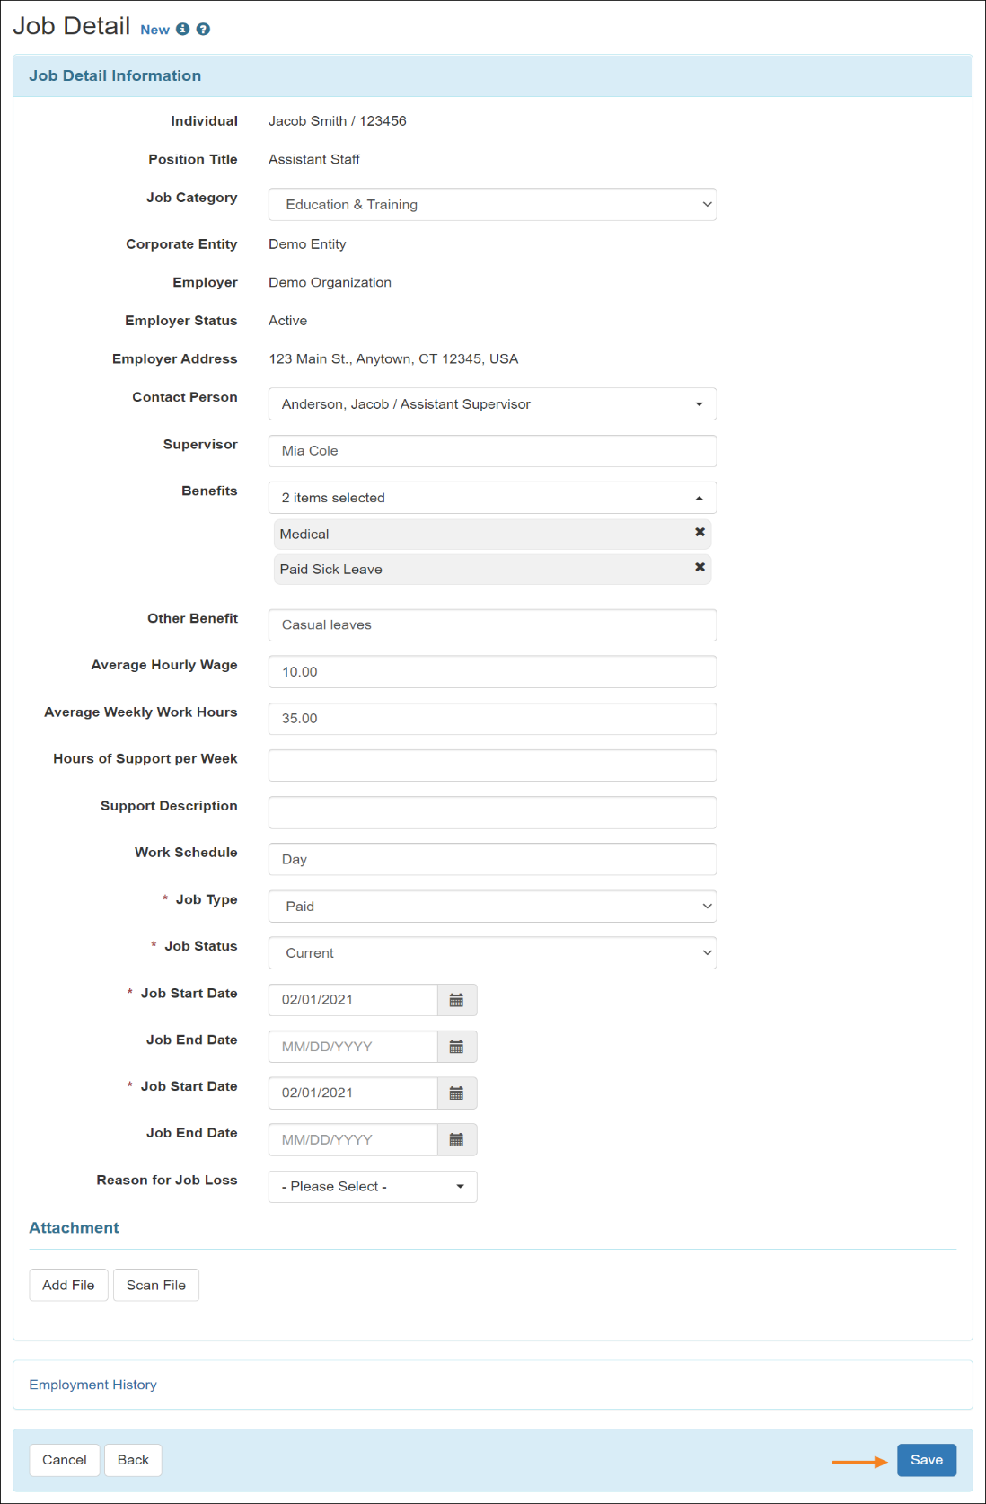

Users will receive an error message if the values entered in the following fields do not meet the requirements:

* + Average Hourly Wage must be greater than or equal to 0.00
  + Average Weekly Work Hours must be less than or equal to 168.00
  + Hours of Support per Week must be less than or equal to 168.00

1. These fields will show the value up to two decimal places. If users enter a value which is not in this format, then decimal point and zero(es) will be automatically added to match this format.

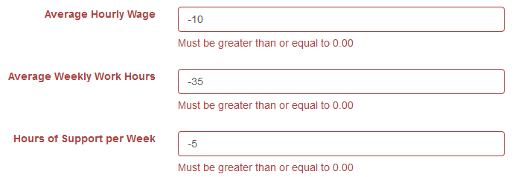

1. A confirmation message will appear once the form is successfully saved.

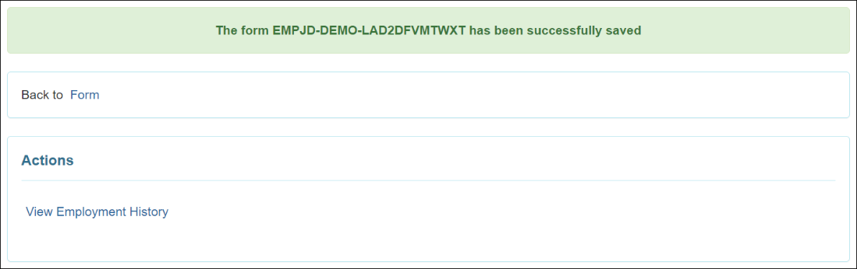

1. The Job Outcome Data List section will be populated once the Job Detail is saved. Click on the date to view the Job Outcome Data or click on the **Add Job Outcome Data** button to add new Job Outcome Data.

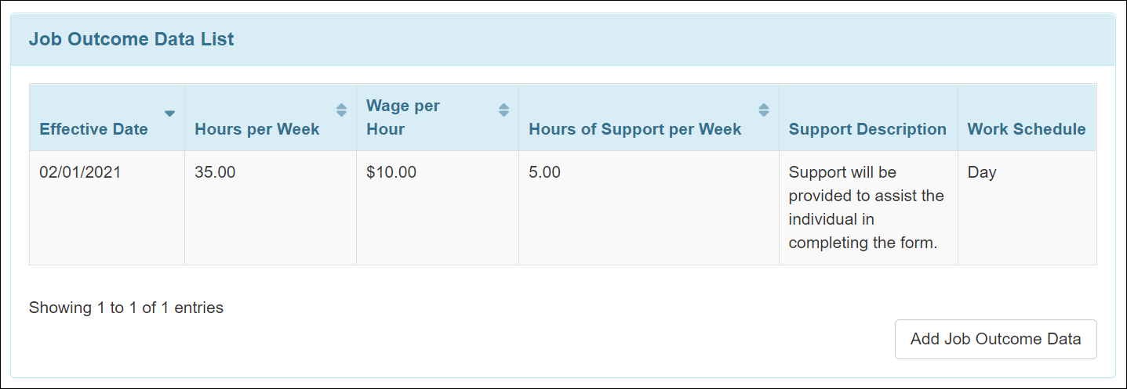

1. On the Job Outcome Data page, edit the information if necessary and click on the **Continue** button.

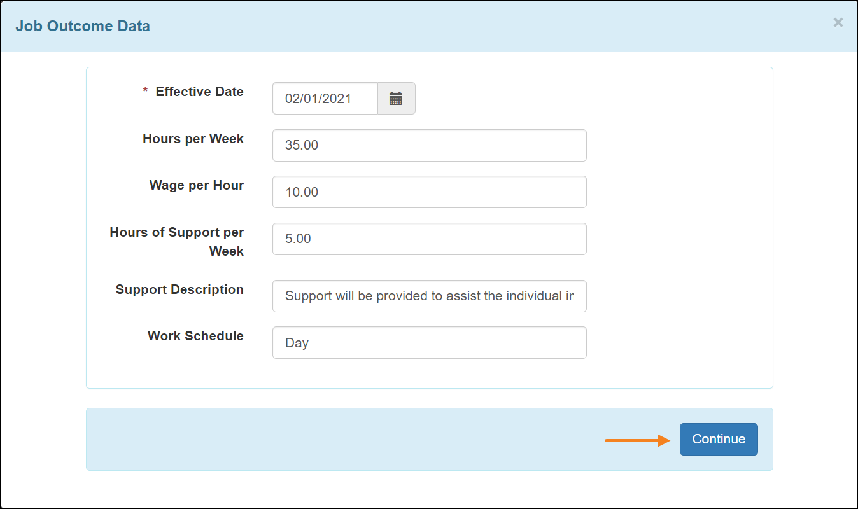

1. Users will receive an error message if the values entered in the following fields do not meet the requirements:
   * Hours per Week must be less than or equal to 168.00
   * Wage per Hour must be greater than or equal to 0.00
   * Hours of Support per Week must be less than or equal to 168.00
2. These fields will show the value up to two decimal places. If users enter a value which is not in this format, then decimal point and zero(es) will be automatically added to match this format.

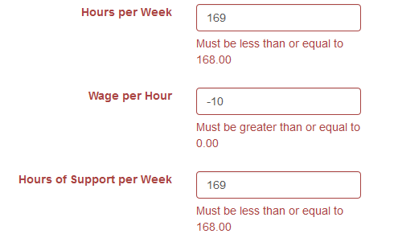

1. Once a Job Outcome Data is added or updated on the Job Detail form, click on the **Update** button on the Job Detail form to save the Job Outcome Data information.



### Search, Update, and Delete Job Detail

Users assigned with the ***Employment Submit*** or the ***Employment View*** caseload-based role can search for and view approved Job Detail forms. Users assigned with the ***Employment Update*** caseload-based role can update Job Detail forms. Users assigned with the ***Employment Delete*** caseload-based role can delete approved forms, and view approved and deleted forms.

1. Click on the **Search** link beside the Job Detail option of the Individual tab.

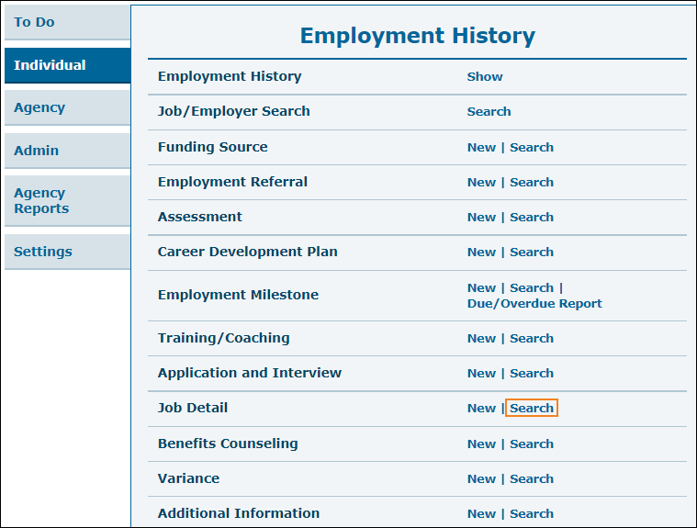

1. You will be taken to the Job Detail Search page. Fill in your search parameters then click on the **Search** button.

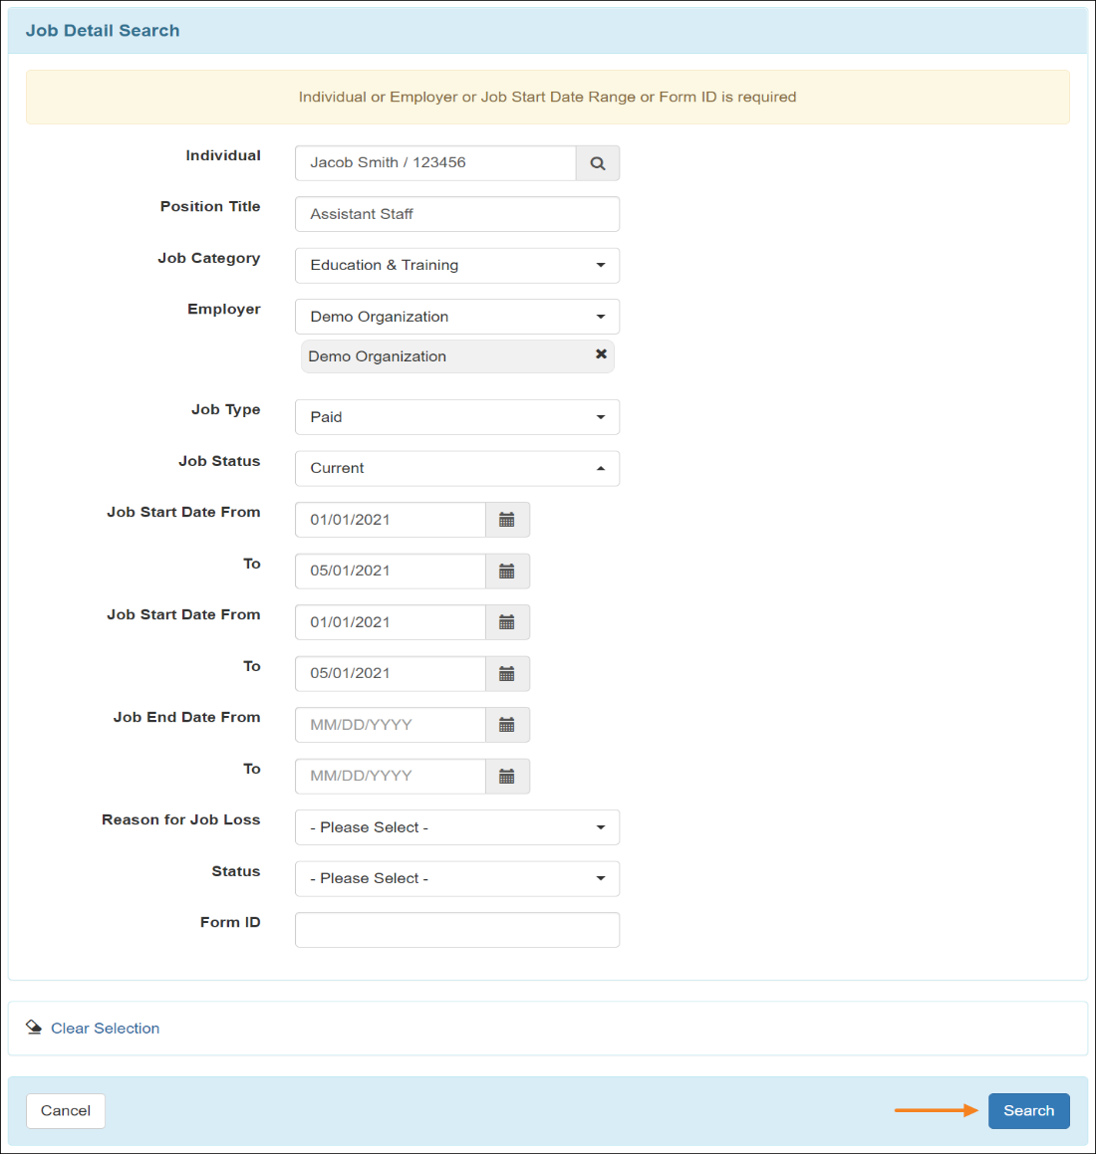

1. On the Job Detail Search result page click on a row to view the Job Detail information. Clicking on the **New Search** link will take you back to the previous page to search for another form. You may click on the **Export to Excel** link to export the search result to Excel.

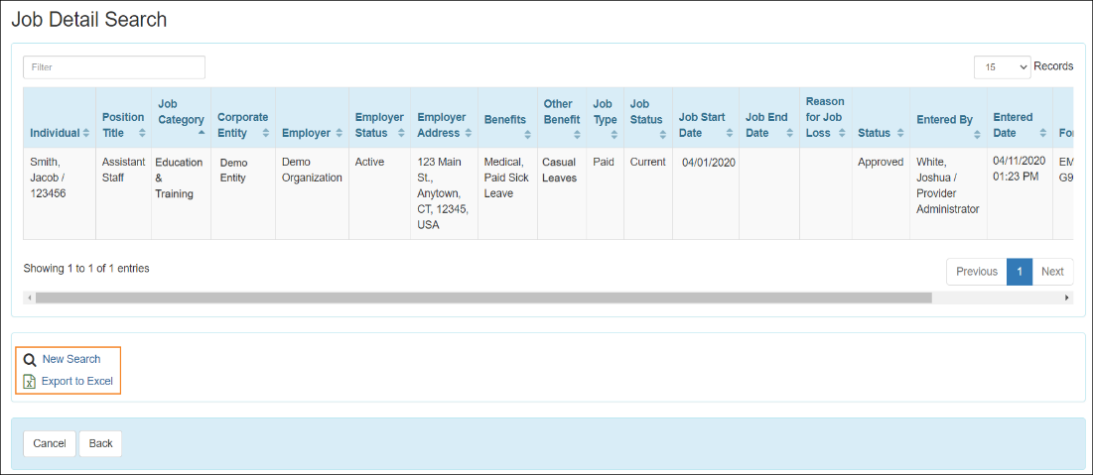

1. Next, you will be directed to the Job Detail page. On this page, you can edit the Job Detail information for the individual. When you are done, click on the **Update** button available at the bottom of the page. To delete a Job Detail form, click on the **Delete** button.

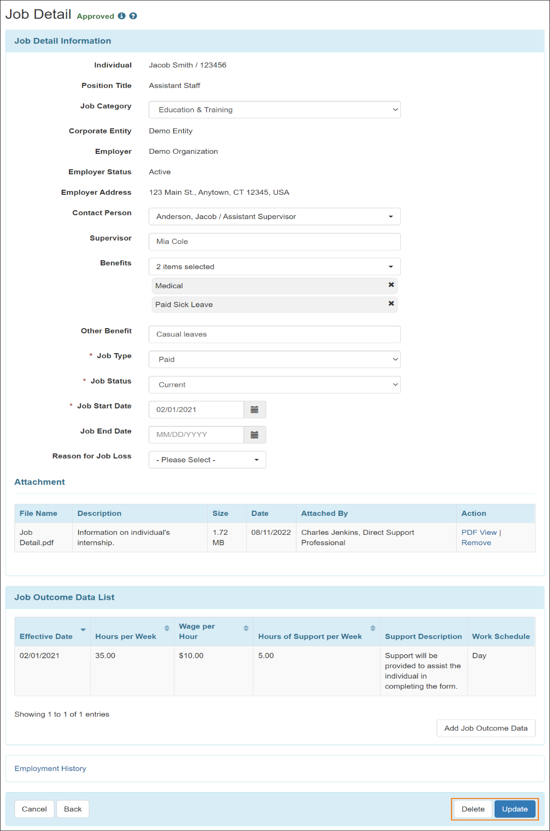

## Application and Interview (PROVIDER OPTIONAL FIELD)

Users assigned with the ***Employment Submit*** role will be able to save Application and Interview forms.

1. Click on the **New** link beside the Application and Interview option of the Individual tab.

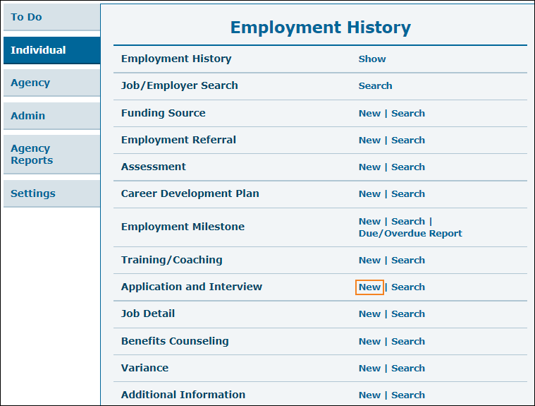

1. Select an individual from the Individual List page.



1. You will then be taken to the Application and Interview page where you will need to fill out Application and Interview information. Click on the **Add File** or **Scan File** buttons in the 'Attachment' section to add external files to the form. Click on the **Save** button to create Application and Interview.

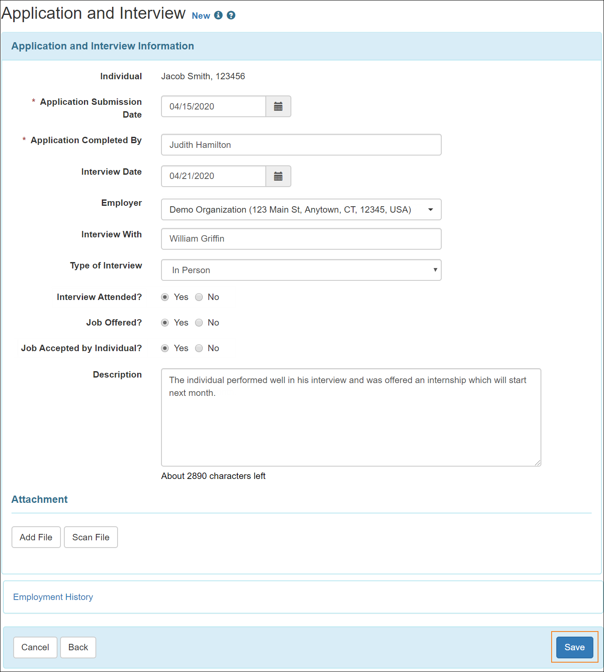

1. The following confirmation message will appear if the Application and Interview has been successfully saved.

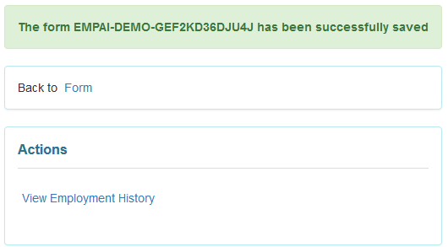

## Benefits Counseling (PROVIDER REQUIRED FIELD, only if individual has received or is receiving benefits counseling services)

Users assigned with the ***Employment Submit*** role will be able to save Benefits Counseling forms.

1. Click on the **New** link beside the Benefits Counseling option on the Individual tab.

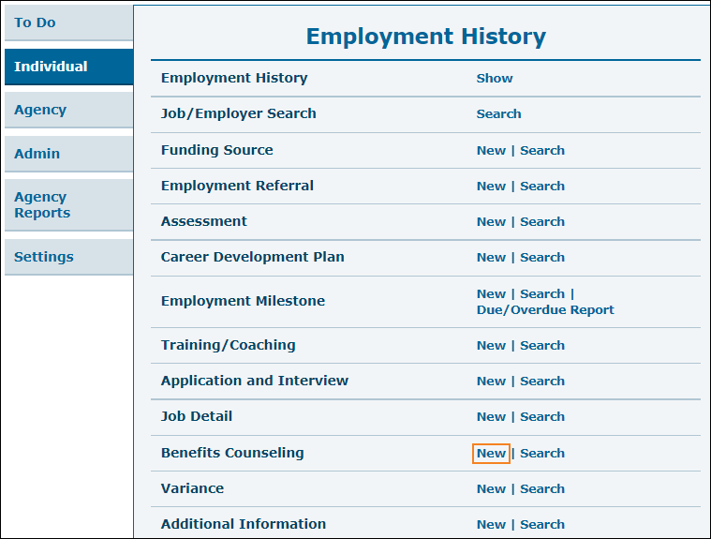

1. Select an individual from the Individual List page.



1. Now you will be taken to the Benefits Counseling page where you will need to fill out required information. Click on the **Add File** or **Scan File** buttons in the 'Attachment' section to add external files to the form. Click on the **Save** button to save the Benefits Counseling form.

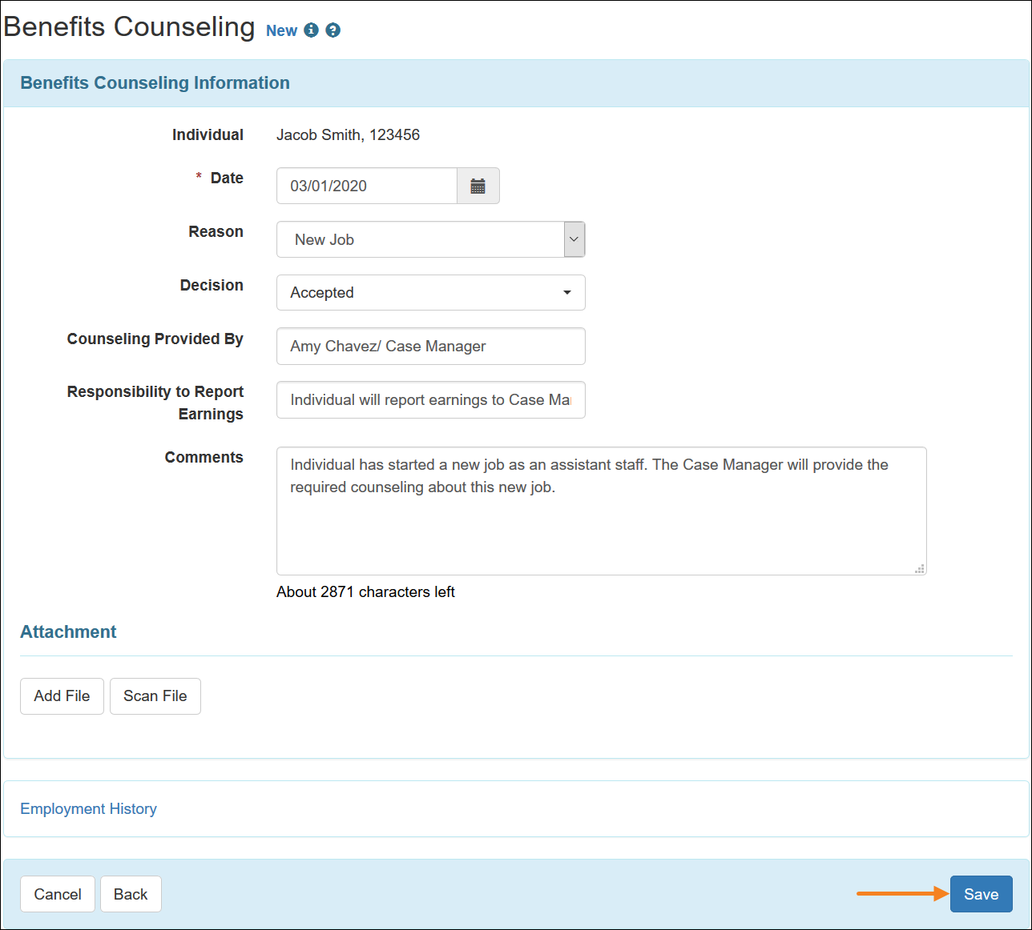

1. A confirmation message will appear if the Benefits Counseling form has been successfully saved.

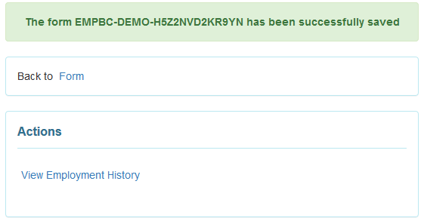

## Variance (PROVIDER REQUIRED FIELD for individuals who are unemployed)

Users assigned with the ***Employment Submit*** caseload-based role can save Variance forms.

1. Click on the **New** link beside the Variance option of the Individual tab.

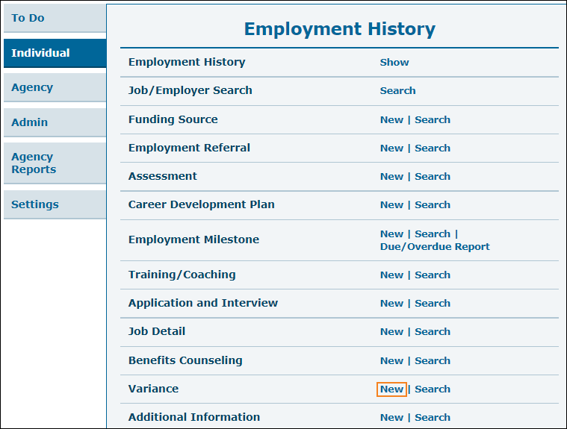

1. Select an individual from the Individual List page.



1. Now you will be taken to the Variance page where you will need to fill out required information. Click on the **Add File** or **Scan File** buttons in the 'Attachment' section to add external files to the form. Click on the **Save** button to create Variance.

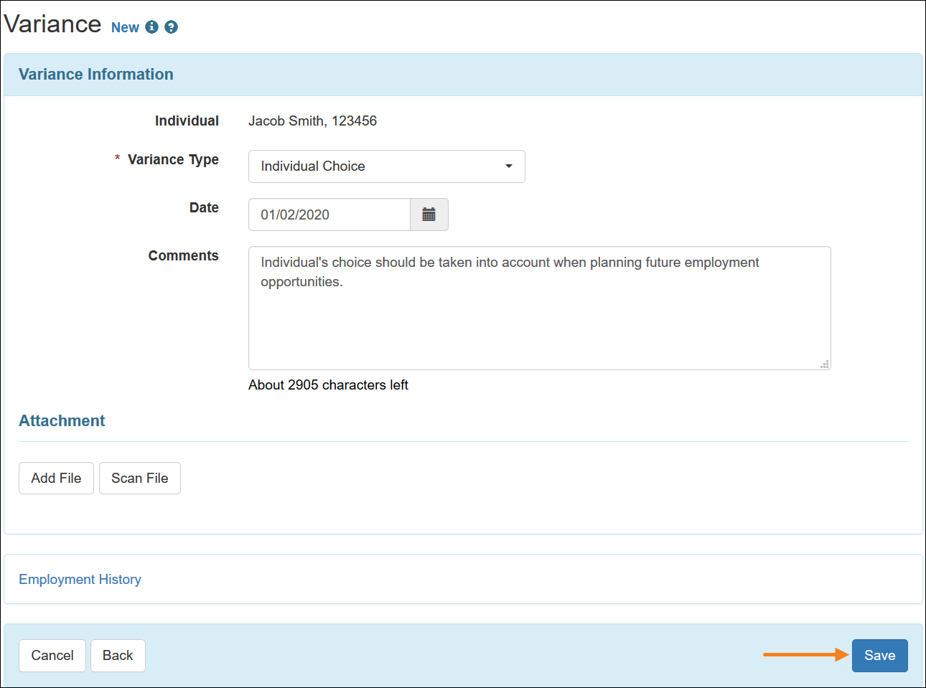

1. A confirmation message will appear after successfully creating the Variance.

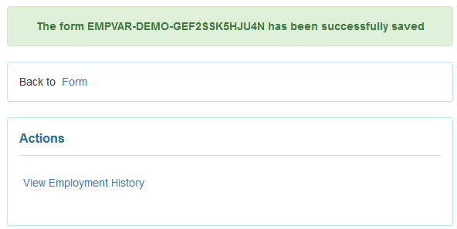

## Additional Information (PROVIDER OPTIONAL FIELD)

Users assigned with the ***Employment Submit*** role will be able to save Additional Information forms.

1. Click on the **New** link beside the Additional Information option of the Individual tab.

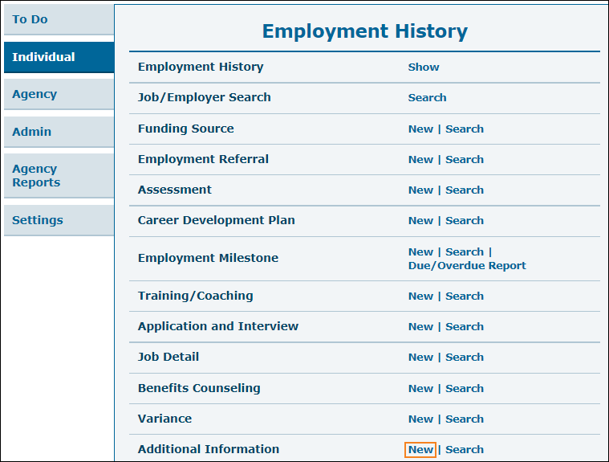

1. Select an individual from the Individual List page.



1. Now you will be taken to the 'Additional Information' form where you will need to fill out required information. Click on the **Add File** or **Scan File** buttons in the 'Attachment' section to add external files to the form. Click on the **Save** button to save Additional Information.

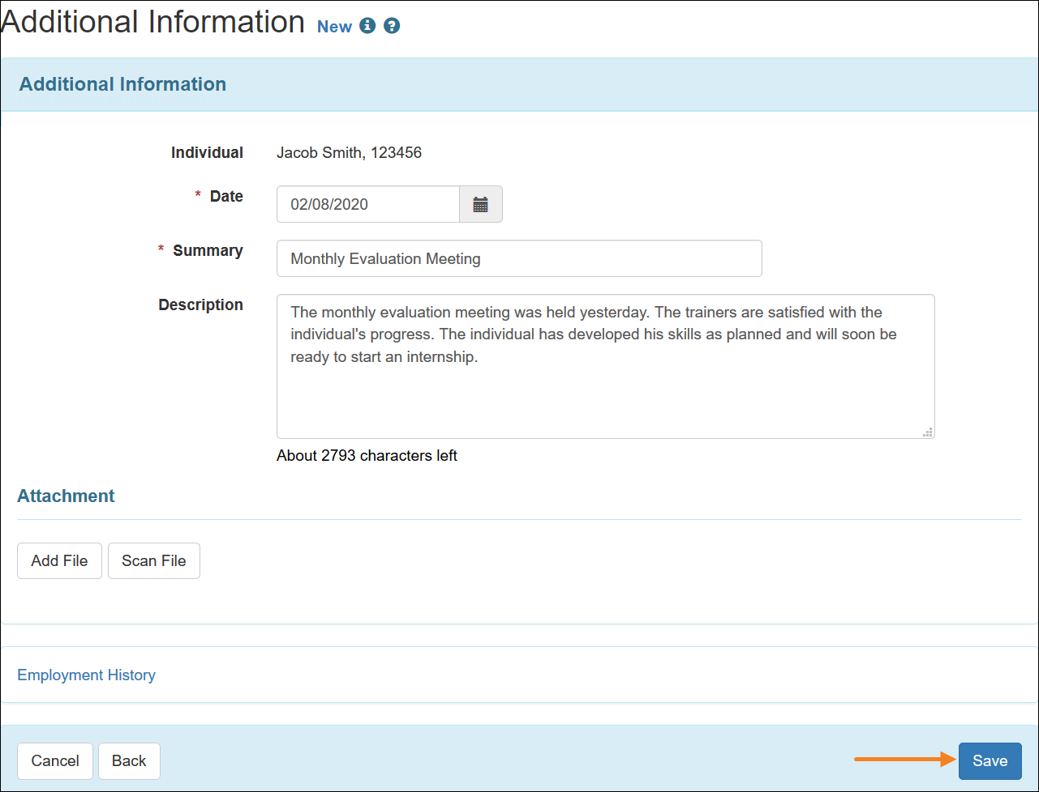

1. A confirmation message will appear if the Additional Information has been successfully saved.

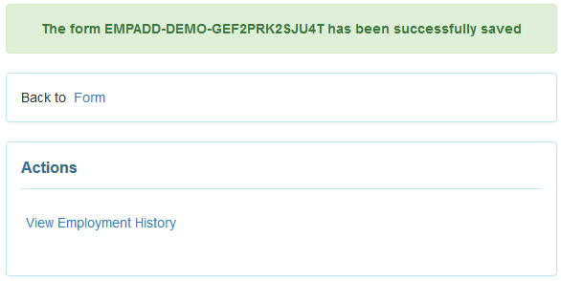

# **Appendix**

## Reports

There are several reports available in the Therap system that can be generated by providers.

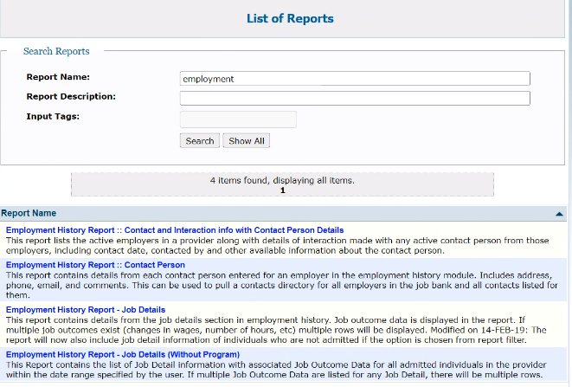

## Acronyms and Abbreviations Definitions

| **Acronym / Abbreviation** | **Definition** |
| --- | --- |
| Benefit Programs | This is the Waiver that an individual has been approved for; i.e. CAC, SD, SW. |
| CAC | Comprehensive Aggregate Cap  One of the waivers under the HBCS/1915c amendment |
| CM | CM = Case Manager  ISC agencies and DDA have Case Managers that support individuals in the various Waivers or Benefit Programs. |
| COS | Circle of Support |
| DDA | DDA supports individuals in the Home and Communication waivers such as CAC, SD, SW. DDA also supports children in the Katie Beckett Program. |
| HCBS | Home and Community Based Services  CAC, SD and SW waivers fall into this category. |
| IDF | The Individual Demographic Form (IDF) is designed to help users maintain essential information such as race, religion, SSN, Medicare, Medicaid number, admission date, program enrollment date, contacts, etc. for individuals, along with their basic identification details such as name, date of birth, physical features, and ID Numbers. |
| ISC | Individual Support Coordinator.  An agency that assists with writing support plans for CAC and SW benefit program recipients |
| KB | Katie Beckett Program.  Benefit program for children 18 and younger. |
| PCSP | Person Centered Support Plan |
| SD | Self Determination Waiver  One of the waiver programs under the HBCS/1915c amendments |
| SW | Statewide Waiver  One of the waiver programs under the HBCS/1915c amendments |
| Waivers | HCBS benefit programs that include SD, SW, and CAC under the 1915c grouping. |