**Therap Employment History Module At-A-Glance Guide**

**\*\*\*You must assign privileges first\*\*\***

In order for employment data/employment status to be entered into the Employment History Module, the Super Admin needs to give the person(s) who will enter employment data privileges by doing the following:

1. Admin Tab 🡪 User Privileges (manage) 🡪 find the staff member’s name 🡪 click on the username 🡪 make sure the following privileges have a check mark next to them:

* Employer Management (to add/edit & view)
* Report Library
* Export Excel

***Please make sure to click “save” at the bottom of the page if you made any changes.

**AND**

1. Admin Tab 🡪 Super Role (manage) 🡪 all roles (edit) 🡪 scroll down to the “Employment” section 🡪 make sure the following privileges have a check mark next to them:

* Employment Submit
* Employment Update
* Employment View

***Please make sure to click “save” at the bottom of the page if you made any changes. Be sure that the Employment Delete option is ***NOT*** checked.

**AND**

1. Admin Tab 🡪 Employment History (preference) 🡪 Please make sure all the options are selected. A screenshot of the “Employment History Preference” is provided below.

***Please make sure to click “save” at the bottom of the page if you made any changes.

Therap Guide: [Set Up Employment History Preference (therapservices.net)](https://help.therapservices.net/s/article/411)

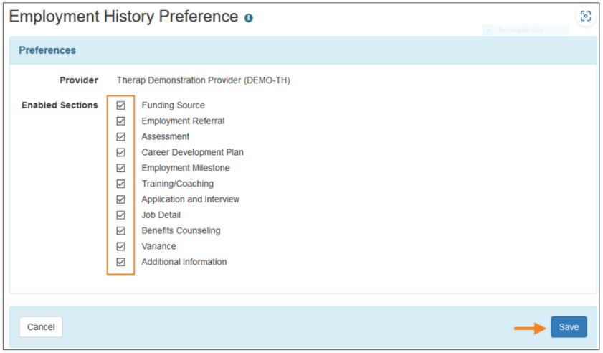

After you have assigned all the necessary privileges, please have the staff member check to make sure they can see all the following Employment History options below. If they do not have all the options, please have the staff member sign out of Therap and then sign back in to ensure the privileges refresh.

**Under the Agency Tab:**

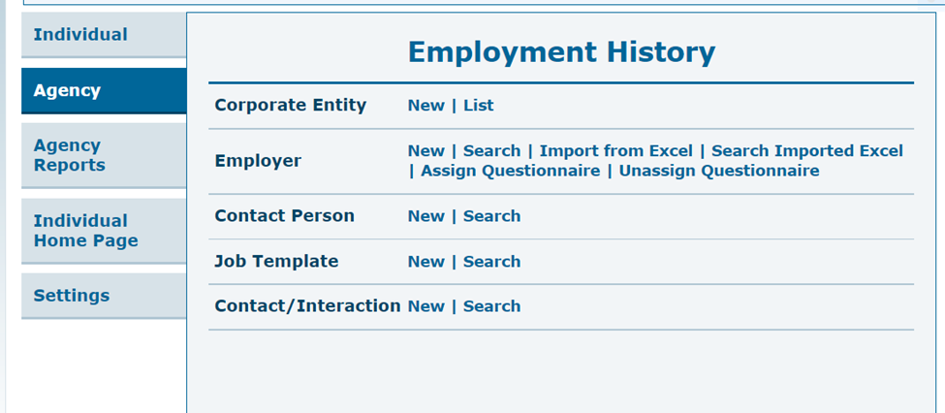

**AND**

**Under the Individual Tab:**

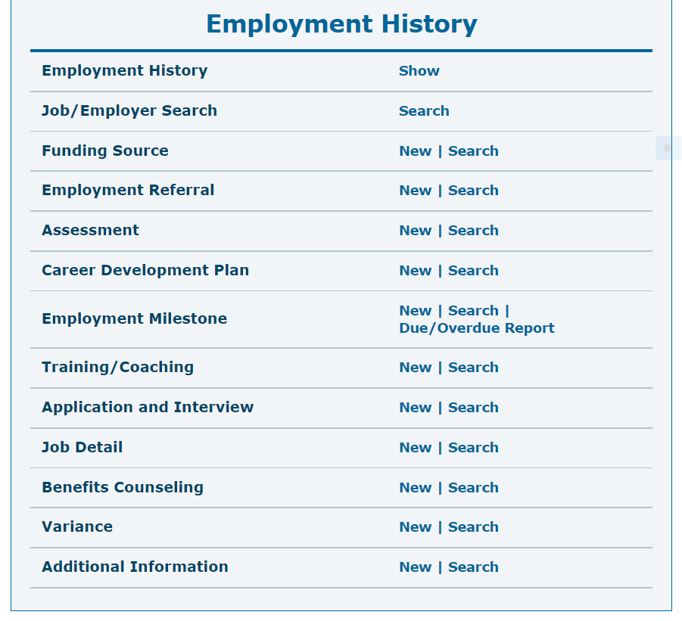

**How to Enter Data**

**If the person is not employed:**

**Enter a “Variance”**

You will enter a “variance” if the person receives any type of DIDD/1915c service, and they are not employed. You can enter a variance by doing the following:

Individual Tab 🡪 Variance (new) 🡪 select the person’s name 🡪 select the “variance type” 🡪 Optional: Date. However, it is best practice to enter the date any time there is a change to the variance type 🡪 comments are optional 🡪 Please make sure to click “save” or “update” at the bottom of the page.

**If the person is employed:**

**\*\*\* All the following steps are required for individuals who are employed. \*\*\***

**Enter employer information first.**

You are required to enter “employer” information. The “corporate entity” field is optional.

* “Corporate Entity” - General employer name, mostly for chain stores/franchises
  + For example: “Walmart” or “Walgreens” or “Lowes”
* “Employer” – Specific employer name and location
  + For example: “McDonald’s Store 598” or “McDonald’s – Washington Ave”

Agency Tab 🡪 Employer (new) 🡪 Optional: Corporate Entity 🡪 Required: Enter the Organization’s name 🡪 It is best practice to enter as much employer information as possible (address, etc.). 🡪 Please make sure to click “save” or “update” at the bottom of the page.

**Job Template**

Agency Tab 🡪 Job Template (new) 🡪 select the correct employer 🡪 Complete the required field(s) noted by an asterisk (*). 🡪 Please make sure to click “save” or “update” at the bottom of the page.

**Funding Source**

Individual Tab 🡪 Funding Source (new) 🡪 select the person’s name 🡪 select the funding source 🡪 Please make sure to click “save” or “update” at the bottom of the page.

**Job Detail**

Individual Tab 🡪 Job detail (new) 🡪 select the person’s name 🡪 select the correct employer 🡪 select the correct job template/position title 🡪 On the “job detail information” form, please complete the required fields noted by an asterisk (*). However, it is best practice to enter as much accurate information as you have access to. 🡪 Please make sure to click “save” or “update” at the bottom of the page.

**Benefits Counseling**

*** This is only required if the person is receiving or has received benefits counseling. ***

Individual Tab 🡪 Benefits Counseling (new) 🡪 Please complete the required fields noted by an asterisk (*). 🡪 Please make sure to click “save” or “update” at the bottom of the page.

**Additional Resources:** [**Therap Employment History Module (therapservices.net)**](https://help.therapservices.net/s/employment-history)