

2026 Annual Report to the Public
Reporting Period July 1, 2024-June 30, 2025



Contents

Contents 3
Tennessee Early Intervention System 2026 Report to the Public 4
Overview 4
TEIS Point of Entry Offices 4
Key Definitions 4
Introduction to Annual Performance Report Indicators 5
Tennessee Early Intervention System 2025 Report to the Public 6
FIRST TENNESSEE 6
EAST TENNESSEE 9
SOUTHEAST 13
UPPER CUMBERLAND 16
GREATER NASHVILLE 19
SOUTH CENTRAL 23
NORTHWEST 27
SOUTHWEST 30
MEMPHIS DELTA 33
FFY 2024-25 Snapshot Data: State and TEIS POEs Indicators 37

Tennessee Early Intervention System 2026 Report to the Public
Reporting Period: July 1, 2024 – Jun 30, 2025

Overview
Individuals with Disabilities Education Act (IDEA) requires states to provide an annual report to the public about the performance of early intervention service programs (EIS programs) compared to the state’s performance on indicator targets. In Tennessee, EIS programs are defined as the nine TEIS point of entry offices. These offices employ state personnel who oversee referrals from entry into the system through exit from the system. Responsibilities include eligibility determination and for eligible children, the coordination of the following activities: development of an individual family service plan (IFSP), coordination of early intervention service delivery specified by the IFSP, and transition planning as the child nears age three. The Annual Report to the Public that you are about to view, contains data during the reporting period of July 1, 2024 – June 30, 2025.

TEIS Point of Entry Offices
 |  |  | 
First Tennessee  Johnson City | Upper Cumberland  Cookeville | Northwest  Martin
East Tennessee  Knoxville | Greater Nashville  Nashville | Southwest  Jackson
Southeast  Chattanooga | South Central  Murfreesboro | Memphis Delta  Memphis

Key Definitions
- Reporting Period: the time information was gathered for this report, July 1 through June 30 for the reporting year.
- State Performance Plan (SPP): a multi-year plan required by all states that measure state performance on federal performance indicators (benchmarks). There are eleven performance indicators within the SPP, each having targets against which performance is compared. District performance on eight of the eleven performance indicators are included in this report.
- Annual Performance Report (APR): Annual Performance Report. Each year states report to the Federal Office of Special Education Programs (OSEP) the progress the state made towards reaching its targets set in the SPP. A copy of Tennessee’s APR may be found at the following website link, Reports & Data.

Introduction to Annual Performance Report Indicators

- Timely Service Delivery
- Average length of time between, receiving guardian’s consent on the IFSP and the delivery of the first service (within 30 days).

- Settings in the natural environment (home, community, other)
- Measures whether services for IFSPs occur in settings where infants, toddlers, and preschoolers typically spend their time, rather than in segregated groups or facilities.

- Early Childhood Outcomes (ECO)
- Measures whether children are making progress in social-emotional skills, knowledge and skills, and the use of appropriate behaviors to meet their needs.

- Family Involvement (family outcomes survey)
- Measures the impact of TEIS on the family’s understanding of their rights, ability to support their child’s development, and participate in decision-making processes.

- Number of children served birth to one-year
- A percentage of how many infants, birth to one year old, enrolled in TEIS. This information is obtained from US Census Bureau.

- Number of children served birth through two years
- A percentage of how many infants, birth to two years old, enrolled in TEIS. This information is obtained from US Census Bureau.

- Timely eligibility determination and initial IFSP development
- Measures the time it takes to determine eligibility, if deemed eligible, and how long it takes to create the child’s IFSP (within 45 days).

- Early Childhood Transition
- Percent of toddlers exiting Part C with timely transition planning for whom the Lead Agency has:
- Developed an IFSP with transition steps and services
- Notified the SEA and LEA where the child resides at least ninety days prior to their third birthday
- Conducted the LEA transition conference with approval of the family at least 90 days, but not more than nine months prior to the child’s third birthday.

Tennessee Early Intervention System 2025 Report to the Public

FIRST TENNESSEE
196 Freckles Court Johnson City, TN 37601
District Administrator – Alissa Ongie

Counties Served – Carter, Cocke, Greene, Hancock, Hamblen. Hawkins, Johnson, Sullivan, Unicoi, Washington
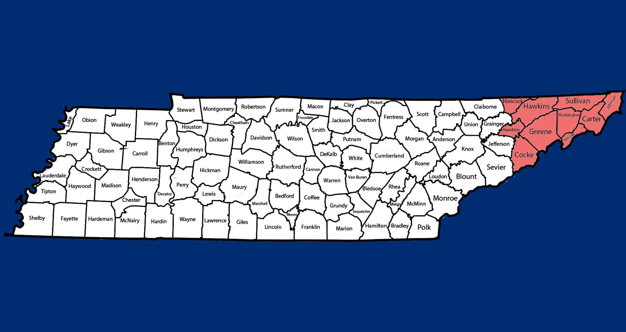

Indicator | Program Performance  2023-24 | Program Performance  2024-25 | State Target 2024-25 | State Performance 2024-25
1. Percent of infants and toddlers who receive IFSP services in a timely manner. | 100% | 100% | 100% | 98.81%
2. Percent of IFSP services provided in family’s natural environment. | 71.84%  (699 children) | 70.37%  (741 children) | 84.00% | 73.52%  (7,273 children)
3. Percent of infants and toddlers who demonstrate improved early childhood outcomes in the three outcomes areas below. | Progress ratings collected for 607 children
A. Positive social-emotional skills (including social relationships).
i. The percentage of children who made substantial developmental progress on outcome A by the time\ they exited TEIS. | 75.60% | 62.29% | 59.00% | 59.66%
ii. The percent of children who were functioning within age expectations on outcome A by the time they exited TEIS. | 69.91% | 71.99% | 52.00% | 72.51%
B. Acquisition and use of knowledge and skills (including early language/communication).
i. The percentage of children who made substantial developmental progress on outcome B by the time they exited TEIS. | 54.45% | 47.26% | 58.00% | 44.60%
ii. The percent of children who were functioning within age expectations on outcome B by the time they exited TEIS. | 52.82% | 51.24% | 34.00% | 45.72%

Indicator | Program Performance  2023-24 | Program Performance  2024-25 | State Target 2024-25 |  | State Performance 2024-25
C. Use of appropriate behaviors to meet their needs.
i. The percentage of children who made developmental progress on outcome C by the time they exited TEIS. | 66.31% | 55.58% | 67.50% | 50.01%
ii. The percent of children who were functioning within age  expectations on outcome C by the time they exited TEIS | 69.91% | 63.43% | 53.00% | 62.03%
4. Percent of families reporting that early intervention services have helped their family demonstrate improved family outcomes in the three outcome areas below. | 94.09% responses from families in First TN. 93.16% responses from families statewide.
A. Know their rights. | 97.19% | 96.84% | 95.00% | 94.55%
B. Effectively communicate their children’s needs. | 97.18% | 96.71% | 96.00% | 94.30%
C. Help their children develop and learn. | 95.92% | 94.99% | 93.00% | 91.49%
5. Percent of infants, birth to one year old, enrolled in TEIS. | 2.67%  (155 children) | 2.62%  (155 children) | 1.53% | 1.47%  (1,223 children)
6. Percent of infants and toddlers, birth through the age of two years, enrolled in TEIS. | 5.53%  (974 children) | 5.84%  (1,050 children) | 3.49% | 3.95%  (9,892 children)
7. Percent of infants and toddlers who had timely eligibility evaluations and an initial Individualized Family Service Plan within 45-days of referral into the early intervention system. | 100% | 98.48% | 100% | 99.08%
8. Percent children exiting TEIS at age three years who had timely transition planning as demonstrated by the three areas below.
A. Development of a transition plan on the IFSP. | 100% | 100% | 100% | 100%
B. Notification to the state 619 preschool coordinator and the local school system on children potentially eligible for special education preschool services. | 100% | 99.45% | 100% | 99.83%
C. Convening a transition planning conference with the local school system, with parent permission. | 100% | 100% | 100% | 100%

EAST TENNESSEE
520 W. Summit Hill Drive, Suite 201 , Knoxville, TN 37902
District Administrator - Rachel Meyer

Counties Served – Anderson, Blount, Campbell, Claiborne, Grainger, Jefferson, Knox, Loudon, Monroe, Morgan, Roane, Scott, Sevier, Union

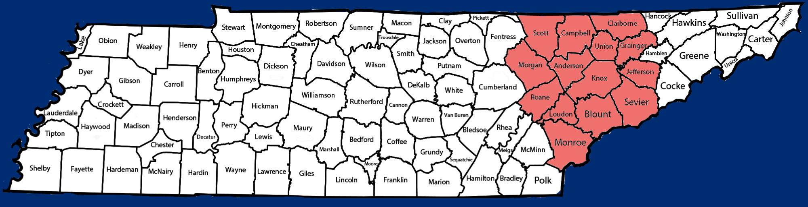

Indicator | Program Performance  2023-24 | Program Performance  2024-25 | State Target 2024-25 | State Performance 2024-25
1. Percent of infants and toddlers who receive IFSP services in a timely manner. | 100% | 99.08% | 100% | 98.81%
2. Percent of IFSP services provided in family’s natural environment. | 64.15%  (1,027 children) | 61.42%  (968 children) | 84.00% | 73.52%  (7,273 children)
3. Percent of infants and toddlers who demonstrate improved early childhood outcomes in the three outcomes areas below. | Progress ratings collected for 1,112 children
A. Positive social-emotional skills (including social relationships).
i. The percentage of children who made substantial developmental progress on outcome A by the time they exited TEIS. | 76.79% | 63.14% | 59.00% | 59.66%
ii. The percent of children who were functioning within age expectations on outcome A by the time they exited TEIS. | 68.19% | 75.18% | 52.00% | 72.51%
B. Acquisition and use of knowledge and skills (including early language/communication).
i. The percentage of children who made substantial developmental progress on outcome B by the time they exited TEIS. | 58.24% | 51.59% | 58.00% | 44.60%
ii. The percent of children who were functioning within age expectations on outcome B by the time they exited TEIS. | 53.58% | 54.86% | 34.00% | 45.72%

Indicator | Program Performance  2023-24 | Program Performance  2024-25 |  | State Target 2024-25 |  | State Performance 2024-25
C. Use of appropriate behaviors to meet their needs.
i. The percentage of children who made developmental progress on outcome C by the time they exited TEIS. | 66.71% | 52.12% | 67.50% |  | 50.01%
ii. The percent of children who were functioning within age  expectations on outcome C by the time they exited TEIS. | 68% | 62.77% | 53.00% |  | 62.03%
4. Percent of families reporting that early intervention services have helped their family demonstrate improved family outcomes in the three outcome areas below. | 83.32% responses from families in East TN. 93.16% responses from families statewide.
A. Know their rights. | 95.57% | 95.78% | 95.00% |  | 94.55%
B. Effectively communicate their children’s needs. | 95.66% | 96.05% | 96.00% |  | 94.30%
C. Help their children develop and learn. | 92.93% | 92.38% | 93.00% |  | 91.49%
5. Percent of infants, birth to one year old, enrolled in TEIS. | 1.61%  (199 children) | 1.40%  (173 children) | 1.53% |  | 1.47%  (1,223 children)
6. Percent of infants and toddlers, birth through the age of two years, enrolled in TEIS. | 4.29%  (1,600 children) | 4.21%  (1,578 children) | 3.49% |  | 3.95%  (9,892 children)
7. Percent of infants and toddlers who had timely eligibility evaluations and an initial Individualized Family Service Plan within 45-days of referral into the early intervention system. | 100% | 100% | 100% |  | 99.08%
8. Percent children exiting TEIS at age three years who had timely transition planning as demonstrated by the three areas below.
A. Development of a transition plan on the IFSP. | 100% | 100% | 100% |  | 100%
B. Notification to the state 619 preschool coordinator and the local school system on children potentially eligible for special education preschool services. | 100% | 100% | 100% |  | 99.83%
- Convening a transition planning conference with the local school system, with parent permission. | 100% | 100% | 100% |  | 100%

SOUTHEAST
1501 Riverside Dr., Suite 230 Chattanooga, TN 37406
District Administrator - Holly Wilson

Counties Served – Bledsoe, Bradley, Grundy, Hamilton, McMinn, Marion, Meigs, Polk, Rhea, Sequatchie

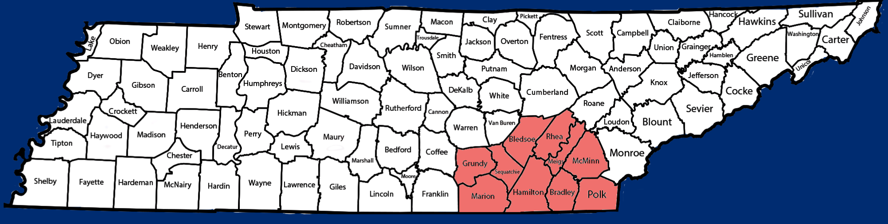

Indicator | Program Performance  2023-24 | Program Performance  2024-25 | State Target 2024-25 | State Performance 2024-25
1. Percent of infants and toddlers who receive IFSP services in a timely manner. | 98.91% | 97.41% | 100% | 98.81%
2. Percent of IFSP services provided in family’s natural environment. | 74.25%  (568 children) | 69.22%  (569 children) | 84.00% | 73.52%  (7,273 children)
3. Percent of infants and toddlers who demonstrate improved early childhood outcomes in the three outcomes areas below. | Progress ratings collected for 581 children
A. Positive social-emotional skills (including social relationships).
i. The percentage of children who made substantial developmental progress on outcome A by the time they exited TEIS. | 76.76% | 58.02% | 59.00% | 59.66%
ii. The percent of children who were functioning within age expectations on outcome A by the time they exited TEIS. | 70.79% | 70.05% | 52.00% | 72.51%
B. Acquisition and use of knowledge and skills (including early language/communication).
i. The percentage of children who made substantial developmental progress on outcome B by the time they exited TEIS. | 50% | 42.12% | 58.00% | 44.60
ii. The percent of children who were functioning within age expectations on outcome B by the time they exited TEIS. | 46.42% | 42.86% | 34.00% | 45.72%

Indicator | Program Performance  2023-24 | Program Performance  2024-25 | State Target 2024-25 | State Performance 2024-25
C. Use of appropriate behaviors to meet their needs.
i. The percentage of children who made developmental progress on outcome C by the time they exited TEIS. | 60.18% | 50.83% | 67.50% | 50.01%
ii. The percent of children who were functioning within age  expectations on outcome C by the time they exited TEIS. | 64.99% | 60.76% | 53.00% | 62.03%
4. Percent of families reporting that early intervention services have helped their family demonstrate improved family outcomes in the three outcome areas below. | 92.78% responses from families in Southeast TN. 93.16% responses from families statewide.
A. Know their rights. | 97.38% | 96.39% | 95.00% | 94.55%
B. Effectively communicate their children’s needs. | 96.63% | 96.54% | 96.00% | 94.30%
C. Help their children develop and learn. | 95.30% | 94.08% | 93.00% | 91.49%
5. Percent of infants, birth to one year old, enrolled in TEIS. | 1.34%  (155 children) | 1.23%  95 children) | 1.53% | 1.47%  (1,223 children)
6. Percent of infants and toddlers, birth through the age of two years, enrolled in TEIS. | 3.29%  (974 children) | 3.48%  (822 children) | 3.49% | 3.95%  (9,892 children)
7. Percent of infants and toddlers who had timely eligibility evaluations and an initial Individualized Family Service Plan within 45-days of referral into the early intervention system. | 100% | 100% | 100% | 99.08%
8. Percent children exiting TEIS at age three years who had timely transition planning as demonstrated by the three areas below.
A. Development of a transition plan on the IFSP. | 100% | 100% | 100% | 100%
B. Notification to the state 619 preschool coordinator and the local school system on children potentially eligible for special education preschool services. | 100% | 100% | 100% | 99.83%
C. Convening a transition planning conference with the local school system, with parent permission. | 100% | 100% | 100% | 100%

UPPER CUMBERLAND
1519 E. Spring Street, Suite E, Cookeville, TN 38506
District Administrator - Jeanna McCloud

Counties Served – Cannon, Clay, Cumberland, Dekalb, Fentress, Jackson, Macon, Overton, Pickett, Putnam, Smith, Sumner, Trousdale, Van Buren, Warren, White

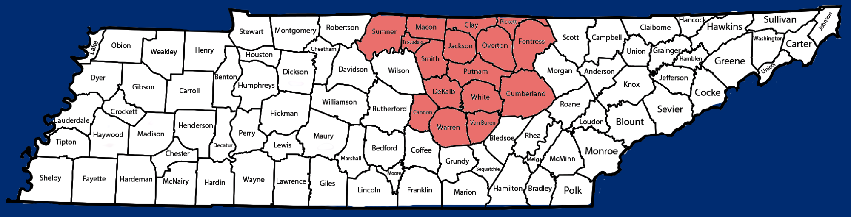

Indicator | Program Performance  2023-24 | Program Performance  2024-25 | State Target 2024-25 | State Performance 2024-25
1. Percent of infants and toddlers who receive IFSP services in a timely manner. | 100% | 98.01% | 100% | 98.81%
2. Percent of IFSP services provided in family’s natural environment. | 80.02%  (821 children) | 83.61%  (852 children) | 84.00% | 73.52%  (7,273children)
3. Percent of infants and toddlers who demonstrate improved early childhood outcomes in the three outcomes areas below. | Progress ratings collected for 784 children
A. Positive social-emotional skills (including social relationships).
i. The percentage of children who made substantial developmental progress on outcome A by the time they exited TEIS. | 80.95% | 59.11% | 59.00% | 59.66%
ii. The percent of children who were functioning within age expectations on outcome A by the time they exited TEIS. | 75.19% | 70.03% | 52.00% | 72.51%
B. Acquisition and use of knowledge and skills (including early language/communication).
i. The percentage of children who made substantial developmental progress on outcome B by the time they exited TEIS. | 59.59% | 50.72% | 58.00% | 44.60%
ii. The percent of children who were functioning within age expectations on outcome B by the time they exited TEIS. | 54.09% | 52.04% | 34.00% | 45.72%

Indicator | Program Performance  2023-24 | Program Performance  2024-25 |  | State Target 2024-25 |  | State Performance 2024-25
C. Use of appropriate behaviors to meet their needs.
i. The percentage of children who made developmental progress on outcome C by the time they exited TEIS. | 68.28% | 48.90% | 67.50% |  | 50.01%
ii. The percent of children who were functioning within age  expectations on outcome C by the time they exited TEIS. | 70.88% | 59.82% | 53.00% |  | 62.03%
4. Percent of families reporting that early intervention services have helped their family demonstrate improved family outcomes in the three outcome areas below. | 98.86% responses from families in Upper Cumberland. 93.16% responses from families statewide.
A. Know their rights. | 95.99% | 95.02% | 95.00% |  | 94.55%
B. Effectively communicate their children’s needs. | 96.89% | 95.02% | 96.00% |  | 94.30%
C. Help their children develop and learn. | 93.89% | 92.59% | 93.00% |  | 91.49%
5. Percent of infants, birth to one year old, enrolled in TEIS. | 1.89%  (119 children) | 2.23%  (144 children) | 1.53% |  | 1.47%  (1,223 children)
6. Percent of infants and toddlers, birth through the age of two years, enrolled in TEIS. | 5.33%  (1,023 children) | 5.14%  (1,019 children) | 3.49% |  | 3.95%  (9,892children)
7. Percent of infants and toddlers who had timely eligibility evaluations and an initial Individualized Family Service Plan within 45-days of referral into the early intervention system. | 100% | 100% | 100% |  | 99.08%
8. Percent children exiting TEIS at age three years who had timely transition planning as demonstrated by the three areas below.
A. Development of a transition plan on the IFSP. | 100% | 100% | 100% |  | 100%
B. Notification to the state 619 preschool coordinator and the local school system on children potentially eligible for special education preschool services. | 99.71% | 99.70% | 100% |  | 99.83%
C. Convening a transition planning conference with the local school system, with parent permission. | 100% | 100% | 100% |  | 100%

GREATER NASHVILLE
275 Stewarts Ferry Pike, One Cannon Way, Nashville, TN 37214
District Administrator – Jessica Shook

Counties Served – Cheatham, Davidson, Dickson, Montgomery, Robertson, Wilson

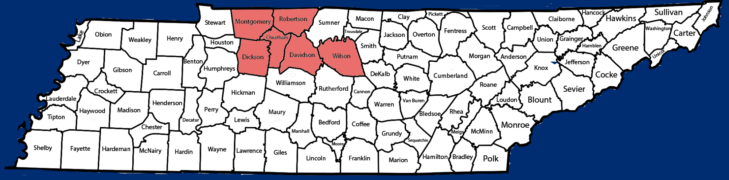

Indicator | Program Performance  2023-24 | Program Performance  2024-25 | State Target 2024-25 | State Performance 2024-25
1. Percent of infants and toddlers who receive IFSP services in a timely manner. | 95.09% | 98.60% | 100% | 98.81%
2. Percent of IFSP services provided in family’s natural environment. | 76%  (1,216 children) | 74.78%  (1,266 children) | 84.00% | 73.52%  (7,273 children)
3. Percent of infants and toddlers who demonstrate improved early childhood outcomes in the three outcomes areas below. | Progress ratings collected for 1,245 children
A. Positive social-emotional skills (including social relationships).
i. The percentage of children who made substantial developmental progress on outcome A by the time they exited TEIS. | 73.44% | 58.64% | 59.00% | 59.66%
ii. The percent of children who were functioning within age expectations on outcome A by the time they exited TEIS. | 70.84% | 72.29% | 52.00% | 72.51%
B. Acquisition and use of knowledge and skills (including early language/communication).
i. The percentage of children who made substantial developmental progress on outcome B by the time they exited TEIS. | 49.90% | 42.80% | 58.00% | 44.60%
ii. The percent of children who were functioning within age expectations on outcome B by the time they exited TEIS. | 43.02% | 44.18% | 34.00% | 45.72%

Indicator | Program Performance  2023-24 | Program Performance  2024-25 | State Target 2024-25 | State Performance 2024-25
C. Use of appropriate behaviors to meet their needs.
i. The percentage of children who made developmental progress on outcome C by the time they exited TEIS. | 60.60% | 52.12% | 67.50% | 50.01%
ii. The percent of children who were functioning within age  expectations on outcome C by the time they exited TEIS. | 66.19% | 64.18% | 53.00% | 62.03%
4. Percent of families reporting that early intervention services have helped their family demonstrate improved family outcomes in the three outcome areas below. | 96.35% responses from families in Greater Nashville. 93.16% responses from families statewide.
A. Know their rights. | 90.10% | 90.68% | 95.00% | 94.55%
B. Effectively communicate their children’s needs. | 89.90% | 90.23% | 96.00% | 94.30%
C. Help their children develop and learn. | 85.96% | 87.10% | 93.00% | 91.49%
5. Percent of infants, birth to one year old, enrolled in TEIS. | 1.02%  (180 children) | 1.19%  (216 children) | 1.53% | 1.47%  (1,223 children)
6. Percent of infants and toddlers, birth through the age of two years, enrolled in TEIS. | 3.15%  (1,604 children) | 3.16%  (1,694 children) | 3.49% | 3.95%  (9,892 children)
7. Percent of infants and toddlers who had timely eligibility evaluations and an initial Individualized Family Service Plan within 45-days of referral into the early intervention system. | 100% | 98.19% | 100% | 99.08%
8. Percent children exiting TEIS at age three years who had timely transition planning as demonstrated by the three areas below.
A. Development of a transition plan on the IFSP. | 100% | 100% | 100% | 100%
B. Notification to the state 619 preschool coordinator and the local school system on children potentially eligible for special education preschool services. | 100% | 99.66% | 100% | 99.83%
C. Convening a transition planning conference with the local school system, with parent permission. | 100% | 100% | 100% | 100%

SOUTH CENTRAL
745 South Church Street, Suite 703 Murfreesboro, TN 37130
District Administrator - Vacant

Counties Served – Bedford, Coffee, Franklin, Giles, Hickman, Lawrence, Lewis, Lincoln, Marshall, Maury, Moore, Perry, Rutherford, Wayne, Williamson

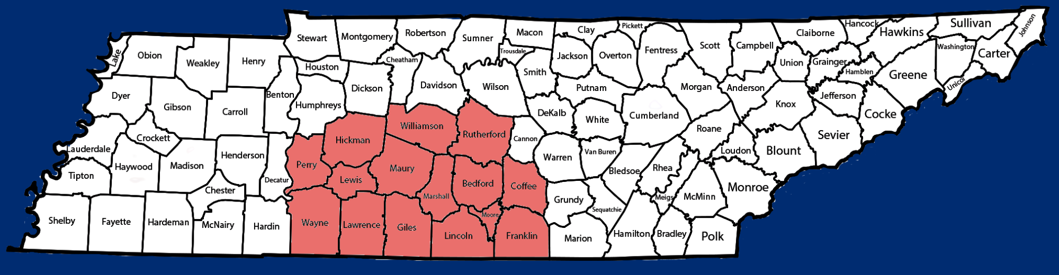

Indicator | Program Performance  2023-24 | Program Performance  2024-25 | State Target 2024-25 | State Performance 2024-25
1. Percent of infants and toddlers who receive IFSP services in a timely manner. | 94.92% | 99.47% | 100% | 98.81%
2. Percent of IFSP services provided in family’s natural environment. | 65.38%  (878 children) | 65.50%  (957 children) | 84.00% | 73.52%  (7,273 children)
3. Percent of infants and toddlers who demonstrate improved early childhood outcomes in the three outcomes areas below. | Progress ratings collected for 998 children
A. Positive social-emotional skills (including social relationships).
i. The percentage of children who made substantial developmental progress on outcome A by the time they exited TEIS. | 75.18% | 54.81% | 59.00% | 59.66%
ii. The percent of children who were functioning within age expectations on outcome A by the time they exited TEIS. | 67.38% | 70.04% | 52.00% | 72.51%
B. Acquisition and use of knowledge and skills (including early language/communication).
i. The percentage of children who made developmental progress on outcome B by the time they exited TEIS. | 54.38% | 46.15% | 58.00% | 44.60%
ii. The percent of children who were functioning within age expectations on outcome B by the time they exited TEIS. | 48.66% | 48.40% | 34.00% | 45.72%

Indicator | Program Performance  2023-24 | Program Performance  2024-25 |  | State Target 2024-25 |  | State Performance 2024-25
C. Use of appropriate behaviors to meet their needs.
i. The percentage of children who made substantial developmental progress on outcome C by the time they exited TEIS. | 61.49% | 48.99% | 67.50% |  | 50.01%
ii. The percent of children who were functioning within age  expectations on outcome C by the time they exited TEIS. | 64.92% | 62.12% | 53.00% |  | 62.03%
4. Percent of families reporting that early intervention services have helped their family demonstrate improved family outcomes in the three outcome areas below. | 93.11% responses from families in South Central. 93.16% responses from families statewide.
A. Know their rights. | 94.59% | 95.46% | 95.00% |  | 94.55%
B. Effectively communicate their children’s needs. | 95.23% | 95.20% | 96.00% |  | 94.30%
C. Help their children develop and learn. | 91.42% | 91.10% | 93.00% |  | 91.49%
5. Percent of infants, birth to one year old, enrolled in TEIS. | 1.11%  (137 children) | 1.37%  (174 children) | 1.53% |  | 1.47%  (1,223 children)
6. Percent of infants and toddlers, birth through the age of two years, enrolled in TEIS. | 3.56%  (1,342 children) | 3.75%  (1,461 children) | 3.49% |  | 3.95%  (9,892 children)
7. Percent of infants and toddlers who had timely eligibility evaluations and an initial Individualized Family Service Plan within 45-days of referral into the early intervention system. | 98.67% | 100% | 100% |  | 99.08%
8. Percent children exiting TEIS at age three years who had timely transition planning as demonstrated by the three areas below.
A. Development of a transition plan on the IFSP. | 100% | 100% | 100% |  | 100%
B. Notification to the state 619 preschool coordinator and the local school system on children potentially eligible for special education preschool services. | 99.8% | 100% | 100% |  | 99.83%
C. Convening a transition planning conference with the local school system, with parent permission. | 100% | 100% | 100% | 100%

NORTHWEST
1010 Mount Zion Road Union City, TN 38261
District Administrator - Jenny Patterson

Counties Served – Benton, Carroll, Crockett, Dyer, Gibson, Henry, Houston, Humphreys, Lake, Lauderdale, Obion, Stewart, Weakley
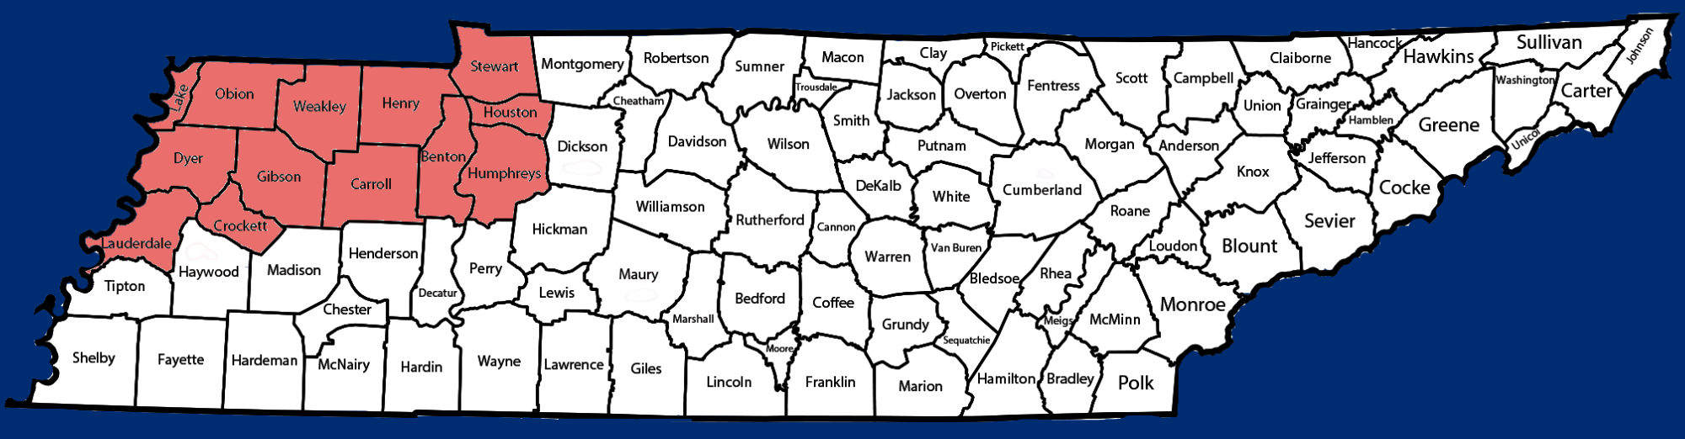

Indicator | Program Performance  2023-24 | Program Performance  2024-25 | State Target 2024-25 | State Performance 2024-25
1. Percent of infants and toddlers who receive IFSP services in a timely manner. | 100% | 100% | 100% | 98.81%
2. Percent of IFSP services provided in family’s natural environment. | 74.52%  (348 children) | 73.96%  (372 children) | 84.00% | 73.529%  (7,273 children)
3. Percent of infants and toddlers who demonstrate improved early childhood outcomes in the three outcomes areas below. | Progress ratings collected for 363 children
A. Positive social-emotional skills (including social relationships).
i. The percentage of children who made substantial developmental progress on outcome A by the time they exited TEIS. | 90.55% | 78.71% | 59.00% | 59.66%
ii. The percent of children who were functioning within age expectations on outcome A by the time they exited TEIS. | 80.53% | 85.95% | 52.00% | 72.51%
B. Acquisition and use of knowledge and skills (including early language/communication).
i. The percentage of children who made developmental progress on outcome B by the time they exited TEIS. | 52.75% | 47.67% | 58.00% | 44.60%
ii. The percent of children who were functioning within age expectations on outcome B by the time they exited TEIS. | 44.22% | 49.31% | 34.00% | 45.72%

Indicator | Program Performance  2023-24 | Program Performance  2024-25 |  | State Target 2024-25 |  | State Performance 2024-25
C. Use of appropriate behaviors to meet their needs.
i. The percentage of children who made substantial developmental progress on outcome C by the time they exited TEIS. | 67.51% | 57.22 | 67.50% |  | 50.01%
ii. The percent of children who were functioning within age  expectations on outcome C by the time they exited TEIS. | 73.27% | 71.90 | 53.00% |  | 62.03%
4. Percent of families reporting that early intervention services have helped their family demonstrate improved family outcomes in the three outcome areas below. | 99.75% responses from families in Northwest TN. 93.16% responses from families statewide.
A. Know their rights. | 96.98% | 96.68% | 95.00% |  | 94.55%
B. Effectively communicate their children’s needs. | 97.87% | 95.92% | 96.00% |  | 94.30%
C. Help their children develop and learn. | 95.12% | 93.62% | 93.00% |  | 91.49%
5. Percent of infants, birth to one year old, enrolled in TEIS. | 2.12%  (74 children) | 2.15%  (73 children) | 1.53% |  | 1.47%  (1,223 children)
6. Percent of infants and toddlers, birth through the age of two years, enrolled in TEIS. | 4.53%  (468 children) | 4.91%  (503) | 3.49% |  | 3.95%  (9,892 children)
7. Percent of infants and toddlers who had timely eligibility evaluations and an initial Individualized Family Service Plan within 45-days of referral into the early intervention system. | 100% | 100% | 100% |  | 99.08%
8. Percent children exiting TEIS at age three years who had timely transition planning as demonstrated by the three areas below.
A. Development of a transition plan on the IFSP. | 100% | 100% | 100% |  | 100%
B. Notification to the state 619 preschool coordinator and the local school system on children potentially eligible for special education preschool services. | 100% | 100% | 100% |  | 99.83%
C. Convening a transition planning conference with the local school system, with parent permission. | 100% | 100% | 100% |  | 100%

SOUTHWEST
225 Dr. Martin Luther King Jr. Dr. 4th Floor, Building B Jackson, TN 38301
District Administrator - Elizabeth McClarin

Counties Served – Chester, Decatur, Fayette, Hardeman, Hardin, Haywood, Henderson, McNairy, Madison, Tipton
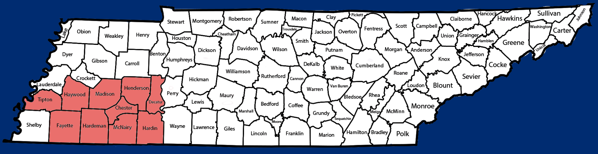

Indicator | Program Performance  2023-24 | Program Performance  2024-25 | State Target 2022-23 | State Performance 2023-24
1. Percent of infants and toddlers who receive IFSP services in a timely manner. | 91.30% | 100% | 100% | 98.81%
2. Percent of IFSP services provided in family’s natural environment. | 85.51%  (413 children) | 77.92%  (413 children) | 84.00% | 73.52%  (7,273 children)
3. Percent of infants and toddlers who demonstrate improved early childhood outcomes in the three outcomes areas below. | Progress ratings collected for 352 children
A. Positive social-emotional skills (including social relationships).
i. The percentage of children who made substantial developmental progress on outcome A by the time they exited TEIS. | 79.17% | 65.05% | 59.00% | 59.66%
ii. The percent of children who were functioning within age expectations on outcome A by the time they exited TEIS. | 75.74% | 78.41% | 52.00% | 72.51%
B. Acquisition and use of knowledge and skills (including early language/communication).
i. The percentage of children who made developmental progress on outcome B by the time they exited TEIS. | 57.47% | 42.96% | 58.00% | 44.60%
ii. The percent of children who were functioning within age expectations on outcome B by the time they exited TEIS. | 48.22% | 41.48% | 34.00% | 45.72%

Indicator | Program Performance  2023-24 | Program Performance  2024-25 | State Target 2022-23 |  | State Performance 2023-24
C. Use of appropriate behaviors to meet their needs.
i. The percentage of children who made developmental progress on outcome C by the time they exited TEIS. | 64.84% | 47.62% | 67.50% | 50.01%
ii. The percent of children who were functioning within age  expectations on outcome C by the time they exited TEIS. | 70.12% | 63.64% | 53.00% | 62.03%
4. Percent of families reporting that early intervention services have helped their family demonstrate improved family outcomes in the three outcome areas below. | 95.47% responses from families in Southwest 93.16% responses from families statewide.
A. Know their rights. | 93.94% | 94.95% | 95.00% | 94.55%
B. Effectively communicate their children’s needs. | 92.59% | 94.15% | 96.00% | 94.30%
C. Help their children develop and learn. | 90.91% | 92.02% | 93.00% | 91.49%
5. Percent of infants, birth to one year old, enrolled in TEIS. | 1.43%  (56 children) | 1.97%  (78 children) | 1.53% | 1.47%  (1,223 children)
6. Percent of infants and toddlers, birth through the age of two years, enrolled in TEIS. | 4.06%  (482 children) | 4.47%  (530 children) | 3.49% | 3.95%  (9,892 children)
7. Percent of infants and toddlers who had timely eligibility evaluations and an initial Individualized Family Service Plan within 45-days of referral into the early intervention system. | 97.14% | 100% | 100% | 99.08%
8. Percent children exiting TEIS at age three years who had timely transition planning as demonstrated by the three areas below.
A. Development of a transition plan on the IFSP. | 100% | 100% | 100% | 100%
B. Notification to the state 619 preschool coordinator and the local school system on children potentially eligible for special education preschool services. | 100% | 100% | 100% | 99.83%
C. Convening a transition planning conference with the local school system, with parent permission. | 100% | 100% | 100% | 100%

MEMPHIS DELTA
2175 Business Center Dr., Suite 11, Memphis, TN 38134
District Administrator - Angie Powell

Counties Served – Shelby

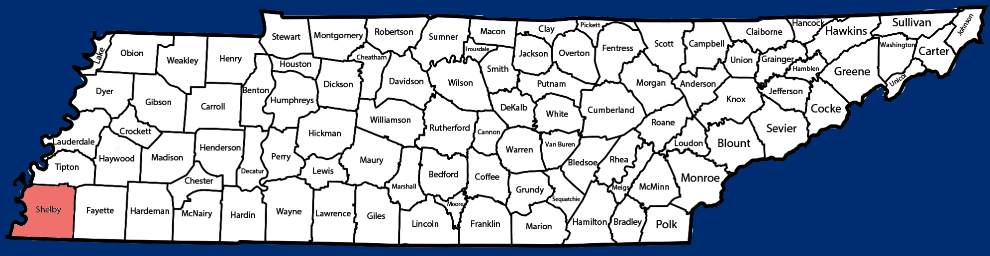

Indicator | Program Performance  2023-24 | Program Performance  2024-25 | State Target 2022-23 | State Performance 2023-24
1. Percent of infants and toddlers who receive IFSP services in a timely manner. | 100% | 98.04% | 100% | 98.81%
2. Percent of IFSP services provided in family’s natural environment. | 90.47%  (1,082 children) | 91.90%  (1,135 children) | 84.00% | 73.52%  (7,273 children)
3. Percent of infants and toddlers who demonstrate improved early childhood outcomes in the three outcomes areas below. | Progress ratings collected for 1,113 children
A. Positive social-emotional skills (including social relationships).
i. The percentage of children who made substantial developmental progress on outcome A by the time they exited TEIS. | 73.65% | 55.21% | 59.00% | 59.66%
ii. The percent of children who were functioning within age expectations on outcome A by the time they exited TEIS. | 70.65% | 69.36% | 52.00% | 72.51%
B. Acquisition and use of knowledge and skills (including early language/communication).
i. The percentage of children who made substantial developmental progress on outcome B by the time they exited TEIS. | 45.31% | 34.92% | 58.00% | 44.60%
ii. The percent of children who were functioning within age expectations on outcome B by the time they exited TEIS. | 37.46% | 30.10% | 34.00% | 45.72%

Indicator | Program Performance2023-24 | Program Performance 2024-2025 |  | State Target 2022-23 |  | State Performance 2023-24
C. Use of appropriate behaviors to meet their needs.
i. The percentage of children who made developmental progress on outcome C by the time they exited TEIS. | 57.49% | 42.98% | 67.50% |  | 50.01%
ii. The percent of children who were functioning within age  expectations on outcome C by the time they exited TEIS. | 61.58% | 56.51% | 53.00% |  | 62.03%
4. Percent of families reporting that early intervention services have helped their family demonstrate improved family outcomes in the three outcome areas below. | 93.04% responses from families in Memphis Delta. 93.16% responses from families statewide.
A. Know their rights. | 90.22% | 93.07% | 95.00% |  | 94.55%
B. Effectively communicate their children’s needs. | 88.61% | 92.34% | 96.00% |  | 94.30%
C. Help their children develop and learn. | 86.67% | 90.52% | 93.00% |  | 91.49%
5. Percent of infants, birth to one year old, enrolled in TEIS. | 0.88%  (110 children) | 0.92%  (115 children) | 1.53% |  | 1.47%  (1,223 children)
6. Percent of infants and toddlers, birth through the age of two years, enrolled in TEIS. | 3.25%  (1,196 children) | 3.38%  (1,235 children) | 3.49% |  | 3.95%  (9,892 children)
7. Percent of infants and toddlers who had timely eligibility evaluations and an initial Individualized Family Service Plan within 45-days of referral into the early intervention system. | 96.23% | 96.85% | 100% |  | 99.08%
8. Percent children exiting TEIS at age three years who had timely transition planning as demonstrated by the three areas below.
A. Development of a transition plan on the IFSP. | 100% | 100% | 100% |  | 100%
B. Notification to the state 619 preschool coordinator and the local school system on children potentially eligible for special education preschool services. | 100% | 99.77% | 100% |  | 99.83%
C. Convening a transition planning conference with the local school system, with parent permission. | 100% | 100% | 100% |  | 100%

FFY 2024-25 Snapshot Data: State and TEIS POEs Indicators
Indicator | Target | State | FT | ET | SE | UC | GN | SC | NW | SW | MD
1-Timely services | 100% | 98.81% | 100% | 99.08% | 97.41% | 98.01% | 98.60% | 99.47% | 100% | 100% | 98.04%
2-Home/ Community  Settings | 84.00% | 73.52% | 70.37% | 61.42% | 69.22% | 83.61% | 74.78% | 65.50% | 73.96% | 77.92% | 91.90%
3A1– Progress in  Soc./Emotional Dev. | 59.00% | 59.66% | 62.29% | 63.14% | 58.02% | 59.11% | 58.64% | 54.81% | 78.71% | 65.05% | 55.21%
3A2-Comparable to same age peers in Soc./Emotional Dev. | 52.00% | 72.51% | 71.99% | 75.18% | 70.05% | 70.03% | 72.29% | 70.04% | 85.95% | 78.41% | 69.36%
3B1–Progress in  Knowledge & Skill Dev. | 58.00% | 44.60% | 47.26% | 51.59% | 42.12% | 50.72% | 42.80% | 46.15% | 47.67% | 42.96% | 34.92%
3B2-Comparable to same age peers in Knowledge & Skill Dev. | 34.00% | 45.72% | 51.24% | 54.86% | 42.86% | 52.04% | 44.18% | 48.40% | 49.31% | 41.48% | 30.10%
3C1–Progress in Use of Appropriate Behaviors to Meet Needs | 67.50% | 50.01% | 55.58% | 52.12% | 50.83% | 48.90% | 52.12% | 48.99% | 57.22% | 47.62% | 42.98%
3C2–Comparable to same age peers in Use of App. Beh. To Meet Needs | 53.00% | 62.03% | 63.43% | 62.77% | 60.76% | 59.82% | 64.18% | 62.12% | 71.90% | 63.64% | 56.51%
4A-Family Outcomes,  Know Rights | 95.00% | 94.55% | 96.84% | 95.78% | 96.39% | 95.02% | 90.68% | 95.46% | 96.68% | 94.95% | 93.07%
4B–Family Outcomes,  Communicate Needs | 96.00% | 94.30% | 96.71% | 96.05% | 96.54% | 95.02% | 90.23% | 95.20% | 95.92% | 94.15% | 92.34%
4C-Family Outcomes,  Help Child Dev. and Learn | 93.00% | 91.49% | 94.99% | 92.38% | 94.08% | 92.59% | 87.10% | 91.10% | 93.62% | 92.02% | 90.52%
5-Child Find 0-1 | 1.53% | 1.47% | 2.62% | 1.40% | 1.23% | 2.23% | 1.19% | 1.37% | 2.15% | 1.97% | 0.92%
6-Child Find 0-3 | 3.49% | 3.95% | 5.84% | 4.21% | 3.48% | 5.14% | 3.16% | 3.75% | 4.91% | 4.47% | 3.38%
7-Timely IFSP | 100% | 99.08% | 98.48% | 100% | 100% | 100% | 98.19% | 100% | 100% | 100% | 96.85%
8B-Timely SEA/ LEA Notification | 100% | 99.83% | 99.45% | 100% | 100% | 99.70% | 99.66% | 100% | 100% | 100% | 99.77%
8C-Timely TPC  Conference | 100% | 100% | 100% | 100% | 100% | 100% | 100% | 100% | 100% | 100% | 100%

