House Hold Cost Resources

Organized by the Strategies to Assist People to Live within their Means Workgroup
DIDD Community Providers (Emory Valley Center, Michael Dunn Center)
and East Tennessee Regional Office


MEDICARE

What is Medicare?

Medicare is the national health insurance program for:

- people age 65 and older
- people with certain disabilities
- people with End-Stage Renal Disease (ESRD)
- people with amyotrophic lateral sclerosis (Lou Gehrig’s disease)

Medicare is financed by a portion of the payroll taxes paid by workers and their employers. It also is financed in part by monthly premiums deducted from Social Security checks.

Medicare has four parts:

  - Medicare Part A: Helps pay for inpatient care in a hospital or skilled nursing facility (following a hospital stay), some home health and hospice care.

  - Medicare Part B: Helps pay for doctors’ services, hospital outpatient care, home health care, some preventative services, and medical services or supplies that are not covered by hospital insurance.

  - Medicare Part C: Medicare Advantage Plans (like HMO or PPO) are health plans run by Medicare approved private insurance companies. People with Medicare Part A and B can choose to receive their services through one of these plans. Includes the Part A, Part B and usually other coverage like Medicare Part D, possibly some vision, or other coverage. Usually for an extra cost.

  - Medicare Part D: Medicare prescription drug coverage that helps pay for medications doctors prescribe. May help lower prescription drug costs and help protect against higher costs in the future.

What is Extra Help with Medicare prescription drug plan costs?

Anyone who has Medicare can get Medicare prescription drug coverage.

People with limited resources and income also are eligible for Extra Help to pay for the costs- monthly premiums, annual deductibles, and prescription co-payments related
to a Medicare prescription drug plan.

The Extra Help is estimated to be worth about $4000 per year. Many people qualify for these savings and don’t even know it.

To qualify for Extra Help:

  - You must reside in one of the 50 States or the District of Columbia;
  - Your resources must be limited to $12,640 for an individual or $25,260 for a married couple living together. Resources include such things as bank accounts, stock, and bonds. Not counted are your home, car, and any life insurance policies; and

  - Your annual income must be limited to $16,335 for an individual or $22,065 for a married couple living together. Even if your annual income is higher, you still may be able to get some help. Some examples where your income may be higher are if you or your spouse :

* Support other family members who live with you;
* Have earnings from work;
* Live in Alaska or Hawaii.

How do I apply for Extra Help?

You can complete the Security Security’s Application for Extra Help with Medicare Prescription Drug Plan Costs, (SSA-1020)

  - You can apply online at www.socialsecurity.gove/extrahelp ;
  - Call Social Security at 1-800-772-1213 (TTY 1-800-325-0778) to apply over the phone or to request an application; or
  - Apply at your local Social Security office.

After you apply, Social Security will review your application and send you a letter to let you know if you qualify for the Extra Help.

Once you qualify you can choose a Medicare prescription drug plan.

If you do not select a plan, the Canters for Medicare and Medicaid Services (CMS) will do it for you.
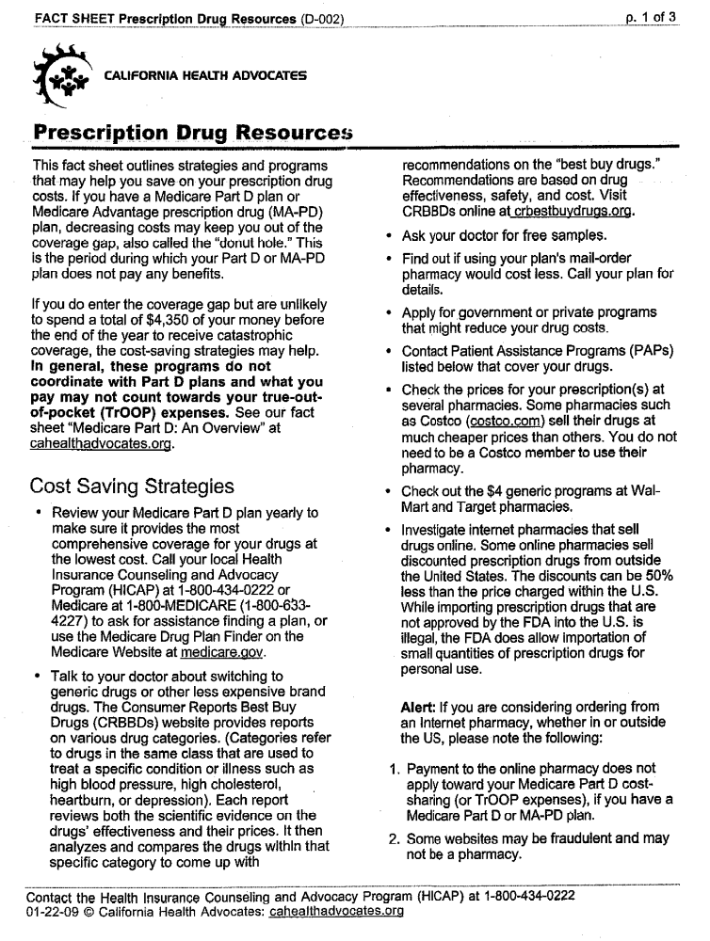
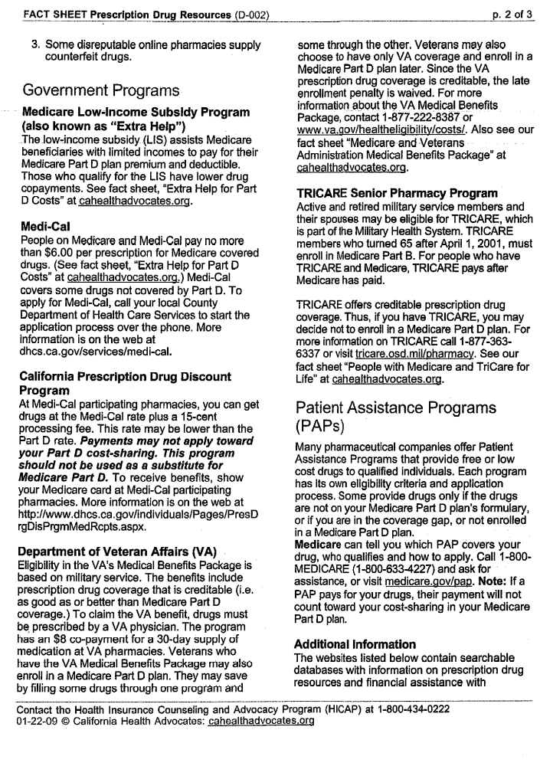
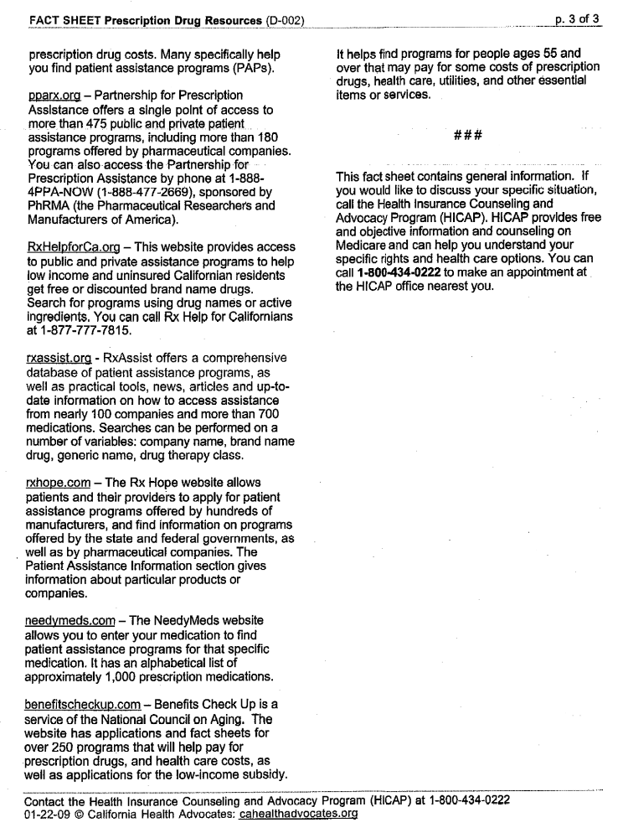
Medicare Premiums:
Part A:
Most people don’t pay a Part A premium because they paid Medicare taxes while working.
In 2011, you pay up to $450 each month if you don’t get premium-free Part A. If you pay a late enrolment penalty, this amount is higher.

Part B;
Currently Part B premiums can run from $96.40 up to $115.40 (possible higher, up to $369.10; depending upon Individual Tax Returns filed for tax year 2009). Medicare premiums have not increase for some enrollees since 1-1-10. Newer enrollee may have a higher premium depending upon when they became eligible for Medicare and enrolled in Part B.

Part C and D;
Amount of premium depends upon the MCO chosen and whether or not you are eligible for Extra Help of some kind.

You can get further general information on Medicare benefits at:
www.medicare.gov/Publications/Pubs/pdf/10050.pdf

www.medicare.gov

Medicare handbook called Medicare and You, is available through Social Security.

Medicaid Waiver for individuals with Intellectual Disabilities:

Most individuals that are eligible for the waiver become eligible for Medicare benefits because:

  - They have paid into the Social Security system or are the disabled child of some one who paid into the system;
  - They have been determined to be disabled by Social Security;
  - They are drawing Social Security Disability benefits and have drawn those benefits for at least 24 months.

An individual can draw Social Security Disability benefits because they worked and paid into the system. They can also draw if they are disabled; one of their parents paid into the system; and that parent becomes disabled, retires, or dies.

Notices are mailed out to the payee advising of eligibility for Medicare with information on how to get enrolled onto Medicare Part A and B. Private Managed Care Organization’s (MCO) may send out information on how to enroll in Part C if any of our individuals are interested in that type of coverage.

***If an individual is receiving TennCare/Medicaid in Tennessee and are enrolled into Medicare, TennCare will stop paying for prescription costs. The individual would need to enroll in a Medicare Part D plan to obtain prescription coverage.

***The individual may also be eligible for Qualified Medicare Beneficiary or Special Low Income Medicare Beneficiary benefits, available by application through Department of Human Services (DHS). When someone in the waiver receives notice of Medicare benefits starting, you need to notify the appropriate DHS/DIDD counselor to determine whether or not the individual meets the requirement for one of these benefits.

Qualified Medicare Beneficiary (QMB)

The Medicare Catastrophic Coverage Act (MCCA) of 1988 mandated coverage for individuals who are entitled to and have Medicare Part A and who meet specified resource and income standards. The coverage will provide for payment of Medicare premiums, coinsurance, and deductibles of Medicare covered services (Part A and B).

Individuals may be eligible for this coverage if they are entitled to and have Part A, and their total countable resources do not exceed 200% of the SSI resource limit (currently $4000 for an individual and $6000 for a couple). Also, their income must be equal to or less than 100% of the Federal Poverty Level Income Standard (PLIS- currently $908 for an individual, $1226 for a couple).

***Individuals who do not have Part A may be referred to the local Social Security office for enrollment. The enrollment period extends from January 1 to March 31 each year. Entitlement does not begin until July of the same year.
Special Low Income Medicare Beneficiary (SLMB)

Effective January 1, 1993, Section 4501 (b) of the Omnibus Budget Reconciliation Act (OBRA) of 1990 required states to pay Medicare Part B premiums for individuals whose income exceed QMB standards but is less than a specified higher percentage of Poverty Level. The coverage is similar to QMB but with these requirements:

  - Eligibility is based on a higher income standard of 120% of the PLIS (currently $1089 for an individual, $1471 for a couple.
  - The only benefit payment is of the Part B Medicare premium.
  - SLMB eligibility may serve to establish Part B Medicare coverage for individuals who had earner refused this coverage. Since no premiums were withheld in this situation, no refund is due.
  - Individuals may be eligible for this coverage is entitled to or receiving Medicare Part A due to attaining age 65 or receipt of Social Security disability for 24 months.
  - Countable resources may not exceed 200% of the SSI resource limit ($4000 for an individual, $6000 for a couple).

Qualifying Individuals (QI1)

The Balande Budget Act (BBA) of 1997 created a new category of eligibility for states so assist qualified individuals in payment of Medicare Part B premiums. This new category is in addition to the QMB and SLMB.

Any individual may qualify for the QI1 category by meeting the following requirements;

  - Must have income over the 120% of PLIS (currently $1089 for individual, $1472 for a couple) but no more than 135% of PLIS (currently $1226 for individual);
  - Must have resources below or at $4000 for individual, and
  - Must not be enrolled in TennCare/Medicaid or TennCare Standard.

QI1 pays only the current Medicare Part B premium; it does not pay additional medical benefits. Once an individual has been approved for QI!, the recipient will remain eligible for this benefit for the remainder of the current year. Eligibility must be re-determined in December in order to qualify for the next year.

Qualified Disabled Working Individuals (QDWI)

Section 6012 of the Omnibus Budget Reconciliation Act (OBRA) of 1989 provides for certain disabled working individuals (DWI) under age 65 who have exhausted their Medicare coverage an option to purchase Medicare Hospital Insurance Benefits (Medicare Part A) for an indefinite period.

DWI are responsible for paying their own Medicare premium themselves if their income is more than 200% of the PLIS, or their resource exceed twice the SSI resource standard for an individual/couple, or they are recipients of full TennCare Medicaid coverage.

This type of coverage would not be available to MR Medicaid Waiver participants or any other individual who is eligible for TennCare/Medicaid benefits.

- No TennCare card will be issued for QDWI. The Approval Notice of Disposition will be the individual’s proof of eligibility.
- The Centers for Medicare and Medicaid Services (CMS) will issue a Medicare card to the QDWI individual indicating the changes made about the individual’s Medicare eligibility.
- An individual will lose QDWI eligibility when:

- He/she becomes eligible for any category of
TennCare/Medicaid coverage for any period of time or;
- Resources exceed the resource limit, or;
- Income exceeds 200% of the PLIS in effect at the time, or;
- He/she becomes age 65 and is eligible for free Part A Medicare, or;
- SSA notifies DHS that the individual no longer meets the
disability requirements.

Representative Payee
A payee acts on behalf of the beneficiary. A payee is responsible for everything related to benefits that a capable beneficiary would do for himself or herself. SSA encourages payees to go beyond just managing finances and to be actively involved in the beneficiary’s life. The following lists the required duties of a payee.
Required Duties:
- Determine the beneficiary’s needs and use his or her payments to meet those needs;
- Save any money left after meeting the beneficiary’s current needs in an interest bearing account or savings bonds for the beneficiary's future needs;
- Report any changes or events which could affect the beneficiary’s eligibility for benefits or payment amount;
- Keep records of all payments received and how they are spent and/or saved;
- Provide benefit information to social service agencies or medical facilities that serve the beneficiary;
- Help the beneficiary get medical treatment when necessary;
- Notify SSA of any changes in your (the payee's) circumstances that would affect your performance or continuing as payee;
- Complete written reports accounting for the use of funds; and
- Return any payments to which the beneficiary is not entitled to SSA.
Food Stamps
- Food: Households consisting entirely of Supplemental Security Income (SSI) and/or Families First (FF) recipients are categorically eligible for Food Stamps. Consider individuals as SSI or FF recipients when they are:

- receiving a Families First or Supplemental Security Income cash assistance; or

- eligible for FF or SSI payments, but the payments are being recouped or suspended; or
- Approved for FF, but do not receive a payment because the grant amount is less than $10.

Eligible Foods using Food Stamps
- Any food or food product intended for human consumption except alcoholic beverages, tobacco, and hot foods and hot food products prepared for immediate consumption;

- Seeds and plants to grow for the personal consumption of eligible food stamp households;

- Meals prepared and delivered by an authorized meal delivery service to households eligible to use coupons to purchase meals or to households eligible to use coupons for communal dining at communal dining facilities for the elderly, for SSI households or both;

- Meals prepared and served by an authorized drug addict or alcoholic treatment and rehabilitation center to households eligible to use coupons to purchase those meals;

- Meals prepared and served by an authorized group living arrangement facility to residents who are blind or disabled recipients of benefits under Title II (RSDI) or Title XVI (SSI) of the Social Security Act;

- Meals prepared by and served by a shelter for battered women and children to its eligible residents.
Energy Assistance Programs
http://liheap.ncat.org/profiles/Tenn.htm - can search by area utility
http://www.tennessee.gov/humanserv/adfam/afs_hea.html
http://www.ethra.org/services/housing-restoration/energy-assistance.htm
http://www.utilitybillassistance.com/html/tennessee_assistance_and_help_.html
www.uethda.org/mpc/FY10%20Client%20LIHEAP%20Application.pdf

Online Coupon or Savings Website/Resources

www.groupon.com
www.halfpricedepot.com
www.livingsocial.com

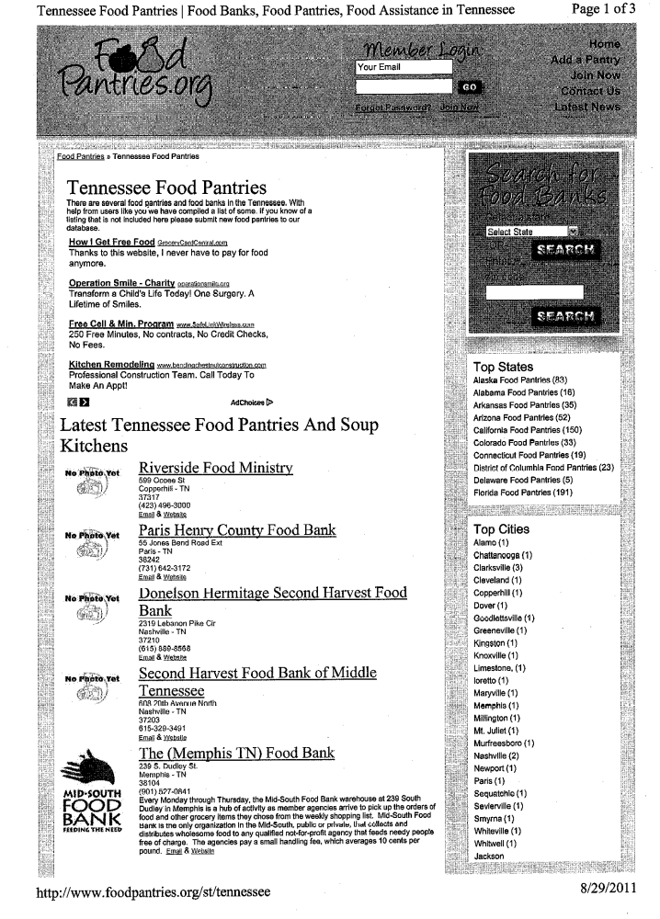
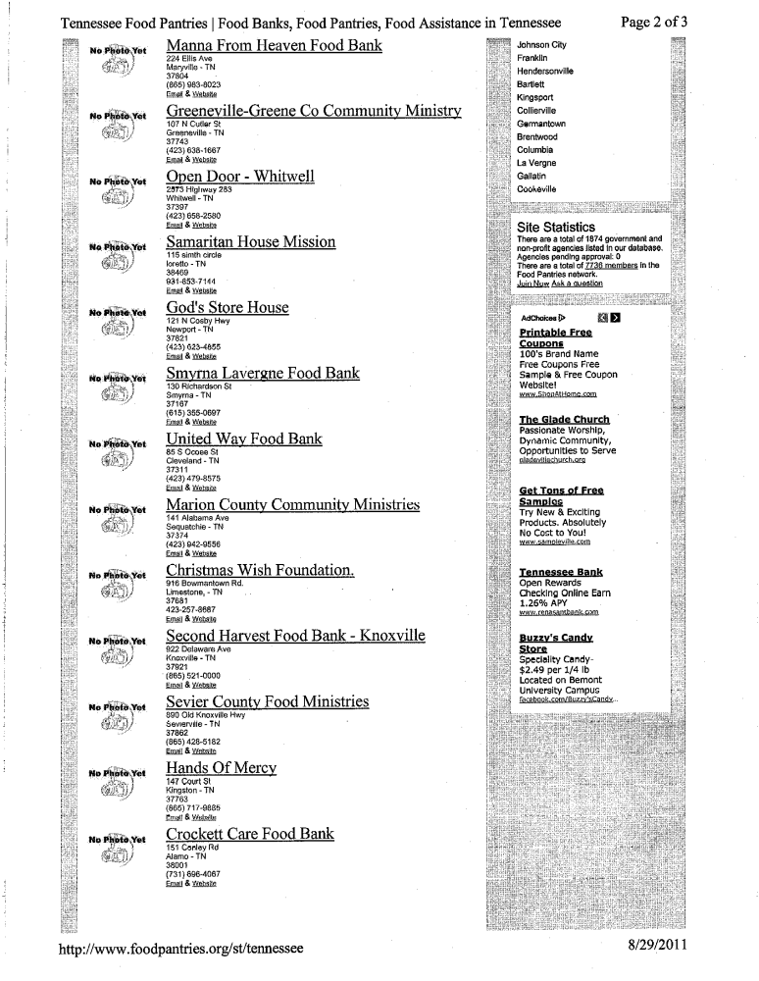
Television/Cable Access
  - Cable service requires a cable, and thus many rural and highly remote areas are not served by cable companies. Cable service is almost universally available in towns and cities. Satellite service is available anywhere that a satellite dish has an uninterrupted view of the southern sky.
- DIRECTV® Official Sitewww.directv.com
150+Chs For $29.99/mo(1yr) + Access 6,000 Shows & Movies + Free Install
- AT&T™ Official Siteatt.com/U-verse
- DIRECTV® Official OfferDIRECTstarTV.com/Directv-Deals
150+ Channels Only $29.99/mo (1yr) Call & Get Free Showtime (3 Months)
- Comcast® - Official Sitewww.comcast.com/move
Sign Up For Comcast Digital Cable Learn More About Local Offers
Read more: Comparison of Cable & Satellite | eHow.com

http://www.ehow.com/about_6327893_comparison-cable-satellite.html#ixzz1WQm4Mc4d

Packages | AT&T | Comcast | DirecTV | DISH | Verizon Fios
Number of National Packages | 6 | 6 | 4 | 8 | 3
Package Price Range | $19 to $117 | $20 to $134 | $61 to $115 | $35 to $105 | $65 to $90
Average Package Price | $67 | $73 | $78 | $59 | $77
"Entry" Package Price | $19 | $20 | $61 | $35 | $65
Overall Packages | Very Good | Fair | Good | excellent | Fair
Netflix; For only $7.99 a month, instantly watch unlimited movies & TV episodes streaming over the Internet to your TV via an Xbox 360, PS3, Wii or any other device that streams from Netflix. You can also watch instantly on your computer too!
Employment

Benefits To Work
If you are hesitant about pursuing work goals because of concerns about your benefits, Benefits to Work can help at absolutely no charge to you!
- Are you currently a Social Security beneficiary (SSI or SSDI) and interested in returning to work?
- Do you often wonder what will happen to your Social Security cash benefits if you return to work?
- Do you wonder how working may affect your Medicare or Medicaid?
- Do you question how much you can earn and still receive disability benefits?
Benefits to Work, a program of Tennessee Disability Coalition and the Center for Independent Living of Middle Tennessee (CIL-MT) can help you find the answers. Our Work Incentive Planning and Assistance program (WIPA) is offered to all residents of Tennessee. WIPA programs are community-based organizations that receive grant funding from the Social Security Administration (SSA) to work with SSA beneficiaries with disabilities to explore work options and career development.
Our WIPA program is staffed with counselors called, Community Work Incentive Coordinators (CWIC), who are stationed across the state to best serve our clients in the communities where they live. CWICs can provide you with an individualized plan to help you make informed choices about employment and answer any questions about SSA rules.
Planning Services:
- We will review your current situation with you.
- We will ask you to share your goal(s) to pursue, maintain, or advance employment (or self-employment).
- We will contact Social Security to request information about your disability benefits.
- This background will provide a basis to educate you about the work incentives that may be available to support your employment goals.
- In doing so, we will help you to understand the potential impact of employment on your specific circumstances.
- We may write a Benefits Summary and Analysis report (BS & A) that will provide an overview of your specific circumstances, the potential impact of working, and available options.
- We may write a Work Incentive Plan (WIP) that will provide a step-by-step plan for pursuing your work goals and it will be updated as your circumstances change.
Assisting Services:
- We work in cooperation with Federal, state, and nonprofit organizations that serve beneficiaries with disabilities.
- We will tell you about (and refer you to) employment supports agencies such as Employment Networks (ENs) or Vocational Rehabilitation (VR) We will provide long-term support of your employment efforts.
- We will be available to answer questions as you move from benefit dependency to independence.
- We will refer you to those who can protect your rights if employment discrimination is suspected, e.g. the Protection and Advocacy for Beneficiaries of Social Security program (PABSS).
Community Outreach and Education Services:
- Benefits to Work facilitates community-based Work Incentives SEminars (WISE) for individuals with disabilities and their families.
- These SSA-sponsored WISE events provide education about Ticket to Work and/or other work incentives.
- At these seminars you will have the opportunity to meet representatives of organizations who can assist you with going to work for the first time, returning to work, or reaching other employment goals.
To be eligible for services from Benefits to Work, you must be:
  - Between the ages of 14 and 64;
  - Working or interested in working;
  - A current beneficiary of Social Security Disability (SSDI) and/or (SSI); and
  - Be a resident of one of these counties in east and middle Tennessee: Anderson, Bledsoe, Blount, Bradley, Campbell, Cannon, Carter, Claiborne, Clay, Cocke, Coffee, Cumberland, DeKalb, Fentress, Franklin, Grainger, Greene, Grundy, Hamblen, Hamilton, Hancock, Hawkins, Jackson, Jefferson, Johnson, Knox, Loudon, Macon, Mrion, McMinn, Meigs, Monroe, Moore, Morgan, Overton, Pickett, Polk, Putnam, Rhea, Roane, Scott, Sequatchie, Sevier, Smith, Sullivan, Unicoi, Union, Van Buren, Warren, Washington, or White.
All other counties are served by CIL-MT. To learn more visit: www.cil-mt.org.
For more information contact:
Toll Free: 1 (888) 839-5333

Senior Services
http://seniordirectory.com

Comprehensive Listing of Senior Services:
Senior Housing, Home Health, Professional Services, Health Services, Community Resources, Activities and Entertainment, etc

About BenefitsCheckUp
http://www.benefitscheckup.org/
Many older people need help paying for prescription drugs, health care, utilities, and other basic needs. Ironically, millions of older Americans — especially those with limited incomes — are eligible for but not receiving benefits from existing federal, state and local programs. Ranging from heating and energy assistance to prescription savings programs to income supplements, there are many public programs available to seniors in need if they only knew about them and how to apply for them.
Developed and maintained by The National Council on Aging (NCOA), BenefitsCheckUp is the nation's most comprehensive Web-based service to screen for benefits programs for seniors with limited income and resources.
BenefitsCheckUp includes more than 2,000 public and private benefits programs from all 50 states and the District of Columbia, such as:
- Prescription drugs
- Nutrition (including Supplemental Nutrition Assistance (SNAP)/Food Stamps)
- Energy assistance
- Financial
- Legal
- Health care
- Social Security
- Housing
- In-home services
- Tax relief
- Transportation
- Educational assistance
- Employment
- Volunteer services
Since 2001, millions of people have used BenefitsCheckUp to find benefits programs that help them pay for prescription drugs, health care, rent, utilities, and other needs.

