Dignified Changes: Universal Changing Tables

Community inclusion means getting our loved ones off the floors of public restrooms.

The Problem:
- Most people have never thought about adult sized changing tables, but approximately 200,000 Tennesseans (4% of the population) needs assistance with daily living, including toileting.
- Without adult-sized changing tables, Tennesseans who need them must choose between changing in an unhygienic setting – like on a restroom floor – or remaining isolated from the community.
- This issue affects thousands more Tennesseans: family members, friends and caregivers cannot spend time in the community without access to adult-sized changing tables.

The Solution:
- Adult-sized changing tables are also known as “universal changing tables” because they can accommodate people of all ages. They can replace baby changing tables to support everyone, through the lifespan.

Best Practices for changing tables:
- Powered and height-adjustable, for safety of the person and caregiver assisting
- Placed in single occupancy restrooms, universal to gender
- Size of room: 10x14.6. Turning radius of 60” for the wheelchair in the middle of the room and 36” of space at one end of the table.
- Clear signage at the entrance of the building

Recommended Models:
Manufacturer/ Model | Wall Mounted or Free Standing | Size  (W x L) | Weight Capacity | Height Range from floor | Foldable  (Manual or Electric Fold) | Control Options | Safety Belt | Price Range | Recommended Use
Pressalit  1000 (R8403000-93)  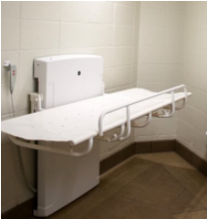 | Wall | 23.5” x 71” | 331 lbs. | 18.9 -34.7” | Yes  (Manual Fold) | Wired Hand control; | No | $6199 | Individual, low volume use.  Requires some cleaning,  Mattress may wear with high volume use.
OmniMax Family Restroom Changing Table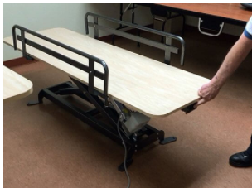 | Freestanding- Bolt to floor | 25” x 72” and  30” x 76” | 400 lbs. | 18” -37” | No– Floor Mounted | Built in rocker switch (head/foot of table) | Yes | $2445 -$2645 | Public Restroom, High volume unsupervised use. Solid, non-porous surface.  Vandal resistant, not many moving parts

