Timber Sale Document Packet


Division of Forestry | P.O. Box 40627 | Nashville, TN 37204
Phone: 615-837-5411 | http://www.tn.gov/agriculture/forests

PUBLIC NOTICE

STATE FOREST TIMBER SALE BIDS

ANNOUNCEMENT
A current list of state forest timber sales can be found at: https://www.tn.gov/agriculture/forests/state-forests/state-forest-timber-sales.html.

Instructions to Bid on Sale(s)
- Download and review the "Invitation to Bid and Pro Forma Contract" using the link for the timber sale(s) you are interested in submitting a bid (for example A-04-21-02). Save the file(s) to your computer. Then, either:
  - Print and fill out the "Invitation to Bid" pages for each sale that you want to submit a bid on and submit by hand or mail. OR
  - Digitally fill out and submit the online State Forest Timber Sale Bid Form located here: https://stateoftennessee.formstack.com/forms/state_forest_timber_sale_bids.
- Complete the "Bid" information for each sale you want to submit a bid on. One digital or physical form must be completed for each individual sale. All "required" information must be provided or the bid will be rejected.
- Deliver bid - Bids will be accepted in the following methods:
  - ONLINE:
  - Select the individual sale you are bidding on from the drop-down menu, then fill in the rest of the required information on the form.
    - NOTE: Only select one sale at a time. If bidding on multiple sales, you must complete the bid form once for each sale. You may not submit one form for multiple sales.
  - Enter your name at the end of the form to sign the bid submission, then click on the "PLACE BID" button to submit your bid. The form is the same for all sales.
  - Repeat these steps for each sale you are bidding on.
  - HAND DELIVERY
  - The appropriate bid number must be on the outside of the envelope and the envelope sealed. Only one bid per envelope. Please print the name of the bidder, organization, and telephone number on the outside of the bid using the ‘Pre-printed Bid Envelope Label’ provided in the bid packet. The State assumes no responsibility for lost or misdirected bids.
  - Bring the sealed Bid to the Bid Opening location during normal business hours prior to the specified time bids are to be opened.
  - MAILED
  - The appropriate bid number must be on the outside of the envelope and the envelope sealed. Only one bid per envelope. Please print the name of the bidder, organization, and telephone number on the outside of the bid using the ‘Pre-printed Bid Envelope Label’ provided in the bid packet. The State assumes no responsibility for lost or misdirected bids.
  - Put the sealed envelope into a larger envelope and mail to the address provided in the "Invitation to Bid". If more than one bid is being submitted, the individual sealed envelopes may be placed in one large envelope and mailed to the appropriate address.
Submission of the bid(s) shall follow the GENERAL PROVISIONS of the bid.
If you have problems downloading or viewing the timber sales files, please contact Greg Bailey, State Forest Unit Leader, to get invitations to bid by mail. Please include the sale number(s) along with your name, street address, city, zip code and phone number with your request.

Greg Bailey
State Forest Unit Leader – Tennessee Department of Agriculture Division of Forestry
P.O. Box 40627
Nashville, TN 37220
(615) 253-1602
greg.bailey@tn.gov

Bid Opening Online Public Access
There will be an online video meeting for each of the timber sale bid openings.
Each session will start an hour before the actual time of the meeting so any technology issues can be worked out. Participants are advised to take advantage of this lead time to test their connection.
There is a unique password and unique link for each of the sessions. This is an extra security measure to dissuade attackers rather than keep out the public.
A link to the WebEx meeting will be available on the State Forest Timber Sales webpage by noon the day prior to the bid opening - https://www.tn.gov/agriculture/forests/state-forests/state-forest- timber-sales.html

Procedures

State Forest Timber Sale Information
Each year, selected stands of timber in Tennessee’s State Forests are harvested to promote healthy forest growth, renew forest cycles, and maintain a balanced mix of tree ages and habitat.
State Forest resources are managed for the benefit of Tennessee’s citizens and serve multiple uses. Management follows state laws (Tennessee Code Annotated, Title 11, Chapter 4) and forestry rules (Chapter 0080-07-01, Protection of the State Forests). Professional foresters apply sound, science- based practices to ensure the forests remain healthy, productive, and sustainable.
Timber harvests are conducted through sales governed by General Services Rule 0690-2-1-.18(a), Disposal of Forestry Products. These sales use a sealed bid process, awarding the timber to the highest bidder. The successful purchaser enters into a Timber Sales Contract detailing the terms and conditions for harvesting and removal. By rule, all sales require the purchaser to submit a performance deposit equal to 7% of the sale price.

State Forest Timber Sale Public Notice
The Tennessee Department of Agriculture, Division of Forestry, is offering for sale under Bid # A-09-27-01, A-09-27-02, and A-09-27-03 certain timber on Natchez Trace State Forest near Lexington, Tennessee. Sealed bids will be received in the Natchez Trace State Forest Work Center of the Division of Forestry, located at 465 Parsons Road, Wildersville, TN 38388, until 10:30 AM CST on March 31st, 2026, at which time they will be publicly opened. The Forestry Division estimates but does not guarantee that 954,000 board feet (Doyle Rule) of sawtimber are available for removal.
Only bids submitted on bid forms furnished by the Tennessee Department of Agriculture, Division of Forestry, will be considered. The successful bidder will be required to sign a timber sale contract, at which time they will pay the full purchase price and post a performance bond equaling Seven (7) percent of the sale price of the timber. Each of these amounts will be in the form of a certified check payable to the Tennessee Department of Agriculture, Division of Forestry (separate checks will be required).
Forestry Division personnel will conduct a tour of the sale area to perspective timber buyers by appointment only.
Interested bidders may obtain bid forms, pro forma contract, a map of the sale area, and additional information at:
https://www.tn.gov/agriculture/forests/state-forests/state-forest-timber-sales.html
Or, by contacting State Forest Unit Leader, Greg Bailey (615) 253-1602 or Forester, Jonathan Vonesh (731) 234 8049 at 465 Parsons Rd, Wildersville TN 38388.

Pro Forma Contract
This Contract, by and between the State of Tennessee, Department of Agriculture, Division of Forestry (“STATE”) and Purchaser’s Name (“PURCHASER”), provides for the sale and harvesting of timber on state forest land, as further defined in this Contract. The STATE and the PURCHASER may be referred to individually as a “Party” or collectively as the “Parties” to this Contract.
The PURCHASER’s address is:
Street
City State, Zip Code

The PURCHASER agrees to buy, and the STATE agrees to sell certain timber on Natchez Trace State Forest (“State Forest”) further described in Addendum A and location depicted on maps in Addendum B.
The PURCHASER agrees to harvest said timber and provide other services in strict compliance with all terms set forth in this Contract.
- CONTRACT TERM - This Contract shall be effective on the latter day of execution signed below and extend until December 1, 2028 (“Term”). The date for completion of this Contract or other dates specified therein may be subject to extension(s) at the STATE's discretion. The PURCHASER shall complete all services and activities set forth in this Contract within the Term of the Contract.
- PAYMENT - Purchase price shall be paid in full by a certified check or a cashier’s check payable to the Tennessee Division of Forestry in the amount of $AMOUNT when the timber sale contract is signed. The interior body of the check must not be perforated or have holes punched into its surface. Unless otherwise provided for in this Contract, the STATE shall have no obligation to return any portion of the purchase price to the PURCHASER.
- BOND - A performance bond (7% of purchase price) in the amount of $AMOUNT shall be furnished by the PURCHASER. Bond shall be furnished in the form of a certified check or a cashier’s check. The interior body of the check must not be perforated or have holes punched into its surface. The bond is returnable in full to the PURCHASER at the time the terms of this agreement have been fully met. If any conditions of this agreement are not complied with, the value of such damages or violations shall be deducted and the balance, if any, shall be returned to the PURCHASER.
The PURCHASER shall notify the STATE in writing upon termination of cutting and shall request in writing the return of the performance bond subject to final inspection of the sale area by the STATE and any performance bond deductions for damage or penalties. If the PURCHASER fails to submit a written request to the STATE within thirty (30) days after the end of the Term, the State shall conduct a review of the sale area(s) and send the any performance bond balance to the PURCHASER’s address provided in this Contract.
- EXTENSIONS – The STATE has the authority to grant extensions requested in writing by the PURCHASER at a fee of twelve percent (12%) of total sale price per year or a minimum of two hundred dollars ($200.00) per month. Extensions shall be for a minimum of one (1) month. PURCHASER must request an extension in writing at least thirty (30) days prior to the expiration date of this Contract or the date specified for the applicable activity. An extension of the term of this Contract or other specified date(s) shall be affected through an amendment to the Contract.
- MODIFICATION AND AMENDMENT - This Contract may be modified only by a written amendment signed by all Parties and approved by all applicable State officials.
- SPECIAL TERMS AND CONDITIONS – Special terms and conditions are described and listed in Addendum C. Should any of these special terms and conditions conflict with any other terms and conditions of this Contract, these special terms and conditions shall control.
- PENALTIES - PURCHASER shall exercise caution, to prevent damage to trees not designated for harvest. Any undesignated trees cut or damaged shall be paid for at the rate of $3,000.00 per thousand board feet, Doyle Rule, for sawtimber and $100.00 per ton for pulpwood as estimated solely by the STATE. Any undesignated trees cut or damaged in designated retention zones or streamside management zones shall be paid at the rate of $2,500.00 per occurrence plus the above-mentioned rates for sawtimber and pulpwood for the individual trees cut or damaged as determined and estimated by the STATE. Excepting at places designated by the STATE or other terms and conditions of this Contract, excessive travelling in or through retention zones, streamside management zones, equipment restriction zones or outside the sale area with heavy equipment shall be paid at the rate of $2,500.00 per occurrence as determined solely by the STATE.
- PROTECTION - PURCHASER shall exercise reasonable care to prevent undue damage to the forest, roads, and skid trails and undue risk to public safety. The STATE shall have authority to temporarily close all or any part of the PURCHASER'S operations to prevent damage and threats to public safety.
  - PURCHASER shall keep all roads, trails, ditch lines, fields, and streams clear of treetops, limbs, and other debris. Forest roads used in connection with this sale shall be kept in a passable condition for normal use.
  - PURCHASER shall construct on temporary roads and skid trails erosion control structures such as water bars and broad-based dips to satisfaction of the STATE. All erosion control structures shall be maintained in working condition during PURCHASER'S operations.
  - PURCHASER shall remove daily all bottles, cans, paper and other litter from the timber sale area(s).
  - PURCHASER, at the direction of the STATE or by other terms and conditions of this contract, shall stop timber harvesting operations one day before and during managed hunts or other times hunting seasons are open as designated by proclamation of the Tennessee Wildlife Resources Agency Commission.
  - PURCHASER shall prevent and suppress any forest fires in or adjacent to the sale area(s). PURCHASER shall notify the STATE that a forest fire(s) occurred in or adjacent to the sale area(s). If necessary to prevent death, bodily injury, or damage to the State Forest, PURCHASER shall alert local law enforcement and emergency responders of any active forest fire in or adjacent to the sale area(s).
  - PURCHASER shall disperse logging slash and debris from timber bunching areas to the satisfaction of the STATE.
  - PURCHASER shall not allow a third-party to take possession of timber sold by the PURCHASER to a third-party while on the State Forest.
  - PURCHASER shall not bring onto the State Forest logs or unprocessed forest products not cut on the State Forest, except as permitted by the STATE. State, county, or municipal public roads or rights-of-way passing through the State Forest are not considered State Forest.
  - The PURCHASER shall not drain or dump grease, hydraulic fluid, oil, fuel, antifreeze or hazardous material on the State Forest. If a spill or leak occurs, the PURCHASER is responsible for the cleanup and proper disposal of the spilled material, contaminated materials used to contain or clean-up the spill, and contaminated soil. PURCHASER and/or subcontractor(s) shall have tools and materials on-site to contain and clean up spills. The PURCHASER shall notify the STATE immediately of any spill of hazardous material that meets or exceeds reporting requirements according to federal and state laws, rules or regulations. Where a more stringent quantity reporting amount does not exist, the PURCHASER shall notify the STATE immediately of any spill greater than five (5) gallons.
- IMPROVEMENTS - The location of all improvements, including sawmill sets, roads, skid trails, bridges, culverts, and timber bunching areas to be made by the PURCHASER in performing this Contract shall be approved by the STATE in advance of location or construction. All structural improvements are to be removed on or before the date of completion of this Contract, unless otherwise agreed upon. If PURCHASER fails to remove all improvement(s) within the stated period, they shall become the property of the STATE, but that shall not relieve PURCHASER of liability for the cost of their removal and restoration of the site.
- LIMITATION OF STATE’S LIABILITY - The STATE shall have no liability except as specifically provided in this Contract. In no event will the STATE be liable to the PURCHASER or any other party for any lost revenues, lost profits, loss of business, decrease in the value of any securities or cash position, time, goodwill, or any indirect, special, incidental, punitive, exemplary or consequential damages of any nature, whether based on warranty, contract, statute, regulation, tort (including but not limited to negligence), or any other legal theory that may arise under this Contract or otherwise.
- HOLD HARMLESS - The PURCHASER agrees to indemnify and hold harmless the State of Tennessee as well as its officers, agents, and employees from and against any and all claims, liabilities, losses, and causes of action which may arise, accrue, or result to any person, firm, corporation, or other entity which may be injured or damaged as a result of acts, omissions, or negligence on the part of the PURCHASER, its employees, or any person acting for or on its or their behalf relating to this Contract. The PURCHASER further agrees it shall be liable for the reasonable cost of attorneys’ fees, court costs, expert witness fees, and other litigation expenses for the State to enforce the terms of this Contract.
In the event of any suit or claim, the Parties shall give each other immediate notice and provide all necessary assistance to respond. The failure of the State to give notice shall only relieve the PURCHASER of its obligations under this Section to the extent that the PURCHASER can demonstrate actual prejudice arising from the failure to give notice. This Section shall not grant the PURCHASER, through its attorneys, the right to represent the State in any legal matter, as the right to represent the State is governed by Tenn. Code Ann.
§ 8-6-106.
- ASSIGNMENT AND SUBCONTRACTING - The PURCHASER shall not assign this Contract or enter into a subcontract for any of the services performed under this Contract without the prior written approval of the STATE. Notwithstanding any use of approved subcontractors, the PURCHASER shall be the prime contractor and responsible for compliance with all terms and conditions of this Contract. The STATE reserves the right to request additional information or impose additional terms and conditions before approving an assignment of this Contract in whole or in part or the use of subcontractors in fulfilling the PURCHASER’s obligations under this Contract.
- CROSSING PRIVATE PROPERTY - PURCHASER shall be responsible for securing permission to cross private property as may be convenient or necessary in the performance of this contract.
- CONFLICT OF INTEREST - The PURCHASER warrants that no part of the PURCHASER’S compensation shall be paid directly or indirectly to an employee or official of the State of Tennessee as wages, compensation, or gifts in exchange for acting as an officer, agent, employee, subcontractor, or consultant to the PURCHASER in connection with any work contemplated or performed under this Contract.
The PURCHASER acknowledges, understands, and agrees that this Contract shall be null and void if the PURCHASER is, or within the past six (6) months has been, an employee of the State of Tennessee or if the PURCHASER is an entity in which a controlling interest is held by an individual who is, or within the past six (6) months has been, an employee of the State of Tennessee.
- BEST MANAGEMENT PRACTICES - Where a more strict standard is not required by the terms this Contract or where this Contract does not provide a standard, the standard of performance shall be consistent with STATE’s publication "Best Management Practices (BMP) for Timber Harvesting in Tennessee."
- MASTER LOGGER REQUIREMENT - PURCHASER’s on-site supervisor must have successfully completed Tennessee’s Master Logger Program, or an equivalent program in another state.
Documentation of successful completion of the Master Logger Program must be provided to the STATE before any timber is cut and/or removed from the sale area(s). This requirement applies to the PURCHASER if the PURCHASER is the logging supervisor or to any logging supervisor that is subcontracted by the PURCHASER. If a subcontractor is to be used, documentation for the successful completion of the Master Logger Program or an equivalent program by the subcontractor’s on-site supervisor must be provided to the STATE at the time the subcontractor is submitted for approval. All Master Logger documentation shall be valid for the entire duration of this Contract. It is solely the PURCHASER’s responsibility to ensure all Master Logger documentation is valid.
- WATER QUALITY ENFORCEMENT ACTIONS – Neither the PURCHASER, the PURCHASER’S on-
site supervisor nor subcontractor’s on-site logging supervisor shall be permitted to conduct any logging activities on the State Forest if the individual(s) is subject of an open Notice of Violation (NOV) with the Department of Environment and Conservation, hereinafter referred to as “TDEC”, or similar action(s) in another state(s). All logging activities shall cease until any and all NOVs are closed by TDEC or similar authority in another state or permitted to resume by the State Forester.
No PURCHASER, PURCHASER’s on-site supervisor nor PURCHASER’s subcontracted on-site logging supervisor shall be permitted to conduct logging activities on the State Forest if the individual has received from TDEC a “Stop Work”, “Director’s” or “Commissioner’s” Order under Tennessee Code Annotated, Water Control Act, Sections 69-3-100 through 69-3-142, or similar action(s) in another state. Should such Orders be issued to the PURCHASER, on-site supervisor or subcontractor during the contract term, all logging activity shall cease until a qualified on-site supervisor or approved subcontractor replacement can be found.
PURCHASER shall notify the STATE within twenty-four (24) hours of receiving any water quality enforcement action issued by TDEC or similar authority in another state, excepting weekends and state holidays.
- STRICT PERFORMANCE - Failure by any Party to this Contract to require, in any one or more cases, the strict performance of any of the terms, covenants, conditions, or provisions of this Contract shall not be construed as a waiver or relinquishment of any term, covenant, condition, or provision. No term or condition of this Contract shall be held to be waived, modified, or deleted except by a written amendment signed by the Parties.
- INDEPENDENT PURCHASER - The Parties shall not act as employees, partners, joint venturers, or associates of one another. The Parties are independent contracting entities.
Nothing in this Contract shall be construed to create an employer/employee relationship or to allow either Party to exercise control or direction over the manner or method by which the other transacts its business affairs or provides its usual services. The employees or agents of one Party are not employees or agents of the other Party.
- STATE AND FEDERAL COMPLIANCE - The PURCHASER shall comply with all State and federal laws and regulations applicable to PURCHASER in the PURCHASER’S performance of this Contract.
- GOVERNING LAW - This Contract shall be governed by and construed in accordance with the laws of the State of Tennessee, without regard to its conflict or choice of law rules. The Tennessee Claims Commission or the state or federal courts in Tennessee shall be the venue for all claims, disputes, or disagreements arising under this Contract. The PURCHASER acknowledges and agrees that any rights, claims, or remedies against the State of Tennessee or its employees arising under this Contract shall be subject to and limited to those rights and remedies available under Tenn. Code Ann. §§ 9-8-101 - 408.
- COMPLETENESS - This Contract is complete and contains the entire understanding between the Parties relating to its subject matter, including all the terms and conditions of the Parties’ agreement. This Contract supersedes any and all prior understandings, representations, negotiations, and agreements between the Parties, whether written or oral.
- SEVERABILITY - If any terms and conditions of this Contract are held to be invalid or unenforceable as a matter of law, the other terms and conditions of this Contract shall not be affected and shall remain in full force and effect. The terms and conditions of this Contract are severable.
- HEADINGS - Section headings of this Contract are for reference purposes only and shall not be construed as part of this Contract.
- RESIDUAL TIMBER - Any standing or felled timber remaining on the designated sale area(s) after the term of this Contract, shall thereafter be the sole and exclusive property of the STATE.
Notwithstanding any standing or felled timber remaining on the designated area(s) after the term of this Contract, the STATE shall have no obligation to return any portion of the purchase price to the PURCHASER.
- STATE FURNISHED PROPERTY - The PURCHASER shall be responsible for the correct use, maintenance, and protection of all articles of nonexpendable, tangible, personal property furnished by the STATE for the PURCHASER’s use under this Contract. Upon termination of this Contract, all property furnished by the STATE shall be returned to the STATE in the same condition as when received, less ordinary wear. Should the property be destroyed, lost, or stolen, the PURCHASER shall be responsible to the STATE for the fair market value of the property at the time of loss.
- PROHIBITED ADVERTISING - The PURCHASER shall not suggest or imply in advertising or marketing materials that PURCHASER’S goods or services are endorsed by the STATE. The restrictions on PURCHASER advertising or marketing materials under this Section shall survive the termination of this Contract.
- COMMUNICATIONS AND CONTACTS - All instructions, notices, consents, demands, or other communications required or contemplated by this Contract shall be in writing and shall be given by hand delivery, by certified or registered mail, by a national overnight receipted delivery services which provides signed acknowledgments of receipt (including Federal Express, UPS, and other similar couriers delivery services), or by e-mail and addressed to the respective Party set forth in Addendum D. Such notices shall be deemed to have been given in the case of certified or registered mail when deposited in the United States mail with postage prepaid, in the case of overnight receipted delivery service the day the notice is deposited with the overnight delivery service, and in the case of e-mail when sent. All communications, regardless of method of transmission, shall be addressed to the respective Party at the appropriate mailing address or email address as set forth in Addendum D or any other address provided in writing by a Party.
- INCORPORATION OF ADDITIONAL DOCUMENTS - Each of the following documents is included as a part of this Contract by reference. In the event of a discrepancy or ambiguity regarding the PURCHASER’S duties, responsibilities, and performance under this Contract, these items shall govern in order of precedence below:
  - Any amendment to this Contract, with the latter in time controlling over any earlier amendments.
  - This Contract with any attachments or exhibits (excluding the items listed at subsections C. through E., below), which includes Addendum A, B, C, and D.
  - The STATE’s solicitation, as may be amended, requesting responses in
competition for this Contract.
  - Any technical specifications provided to bidders during the bidding process to award this Contract; and
  - The PURCHASER’s response seeking this Contract.
- TERMINATION FOR CONVENIENCE – The STATE may terminate this Contract for convenience without cause and for any reason. The STATE shall give PURCHASER at least thirty (30) days’ written notice before the termination date. Said termination shall not be deemed a breach of contract by the STATE. In no event shall the STATE’s exercise of its right to terminate this Contract for convenience relieve PURCHASER of any liability to the STATE for any damages or claims arising under this Contract.
Should the STATE exercise this provision, the STATE shall return a portion of the purchase price assessed under this Contract to PURCHASER in an amount equal to the value of any standing timber remaining on the designated sale area(s) on the date of termination. The final decision as to what the volume of any standing timber is shall be determined by the STATE. At the time of termination, the value of the timber shall be equal to the market value on the effective date of this Contract. In the event of disagreement, PURCHASER may file a claim with the Tennessee Claims Commission in order to seek redress.
Upon such termination, PURCHASER shall have no right to any actual, general, special, incidental, consequential, or any other damages whatsoever of any description or amount.
- TERMINATION FOR CAUSE - If the PURCHASER fails to properly perform its obligations under this Contract in a timely or proper manner, or if the PURCHASER materially violates any terms of this Contract (“Breach Condition”), the STATE shall have the right to immediately terminate the Contract. Should the STATE exercise this provision, the STATE may require the PURCHASER to forfeit any part or all performance bond amounts provided to the STATE at the sole discretion of the STATE. Notwithstanding the above, the PURCHASER shall not be relieved of liability to the STATE for damages sustained by virtue of any Breach Condition and the STATE may seek other remedies allowed at law or in equity for breach of this Contract. In the event of termination of this Contract in accordance with this provision, no portion of the purchase price provided to the STATE under this Contract shall be owed or be repayable to the PURCHASER.
- FORCE MAJEURE - “Force Majeure Event” means fire, flood, earthquake, elements of nature or acts of God, wars, riots, civil disorders, rebellions or revolutions, acts of terrorism or any other similar cause beyond the reasonable control of the Party except to the extent that the non-performing Party is at fault in failing to prevent or causing the default or delay, and provided that the default or delay cannot reasonably be circumvented by the non- performing Party through the use of alternate sources, workaround plans or other means. A strike, lockout or labor dispute shall not excuse either Party from its obligations under this Contract.
Except as set forth in this Section, any failure or delay by a Party in the performance of its obligations under this Contract arising from a Force Majeure Event is not a default under this Contract or grounds for termination. The non-performing Party will be excused from performing those obligations directly affected by the Force Majeure Event, and only for as long as the Force Majeure Event continues, provided that the Party continues to use diligent, good faith efforts to resume performance without delay. The occurrence of a Force Majeure Event affecting PURCHASER’S representatives, suppliers, subcontractors, customers or business apart from this Contract is not a Force Majeure Event under this Contract. PURCHASER will promptly notify the STATE of any delay caused by a Force Majeure Event (to be confirmed in a written notice to the STATE within one (1) day of the inception of the delay) that a Force Majeure Event has occurred and will describe in reasonable detail the nature of the Force Majeure Event. If any Force Majeure Event results in a delay in PURCHASER’s performance longer than thirty (30) days, the State may, upon written notice to Contractor immediately terminate this Contract. Contractor will not increase its charges under this Contract or charge the State any fees other than those provided for in this Contract as the result of a Force Majeure Event. In the event of termination of this Contract in accordance with this provision, the STATE may, in the STATE’s sole discretion, return to the PURCHASER any portion of the purchase price attributable to any standing or felled timber remaining on the designated sale area(s) at the time of termination.
- NONDISCRIMINATION - The PURCHASER hereby agrees, warrants, and assures that no person shall be excluded from participation in, be denied benefits of, or be otherwise subjected to discrimination in the performance of this Contract or in the employment practices of the PURCHASER on the grounds of handicap or disability, age, race, creed, color, religion, sex, national origin, or any other classification protected by federal or state law. The PURCHASER shall, upon request, show proof of nondiscrimination and shall post in conspicuous places, available to all employees and applicants, notices of nondiscrimination.
- WARRANTY - All stumpage offered for sale is sold "Where Is and As Is" without recourse. No representation, warranty (either express or implied), or guaranty is made by the STATE as to the quantity, quality, condition, size or description. Any discrepancy between the STATE'S estimated volume and the volume cut will not affect the validity of the sale or be considered the basis of a claim.
- REQUIRED APPROVALS - The STATE is not bound by this Contract until it is duly approved by the Parties and all appropriate STATE officials in accordance with applicable Tennessee laws and regulations. Approval shall be evidenced by signature or electronic approval.
- EARLY TERMINATION BY PURCHASER – PURCHASER may, upon 30 days’ written notice to the STATE, terminate this Contract without cause and receive return of the purchase price assessed under this Contract, provided that PURCHASER waives return of that portion of the purchase price, calculated as follows and equal to the greater of:
- 10% of the purchase price plus an additional amount calculated pro rata based on the number of days in the term that expired prior to the effective date of termination, relative to the number of days in the term; or
- 10% of the purchase price plus an additional amount calculated pro rata based on the value of timber felled prior to the effective date of termination, relative to the value of timber sold under this Contract. At the time of termination, the value of the timber shall be equal to the market value on the effective date of this Contract. The final determination as to volume of timber shall be determined by the STATE.

(Signatures on the following page)

Pro Forma Contract – Signatures Page
To be filled in following acceptance of a the bid by the Tennessee Department of Agriculture Division of Forestry.
Purchaser Signature, Organization, and Date

______________________________________________________
Type or Print Purchaser’s Name or Organization Above

______________________________________________________
Owner or Authorized Representative Signature Above

______________________________________________________
Enter Date Above

Tennessee Department of Agriculture Signature and Date

______________________________________________________
Commissioner, Andy Holt

______________________________________________________
Date

Forestry Division Signature and Date

______________________________________________________
State Forester, Heather Slayton

______________________________________________________
Date

Addendum A

Description of the A-09-27-02 Timber Sale Location and Timber being Sold

The Tennessee Department of Agriculture, Division of Forestry offers for sale certain marked timber in 2 sale area(s) located on:
State Forest – Natchez Trace State Forest County - Henderson
Nearest Town/City – Lexington Map Reference – Addendum B
Forest | Sale Area Number | Compartment | Stand | Acres | Boundary Color
NTSF | 1 | 24 | 5 | 36 | Orange
NTSF | 2 | 25 | 20 | 23 | Orange
TOTAL |  |  |  | 59

Although the Division of Forestry does not guarantee the accuracy of these figures, the species, estimated number of trees, and estimated board foot volume (Doyle Rule) are as follows:
Species | Number of Trees | Estimated Sawtimber Board Foot Volume Doyle (BF)
Loblolly Pine | 951 | 395,400
White Oak | 118 | 12,100
Red Oak | 49 | 3,100
Scarlet Oak | 8 | 3,200
Hickory | 29 | 1,500
Yellow Poplar | 225 | 26,900
Gum | 112 | 5,100
TOTAL | 1,492 | 447,300

Addendum B Maps
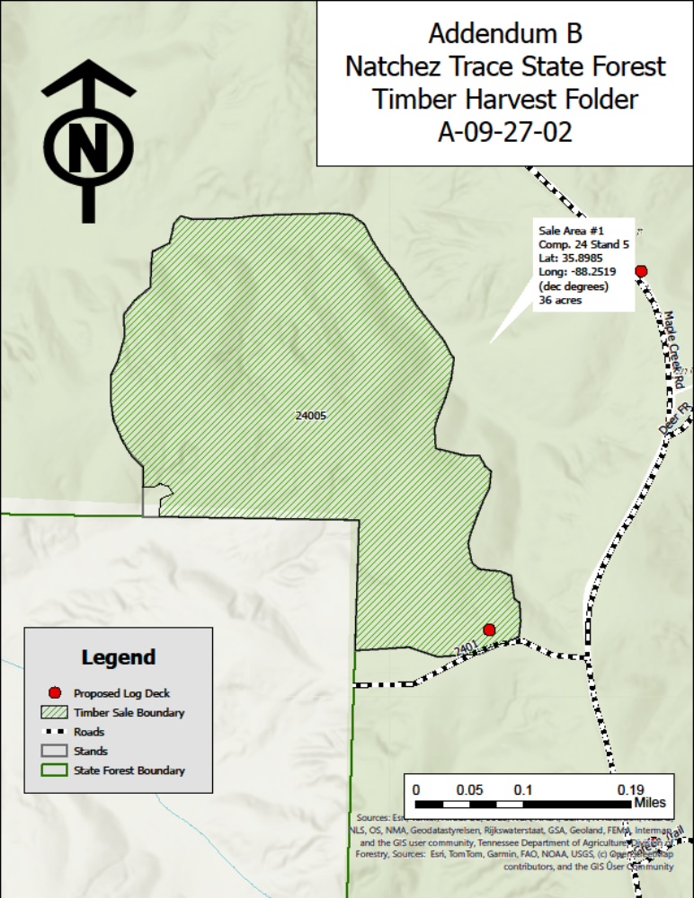
Map 1 Description: Map of Natchez Trace State Forest showing Sale Area #1 in Compartment 24, Stand 5. The 36-acre harvest boundary is outlined with nearby roads, state forest boundary, and proposed log deck locations.

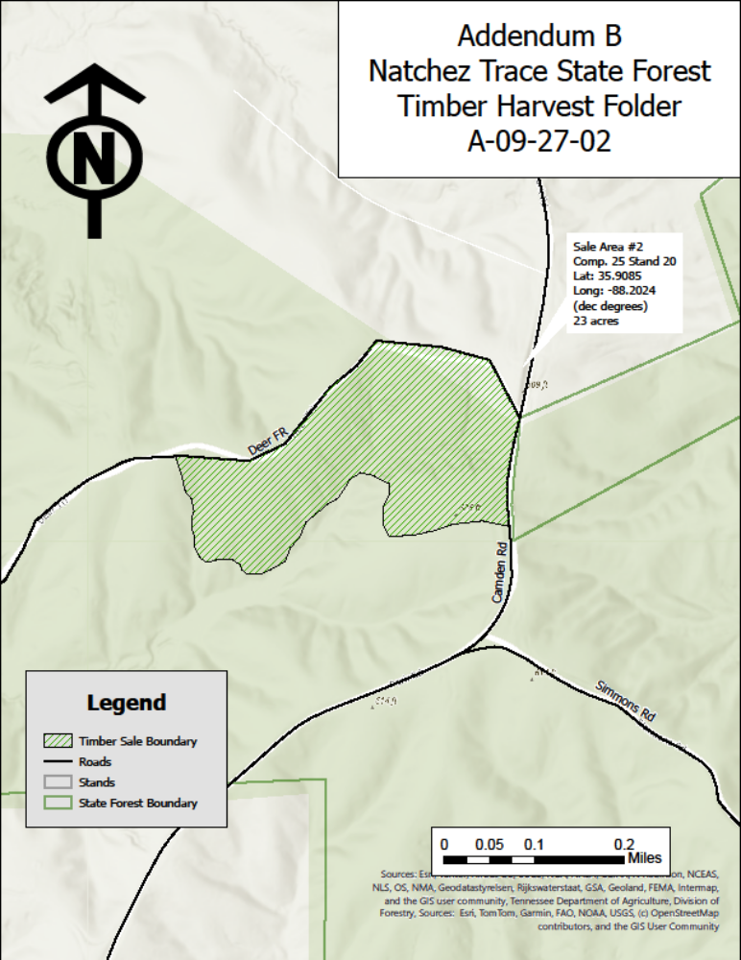
Map 2 Description: Map of Natchez Trace State Forest showing Sale Area #2 in Compartment 25, Stand 20. The 23-acre harvest boundary is outlined with nearby roads, state forest boundary, and proposed log deck locations.

Addendum C

Special Terms and Conditions
- Due to historically wet conditions, no timber harvesting shall be permitted on the State Forest between the dates of December 16 and February 28 except as permitted by the STATE.
- The PURCHASER shall purchase and spread 400 tons # 3 or #4 coarse aggregate limestone gravel. All gravel shall be spread on haul roads or at locations designated by the STATE before any timber is cut or removed from the sale area(s). The STATE reserves the right to request any documentation to verify the PURCHASER’S application of the gravel required under this Contract.
- The PURCHASER shall exercise caution and utmost care to prevent damage to trees not designated for harvest. Damage shall be determined and assessed at the sole discretion of the STATE and/or according to Section 7 (Penalties) of this Contract. The PURCHASER shall not cut, push down, or negligently damage any trees that have been marked with orange paint to mark the boundary of the sale areas and/or bands of blue paint to mark den or other leave trees.
- The PURCHASER shall cut all trees 4.5 feet tall and taller (slashing), except within equipment restriction zones or other areas otherwise designated, where slashing shall not be implemented. Stumps of severed trees shall not exceed 12 inches in height above the ground.
- The PURCHASER shall not enter equipment restriction zones with motorized equipment (bulldozers, skidders, and like equipment). Trees marked for removal in these areas shall be removed by cable. Non-merchantable tops and limbs shall be severed in the immediate sale area. Equipment restriction zones and streamside management zones (SMZs) are to retain vegetation to protect the forest floor primarily for wildlife habitat and water quality protection.
- Delimbing devices may be used for pine species only, but such devices shall be located away from the landing(s) at points designated by the STATE. Hardwood species shall be topped and delimbed where the tree falls. Skidding of the tree-length boles (merchantable bole minus top and limbs) is acceptable for all species. Trees falling outside the sale area shall be pulled back into the sale area and non-merchantable tops and limbs severed in the immediate sale area.
- The PURCHASER shall not allow excessive volumes of cut-off logs, tops and limbs to accumulate at either landings or delimbing devices.
Cut-off logs, tops and limbs that for whatever reason accumulate at landings and delimbing devices shall be scattered evenly back onto the sale area each day in a manner and to the degree that is acceptable to the STATE.
- Within each sale area, logging shall be carried out in sections at the discretion of the STATE or designated representative. Each section must be completely harvested, with the exceptions and requirements mentioned above, before proceeding to the next section.
- While on Natchez Trace State Forest, equipment, trucks and trailers must remain on rocked surfaces when outside the sale area(s) and associated landing(s), except with written permission from the STATE.

Addendum D

Communications and Contacts

State of Tennessee
Caleb LaMontagne, Assistant District Forester, West TN District
220 Eastern Shores Dr. Lexington, TN 38351
(931) 510-8715
caleb.lamontagne@tn.gov

Jonathan Vonesh, State Forest Forester
465 Parsons Rd. Wildersville, TN 38388
(731) 234-8049
Jonathan.vonesh@tn.gov

The Purchaser
Name and Title
Organization Name
Address
Phone
Fax
Email


Invitation to Bid

BID NO. A-09-27-02 – Natchez Trace State Forest

The Tennessee Division of Forestry offers for sale the timber described in Addendum “A” of the pro forma contract and subject to the “General Provisions” of the Invitation to Bid. Sealed bids will be received until:
Date: October 20, 2026
Time: 10:30 AM CST
At the following location:
Bids delivered by mail must be mailed to: | Bids delivered by hand must be delivered to:
Tennessee Department of Agriculture  Division of Forestry  P.O. Box 438  Lexington, TN 38351 | Tennessee Department of Agriculture  Division of Forestry  465 Parsons Road  Wildersville, TN 38388

Printed bids will not be accepted at any other location.

SUBMITTING A BID
Please take time to read the below information as the bid submission process has changed.
Online Submission: Bids may be submitted online at the following link: https://stateoftennessee.formstack.com/forms/state_forest_timber_sale_bids. Online bidders no longer need to attach a PDF file to the online form. All relevant information is now collected in the form itself.
Hand or Mail Submission: To submit a physical bid sheet, please print and fill out the below section by hand. Further details on submitting by hand or by mail are on page 1 of this Bid Packet.

To Print: Bid Details
In compliance with the above Invitation and subject to all General Provisions, the undersigned offers and agrees, to purchase and pay for the timber described in Addendum “A” and with the terms and conditions found in the pro forma contract, within 15 business days after Notice of Acceptance by the Tennessee Division of Forestry. All the following information should be provided. Failure to provide the “required” information will result in rejection of the Bid.

My bid for the timber offered for sale is (required): $____________________________

Signature (required): ___________________________ Printed Name: ___________________________
Title: ___________________________ Phone #: ____________________ Email: ___________________________
Owner/Organization Name (required): ______________________________________
Street Address: ________________________________________________
City, State: _____________________________________ Zip Code: ________________________________

TOUR DATES
Forestry Division personnel will give a tour of the sale areas to interested timber buyers only.
Forestry Division personnel will give a tour of the sale areas by appointment only.

For additional information contact:
Name: Jonathan Vonesh
Address: 465 Parsons Rd. Wildersville, TN 38388
Phone: (731) 234-8049
Email: Jonathan.vonesh@tn.gov

GENERAL PROVISIONS
Timber sales shall comply with the procedures outlined in General Services Rule 0690-2-1-.18 (a), Disposal of Forestry Products. The pro forma contract contains the essential terms and conditions of the timber sale contract that is signed by both parties.
The timber sale contract will not be assignable by the purchaser in whole or in part without the written consent of the Division of Forestry.
The departure from the procedures, stipulations or requirements outlined in the Invitation to Bid and General Provisions may be granted only with approval from the Commissioner of the Tennessee Department of Agriculture.
- PREPARATION OF BIDS:
  - Failure to examine any maps and/or instructions will be at bidder’s risk.
Bids must be filled out in ink or typewritten or digitally submitted. No erasures permitted. Errors may be crossed out and corrections printed in ink or typewritten adjacent to the error and must be initialed in ink by a person signing bid.
- SUBMISSION OF BIDS:
  - Bid Envelope – For printed paper submissions, the appropriate bid number must be on the outside of the envelope and envelope sealed. Only one bid per envelope. Please print the name of the bidder, organization and telephone number on the outside of the bid. The State assumes no responsibility for lost or misdirected bids.
  - Signature - Bids must be signed in ink, if printed, or digitally signed, if digitally submitted. The person signing the Invitation to Bid must be a person authorized to bind the bidder contractually. Unsigned bids will be rejected. Unsigned bids cannot be signed after the bid has been opened, even if the bidder or the bidder’s representative is present at the bid opening. No signatures shall be in pencil. The name of the person executing bid and the organization they represent should be typewritten or be legibly printed in longhand.
  - Bid Form - Only bids submitted on bid forms furnished by the Division of Forestry will be considered.
- ACCEPTANCE OF BIDS: The Division of Forestry reserves the right to reject any or all bids. Only bids in sealed envelopes delivered or mailed to the designated location prior to the bid opening time will be considered.
- ERROR IN BID: No bid shall be altered, amended, or withdrawn after the specified time for opening bids. Negligence on the part of the bidder in preparing the bid confers no right for withdrawal of the bid after it has been opened.
- AWARD:
  - The highest responsible bidder who accepts the stipulations specified in this Invitation for Bids will be declared the purchaser. The purchaser will be required to sign a timber sale contract at which time they will pay the full purchase price and post a performance bond equaling seven (7) percent of the sale price. Both amounts shall be in the form of a certified check or a cashier’s check (Attention: the interior body of the check must not be perforated or have holes punched into its surface), payable to the Tennessee Department of Agriculture, Division of Forestry.
  - If the highest responsible bidder does not meet the minimum bid determined by the Division of Forestry which is held in confidence in a sealed envelope and opened during the bid opening (the “Minimum Bid”), but is within 95% of the Minimum Bid, the Division of Forestry may negotiate with the highest responsible bidder to accept the Minimum Bid as the purchase price. If the highest responsible bidder accepts the Minimum Bid as the purchase price, then the highest responsible bidder will be declared the purchaser.
  - Should the highest responsible bidder not accept or meet the requirements or stipulations in the Invitation for Bids or General Provisions, including accepting the Minimum Bid as the purchase price, then the next highest responsible bidder will be offered the opportunity to accept the Minimum Bid as the purchase price and accept the stipulations specified in the Invitation for Bids. If the next highest responsible bidder accepts the purchase price and stipulations, the next highest bidder will be declared the purchaser. If the next highest responsible bidder refuses to accept the Minimum Bid as the purchase price, no award shall be made, and all bids shall be rejected.
  - Should two bids be identical in amount, the winner of a coin toss will determine the highest bidder and next highest bidder.
- REQUIRED DOCUMENTS: Copies of the following documents are required to be provided to the State by the PURCHASER. Copies can be attached to the signed contract, sent to the State’s contact person by mail, or provided to the State’s contact person no later than the pre- operation meeting. All insurances shall be in good standing and maintained for the term of the contract. Should the status of any of these insurances or documents change, copies should be forwarded to the State’s contact person as soon as possible.
  - Proof of Worker’s Compensation Insurance applicable to Tennessee if purchaser and/or logging contractor have employees
  - Proof of General Liability Insurance applicable to Tennessee
  - Proof of Vehicle Insurance for those vehicles utilized under the terms and conditions of the contract applicable to Tennessee
  - Proof of legal alien work status, if applicable
- United States Passport
- Unexpired Foreign Passport with I-551 Stamp
- I-94 Arrival/Departure Record
- Alien Registration Receipt Card (Resident Alien Card) I-551 (Issued after March 1977)
- Alien Registration Receipt Card (Resident Alien Card) I-551 (Issued since 1989)
- Alien Registration Receipt Card (Conditional Resident Alien Card) I-551
- Temporary Resident Card I-688
- Employment Authorization Card I-688A
- Employment Authorization Card I-688B

Envelope Label
Cut the label along the dashed lines and affix it to the front of the sealed bid envelope with clear tape.

Natchez Trace State Forest – Timber Sale A-09-27-02
Bidder’s Name
Organization Telephone

