COLD WEATHER PAVING AND COMPACTION PLAN

- Provide a detailed written justification including the target temperature to pave, mitigation criteria addressing compaction and tack coat practices, options considered, and benefit to the public. Additional data curves will be required when temperatures, wind, and other variables change. The proposed plan shall be representative of the conditions present while paving.

- Provide compaction cooling curves estimating the time available for compaction (TAC). PaveCool software is available for such calculations at:

http://www.dot.state.mn.us/app/pavecool/

Note: Select Options->Start/Stop Temperatures and set the Stop Rolling Temperature to 180 F for PG64-22, 220 F for PG70-22 and 235 F for PG 76-22.

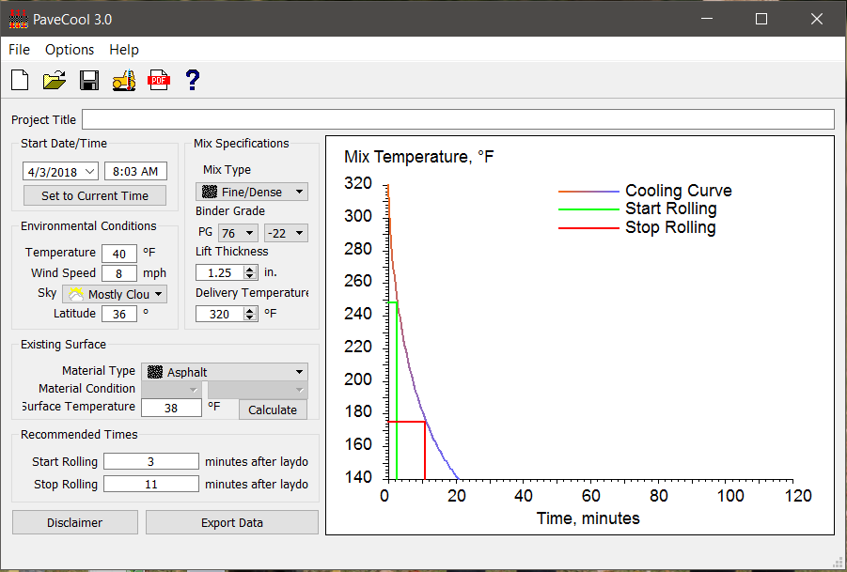

All projects requiring a Cold Weather Paving and Compaction Plan shall utilize Intelligent Compaction at no additional cost to the Department with the exception of small quantity projects such as, but not limited to, bridge approaches, intersections, and temporary traffic shifts.

Required Information:

Date:
Contract ID:
Proposed Construction Date(s):
Minimum Air Temp: | °F
Minimum Surface Temp: | °F
Maximum Wind Speed: | mph
Mix Type(s):
AC Grade(s):
Lift Thickness(es): | in
Minimum Production Temperature: | °F
Maximum Production Temperature: | °F
Warm Mix Asphalt? | Yes / No
Maximum Paver Speed: | ft/sec
Maximum production rate: | tph
Number of Rollers
Roller Speed
Number of Trucks

ADDITIONAL COLD WEATHER TACTICS
Address Compaction:
Tactic | Yes/No? | Comments
Insulated truck beds
Additional rollers
Automated measurement of mix temperature immediately behind screed
Surface heaters
Compaction aids or warm mix asphalt
Additional third-party testing documenting all mixtures placed meet density requirements
Reduced production and paving rates

Address Tack Coat:

Tactic | Yes/No? | Comments
Surface heaters
Hot applied tack or hot applied PG64-22
Apply conventional tack coat at upper limit of table 403.02-1
Allow longer time from application to break

In all cases except if PG64-22 is used, tack must be broken prior to paving. If tack will not break do not pave.

Regional Director (or designee) Approved: ___________________________ Date: _____________

cc: Regional Materials and Tests
HQ Materials and Tests
State Pavement Engineer

