Tennessee Education Broadband Consortium Contract(s)
Form 471 Funding Request Filing Guide

If you have decided to use one or more of the Tennessee Education Broadband Consortium contracts and it’s time to create your funding request(s), you can use this handy guide to help you streamline your process. Your State E-Rate Coordinator’s office has uploaded all of the contract information for each of the available contracts into the Consortium’s EPC portal. You do not have to enter the contract(s) information into YOUR portal; you can simply reference the record that is already established within EPC. This guide along with the attached “TEBC Contract Cheat Sheet” spreadsheet will allow you to easily move through this section of the Form 471 application.

When you get to the section of Form 471 where it’s time to create your Funding Request, just follow the steps below to populate the contract information WITHOUT having to pre-populate all of the information in your own EPC profile.

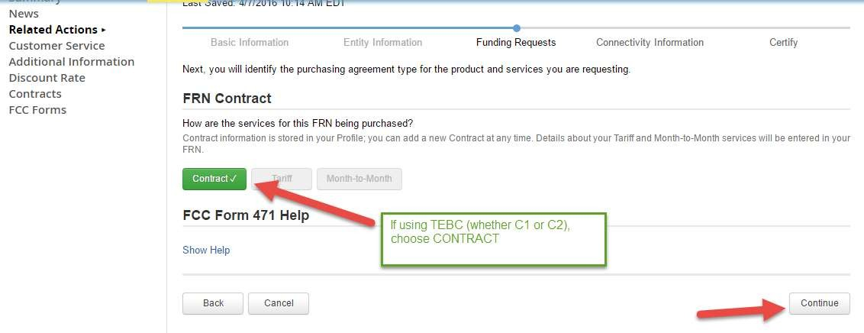

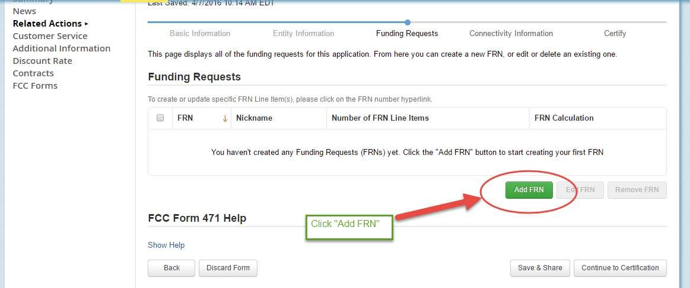
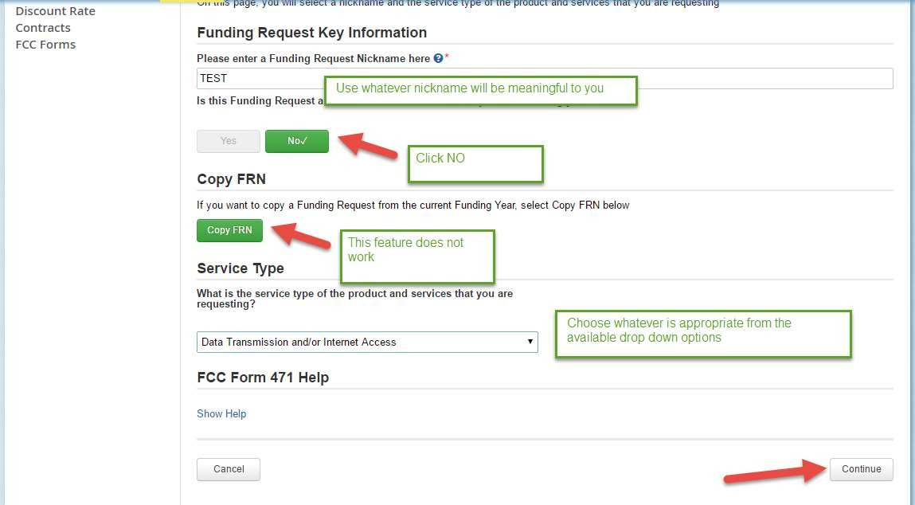

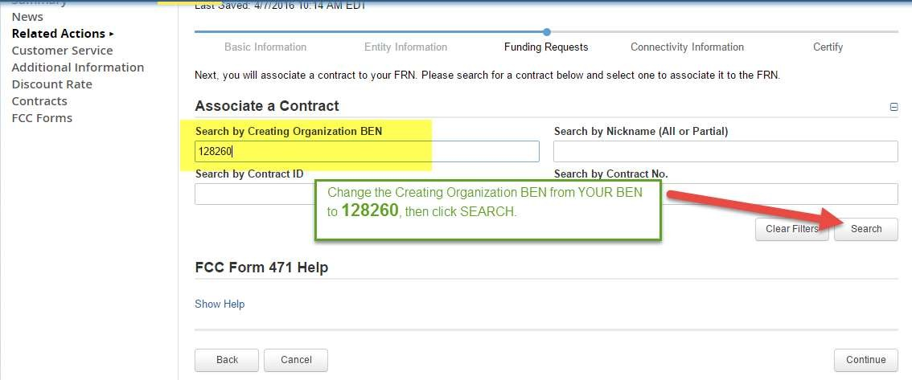
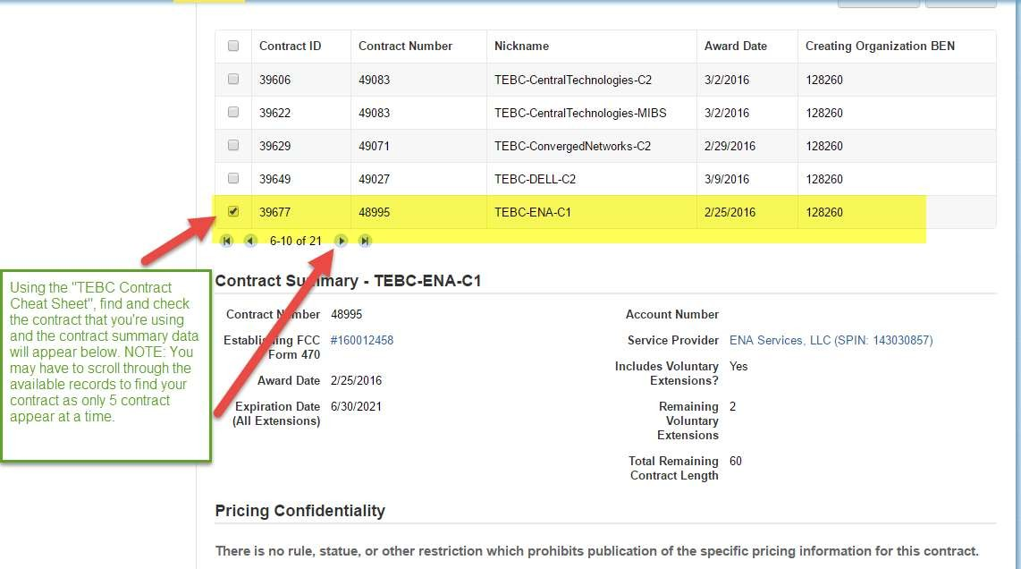

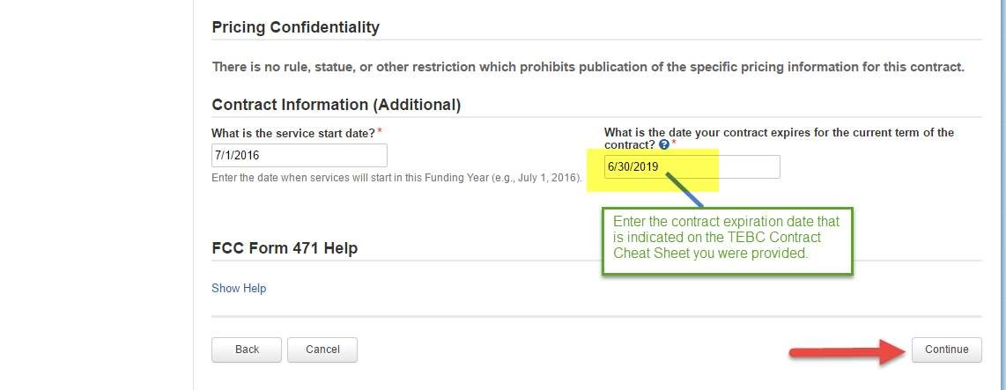

You will then proceed to complete your funding request information answering the service type specific questions in the form and completing the line-item details associated with each of your funding requests.

Be sure to cross-check the contract nickname and EPC contract ID# to be sure you’ve grabbed the right contract for the service you are requesting funding for.

If you have any questions, please don’t hesitate to contact us.

