MECHANICAL, ELECTRICAL, & PLUMBING SYSTEMS
__________

Level One
Level Two
Level Three
Architecture & Construction
__________

Level Four

ABOUT THE PROGRAM OF STUDY
Industry certification options include:
- NCCER Core Curriculum
- NCCER Electrical
- NCCER Plumbing
- EPA Section 608 Universal
- Universal R-410A
- HVAC Excellence
Dual Enrollment options include:
- Course A at local TCAT

The Mechanical, Electrical, & Plumbing Systems program of study prepares students to install, service, and maintain building equipment. Course content is arranged around four sequenced, progressive courses that provide students with the opportunity to understand the principles behind mechanical, electrical, & plumbing systems, to apply basic installation skills, and to safely use and maintain appropriate tools, equipment, and resources to accomplish project goals. The MEP Systems course introduces students to the physical principals involved with these systems and the fundamental skills needed to work with them. In the third level, students have the option to focus in electrical, plumbing, or HVAC/R, and earn an industry credential specific to the focus area. The fourth level course, Construction Practicum, places students with industry partners to complete a capstone project.
Career Opportunities

CAREER OPPORTUNITIES
The installation, maintenance, and repair occupation group is projected to grow by 10.8 percent in Tennessee between 2014 and 2022. More than 3,000 total annual average openings are projected for the occupation group (not including vehicle installers and repairers). Opportunities are available in a broad range of occupations including electrical systems, plumbing systems, and HVAC systems. Notably, the job outlook for the electrical occupations is expected to be excellent due to more job openings expected annually than training completers in recent years.
Occupation | Total Percent Change | Annual Avg. Openings
Maintenance & Repair Workers, General | 7.7% | 880
Electricians | 9.0% | 340
First-Line Supervisors of Mechanics, Installers, & Repairers | 6.3% | 335
HVAC/R Mechanics & Installers | 10.9% | 275
Construction Managers | 4.6% | 235
Supervisors of Construction & Extraction Workers | 9.2% | 210
Mechanical Engineers | 5.3% | 170
Cost Estimators | 11.9% | 170
Sheet Metal Workers | 14.4% | 160
Electrical Power-Line Installers & Repairers | 10.0% | 155
Plumbers, Pipefitters, & Steamfitters | 6.6% | 140
Helpers- Installation, Maintenance, & Repair Workers | 6.6% | 100

Construction Occupations with the Most Annual Average Openings in Tennessee (2014-2022)

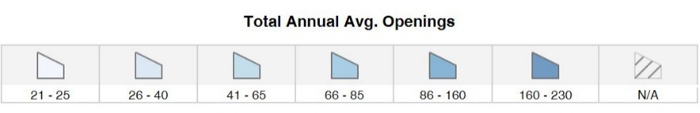
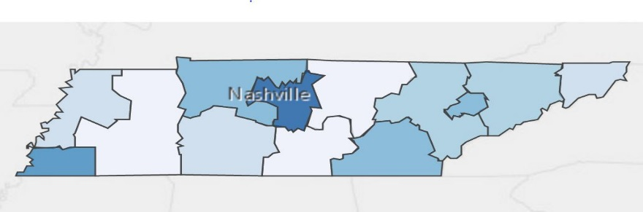
Annual Average Openings for General Maintenance & Repair Workers in Tennessee (2014-2022)

Source: TN Department of Labor and Workforce Development. (2015). Employment Security Division, Labor Market Information Section, on the internet at https://www.jobs4tn.gov/ (visited Feb. 10, 2016)
Students in this program of study will be eligible to join SkillsUSA. In addition to school events, students will be able to compete at the regional, state, and national level. Through SkillsUSA, students not only learn about MEP systems, but also professionalism, leadership, and workplace skills. Walk away from your high school career with experience in competing, networking, applying course content, and more!

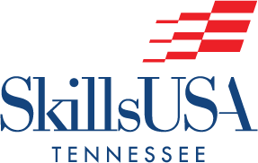
For more information, contact:
Central High School
County Name Schools
CTE Director: Susan Smith Susan.Smith@school.edu
Instructor: Bob Johnson Bob.Johnson@school.edu

See your teacher to learn more about SkillsUSA or visit http://tnskillsusa.com/.
School | Degree Program
TCAT Nashville | Building Construction Technology
TCAT Murfreesboro | HVAC/R
TCAT Knoxville | Plumbing & Pipefitting
TCAT Paris | Residential Building Maintenance
Nashville State | Electrical Engineering Technology
Chattanooga State | Electrical Technology
For more college and career planning resources, visit http://collegefortn.org.

POSTSECONDARY OPTIONS

community college, or some 2-year university programs for free! To learn more, please see your school counselor or visit http://www.tennesseepromise.gov.

Have you registered for the Tennessee Promise? Seniors enrolled in this program have the chance to attend a two-year program at a Tennessee College of Applied Technology (TCAT), community college, or some 2-year university programs for free! To learn more, please see your school counselor or visit http://www.tennesseepromise.gov.

