Environmental and Natural Resource management
Agriculture, Food, and Natural Resources
__________

Level Four
¹ Satisfies one lab science credit required for graduation.
Level One
Level Two
Level Three

ABOUT THE PROGRAM OF STUDY
Dual credit/dual enrollment options include:
- Course A
- Course B
Environmental and Natural Resource Management is designed for students interested in learning more about becoming good stewards of our environment and natural resources as an environmental scientist, conservationist, forester, or wildlife manager. This program of study covers environmental impacts, energy consumption, environmental public policy, and fundamental science and management of ecosystems, with special attention given to current agricultural practices that support the healthy and sustainable cultivation of major crops. Upon completion of this program of study, students will be prepared for a range of careers associated with the science and management of plants, soils, wildlife, and natural resources.

This is not an exhaustive list of all of the opportunities available in Tennessee.

Jobs projections for managers including ecology, natural resources and tourism for 2024

Source: TN Department of Labor and Workforce Development. Accessed Aug. 2017
Environmental and Natural Resources Related Occupations with the Largest Annual Percentage of Openings in Tennessee (2014-2024)
Occupation | 2014 Estimated Employment | 2024 Projected Employment | Total Change | Annual Avg. Percent Change
11-9121 Natural Sciences Managers | 510 | 530 | 10 | 5%
17-2081 Environmental Engineers | 1,010 | 1,220 | 210 | 21%
11-9199 Managers, All Other (Ecology, Natural Resources & Tourism) | 12,500 | 13,790 | 400 | 10%
19-2041 Environmental Scientists and Specialists, including health | 1,370 | 1,480 | 110 | 8%
Source: TN Dept of Labor & Workforce Dev, Div Emp Sec, R&S
Downloaded: May 17, 2017

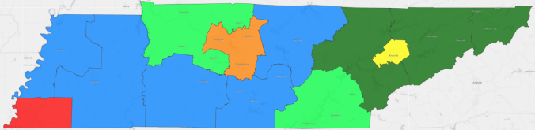

POSTSECONDARY OPTIONS
Have you registered for the Tennessee Promise? Seniors enrolled in this program have the chance to attend a two-year program at a Tennessee College of Applied Technology (TCAT), community college, or some two–year university programs for free! To learn more, please see your school counselor or visit http://www.tennesseepromise.gov.
Postsecondary Offerings
Program of Study | School | Degree Program
Forestry or Wildlife and Fisheries | University of Tennessee, Knoxville | Bachelor’s, Master’s , and/or Doctoral
Natural Resource Management | University of Tennessee, Martin | Bachelor’s
Wildlife & Fisheries Science | Tennessee Tech University | Bachelor’s
Plant and Soil Science | Walters State Community College | Associate’s
For more college and career planning resources, visit http://collegefortn.org.

Students in this program of study will be eligible to join FFA. In addition to school events, students will be able to compete at the district, regional, state, and national levels. Through FFA, students not only learn about agriculture, but also professionalism, leadership, and soft skills. Walk away from your high school career with experience in competing, networking, applying course content, and more! See your agriculture teacher to learn more about FFA or visit http://www.tnffa.org.

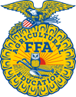
For more information, contact:
Name of High School
Name of School System
CTE Director: [enter name]
Email
Teacher: [enter name]
Email

